UNITED STATES
SECURITIES AND EXCHANGE COMMISSION
Washington, D.C. 20549

FORM 10-Q
(Mark One)
☒ |  |  | QUARTERLY REPORT PURSUANT TO SECTION 13 OR 15(d) OF THE SECURITIES EXCHANGE ACT OF 1934
For the quarterly period ended September 30, 2026

Or
☐ |  |  | TRANSITION REPORT PURSUANT TO SECTION 13 OR 15(d) OF THE SECURITIES EXCHANGE ACT OF 1934
For the transition period from to
Commission file number: 001-41850

NEIGHBORHOOD INTELLIGENCE, INC.
(Exact name of registrant as specified in its charter)
Delaware |  |  |  |  |  |  |  |  | 87-0634302
(State or other jurisdiction of incorporation or organization) |  |  |  |  |  |  |  |  | (I.R.S. Employer Identification Number)
5310 Maryland Way
Brentwood, |  |  | Tennessee |  |  |  |  |  | 37027
(Address of principal executive offices) |  |  |  |  |  |  |  |  | (Zip Code)
(801) 947-3100
(Registrant's telephone number, including area code)
Bed Bath & Beyond, Inc., 433 W. Ascension Way, 3rd Floor, Murray, Utah 84123
(Former name, former address and former fiscal year, if changed since last report)

Securities registered pursuant to Section 12(b) of the Act:
Title of each class |  |  |  |  |  | Trading Symbol(s) |  |  |  |  |  | Name of each exchange on which registered
Common Stock, $0.0001 par value |  |  |  |  |  | NXH |  |  |  |  |  | The Nasdaq Stock Market LLC

Indicate by check mark whether the registrant (1) has filed all reports required to be filed by Section 13 or 15(d) of the Securities Exchange Act of 1934 during the preceding 12 months (or for such shorter period that the registrant was required to file such reports), and (2) has been subject to such filing requirements for the past 90 days. Yes ☒ No ☐

Indicate by check mark whether the registrant has submitted electronically every Interactive Data File required to be submitted pursuant to Rule 405 of Regulation S-T (§232.405 of this chapter) during the preceding 12 months (or for such shorter period that the registrant was required to submit such files). Yes ☒ No ☐

Indicate by check mark whether the registrant is a large accelerated filer, an accelerated filer, a non-accelerated filer, a smaller reporting company, or an emerging growth company. See the definitions of "large accelerated filer," "accelerated filer," "smaller reporting company," and "emerging growth company" in Rule 12b-2 of the Exchange Act.
Large accelerated filer |  |  | ☐ |  |  | Accelerated filer |  |  | ☒
Non-accelerated filer |  |  | ☐ |  |  | Smaller reporting company |  |  | ☐
 |  |  |  |  |  | Emerging growth company |  |  | ☐
If an emerging growth company, indicate by check mark if the registrant has elected not to use the extended transition period for complying with any new or revised financial accounting standards provided pursuant to Section 13(a) of the Exchange Act. ☐

Indicate by check mark whether the registrant is a shell company (as defined in Rule 12b-2 of the Exchange Act). Yes ☐ No ☒

110,017,208 shares of the registrant's common stock, par value $0.0001, were outstanding on November 3, 2026.

Table of Contents

NEIGHBORHOOD INTELLIGENCE, INC.
TABLE OF CONTENTS TO QUARTERLY REPORT ON FORM 10-Q
For the Quarterly Period Ended September 30, 2026

 |  |  |  |  |  | Page
PART I. FINANCIAL INFORMATION
Item 1. |  |  | Financial Statements (Unaudited) |  |  | 5
 |  |  | Consolidated Balance Sheets |  |  | 5
 |  |  | Consolidated Statements of Operations |  |  | 7
 |  |  | Consolidated Statements of Comprehensive Loss |  |  | 8
 |  |  | Consolidated Statements of Changes in Stockholders' Equity |  |  | 9
 |  |  | Consolidated Statements of Cash Flows |  |  | 11
 |  |  | Notes to Unaudited Consolidated Financial Statements |  |  | 13
Item 2. |  |  | Management's Discussion and Analysis of Financial Condition and Results of Operations |  |  | 38
Item 3. |  |  | Quantitative and Qualitative Disclosures About Market Risk |  |  | 51
Item 4. |  |  | Controls and Procedures |  |  | 52
PART II. OTHER INFORMATION
Item 1. |  |  | Legal Proceedings |  |  | 53
Item 1A. |  |  | Risk Factors |  |  | 53
Item 2. |  |  | Unregistered Sales of Equity Securities and Use of Proceeds |  |  | 58
Item 3. |  |  | Defaults Upon Senior Securities |  |  | 58
Item 4. |  |  | Mine Safety Disclosures |  |  | 58
Item 5. |  |  | Other Information |  |  | 58
Item 6. |  |  | Exhibits |  |  | 59
Signatures |  |  |  |  |  | 61

2

Table of Contents

SPECIAL CAUTIONARY NOTE REGARDING FORWARD-LOOKING STATEMENTS
This Quarterly Report on Form 10-Q and the information incorporated herein by reference, and our other public documents and statements our officers and representatives may make from time to time, contain forward-looking statements within the meaning of the federal securities laws. These statements are intended to be covered by the safe harbor provisions of these laws. You can find many of these statements by looking for words such as "may," "would," "could," "should," "will," "expect," "anticipate," "predict," "project," "potential," "continue," "contemplate," "seek," "assume," "believe," "intend," "plan," "forecast," "goal," "estimate," or other similar terms or expressions or the negative of these terms or expressions, although not all forward-looking statements contain these identifying terms or expressions.

These forward-looking statements involve known and unknown risks and uncertainties and relate to future events or our future financial or operating performance. These forward-looking statements are not historical facts, and are based on current expectations, estimates and projections about our industry and business, and on management's beliefs and certain assumptions made by management, many of which, by their nature, are inherently uncertain and beyond our control. Accordingly, you are cautioned that any such forward-looking statements are not guarantees of future performance and are subject to assumptions, risks, uncertainties, and other important factors that are difficult to predict, and that actual results and outcomes may be materially different from the results, performance, achievements, or outcomes expressed or implied by any of our forward-looking statements for a variety of reasons, including among others:

•We depend on third-party companies to perform functions critical to our business, and any failure or increased cost on their part could have a material adverse effect on our business.
•We face intense competition and may not be able to compete successfully against existing or future competitors.
•We may not timely identify or effectively respond to consumer needs, expectations or trends, which could adversely affect our relationship with our customers, the demand for our products and services, and our market share.
•Our business depends on effective marketing, including marketing via email, search engine marketing, influencer marketing, and social media marketing. Our competitors have and may continue to cause us to increase our marketing costs and decrease certain other types of marketing, and have and may continue to outspend us on marketing or be more efficient in their spend.
•Economic factors, including recessions, other economic downturns, inflation, our exposure to the U.S. housing market, and decreases in consumer spending, have affected and could continue to adversely affect us.
•Tariffs, bans, or other measures or events that increase the effective price of products or limit our ability to access products we or our suppliers, fulfillment partners, or other third parties that import or export could have a material adverse effect on our business.
•Our changing business model and use of the Bed Bath & Beyond brand, Overstock brand, buybuy BABY brand, Kirkland's and Kirkland's Home brand, The Container Store brand, Elfa brand, Closet Works brand, Beyond brand, and other brands of ours, could negatively impact our business.
•The changing job market, the changes in our leadership team, the change in our compensation approach, changing job structures, or any inability to attract, retain and engage key personnel could affect our ability to successfully grow our business.
•We rely upon paid and natural search engines to rank our product offerings, and our financial results may suffer if we are unable to maintain our prior rankings in natural searches.
•If we are not profitable and/or are unable to generate sufficient positive cash flow from operations, our ability to continue in business will depend on our ability to raise additional capital, obtain financing or monetize significant assets, and we may be unable to do so.
•Our business depends on the Internet, our infrastructure and transaction-processing systems, and catastrophic events could adversely affect our operating results.
•Compliance with ever-evolving federal, state, and foreign laws and other requirements relating to the handling of information about individuals necessitates significant expenditure and resources, and any failure by us, our vendors or our business partners to comply may result in significant liability, negative publicity, and/or an erosion of trust, which could materially adversely affect our business, results of operations, and financial condition.
•If we or our third-party providers experience cyberattacks or data security incidents, there may be damage to our brand and reputation, material financial penalties, and legal liability, which would materially adversely affect our business, results of operations, and financial condition.
•Failure to comply with, or changes in, laws, regulations and enforcement activities may adversely affect the products, services, and markets in which we operate.
•From time to time, we are subject to various legal proceedings which could adversely affect our business, financial condition or results of operations.
3

Table of Contents

•Damage to our reputation or brand image could adversely affect our sales and results of operations.
•If we do not successfully optimize and operate our fulfillment center or customer service operations, our business could be harmed.
•If we fail to effectively utilize technological advancements, including in artificial intelligence, our business and financial performance could be negatively impacted.
•Global conflict could negatively impact our business, results of operations, and financial condition.
•Product safety and quality concerns could have a material adverse impact on our revenue and profitability.
•We depend on our suppliers' and fulfillment partners' representations regarding product safety, content and quality, product compliance with various laws and regulations, including registration and/or reporting obligations, and for proper labeling of products.
•We have an evolving business model, which increases the complexity of our business.
•Investment in new business strategies, acquisitions, dispositions, partnerships, or other transactions could disrupt our ongoing business, present risks not originally contemplated and materially adversely affect our business, reputation, results of operations and financial condition.
•Regulatory changes or actions may alter the nature of an investment in us or restrict the use of digital assets, including tokens or blockchain technology in a manner that adversely affects our business, prospects, and operations.
•Combining our business with those of The Brand House Collective, Inc. ("TBHC") and The Container Store Holdings, LLC (“TCS”) may be more difficult, costly or time-consuming than expected, and the combined company may fail to realize the anticipated benefits of the mergers with TBHC and TCS, which may adversely affect the combined company's business results and negatively affect the value of the combined company's common stock.
•Changing our corporate name and associated branding to Neighborhood Intelligence, Inc. from Bed Bath & Beyond, Inc. may be more difficult, costly or time-consuming than expected and the new corporate name may cause confusion or fail to realize the anticipated benefits, which may adversely affect the company’s business results and negatively affect the value of the company’s common stock.

In evaluating all forward-looking statements, you should specifically consider the risks outlined above and in this report and our Annual Report on Form 10-K for the year ended December 31, 2025, and our Quarterly Report on Form 10-Q for the quarterly period ended March 31, 2026 and the quarterly period ended June 30, 2026 under the headings, as applicable, "Special Cautionary Note Regarding Forward-Looking Statements," "Summary of Risk Factors," "Risk Factors," "Legal Proceedings," and "Management's Discussion and Analysis of Financial Condition and Results of Operations." These factors may cause our actual results and outcomes to differ materially from those contemplated by any forward-looking statement. Although we believe that our expectations reflected in the forward-looking statements are reasonable, we cannot guarantee or offer any assurance of future results, levels of activity, performance or achievements or other future events. Our forward-looking statements contained in this report speak only as of the date of this report and, except as required by law, we undertake no obligation to update forward-looking statements to reflect events or circumstances occurring after the date of this report or any changes in our expectations or any change in any events, conditions or circumstances on which any of our forward-looking statements are based.

As used herein, the “Company,” “we,” “us,” “our,” “NXH” and “Neighborhood Intelligence” refer to Neighborhood Intelligence, Inc. and its consolidated subsidiaries following the name change and to Bed Bath & Beyond, Inc. and its consolidated subsidiaries prior to the name change, unless otherwise stated or the context otherwise requires.

4

Table of Contents

PART I. FINANCIAL INFORMATION

ITEM 1. FINANCIAL STATEMENTS (UNAUDITED)

Neighborhood Intelligence, Inc.
Consolidated Balance Sheets (Unaudited)
(in thousands, except per share data)
 |  |  | September 30,  2026 |  |  |  |  |  | December 31,  2025
Assets
Current assets:
Cash and cash equivalents |  |  | $ | 100,435 |  |  |  |  | $ | 175,295
Restricted cash |  |  | 26,795 |  |  |  |  |  | 26,924
Accounts receivable, net of allowance for credit losses of $2,818 and $3,377 |  |  | 50,501 |  |  |  |  |  | 20,829
Inventories |  |  | 227,845 |  |  |  |  |  | 5,162
Prepaids and other current assets |  |  | 38,739 |  |  |  |  |  | 11,905
Total current assets |  |  | 444,315 |  |  |  |  |  | 240,115
Property and equipment, net |  |  | 177,348 |  |  |  |  |  | 13,712
Intangible assets, net |  |  | 68,600 |  |  |  |  |  | 45,140
Goodwill |  |  | 140,564 |  |  |  |  |  | 6,160
Equity securities, including securities measured at fair value of $17,075 and $26,903 |  |  | 54,905 |  |  |  |  |  | 66,641
Operating lease right-of-use assets |  |  | 443,587 |  |  |  |  |  | 5,156
Other long-term assets, net, including securities measured at fair value of $17,682 and $42,394 |  |  | 29,292 |  |  |  |  |  | 48,554
Total assets |  |  | $ | 1,358,611 |  |  |  |  | $ | 425,478
Liabilities and Stockholders' Equity
Current liabilities:
Accounts payable |  |  | $ | 208,170 |  |  |  |  | $ | 89,992
Accrued liabilities |  |  | 127,343 |  |  |  |  |  | 51,297
Unearned revenue |  |  | 47,804 |  |  |  |  |  | 34,429
Operating lease liabilities, current |  |  | 100,233 |  |  |  |  |  | 928
Short-term debt, net |  |  | — |  |  |  |  |  | 15,500
Total current liabilities |  |  | 483,550 |  |  |  |  |  | 192,146
Long-term debt, net |  |  | 212,807 |  |  |  |  |  | —
Operating lease liabilities, non-current |  |  | 343,232 |  |  |  |  |  | 5,643
Deferred tax liabilities, long-term |  |  | 9,436 |  |  |  |  |  | —
Other long-term liabilities, including commitments measured at fair value of $— and $2,766 |  |  | 17,044 |  |  |  |  |  | 9,745
Total liabilities |  |  | $ | 1,066,069 |  |  |  |  | $ | 207,534
Commitments and contingencies (Note 10)
Continued on the following page

See accompanying notes to unaudited consolidated financial statements.
5

Table of Contents

Neighborhood Intelligence, Inc.
Consolidated Balance Sheets (Unaudited)
(in thousands, except per share data)
(Continued) |  |  | September 30,  2026 |  |  |  |  |  | December 31,  2025
Stockholders' equity:
Preferred stock, $0.0001 par value, authorized shares - 5,000, issued and outstanding - none |  |  | $ | — |  |  |  |  | $ | —
Common stock, $0.0001 par value, authorized shares - 200,000
Issued shares - 106,771 and 76,358
Outstanding shares - 98,626 and 68,863 |  |  | 11 |  |  |  |  |  | 8
Additional paid-in capital |  |  | 1,401,528 |  |  |  |  |  | 1,239,338
Accumulated deficit |  |  | (924,750) |  |  |  |  |  | (842,711)
Accumulated other comprehensive loss |  |  | (4,896) |  |  |  |  |  | (2,574)
Treasury stock at cost - 8,145 and 7,495 |  |  | (179,675) |  |  |  |  |  | (176,478)
Equity attributable to stockholders of Neighborhood Intelligence, Inc. |  |  | 292,218 |  |  |  |  |  | 217,583
Equity attributable to noncontrolling interests |  |  | 324 |  |  |  |  |  | 361
Total stockholders' equity |  |  | 292,542 |  |  |  |  |  | 217,944
Total liabilities and stockholders' equity |  |  | $ | 1,358,611 |  |  |  |  | $ | 425,478

See accompanying notes to unaudited consolidated financial statements.

6

Table of Contents

Neighborhood Intelligence, Inc.
Consolidated Statements of Operations (Unaudited)
(in thousands, except per share data)

 |  |  | Three months ended  September 30, |  |  |  |  |  |  |  |  |  |  |  | Nine months ended  September 30,
 |  |  | 2026 |  |  |  |  |  | 2025 |  |  |  |  |  | 2026 |  |  |  |  |  | 2025
Net revenue |  |  | $ | 509,314 |  |  |  |  | $ | 257,187 |  |  |  |  | $ | 1,118,228 |  |  |  |  | $ | 771,186
Cost of goods sold |  |  | 336,369 |  |  |  |  |  | 192,024 |  |  |  |  |  | 789,404 |  |  |  |  |  | 580,922
Gross profit |  |  | 172,945 |  |  |  |  |  | 65,163 |  |  |  |  |  | 328,824 |  |  |  |  |  | 190,264
Operating expenses
Sales and marketing |  |  | 54,272 |  |  |  |  |  | 36,126 |  |  |  |  |  | 129,690 |  |  |  |  |  | 105,625
Technology |  |  | 33,549 |  |  |  |  |  | 20,645 |  |  |  |  |  | 79,097 |  |  |  |  |  | 70,584
General and administrative |  |  | 131,238 |  |  |  |  |  | 11,971 |  |  |  |  |  | 203,628 |  |  |  |  |  | 40,373
Customer service and merchant fees |  |  | 16,217 |  |  |  |  |  | 8,873 |  |  |  |  |  | 36,814 |  |  |  |  |  | 27,561
Other operating expense (income), net |  |  | (262) |  |  |  |  |  | — |  |  |  |  |  | 2,754 |  |  |  |  |  | (5,790)
Total operating expenses |  |  | 235,014 |  |  |  |  |  | 77,615 |  |  |  |  |  | 451,983 |  |  |  |  |  | 238,353
Operating loss |  |  | (62,069) |  |  |  |  |  | (12,452) |  |  |  |  |  | (123,159) |  |  |  |  |  | (48,089)
Interest income (expense), net |  |  | (3,749) |  |  |  |  |  | 1,186 |  |  |  |  |  | (1,270) |  |  |  |  |  | 2,837
Other income (expense), net |  |  | 20,712 |  |  |  |  |  | 6,978 |  |  |  |  |  | 21,161 |  |  |  |  |  | (17,780)
Loss before income taxes |  |  | (45,106) |  |  |  |  |  | (4,288) |  |  |  |  |  | (103,268) |  |  |  |  |  | (63,032)
Provision (benefit) for income taxes |  |  | (18,962) |  |  |  |  |  | 233 |  |  |  |  |  | (21,229) |  |  |  |  |  | 714
Net loss |  |  | $ | (26,144) |  |  |  |  | $ | (4,521) |  |  |  |  | $ | (82,039) |  |  |  |  | $ | (63,746)
Net loss per share of common stock:
Basic |  |  | $ | (0.28) |  |  |  |  | $ | (0.07) |  |  |  |  | $ | (1.03) |  |  |  |  | $ | (1.11)
Diluted |  |  | $ | (0.28) |  |  |  |  | $ | (0.07) |  |  |  |  | $ | (1.03) |  |  |  |  | $ | (1.11)
Weighted average shares of common stock outstanding:
Basic |  |  | 94,911 |  |  |  |  |  | 60,333 |  |  |  |  |  | 79,517 |  |  |  |  |  | 57,190
Diluted |  |  | 94,911 |  |  |  |  |  | 60,333 |  |  |  |  |  | 79,517 |  |  |  |  |  | 57,190

See accompanying notes to unaudited consolidated financial statements.

7

Table of Contents

Neighborhood Intelligence, Inc.
Consolidated Statements of Comprehensive Loss (Unaudited)
(in thousands)

 |  |  | Three months ended  September 30, |  |  |  |  |  |  |  |  |  |  |  | Nine months ended  September 30,
 |  |  | 2026 |  |  |  |  |  | 2025 |  |  |  |  |  | 2026 |  |  |  |  |  | 2025
Net loss |  |  | $ | (26,144) |  |  |  |  | $ | (4,521) |  |  |  |  | $ | (82,039) |  |  |  |  | $ | (63,746)
Other comprehensive income (loss)
Pension liability adjustment, net of tax |  |  | 4 |  |  |  |  |  | — |  |  |  |  |  | 4 |  |  |  |  |  | —
Foreign currency translation adjustment, net of tax |  |  | (2,326) |  |  |  |  |  | — |  |  |  |  |  | (2,326) |  |  |  |  |  | —
Other comprehensive loss |  |  | (2,322) |  |  |  |  |  | — |  |  |  |  |  | (2,322) |  |  |  |  |  | —
Comprehensive loss |  |  | $ | (28,466) |  |  |  |  | $ | (4,521) |  |  |  |  | $ | (84,361) |  |  |  |  | $ | (63,746)

See accompanying notes to unaudited consolidated financial statements.

8

Table of Contents

Neighborhood Intelligence, Inc.
Consolidated Statements of Changes in Stockholders' Equity (Unaudited)
(in thousands)

 |  |  | Three months ended  September 30, |  |  |  |  |  |  |  |  |  |  |  | Nine months ended  September 30,
 |  |  | 2026 |  |  |  |  |  | 2025 |  |  |  |  |  | 2026 |  |  |  |  |  | 2025
Equity attributable to stockholders of Neighborhood Intelligence, Inc.
Shares of common stock issued
Balance at beginning of period |  |  | 89,604 |  |  |  |  |  | 64,322 |  |  |  |  |  | 76,358 |  |  |  |  |  | 59,560
Common stock issued upon vesting of restricted stock |  |  | 49 |  |  |  |  |  | 2 |  |  |  |  |  | 1,294 |  |  |  |  |  | 341
Common stock issued for ESPP purchases |  |  | 44 |  |  |  |  |  | 47 |  |  |  |  |  | 111 |  |  |  |  |  | 138
Common stock issued in the acquisition of TBHC |  |  | (1,781) |  |  |  |  |  | — |  |  |  |  |  | 2,953 |  |  |  |  |  | —
Common stock issued in the acquisition of SFV Services |  |  | — |  |  |  |  |  | — |  |  |  |  |  | 7,200 |  |  |  |  |  | —
Common stock issued in the acquisition of TCS |  |  | 13,714 |  |  |  |  |  | — |  |  |  |  |  | 13,714 |  |  |  |  |  | —
Common stock sold through offerings |  |  | 4,998 |  |  |  |  |  | 8,100 |  |  |  |  |  | 4,998 |  |  |  |  |  | 12,432
Other |  |  | 143 |  |  |  |  |  | — |  |  |  |  |  | 143 |  |  |  |  |  | —
Balance at end of period |  |  | 106,771 |  |  |  |  |  | 72,471 |  |  |  |  |  | 106,771 |  |  |  |  |  | 72,471
Shares of treasury stock
Balance at beginning of period |  |  | 7,844 |  |  |  |  |  | 6,917 |  |  |  |  |  | 7,495 |  |  |  |  |  | 6,491
Repurchases of common stock |  |  | — |  |  |  |  |  | 570 |  |  |  |  |  | — |  |  |  |  |  | 903
Tax withholding upon vesting of employee stock awards |  |  | 14 |  |  |  |  |  | — |  |  |  |  |  | 363 |  |  |  |  |  | 93
Treasury stock retained in the participation agreement settlement |  |  | 287 |  |  |  |  |  | — |  |  |  |  |  | 287 |  |  |  |  |  | —
Balance at end of period |  |  | 8,145 |  |  |  |  |  | 7,487 |  |  |  |  |  | 8,145 |  |  |  |  |  | 7,487
Total shares of common stock outstanding |  |  | 98,626 |  |  |  |  |  | 64,984 |  |  |  |  |  | 98,626 |  |  |  |  |  | 64,984
Common stock
Balance at beginning of period |  |  | $ | 9 |  |  |  |  | $ | 6 |  |  |  |  | $ | 8 |  |  |  |  | $ | 5
Common stock sold through offerings |  |  | 1 |  |  |  |  |  | 1 |  |  |  |  |  | 1 |  |  |  |  |  | 2
Common stock issued in the acquisition of SFV Services |  |  | — |  |  |  |  |  | — |  |  |  |  |  | 1 |  |  |  |  |  | —
Common stock issued in the acquisition of TCS |  |  | 1 |  |  |  |  |  | — |  |  |  |  |  | 1 |  |  |  |  |  | —
Balance at end of period |  |  | $ | 11 |  |  |  |  | $ | 7 |  |  |  |  | $ | 11 |  |  |  |  | $ | 7
Additional paid-in capital
Balance at beginning of period |  |  | $ | 1,294,141 |  |  |  |  | $ | 1,102,079 |  |  |  |  | $ | 1,239,338 |  |  |  |  | $ | 1,072,869
Stock-based compensation to employees and directors |  |  | (1,462) |  |  |  |  |  | 3,522 |  |  |  |  |  | 2,146 |  |  |  |  |  | 8,002
Common stock issued for ESPP purchases |  |  | 146 |  |  |  |  |  | 174 |  |  |  |  |  | 500 |  |  |  |  |  | 683
Common stock sold through offerings, net |  |  | 18,329 |  |  |  |  |  | 77,467 |  |  |  |  |  | 18,329 |  |  |  |  |  | 101,688
Common stock issued in the acquisition of TBHC |  |  | — |  |  |  |  |  | — |  |  |  |  |  | 13,761 |  |  |  |  |  | —
Common stock issued in the acquisition of SFV Services |  |  | — |  |  |  |  |  | — |  |  |  |  |  | 37,080 |  |  |  |  |  | —
Common stock issued in the acquisition of TCS |  |  | 67,748 |  |  |  |  |  | — |  |  |  |  |  | 67,748 |  |  |  |  |  | —
Reclassification of Convertible Notes conversion feature to equity |  |  | 21,920 |  |  |  |  |  | — |  |  |  |  |  | 21,920 |  |  |  |  |  | —
Shares issued in settlement of assumed liabilities |  |  | 706 |  |  |  |  |  | — |  |  |  |  |  | 706 |  |  |  |  |  | —
Balance at end of period |  |  | $ | 1,401,528 |  |  |  |  | $ | 1,183,242 |  |  |  |  | $ | 1,401,528 |  |  |  |  | $ | 1,183,242
Continued on the following page

See accompanying notes to unaudited consolidated financial statements.
9

Table of Contents

Neighborhood Intelligence, Inc.
Consolidated Statements of Changes in Stockholders' Equity (Unaudited)
(in thousands)

 |  |  | Three months ended  September 30, |  |  |  |  |  |  |  |  |  |  |  | Nine months ended  September 30,
(Continued) |  |  | 2026 |  |  |  |  |  | 2025 |  |  |  |  |  | 2026 |  |  |  |  |  | 2025
Accumulated deficit
Balance at beginning of period |  |  | $ | (898,606) |  |  |  |  | $ | (799,691) |  |  |  |  | $ | (842,711) |  |  |  |  | $ | (740,466)
Net loss |  |  | (26,144) |  |  |  |  |  | (4,521) |  |  |  |  |  | (82,039) |  |  |  |  |  | (63,746)
Balance at end of period |  |  | $ | (924,750) |  |  |  |  | $ | (804,212) |  |  |  |  | $ | (924,750) |  |  |  |  | $ | (804,212)
Accumulated other comprehensive loss
Balance at beginning of period |  |  | $ | (2,574) |  |  |  |  | $ | — |  |  |  |  | $ | (2,574) |  |  |  |  | $ | —
Net other comprehensive loss |  |  | (2,322) |  |  |  |  |  | — |  |  |  |  |  | (2,322) |  |  |  |  |  | —
Balance at end of period |  |  | $ | (4,896) |  |  |  |  | $ | — |  |  |  |  | $ | (4,896) |  |  |  |  | $ | —
Treasury stock
Balance at beginning of period |  |  | $ | (178,206) |  |  |  |  | $ | (171,526) |  |  |  |  | $ | (176,478) |  |  |  |  | $ | (169,676)
Repurchases of common stock |  |  | — |  |  |  |  |  | (4,907) |  |  |  |  |  | — |  |  |  |  |  | (6,218)
Tax withholding upon vesting of employee stock awards |  |  | (53) |  |  |  |  |  | (5) |  |  |  |  |  | (1,781) |  |  |  |  |  | (544)
Treasury stock retained in the participation agreement settlement |  |  | (1,416) |  |  |  |  |  | — |  |  |  |  |  | (1,416) |  |  |  |  |  | —
Balance at end of period |  |  | $ | (179,675) |  |  |  |  | $ | (176,438) |  |  |  |  | $ | (179,675) |  |  |  |  | $ | (176,438)
Total equity attributable to stockholders of Neighborhood Intelligence, Inc. |  |  | $ | 292,218 |  |  |  |  | $ | 202,599 |  |  |  |  | $ | 292,218 |  |  |  |  | $ | 202,599
Equity attributable to noncontrolling interests
Balance at beginning of period |  |  | $ | 324 |  |  |  |  | $ | 337 |  |  |  |  | $ | 361 |  |  |  |  | $ | —
Proceeds from security token offering, net |  |  | — |  |  |  |  |  | 4 |  |  |  |  |  | — |  |  |  |  |  | 341
Dividends from token offering |  |  | — |  |  |  |  |  | — |  |  |  |  |  | (37) |  |  |  |  |  | —
Net loss attributable to noncontrolling interests |  |  | — |  |  |  |  |  | — |  |  |  |  |  | — |  |  |  |  |  | —
Total equity attributable to noncontrolling interests |  |  | $ | 324 |  |  |  |  | $ | 341 |  |  |  |  | $ | 324 |  |  |  |  | $ | 341
Total stockholders' equity |  |  | $ | 292,542 |  |  |  |  | $ | 202,940 |  |  |  |  | $ | 292,542 |  |  |  |  | $ | 202,940

See accompanying notes to unaudited consolidated financial statements.

10

Table of Contents

Neighborhood Intelligence, Inc.
Consolidated Statements of Cash Flows (Unaudited)
(in thousands)
Nine months ended
September 30,
 |  |  |  | 2026 |  |  |  |  |  | 2025
Cash flows from operating activities:
Net loss |  |  |  | $ | (82,039) |  |  |  |  | $ | (63,746)
Adjustments to reconcile net loss to net cash used in operating activities:
Depreciation and amortization |  |  |  | 28,494 |  |  |  |  |  | 12,803
Amortization of debt issuance and original issue discount cost |  |  |  | 1,159 |  |  |  |  |  | —
Non-cash operating lease cost |  |  |  | 2,407 |  |  |  |  |  | 1,461
Stock-based compensation to employees and directors |  |  |  | 2,146 |  |  |  |  |  | 8,002
Deferred income tax |  |  |  | (18,287) |  |  |  |  |  | —
Gain on sale of intangible assets |  |  |  | — |  |  |  |  |  | (5,790)
Impairment of long-lived assets (including leases) |  |  |  | 4,491 |  |  |  |  |  | —
Gain on lease termination |  |  |  | (2,232) |  |  |  |  |  | —
Loss on disposal of fixed assets |  |  |  | 1,463 |  |  |  |  |  | —
Loss from equity method securities |  |  |  | 3,427 |  |  |  |  |  | 16,644
Gain on loan commitment |  |  |  | (2,766) |  |  |  |  |  | —
Gain on fair value adjustment for derivative |  |  |  | (20,959) |  |  |  |  |  | —
Other non-cash adjustments |  |  |  | (913) |  |  |  |  |  | 1,720
Changes in operating assets and liabilities, net of acquisitions:
Accounts receivable, net |  |  |  | (11,715) |  |  |  |  |  | (1,460)
Inventories |  |  |  | (35,707) |  |  |  |  |  | 4,333
Prepaids and other current assets |  |  |  | (1,445) |  |  |  |  |  | 2,251
Other long-term assets, net |  |  |  | 186 |  |  |  |  |  | (493)
Accounts payable |  |  |  | 16,630 |  |  |  |  |  | 12,375
Accrued liabilities |  |  |  | 1,324 |  |  |  |  |  | (26,990)
Unearned revenue |  |  |  | 2,578 |  |  |  |  |  | (7,275)
Operating lease assets and liabilities, net |  |  |  | (3,447) |  |  |  |  |  | (1,016)
Other long-term liabilities |  |  |  | (3,256) |  |  |  |  |  | (3,031)
Income taxes payable |  |  |  | 12 |  |  |  |  |  | —
Net cash used in operating activities |  |  |  | (118,449) |  |  |  |  |  | (50,212)
Continued on the following page

See accompanying notes to unaudited consolidated financial statements.
11

Table of Contents

Neighborhood Intelligence, Inc.
Consolidated Statements of Cash Flows (Unaudited)
(in thousands)
Nine months ended
September 30,
(Continued) |  |  |  | 2026 |  |  |  |  |  | 2025
Cash flows from investing activities:
Expenditures for property and equipment |  |  |  | $ | (11,963) |  |  |  |  | $ | (5,249)
Purchase of intangible assets |  |  |  | (1,973) |  |  |  |  |  | (15,214)
Acquisitions of businesses, net of cash acquired |  |  |  | 13,114 |  |  |  |  |  | —
Purchase of equity securities |  |  |  | — |  |  |  |  |  | (8,000)
Proceeds from the sale of intangible assets |  |  |  | — |  |  |  |  |  | 6,250
Disbursement of notes receivable |  |  |  | (27,168) |  |  |  |  |  | (8,232)
Proceeds from settlement of loan participation agreement |  |  |  | 6,465 |  |  |  |  |  | —
Other investing activities, net |  |  |  | 50 |  |  |  |  |  | 29
Net cash used in investing activities |  |  |  | (21,475) |  |  |  |  |  | (30,416)
Cash flows from financing activities:
Proceeds from sale of common stock, net of offering costs |  |  |  | 18,329 |  |  |  |  |  | 101,690
Proceeds from short-term debt |  |  |  | 7,500 |  |  |  |  |  | —
Payments on short-term debt |  |  |  | — |  |  |  |  |  | (7,000)
Proceeds from long-term debt |  |  |  | 15,778 |  |  |  |  |  | —
Payments on long-term debt |  |  |  | (73) |  |  |  |  |  | —
Proceeds from revolving line of credit, net |  |  |  | 26,298 |  |  |  |  |  | —
Refinancing costs |  |  |  | (149) |  |  |  |  |  | —
Repurchase of shares |  |  |  | — |  |  |  |  |  | (6,218)
Payments of taxes withheld upon vesting of employee stock awards |  |  |  | (1,781) |  |  |  |  |  | (544)
Proceeds from employee stock purchase plan |  |  |  | 500 |  |  |  |  |  | 683
Dividends from token offering |  |  |  | (37) |  |  |  |  |  | —
Other financing activities, net |  |  |  | (348) |  |  |  |  |  | 341
Net cash provided by financing activities |  |  |  | 66,017 |  |  |  |  |  | 88,952
Effect of exchange rate changes on cash |  |  |  | (1,082) |  |  |  |  |  | —
Net increase (decrease) in cash, cash equivalents, and restricted cash |  |  |  | (74,989) |  |  |  |  |  | 8,324
Cash, cash equivalents, and restricted cash, beginning of period |  |  |  | 202,219 |  |  |  |  |  | 186,093
Cash, cash equivalents, and restricted cash, end of period |  |  |  | $ | 127,230 |  |  |  |  | $ | 194,417
Supplemental disclosures of cash flow information:
Non-cash investing and financing activities:
Non-cash acquisition of TBHC, SFV Services, and TCS |  |  |  | $ | 271,198 |  |  |  |  | $ | —

See accompanying notes to unaudited consolidated financial statements.

12

Table of Contents

Neighborhood Intelligence, Inc.
Notes to Unaudited Consolidated Financial Statements

1. DESCRIPTION OF BUSINESS

Neighborhood Intelligence, Inc. (Nasdaq:NXH), previously Bed Bath & Beyond, Inc., is a data and technology company organized around three interconnected pillars: Omni-Channel Retail, Home Services and Home Ownership. Its portfolio includes Bed Bath & Beyond, Overstock, buybuy BABY, Kirkland's, The Container Store, Elfa and Closet Works, along with its expanding Home Services and Home Ownership businesses. The Company also includes a blockchain asset portfolio inclusive of tZERO, GrainChain, and other assets.

In August 2026, the Company changed its corporate name from Bed Bath & Beyond, Inc. to Neighborhood Intelligence, Inc. and changed the ticker symbol for its common stock from "BBBY" to "NXH". The Company's common stock ceased trading under the ticker symbol "BBBY" on the New York Stock Exchange at the close of market on August 14, 2026, and on August 17, 2026, its common stock began trading under the ticker symbol "NXH" on the Nasdaq Global Select Market. The Company does not distinguish between its prior and current corporate name and refers to its current corporate name throughout these financial statements.

2. SUMMARY OF SIGNIFICANT ACCOUNTING POLICIES

Basis of presentation

The Company has prepared the accompanying unaudited consolidated financial statements in accordance with generally accepted accounting principles in the United States (“GAAP”) and the rules and regulations of the Securities and Exchange Commission ("SEC") regarding interim financial reporting. These financial statements should be read in conjunction with the audited annual consolidated financial statements and related notes included in the Company's Annual Report on Form 10-K for the year ended December 31, 2025. There have been no significant changes to the Company's significant accounting policies disclosed in Note 2—Accounting Policies and Supplemental Disclosures, included in Part II, Item 8, Financial Statements and Supplementary Data, of the Company's Annual Report on Form 10-K for the year ended December 31, 2025, except as disclosed below.

The accompanying unaudited consolidated financial statements include the Company's accounts and the accounts of the Company's wholly-owned subsidiaries and other subsidiaries for which the Company exercises control, and reflect all adjustments, consisting only of normal recurring adjustments, which are, in the Company's opinion, necessary for a fair presentation of results for the interim periods presented. All intercompany account balances and transactions have been eliminated in consolidation. The results of operations for the three and nine months ended September 30, 2026, are not necessarily indicative of the results to be expected for any future period or the full fiscal year, due to seasonality and other factors.

Prior to April 2, 2026, June 30, 2026, and July 8, 2026, The Brand House Collective, Inc. (formerly known as Kirkland’s Inc.) ("The Brand House Collective" or “TBHC”), TwoPonds, Inc., a Delaware corporation (“SFV Services”), and The Container Store Holdings, LLC, a Delaware limited liability company (“TCS” or "The Container Store"), respectively, were not consolidated subsidiaries of the Company. Accordingly, transactions between the Company, and TBHC and TCS prior to the acquisition dates, including any related amendments, were accounted for as transactions with a non-consolidated entity and are reflected in the Company’s consolidated financial statements through the acquisition dates in accordance with their nature.

Beginning on the respective acquisition dates, the results of operations, assets and liabilities of TBHC and TCS are included in the Company’s consolidated financial statements. Accordingly, balances and transactions between the Company, TBHC and TCS occurring after the acquisition date of each entity are eliminated in consolidation.

13

Table of Contents

Use of estimates

The preparation of financial statements in conformity with GAAP requires estimates and assumptions that affect the reported amounts of assets and liabilities, revenues and expenses, and related disclosures of contingent liabilities in the Company's consolidated financial statements and accompanying notes. Estimates are used for, but not limited to, receivables valuation, revenue recognition, loyalty program reward point and gift card breakage, sales returns, inventory valuation, asset useful lives, equity and debt securities valuation, income taxes, stock-based compensation, performance-based compensation, self-funded health insurance liabilities, contingencies, goodwill, and the fair value of assets acquired and liabilities assumed in acquisitions. Although these estimates are based on the Company's best knowledge of current events and actions that the Company may undertake in the future, the accounting of these estimates may change from period to period. To the extent there are differences between these estimates and actual results, the Company's consolidated financial statements may be materially affected.

Business Combinations

Assets acquired and liabilities assumed as part of a business combination are recorded at their fair value at the date of acquisition. The excess of purchase price over the fair value of assets acquired and liabilities assumed is recorded as goodwill. Determining fair value of identifiable assets, particularly intangible assets and liabilities acquired requires management to make estimates, which are based on all available information and in some cases, assumptions, with respect to the timing and amount of future revenues and expenses associated with an asset or liability.

Recently issued accounting standards

In November 2024, the FASB issued ASU 2024-03, Income Statement—Reporting Comprehensive Income—Expense Disaggregation Disclosures (Subtopic 220-40), which requires public entities to disclose disaggregated information about certain income statement line items in the notes to the financial statements. For public entities, ASU 2024-03 is required to be adopted for annual periods beginning after December 15, 2026, and for interim periods beginning after December 15, 2027, with early adoption permitted. This ASU will result in the Company including the additional required disclosures when adopted and does not otherwise have a material impact on the Company's consolidated financial statements.

In September 2025, the FASB issued ASU 2025-06, Intangibles—Goodwill and Other—Internal-Use Software (Subtopic 350-40), Targeted Improvements to the Accounting for Internal-Use Software, which clarified and modernizes the accounting for costs related to internal-use software. The amendments in ASU 2025-06 remove all references to project stages throughout Subtopic 350-40 and clarify the threshold entities apply to begin capitalizing costs. ASU 2025-06 is effective for all entities for annual reporting periods beginning after December 15, 2027, and interim reporting periods within those annual reporting periods, with early adoption permitted. This ASU will result in the Company adopting the new threshold to apply to begin capitalizing costs and does not otherwise have a material impact on the Company's consolidated financial statements.

3. BUSINESS COMBINATIONS

Acquisition of The Container Store Holdings, LLC

On July 8, 2026, the Company completed the previously announced acquisition of TCS, pursuant to the Agreement and Plan of Merger (the “TCS Merger Agreement”), dated April 2, 2026, by and among the Company, TCS Merger Sub, LLC, a Delaware limited liability company and wholly owned subsidiary of the Company (“TCS Merger Sub”) and TCS. Pursuant to the TCS Merger Agreement, upon the terms and subject to the conditions set forth therein, TCS Merger Sub merged with and into TCS, with TCS surviving as a wholly owned subsidiary of the Company (the “Merger”). The acquisition of TCS combines organizing solutions, design services and expertise with the Company's home essentials to provide a more complete home destination that combines organization, essentials, decor and services in one shopping experience.

Pursuant to the terms and conditions of the TCS Merger Agreement, the Company issued an aggregate number of 13,714,287 shares of the Company's common stock and $112.6 million aggregate principal amount of its 5.00% Convertible Senior Notes due 2033 (“2033 Convertible Notes”) to holders of outstanding TCS indebtedness as merger consideration. Please refer to Note 8—Borrowings for additional information regarding these 2033 Convertible Notes.
14

Table of Contents

The results of operations of TCS have been included in the unaudited consolidated financial statements of the Company from July 8, 2026, the TCS Acquisition Date (as discussed further in Note 2—Summary of Significant Accounting Policies). For both the three and nine months ended September 30, 2026, results of operations included $156.4 million in revenues and $30.1 million in net loss attributable to TCS.

The following table summarizes the components of the purchase consideration (in thousands):

Share consideration issued to holders of outstanding TCS indebtedness (1) |  |  |  |  |  | $ | 67,749
Convertible notes consideration issued to holders of outstanding TCS indebtedness (2) |  |  |  |  |  | 108,470
Settlement of preexisting relationships (3) |  |  |  |  |  | (7,500)
Investment in TCS |  |  |  |  |  | $ | 168,719
___________________________________________
(1) Represents the aggregate fair value of 13,714,287 common shares of the Company issued directly to the sellers based on the closing trading price of the Company's common stock of $5.37 per share on the TCS Acquisition Date, adjusted for a discount for lack of marketability of $0.43 due to the unregistered status of the shares issued, resulting in a fair value of $4.94 per share on July 8, 2026.
(2) Represents debt incurred for the issuance of $112.6 million aggregate principal amount of Convertible Notes with a fair value of $108.5 million, reflecting a discount of approximately 3.6% from the principal amount.
(3) Represents the effective settlement of a preexisting relationship for the $7.5 million short-term loan due to TCS.

15

Table of Contents

The Company has provisionally allocated the purchase consideration based on the estimated fair values of the assets acquired and liabilities assumed at the TCS Acquisition Date as follows (in thousands):

 |  |  |  |  |  | July 8, 2026
Cash and cash equivalents |  |  |  |  |  | $ | 19,114
Accounts receivable, net |  |  |  |  |  | 17,168
Inventories |  |  |  |  |  | 139,944
Prepaids and other current assets |  |  |  |  |  | 20,812
Property and equipment, net |  |  |  |  |  | 148,198
Intangible assets, net |  |  |  |  |  | 22,329
Operating lease right-of-use assets |  |  |  |  |  | 338,565
Other long-term assets, net |  |  |  |  |  | 4,861
Total assets acquired |  |  |  |  |  | 710,991
Accounts payable |  |  |  |  |  | 48,689
Accrued liabilities |  |  |  |  |  | 36,693
Unearned revenue |  |  |  |  |  | 29,057
Operating lease liabilities, current |  |  |  |  |  | 68,837
Short-term debt, net |  |  |  |  |  | 282
Long-term debt, net |  |  |  |  |  | 84,600
Operating lease liabilities, non-current |  |  |  |  |  | 269,728
Deferred tax liabilities, long-term |  |  |  |  |  | 27,197
Other long-term liabilities |  |  |  |  |  | 8,219
Total liabilities assumed |  |  |  |  |  | 573,302
Net assets acquired |  |  |  |  |  | 137,689
Goodwill |  |  |  |  |  | 31,030
Less: Cash acquired |  |  |  |  |  | (19,114)
Purchase price, net of cash acquired |  |  |  |  |  | $ | 149,605

The fair values presented were estimated by management, with the assistance of a third-party valuation specialist. Goodwill is the excess over net identifiable assets. The goodwill recognized is attributable to TCS’s assembled workforce and expected synergies from combining the operations of the Company and TCS. None of the goodwill is expected to be deductible for income tax purposes.

In connection with the acquisition, the Company acquired indefinite-lived intangible assets consisting of TCS's trademarks. The acquired trademarks were recorded at fair value using the relief from royalty method.

The Company elected the practical expedient in ASC 805-20-30-29 to recognize and measure contract liabilities assumed from TCS's contracts with customers, consisting of unearned revenue and gift card and store credit liabilities, on the basis of the assessments TCS made in applying ASC 606 to those contracts, rather than performing separate assessments as of the TCS Acquisition Date. As a result, these contract liabilities, which are included within unearned revenue in the table above, were recognized at TCS's carrying value rather than at a remeasured fair value. The Company does not expect the effect of applying this practical expedient, as compared to measuring these contract liabilities at fair value, to be material to the accompanying purchase price allocation.

The initial accounting for the TCS acquisition is incomplete as the valuation of the net assets acquired has not yet been finalized. As such there may be adjustments to the purchase accounting and those adjustments could be material. Management is completing its evaluation during the measurement period, which will not exceed one year from the acquisition date. Any adjustments to the provisional amount arising from new information about facts and circumstances that existed as of the acquisition date will be recognized in the period the adjustment is determined, with a corresponding adjustment to goodwill.

16

Table of Contents

Acquisition of SFV Services

On June 30, 2026 (the “SFV Services Acquisition Date”), the Company, acquired SFV Services and the parent company of SFV-LLGC, LLC, a Florida limited liability company. The integration of SFV Services adds installation, renovation, construction and project-execution capabilities that further differentiates the Company from traditional retailers.

The results of operations of SFV Services have been included in the unaudited consolidated financial statements of the Company from June 30, 2026, the SFV Services Acquisition Date. For both the three and nine months ended September 30, 2026, results of operations included $11.4 million in revenues and $1.2 million in net loss attributable to SFV Services.

The following table summarizes the components of the purchase consideration (in thousands):

Share consideration issued to SFV Services shareholders (1) |  |  |  |  |  | $ | 37,080
Investment in SFV Services |  |  |  |  |  | $ | 37,080
___________________________________________
(1) Represents the aggregate fair value of 7,200,000 unregistered shares of common stock of the Company issued directly to the sellers at price of $5.15 per share, based on the closing trading price of the Company's common stock of $5.79 per share on June 30, 2026, adjusted for discount for lack of marketability of $0.64 per share due to the unregistered status of the shares issued.

The Company has provisionally allocated the purchase consideration based on the estimated fair values of the assets acquired and liabilities assumed at the SFV Services Acquisition Date, as adjusted for measurement period adjustments, as follows (in thousands):

 |  |  |  |  |  | June 30, 2026 |  |  |  |  |  | Measurement period adjustments (1) |  |  |  |  |  | June 30, 2026 (as adjusted)
Total assets acquired |  |  |  |  |  | $ | 8,454 |  |  |  |  | $ | 170 |  |  |  |  | $ | 8,624
Total liabilities assumed |  |  |  |  |  | 3,669 |  |  |  |  |  | (803) |  |  |  |  |  | 2,866
Net assets acquired |  |  |  |  |  | 4,785 |  |  |  |  |  | 973 |  |  |  |  |  | 5,758
Goodwill |  |  |  |  |  | 32,295 |  |  |  |  |  | (973) |  |  |  |  |  | 31,322
Less: cash acquired |  |  |  |  |  | (3,990) |  |  |  |  |  | (10) |  |  |  |  |  | (4,000)
Purchase price, net of cash acquired |  |  |  |  |  | $ | 33,090 |  |  |  |  | $ | (10) |  |  |  |  | $ | 33,080
___________________________________________
(1) The measurement period adjustments primarily reflect changes in the estimated fair value of certain assets and liabilities and did not have a material impact on the previously reported results of operations subsequent to the SFV Services Acquisition Date. The measurement period adjustments were recorded to reflect new information obtained from facts and circumstances existing as of the transaction date and did not result from subsequent intervening events.

The fair values presented were estimated by management. The assets acquired and liabilities assumed, other than goodwill, is primarily composed of working capital balances, including cash and cash equivalents, accounts receivable, net, prepaid expenses and other current assets, accounts payable, and unearned revenue. Goodwill is the excess over net identifiable assets. The goodwill recognized is attributable to SFV Services’s assembled workforce and expected synergies from combining the operations of the Company and SFV Services. None of the goodwill is expected to be deductible for income tax purposes.

Acquisition of The Brand House Collective, Inc.

On April 2, 2026, the Company completed the previously announced acquisition of TBHC pursuant to the Agreement and Plan of Merger, dated as of November 24, 2025 (the “TBHC Merger Agreement”), by and among the Company, Knight Merger Sub II, Inc., a Delaware corporation and wholly owned subsidiary of the Company (“Knight Merger Sub”), and TBHC. Pursuant to
17

Table of Contents

the TBHC Merger Agreement, upon the terms and subject to the conditions set forth therein, Knight Merger Sub merged with and into TBHC, with TBHC surviving as a wholly owned subsidiary of the Company. TBHC is a retailer of home décor and seasonal merchandise with a network of stores located across multiple markets.

Pursuant to the TBHC Merger Agreement, each outstanding share of TBHC common stock was converted into the right to receive 0.1993 shares of the Company's common stock, par value $0.0001 per share. Holders of fractional shares received cash in lieu thereof based on the Company's closing stock price of $4.62 per share on April 1, 2026. In addition, outstanding TBHC stock options and restricted stock units were settled in accordance with the merger agreement, with eligible awards converted into shares of the Company's common stock based on the exchange ratio and certain out-of-the-money options canceled.

The results of operations of TBHC have been included in the unaudited consolidated financial statements of the Company from April 2, 2026, the TBHC Acquisition Date (as discussed further in Note 2—Summary of Significant Accounting Policies). For the three and nine months ended September 30, 2026, results of operations included $61.2 million and $131.7 million in revenues, respectively, and $15.3 million and $34.2 million in net loss, respectively, attributable to TBHC.

The following table summarizes the components of the purchase consideration (in thousands):

Share consideration issued to TBHC shareholders (1) |  |  |  |  |  | $ | 12,498
Share consideration to TBHC's Incentive Plan (2) |  |  |  |  |  | 1,145
Settlement of existing TBHC indebtedness (3) |  |  |  |  |  | 10,000
Settlement of preexisting relationships (4) |  |  |  |  |  | 48,246
Total fair value of consideration paid |  |  |  |  |  | 71,889
Fair value of previously held equity interest in TBHC (5) |  |  |  |  |  | 8,398
Investment in TBHC |  |  |  |  |  | $ | 80,287
___________________________________________
(1) Represents the aggregate fair value of 2,705,263 common shares of the Company issued directly to the sellers based on the closing trading price of the Company's common shares of $4.62 per share on April 2, 2026.
(2) Represents the aggregate fair value of 247,793 common shares of the Company issued in exchange for TBHC RSU equity awards that accelerated upon the change in control.
(3) Represents the settlement of TBHC existing indebtedness.
(4) Represents the effective settlement of preexisting relationships comprised of 1) the settlement of Notes payable and accrued interest due to the Company of $43,732 and $473, respectively, 2) Accounts receivable from inventory sales of $3,836, and 3) Collaboration fee receivable of $205.
(5) Represents the reported amount of the Company’s previously held interests in TBHC.

Prior to the Acquisition Date, the Company owned 39.8% of the outstanding ownership interests in TBHC which it accounted for as an equity method security under the fair value option. The TBHC Acquisition Date fair value of the Company’s previously held ownership interest in TBHC was approximately $8.4 million and is included in the measurement of the investment in TBHC. The Company remeasured the previously held equity investment to its fair value, as of the date of acquisition, based on TBHC’s quoted market price as of April 1, 2026. The remeasurement resulted in an immaterial loss. Refer to Note 2—Summary of Significant Accounting Policies, basis of presentation, and Note 7—Equity Securities for further information.
18

Table of Contents

The Company has provisionally allocated the purchase consideration based on the fair values of the assets acquired and liabilities assumed at the TBHC Acquisition Date, as adjusted for measurement period adjustments, as follows (in thousands):

 |  |  |  |  |  | April 2, 2026 |  |  |  |  |  | Measurement period adjustments (1) |  |  |  |  |  | April 2, 2026 (as adjusted)
Cash and cash equivalents |  |  |  |  |  | $ | — |  |  |  |  | $ | — |  |  |  |  | $ | —
Inventories (2) |  |  |  |  |  | 56,194 |  |  |  |  |  | (9,010) |  |  |  |  |  | 47,184
Prepaids and other current assets |  |  |  |  |  | 7,076 |  |  |  |  |  | — |  |  |  |  |  | 7,076
Property and equipment, net |  |  |  |  |  | 34,128 |  |  |  |  |  | 449 |  |  |  |  |  | 34,577
Operating lease right-of-use assets |  |  |  |  |  | 121,731 |  |  |  |  |  | — |  |  |  |  |  | 121,731
Other long-term assets, net |  |  |  |  |  | 2,477 |  |  |  |  |  | — |  |  |  |  |  | 2,477
Total assets acquired |  |  |  |  |  | 221,606 |  |  |  |  |  | (8,561) |  |  |  |  |  | 213,045
Accounts payable |  |  |  |  |  | 53,887 |  |  |  |  |  | — |  |  |  |  |  | 53,887
Accrued liabilities and unearned revenue |  |  |  |  |  | 18,786 |  |  |  |  |  | (210) |  |  |  |  |  | 18,576
Operating lease liabilities, current |  |  |  |  |  | 33,520 |  |  |  |  |  | — |  |  |  |  |  | 33,520
Long-term debt, net |  |  |  |  |  | 6,811 |  |  |  |  |  | — |  |  |  |  |  | 6,811
Operating lease liabilities, non-current |  |  |  |  |  | 85,699 |  |  |  |  |  | — |  |  |  |  |  | 85,699
Other long-term liabilities |  |  |  |  |  | 6,317 |  |  |  |  |  | — |  |  |  |  |  | 6,317
Total liabilities assumed |  |  |  |  |  | 205,020 |  |  |  |  |  | (210) |  |  |  |  |  | 204,810
Net assets acquired |  |  |  |  |  | 16,586 |  |  |  |  |  | (8,351) |  |  |  |  |  | 8,235
Fair value of previously held equity interest |  |  |  |  |  | (8,398) |  |  |  |  |  | — |  |  |  |  |  | (8,398)
Goodwill |  |  |  |  |  | 63,701 |  |  |  |  |  | 8,351 |  |  |  |  |  | 72,052
Less: Cash acquired |  |  |  |  |  | — |  |  |  |  |  | — |  |  |  |  |  | —
Purchase price, net of cash acquired |  |  |  |  |  | $ | 71,889 |  |  |  |  | $ | — |  |  |  |  | $ | 71,889
___________________________________________
(1) The measurement period adjustments reflect changes in the estimated fair values of certain assets and liabilities, primarily related to inventory, property and equipment, and accrued liabilities. The measurement period adjustments were recorded to reflect new information obtained from facts and circumstances existing as of the TBHC Acquisition Date and did not result from subsequent intervening events.
(2) In September 2026, the Company finalized the valuation of acquired inventory. As a result, inventory was adjusted by $9.0 million based on information obtained from the valuation report received in September 2026. The corresponding adjustment of $9.0 million was recognized in cost of goods sold in the consolidated statement of operations, of which the entire amount related to the previous quarter.

The fair values presented were estimated by management, with the assistance of a third-party valuation specialist. Goodwill is the excess over net identifiable assets. The goodwill recognized is attributable to TBHC’s assembled workforce and expected synergies from combining the operations of the Company and TBHC. None of the goodwill is expected to be deductible for income tax purposes.

The initial accounting for the TBHC acquisition is incomplete as the valuation of the net assets acquired has not yet been finalized. As such there may be adjustments to the purchase accounting and those adjustments could be material. Management is completing its evaluation during the measurement period, which will not exceed one year from the TBHC Acquisition Date. Any adjustments to the provisional amount arising from new information about facts and circumstances that existed as of the acquisition date will be recognized in the period the adjustment is determined, with a corresponding adjustment to goodwill.

19

Table of Contents

For the three and nine months ended September 30, 2026, the Company incurred acquisition costs related to the above transactions of $2.6 million and $10.4 million, respectively. These costs are reported in the consolidated statements of operations as general and administrative and relate to professional expenses and other third-party costs.

Pro forma information (unaudited)

The following reflects the unaudited pro forma impact of the current year acquisitions on the Company’s results of operations giving effect to the transactions as though they had occurred on January 1, 2025 (in thousands):

 |  |  | Three months ended  September 30, |  |  |  |  |  |  |  |  |  |  |  | Nine months ended  September 30,
 |  |  | 2026 |  |  |  |  |  | 2025 |  |  |  |  |  | 2026 |  |  |  |  |  | 2025
Net revenue |  |  | $ | 526,895 |  |  |  |  | 492,915 |  |  |  |  |  | 1,565,735 |  |  |  |  |  | 1,597,486
Net income (loss) |  |  | (32,660) |  |  |  |  |  | (15,097) |  |  |  |  |  | (226,524) |  |  |  |  |  | (149,441)

20

Table of Contents

4. FAIR VALUE MEASUREMENT

The Company accounts for fair value measurements in accordance with ASC 820, which defines fair value, establishes a framework for measurement and expands disclosure about fair value measurements. ASC 820 defines fair value as the price that would be received to sell an asset or paid to transfer a liability in an orderly transaction between market participants at the measurement date (exit price) and classifies the inputs to measure fair value into the following hierarchy:

Level 1: Quoted prices for identical assets or liabilities in active markets.

Level 2: Quoted market prices for similar assets or liabilities in active markets, quoted prices for identical or similar assets or liabilities in markets that are not active, and model-driven valuations whose inputs are observable or whose significant value drivers are observable.

Level 3: Pricing inputs that are unobservable for the assets and liabilities and include situations where there is little, if any, market activity for the assets and liabilities.

The inputs into the determination of fair value require significant management judgment or estimation.

The following tables summarize the Company's assets and liabilities measured at fair value on a recurring basis using the following levels of inputs (in thousands):
 |  |  | Fair Value Measurements at September 30, 2026
 |  |  | Total |  |  |  |  |  | Level 1 |  |  |  |  |  | Level 2 |  |  |  |  |  | Level 3
Assets:
Cash equivalents—Money market funds |  |  | $ | 37,658 |  |  |  |  | $ | 37,658 |  |  |  |  | $ | — |  |  |  |  | $ | —
Equity securities, at fair value |  |  | 17,075 |  |  |  |  |  | — |  |  |  |  |  | — |  |  |  |  |  | 17,075
Available-for-sale debt securities (1) |  |  | 17,682 |  |  |  |  |  | — |  |  |  |  |  | — |  |  |  |  |  | 17,682
Total assets |  |  | $ | 72,415 |  |  |  |  | $ | 37,658 |  |  |  |  | $ | — |  |  |  |  | $ | 34,757

 |  |  | Fair Value Measurements at December 31, 2025
 |  |  | Total |  |  |  |  |  | Level 1 |  |  |  |  |  | Level 2 |  |  |  |  |  | Level 3
Assets:
Cash equivalents—Money market funds |  |  | $ | 22,717 |  |  |  |  | $ | 22,717 |  |  |  |  | $ | — |  |  |  |  | $ | —
Equity securities, at fair value |  |  | 26,903 |  |  |  |  |  | 9,828 |  |  |  |  |  | — |  |  |  |  |  | 17,075
Available-for-sale debt securities (1) |  |  | 18,417 |  |  |  |  |  | — |  |  |  |  |  | — |  |  |  |  |  | 18,417
Debt securities, at fair value (1) |  |  | 23,977 |  |  |  |  |  | — |  |  |  |  |  | 23,977 |  |  |  |  |  | —
Total assets |  |  | $ | 92,014 |  |  |  |  | $ | 32,545 |  |  |  |  | $ | 23,977 |  |  |  |  | $ | 35,492
Liabilities:
Loan commitments, at fair value (2) |  |  | $ | 2,766 |  |  |  |  | $ | — |  |  |  |  | $ | — |  |  |  |  | $ | 2,766
Total liabilities |  |  | $ | 2,766 |  |  |  |  | $ | — |  |  |  |  | $ | — |  |  |  |  | $ | 2,766
___________________________________________
(1) Included in other long-term assets, net in the consolidated balance sheets.
(2) Included in other long-term liabilities in the consolidated balance sheets.

21

Table of Contents

The following table provides activity for the Company's Level 3 investments (in thousands):
 |  |  | Amount
Level 3 investments at December 31, 2025 |  |  | $ | 35,492
Increase due to purchases of Level 3 debt securities |  |  | 7,168
Decrease due to settlement of Level 3 debt securities |  |  | (8,630)
Accrued interest, net on Level 3 debt securities |  |  | 727
Level 3 investments at September 30, 2026 |  |  | $ | 34,757
The following table provides activity for the Company's Level 3 liabilities (in thousands):
 |  |  | Amount
Level 3 liabilities at December 31, 2025 |  |  | $ | 2,766
Recognition of conversion feature associated with 2033 Convertible Notes |  |  | 43,380
Remeasurement of conversion feature due to partial extinguishment |  |  | (501)
Remeasurement of conversion feature upon shareholder approval |  |  | (20,959)
Reclassification of conversion feature to equity |  |  | (21,920)
Derecognition of Level 3 loan commitment |  |  | (2,766)
Level 3 liabilities at September 30, 2026 |  |  | $ | —

The Company utilized the "With-and-Without" method for valuation of the conversion feature. This methodology involves the valuation of the 2033 Convertible Notes: (i) inclusive of all terms, features, and conditions and (ii) exclusive of the benefits provided by the embedded derivatives, and infers the difference in value between (i) and (ii) as reflective of its fair value.

The following table lists the key valuation inputs used in the Company's valuation of the associated conversion feature of the 2033 Convertible Notes as of the following dates (in thousands):

 |  |  | July 8, 2026 |  |  |  |  |  | September 24, 2026
Interest-bearing debt |  |  | $ | 94,300 |  |  |  |  | $ | 125,500
Equity value |  |  | 469,500 |  |  |  |  |  | 336,800
Total invested capital |  |  | $ | 563,800 |  |  |  |  | $ | 462,300
Monte Carlo simulation assumptions:
Dividend yield |  |  | 0.0% |  |  |  |  |  | 0.0%
Expected term |  |  | 6.7 |  | years |  |  |  | 6.5 |  | years
Risk-free rate |  |  | 4.4 |  | % |  |  |  | 5.1 |  | %
Indicated volatility |  |  | 86.0 |  | % |  |  |  | 84.0 |  | %

22

Table of Contents

The fair value of the Company's financial liabilities at September 30, 2026 is estimated below (in thousands).

 |  |  | Principal Amount |  |  |  |  |  | Fair Value
2033 Convertible Notes |  |  | $ | 111,254 |  |  |  |  | $ | 79,620
Eclipse Exit ABL Credit Facility (a) |  |  | 87,048 |  |  |  |  |  | 87,048
2019 Elfa Senior Secured Credit (a) |  |  | 15,005 |  |  |  |  |  | 15,005
BMO Line of Credit (a) |  |  | 15,500 |  |  |  |  |  | 15,500
Bank of America Revolver (a) |  |  | 30,509 |  |  |  |  |  | 30,509
Total debt (b) |  |  | $ | 259,316 |  |  |  |  | $ | 227,682

(a) The fair value of the Company's outstanding borrowings under each of these instruments approximates its reported value, because the interest rate is variable and reflects current market rates. See Note 8—Borrowings for additional information.

(b) The table above excludes finance lease obligations and debt discount.

The fair values presented are based on pertinent information available to management as of the respective period end date. The estimated fair values of the Company's debt are classified as Level 2 in the fair value hierarchy, except for the 2033 Convertible Notes, which are classified at Level 3 in the fair value hierarchy. For the 2033 Convertible Notes, the Company applied the discounted cash flow method under the income approach utilizing a market yield assumption. A Monte Carlo simulation was applied to determine the simulated stock price at each payment date and event that may trigger conversion of the notes. In scenarios without forced redemption/conversion, the Company assumed the holder would force the conversion of the notes to maximize economic returns associated with conversion.

5. PROPERTY AND EQUIPMENT, NET

Property and equipment, net consist of the following (in thousands):
 |  |  | September 30,  2026 |  |  |  |  |  | December 31,  2025
Computer hardware and software, including internal-use software and website development |  |  | $ | 220,915 |  |  |  |  | $ | 186,022
Land and Building |  |  | 24,981 |  |  |  |  |  | —
Furniture and equipment |  |  | 62,483 |  |  |  |  |  | 1,630
Leasehold improvements |  |  | 56,156 |  |  |  |  |  | 1,159
Construction in progress |  |  | 14,830 |  |  |  |  |  | —
 |  |  | 379,365 |  |  |  |  |  | 188,811
Less: accumulated depreciation |  |  | (202,017) |  |  |  |  |  | (175,099)
Total property and equipment, net |  |  | $ | 177,348 |  |  |  |  | $ | 13,712

Depreciation expense is classified within the corresponding operating expense categories on the consolidated statements of operations as follows (in thousands):
 |  |  | Three months ended  September 30, |  |  |  |  |  |  |  |  |  |  |  | Nine months ended  September 30,
 |  |  | 2026 |  |  |  |  |  | 2025 |  |  |  |  |  | 2026 |  |  |  |  |  | 2025
Cost of goods sold |  |  | $ | 905 |  |  |  |  | $ | 1 |  |  |  |  | $ | 1,853 |  |  |  |  | $ | 90
Technology |  |  | 2,468 |  |  |  |  |  | 3,607 |  |  |  |  |  | 9,698 |  |  |  |  |  | 11,857
General and administrative |  |  | 14,583 |  |  |  |  |  | 73 |  |  |  |  |  | 16,456 |  |  |  |  |  | 240
Total depreciation |  |  | $ | 17,956 |  |  |  |  | $ | 3,681 |  |  |  |  | $ | 28,007 |  |  |  |  | $ | 12,187

23

Table of Contents

6. GOODWILL AND INTANGIBLE ASSETS, NET

Goodwill consist of the following (in thousands):

December 31, 2025 balance |  |  | $ | 6,160
Add: TBHC acquisition |  |  | 72,052
Add: SFV acquisition |  |  | 31,322
Add: TCS acquisition |  |  | 31,030
September 30, 2026 balance |  |  | $ | 140,564

Goodwill recognized during the nine months ended September 30, 2026, relates to the Company's acquisitions. Refer to Note 3—Business Combinations for additional information.

Intangible assets, net consist of the following (in thousands):
 |  |  | September 30,  2026 |  |  |  |  |  | December 31,  2025
Intangible assets subject to amortization, gross (1) |  |  | $ | 5,644 |  |  |  |  | $ | 5,645
Less: accumulated amortization of intangible assets |  |  | (4,294) |  |  |  |  |  | (3,813)
Intangible assets subject to amortization, net |  |  | 1,350 |  |  |  |  |  | 1,832
Intangible assets not subject to amortization |  |  | 67,250 |  |  |  |  |  | 43,308
Total intangible assets, net |  |  | $ | 68,600 |  |  |  |  | $ | 45,140
___________________________________________
(1) At September 30, 2026, the weighted average remaining useful life for intangible assets subject to amortization, gross was 1.75 years.

7. EQUITY SECURITIES

Equity securities consist of the following (in thousands):
 |  |  | September 30,  2026 |  |  |  |  |  | December 31,  2025
Equity securities accounted for under the equity method under ASC 323 |  |  | $ | 37,830 |  |  |  |  | $ | 39,738
Equity securities accounted for under the fair value option |  |  | 17,075 |  |  |  |  |  | 26,903
Total equity securities |  |  | $ | 54,905 |  |  |  |  | $ | 66,641

The following table includes the Company's equity securities and related ownership interest as of September 30, 2026:
Ownership
interest
Medici Ventures, L.P. |  |  | 99%
tZERO Group, Inc. |  |  | 21%
Zulily Newco |  |  | 25%

The carrying amount of the Company's equity method securities was $54.9 million at September 30, 2026, which is included in Equity securities on the consolidated balance sheets, of which $17.1 million was valued under the fair value option (tZERO and Zulily Newco). For the equity method investments, there was no difference in the carrying amount of the assets and liabilities and the maximum exposure to loss, and there was no difference between the carrying amount of the investment in Medici Ventures, L.P., and the amount of underlying equity the Company has in the entity's net assets.

24

Table of Contents

The following table summarizes the net loss recognized on equity method securities recorded in other income (expense), net in the consolidated statements of operations (in thousands):
 |  |  | Three months ended  September 30, |  |  |  |  |  |  |  |  |  |  |  | Nine months ended  September 30,
 |  |  | 2026 |  |  |  |  |  | 2025 |  |  |  |  |  | 2026 |  |  |  |  |  | 2025
Net loss recognized on the Company's proportionate share of the net assets of our equity method securities |  |  | $ | (1,023) |  |  |  |  | $ | (565) |  |  |  |  | $ | (1,907) |  |  |  |  | $ | (9,559)
Increase / (decrease) in fair value of equity method securities held under fair value option |  |  | — |  |  |  |  |  | 7,570 |  |  |  |  |  | (1,521) |  |  |  |  |  | (7,085)

Upon obtaining control of TBHC, the Company discontinued its application of equity method accounting resulting in a decrease in the carrying amount of equity method securities held under the fair value option of $8.4 million. Refer to Note 3—Business Combinations for further information on consolidation of TBHC.

TZROP Conversion

On April 29, 2026, tZERO, an investee of the Company in which the Company is the largest shareholder, announced that the required majority of holders of its Series A Preferred Equity Tokens ("TZROP tokens") had approved the proposal to convert each outstanding TZROP token into three shares of tZERO's Series B preferred stock and eight shares of tZERO's common stock. As a result of the conversion, the Company's combined direct and indirect ownership in tZERO, decreased from approximately 49.4% to 36.2%. The decrease in the Company's combined indirect and direct ownership did not have a material impact on the carrying value of the Company's investment in tZERO.

In connection with the proposed conversion, the Company entered into a non-binding Letter of Intent with tZERO pursuant to which the Company has indicated its intent to lead up to $10.0 million in additional financing through a convertible note financing. The proposed financing is expected to be funded in tranches subject to the achievement of specified operational and financial milestones. As of September 30, 2026, the proposed financing has not been funded or approved.

8. BORROWINGS

Long-term debt consists of the following (in thousands):
September 30,
2026
2033 Convertible Notes |  |  | $ | 111,254
Eclipse Exit ABL Credit Facility |  |  | 87,048
2019 Elfa Senior Secured Credit |  |  | 15,005
BMO Line of Credit |  |  | 15,500
Bank of America Revolver |  |  | 30,509
Elfa Finance Lease |  |  | 253
Total debt, gross |  |  | $ | 259,569
Less: Unamortized debt discount |  |  | (46,762)
Total long-term debt, net |  |  | $ | 212,807

2033 Convertible Notes

On July 8, 2026, in connection with the Company's acquisition of TCS, the Company issued $112.6 million aggregate principal amount of 5.00% Convertible Senior Notes due 2033 (the "2033 Convertible Notes") to holders of outstanding TCS indebtedness as merger consideration under an indenture, dated as of July 8, 2026 (the “Indenture”), among the Company, the
subsidiary guarantors from time to time party thereto and Computershare Trust Company, National Association, as trustee.
25

Table of Contents

The 2033 Convertible Notes are senior, unsecured obligations of the Company and accrue interest payable semiannually in arrears at a rate of 5.00% per year on April 1 and October 1 of each year, beginning April 1, 2027. The 2033 Convertible Notes mature on July 8, 2033, unless earlier converted or repurchased. The 2033 Convertible Notes are guaranteed on a senior, unsecured basis by certain subsidiaries of the Company.

A holder of 2033 Convertible Notes may, at its option, convert all or any portion of its 2033 Convertible Notes at any time prior to the close of business on the second scheduled trading day immediately preceding the maturity date. The Company may, at its election, settle conversions of the 2033 Convertible Notes through physical settlement (i.e., issuance of shares of Company’s common stock, the default settlement method), cash settlement or combination settlement, subject to the terms of the Indenture.
The conversion rate is initially 109.8901 shares of the Company's common stock per $1,000 principal amount of the 2033 Convertible Notes (equivalent to an initial conversion price of approximately $9.10 per share of the Company's common stock). The conversion rate is subject to adjustment upon the occurrence of certain specified events (as set forth in the Indenture), but will not be adjusted for any accrued and unpaid interest. In addition, following certain corporate events that constitute a “Make-Whole Fundamental Change” (as defined in the Indenture) or if the 2033 Convertible Notes are subject to redemption, the Company will in certain circumstances, increase the conversion rate by a number of additional shares of Company common stock (not to exceed 228.8329 shares of Company common stock per $1,000 principal amount of the 2033 Convertible Notes) for a holder who elects to convert its 2033 Convertible Notes in connection with such Make-Whole Fundamental Change or such redemption.

In connection with the issuance of the 2033 Convertible Notes on July 8, 2026, the Company bifurcated the conversion feature from the debt host and accounted for it as a derivative liability measured at fair value, with changes in fair value recognized in earnings. The conversion feature did not initially qualify for the scope exception in Accounting Standards Codification 815, Derivatives and Hedging ("ASC 815") for contracts indexed to, and classified in, the Company’s own equity. Until Company stockholder approval was obtained under applicable stock exchange rules, the number of shares issuable upon conversion was capped at 19.99% of the Company’s outstanding common stock, and any conversion obligation above the cap was required to be settled in cash.
If the Company undergoes certain fundamental changes, holders are entitled to require the Company to repurchase for cash all or any portion of their 2033 Convertible Notes at a fundamental change repurchase price equal to 100% of the principal amount of the 2033 Convertible Notes to be repurchased, plus any accrued and unpaid interest to, but excluding, the fundamental change repurchase date.

The Indenture provides for customary events of default, which, if any of them occurs, would permit or require the principal, interest and any other monetary obligations on all outstanding 2033 Convertible Notes to become due and payable immediately.

Under the Indenture, the Company agreed to use its reasonable best efforts to obtain the approval of its stockholders that is required under the applicable stock exchange rules in connection with the issuance of the Company's common stock upon conversion of the 2033 Convertible Notes (the “Stockholder Approval”). The Indenture provided that if the Company had not obtained Stockholder Approval on or before the earlier of October 8, 2026 and the date of the first special meeting of the Company’s stockholders held to obtain the Stockholder Approval, the interest payable on the 2033 Convertible Notes would increase to 10.00% per year from that date, and if the Company had not obtained the Stockholder Approval on or before the earlier of January 8, 2027 and the date of the second special meeting of the Company’s stockholders held to obtain the Stockholder Approval, the interest payable on the 2033 Convertible Notes would increase to 12.00% per year until such stockholder approval is obtained.

Because of the settlement limitation described above that applies prior to obtaining the Stockholder Approval, the conversion feature did not, at issuance, qualify for the scope exception to derivative accounting for contracts indexed to the Company's own equity, and therefore required bifurcation as a derivative liability under ASC 815. Using the with-and-without methodology, the Company allocated the $108.5 million acquisition-date fair value first to the derivative liability of $43.4 million and with the residual amount to the debt host of $65.1 million representing the initial net carrying amount. The total debt discount of $47.5 million was created at issuance, representing the difference between the initial net carrying amount of the debt host contract and the principal amount, which will be amortized to interest expense over the term of the 2033 Convertible Notes.
26

Table of Contents

On July 8, 2026, the Company cancelled $1.3 million aggregate principal amount of the 2033 Convertible Notes in connection with the settlement of previously held participation interests in certain TCS loans immediately following the closing of the TCS
Acquisition. The transaction was accounted for as a partial extinguishment of debt, resulting in a loss of approximately $0.1 million.

On September 24, 2026, the Company obtained the Stockholder Approval pursuant to applicable stock exchange requirements, at which point the conversion feature qualified for the scope exception to derivative accounting under ASC 815 and no longer required bifurcation. The derivative liability on the approval date was remeasured to its fair value of $21.9 million and reclassified to additional paid-in capital (Refer to Note 12—Stockholders' Equity).

As of September 30, 2026, the 2033 Convertible Notes had an outstanding principal balance of $111.3 million and unamortized debt discount of $46.0 million, resulting in a net carrying value of $65 million, classified within long-term debt. Interest expense related to the 2033 Convertible Notes, consisting of contractual interest and amortization of the debt discount, was $2.2 million for each of the three and nine months ended September 30, 2026, (effective interest rate of 14.41%). No conversions occurred during the three and nine months ended September 30, 2026.

Eclipse Exit Asset-Based Lending (ABL) Credit Facility

On January 28, 2025, The Container Store, Inc. and certain of their domestic subsidiaries (the “TCS Company Parties") entered into an exit asset-based revolving credit agreement with Eclipse Business Capital LLC, providing for a $140 million aggregate revolving credit commitment, subject to a borrowing base as set forth in the Exit ABL Credit Agreement (the "Exit ABL Credit Facility"). As of September 30, 2026, $22.5 million was available to borrow under the Exit ABL Credit Facility.

The Exit ABL Credit Facility bears interest at a percentage per annum equal to SOFR plus 4.25% and matures on January 28, 2028. Interest expense related to the Exit ABL Credit Facility was $2.2 million for the three and nine months ended September 30, 2026. The Exit ABL Credit Facility is secured by substantially all assets of the TCS Company Parties (subject to customary exceptions), with a first-priority lien on inventory, accounts receivable (including credit card receivables) and other working capital assets (and proceeds thereof) (the “ABL Priority Assets”) and a second-priority lien on equipment, real property, intellectual property, investment property and other fixed assets (and proceeds thereof) (the “Term Priority Assets"). The Exit ABL Credit Facility contains a number of covenants that, among other things, restrict the Company's ability, subject to specified exceptions, to incur additional debt; incur additional liens and contingent liabilities; sell or dispose of assets; merge with or acquire other companies; liquidate or dissolve ourselves, engage in businesses that are not in a related line of business; make loans, advances or guarantees engage in transactions with affiliates; and make investments. In addition, the financing agreements contain certain cross-default provisions. The Company is required to maintain minimum availability of at least 10% of the greater of the borrowing base and the aggregate commitments (as defined in the agreement). As of September 30, 2026, the Company was in compliance with all covenants under the Exit ABL Credit Facility and no Event of Default has occurred.

2019 Elfa Senior Secured Credit Facilities

Elfa International AB, a wholly owned Swedish subsidiary ("Elfa"), has a master credit agreement with Nordea Bank AB, which consists of (i) an SEK 110.0 million (approximately $11.0 million as of September 30, 2026) revolving credit facility (the “2019 Original Revolving Facility”), (ii) upon Elfa’s request, an additional SEK 115.0 million (approximately $11.5 million as of September 30, 2026) revolving credit facility ( the “2019 Elfa Revolving Facilities”), and (iii) an uncommitted term loan facility in the amount of SEK 25.0 million (approximately $2.5 million as of September 30, 2026), which is subject to receipt of Nordea Bank’s commitment and satisfaction of specified conditions. The term for the 2019 Elfa Senior Secured Credit Facilities matures on September 30, 2028. Loans borrowed under the 2019 Elfa Revolving Facilities bear interest at Nordea Bank’s base rate +1.40%. Any loan borrowed under the Incremental Term Facility would bear interest at Stibor +1.70%. Interest expense related to the 2019 Elfa Senior Secured Credit Facilities was SEK 0.4 million (approximately less than $0.1 million) for the three and nine months ended September 30, 2026.
The 2019 Elfa Senior Secured Credit Facilities are secured by the majority of assets of Elfa. The 2019 Elfa Senior Secured Credit Facilities contains a number of covenants that, among other things, restrict Elfa’s ability, subject to specified exceptions, to incur additional liens, sell or dispose of assets, merge with other companies, engage in businesses that are not in a related line of business and make guarantees. In addition, Elfa is required to maintain (i) a Group Equity Ratio (as defined in the 2019 Elfa Senior Secured Credit Facilities) of not less than 32.5% and (ii) a consolidated ratio of net debt to EBITDA (as defined in the 2019 Elfa Senior Secured Credit Facilities) of less than 3.20. As of September 30, 2026, this facility is fully drawn and Elfa was
27

Table of Contents

in compliance with all covenants under the 2019 Elfa Senior Secured Credit Facilities and no Event of Default (as defined in the 2019 Elfa Senior Secured Credit Facilities) had occurred.

BMO Line of Credit

In October 2024, the Company entered into a Loan and Security Agreement (the "Loan Agreement") with BMO Bank N.A. (in such capacity, "BMO"), pursuant to which BMO agrees to lend the Company up to $25.0 million on a one-year revolving line of credit to aid the Company in securing strategic ventures. As of September 30, 2026, the Company had $15.5 million in outstanding borrowings and $9.5 million in outstanding standby letters of credit. Accordingly, no additional borrowing capacity was available under the BMO Line of Credit. In connection with the Loan Agreement, BMO issued a revolving line of credit promissory note (the "Revolving Note") and granted a lien on the cash collateral account specified in the Loan Agreement (the "Cash Collateral Account"). The revolving line of credit bears interest on the unpaid principal balance at an annual rate equal to the Secured Overnight Financing Rate ("SOFR") rate, for a one-month interest period plus 1.00%, established by the Federal Reserve Bank of New York. For the three and nine months ended September 30, 2026, the Company recorded interest expense of $0.2 million and $0.6 million related to the BMO Line of Credit. For the three and nine months ended September 30, 2025, the Company recorded interest expense of $0.2 million and $0.9 million related to the BMO Line of Credit.The Company is obligated to pay certain commitment fees on undrawn amounts under the Loan Agreement in amounts specified in the Loan Agreement. The Loan Agreement and Revolving Note was scheduled to terminate on October 18, 2026, and loans thereunder may be borrowed, repaid, and reborrowed up to such date. In September 2025, the Company and BMO extended the term of the Loan Agreement and Revolving Note by one year to October 2026. In October 2026, the Company and BMO extended the term of the Loan Agreement and Revolving Note for an additional year, which will now terminate in October 2027 (Refer to Note 18—Subsequent Events).

The Loan Agreement is subject to limited affirmative covenants and negative covenants, including the requirement that the Company maintain cash in the Cash Collateral Account in an amount that is three percent greater than BMO's aggregate commitments under the Loan Agreement. For the three and nine months ended September 30, 2026, the Company was in compliance with its debt covenants and continues to monitor ongoing compliance with the debt covenants.

Bank of America Revolver

On April 2, 2026, following the acquisition of TBHC, TBHC entered into a Sixth Amendment to Third Amended and Restated Credit Agreement (as the same has been amended from time to time, the “2023 Credit Agreement”) with Bank of America, N.A., as administrative agent and collateral agent, and lender, pursuant to which Bank of America, N.A. agreed to lend the Company up to $90.0 million. During the three and nine months ended September 30, 2026, the Company borrowed $19.0 million and $44.9 million, respectively and repaid $3.1 million and $21.2 million, respectively under the 2023 Credit Agreement. For the three and nine months ended September 30, 2026, the Company recorded interest expense of $0.6 million and $1.0 million related to the 2023 Credit Agreement. The 2023 Credit Agreement matures on March 31, 2028 and bears interest at a fluctuating rate per annum equal to the highest of (a) the federal funds rate plus 1/2 of 1%, (b) the rate of interest in effect for such day as publicly announced from time to time by Bank of America as its “prime rate,” and (c) Term SOFR plus 1.00%. The fee paid to the lenders on the unused portion of the 2023 Credit Agreement is 25 basis points when usage is greater than 50% of the total commitment amount; otherwise, the fee on the unused portion is 37.5 basis points per annum.

Pursuant to the 2023 Credit Agreement, the Company entered into a pledge and security agreement with the administrative agent to the 2023 Credit Agreement, pledging its equity interests in TBHC. The Company has not guaranteed the obligations under the 2023 Credit Agreement or pledged any assets, other than the pledged equity interests in TBHC as collateral.

9. LEASES

The Company has operating leases for office space, a data center, distribution centers, manufacturing facilities, retail store locations, warehouses, and certain vehicles and equipment. The Company also leases computer hardware under operating leases and has finance leases within its subsidiary Elfa. The Company's operating leases generally have remaining lease terms ranging from one year to thirteen years, some of which may provide the Company renewal options to extend the leases, and some of which may include options to terminate the leases within one year.

28

Table of Contents

The components of lease expenses were as follows (in thousands):
 |  |  | Three months ended  September 30, |  |  |  |  |  |  |  |  |  |  |  | Nine months ended  September 30,
 |  |  | 2026 |  |  |  |  |  | 2025 |  |  |  |  |  | 2026 |  |  |  |  |  | 2025
Operating lease cost |  |  | $ | 31,269 |  |  |  |  | $ | 323 |  |  |  |  | $ | 41,678 |  |  |  |  | $ | 1,756
Finance lease cost |  |  | 79 |  |  |  |  |  | — |  |  |  |  |  | 79 |  |  |  |  |  | —
Short-term lease cost |  |  | 258 |  |  |  |  |  | — |  |  |  |  |  | 484 |  |  |  |  |  | —
Variable lease cost |  |  | 135 |  |  |  |  |  | 234 |  |  |  |  |  | 167 |  |  |  |  |  | 851

The following table provides a summary of other information related to leases (in thousands):
Nine months ended
September 30,
 |  |  | 2026 |  |  |  |  |  | 2025
Cash payments included in operating cash flows from lease arrangements |  |  | $ | 45,210 |  |  |  |  | $ | 1,313

The following table provides supplemental balance sheet information related to leases:
 |  |  | September 30,  2026 |  |  |  |  |  | December 31,  2025
Weighted-average remaining lease term—operating leases |  |  | 5.14 years |  |  |  |  |  | 6.76 years
Weighted-average discount rate—operating leases |  |  | 11 |  | % |  |  |  | 7 |  | %

Maturity of lease liabilities under non-cancellable operating leases as of September 30, 2026, are as follows (in thousands):
Payments due by period |  |  |  |  |  | Amount
2026 (Remainder) |  |  |  |  |  | $ | 58,416
2027 |  |  |  |  |  | 122,359
2028 |  |  |  |  |  | 98,063
2029 |  |  |  |  |  | 77,166
2030 |  |  |  |  |  | 56,851
Thereafter |  |  |  |  |  | 110,062
Total lease payments |  |  |  |  |  | 522,917
Less interest |  |  |  |  |  | 79,452
Present value of lease liabilities |  |  |  |  |  | $ | 443,465
During the three and nine months ended September 30, 2026, the Company recognized an immaterial loss and a loss of $4.5 million for impairment related to right-of-use assets and related long-lived store assets arising from store-closure decisions. Impairment expense is recognized in the consolidated statement of operations as other operating expense (income), net.

29

Table of Contents

10. COMMITMENTS AND CONTINGENCIES

Legal proceedings and contingencies

From time to time, the Company is involved in litigation concerning consumer protection, employment, intellectual property, claims under the securities laws, and other commercial matters related to the conduct and operation of the business and the sale of products on the Company's websites. In connection with such litigation, the Company has been in the past and may be in the future subject to judgments requiring the Company to pay significant damages or associated costs. In some instances, other parties may have contractual indemnification obligations to the Company. However, such contractual obligations may prove unenforceable or non-collectible, and if the Company cannot enforce or collect on indemnification obligations, the Company may bear the full responsibility for damages, fees, and costs resulting from such litigation. As a result of such litigation, the Company may also be subject to penalties and equitable remedies that could force the Company to alter important business practices. Such litigation could be costly and time consuming and could divert or distract the Company's management and key personnel from the business operations. Due to the uncertainty of litigation and depending on the amount and the timing, an unfavorable resolution of some or all of such matters could materially affect the Company's business, results of operations, financial position, or cash flows.

The Company establishes liabilities when a particular contingency is probable and estimable which are included in accrued liabilities on the consolidated balance sheets. At September 30, 2026 and December 31, 2025, the Company's established liabilities were not material.

Tariffs

The International Emergency Economic Powers Act ("IEEPA") was used by the Trump administration to impose tariffs on imports. The U.S. Supreme Court ruled on February 20, 2026, that IEEPA does not authorize the President to impose tariffs, and as a result, on March 4, 2026, the Court of International Trade (CIT) ordered the Trump administration to begin refunding all tariffs imposed under IEEPA. On May 29, 2026, the administration appealed the CIT's ruling requiring universal refunds and reliquidation of finally liquidated entries. However, other entries, that are not finally liquidated are already being processed by U.S. Customs and Border Protection ("CBP"). The Company participated in the phase one IEEPA claim submissions, which began on April 20, 2026, and submitted a refund request for tariffs previously paid. During May and June 2026, the Company was informed that entries that paid tariffs of $9.2 million were approved for refunds and that the Company would also be paid $0.3 million of accrued interest. The Company received a nominal initial payment in July 2026 and substantially all remaining consideration in August and September 2026.

The Company applied a loss recovery model to account for the tariff refunds and a gain contingency model to account for the accrued interest, as under the loss recovery model, recovery of previously incurred losses is recognized when probable and reasonably estimable. Interest income was recognized upon resolution of all uncertainties associated with the claim and confirmation of the amounts to be received.

As of September 30, 2026, the Company has received $9.6 million of its tariff refund claims and related accrued interest, with an immaterial receivable remaining outstanding. The Company recognized $9.2 million of tariff refund claims as an offset against cost of goods sold, the financial statement caption in which the original tariff cost was recognized, and the $0.4 million of interest income in interest income, net, on the Company's consolidated statement of operations. The Company received the remaining receivable in October 2026, and accordingly, there are no remaining uncertainties associated with the tariff refund claims and related accrued interest.

30

Table of Contents

11. INDEMNIFICATIONS AND GUARANTEES

During the normal course of business, the Company has made certain indemnities, commitments, and guarantees under which the Company may be required to make payments in relation to certain transactions. These indemnities include, but are not limited to, indemnities to various lessors in connection with facility leases for certain claims arising from such facility or lease, the environmental indemnity the Company entered into in favor of the lenders under its prior loan agreements, customary indemnification arrangements in underwriting agreements and similar agreements, and indemnities to its directors and officers to the maximum extent permitted under the laws of the State of Delaware, and the guarantee of 2033 Convertible Notes by certain subsidiaries of the Company. The duration of these indemnities, commitments, and guarantees varies, and in certain cases, is indefinite. In addition, the majority of these indemnities, commitments, and guarantees do not provide for any limitation of the maximum potential future payments the Company could be obligated to make. As such, the Company is unable to estimate with any reasonableness its potential exposure under these items. The Company has not recorded any liability for these indemnities, commitments, and guarantees in the accompanying consolidated balance sheets. The Company does, however, accrue losses for any known contingent liability, including those that may arise from indemnification provisions, when future payment is both probable and reasonably estimable.

12. STOCKHOLDERS' EQUITY

JonesTrading Sales Agreements

The Company entered into a Capital on DemandTM Sales Agreement (the "June 2024 Sales Agreement") dated June 10, 2024 with JonesTrading Institutional Services LLC ("JonesTrading"), under which the Company has conducted "at the market" public offerings of its common stock. Under the June 2024 Sales Agreement, JonesTrading, acting as the Company's sales agent or principal, had the ability to offer the Company's common stock in the market on a daily basis, or otherwise, as the Company requested, from time to time. The Company had no obligation to sell shares under the June 2024 Sales Agreement.

During the nine months ended September 30, 2026, the Company sold 4,217,044 shares of its common stock pursuant to the June 2024 Sales Agreement and has recognized $15.7 million in proceeds, net of $0.3 million of offering costs, including commissions paid to JonesTrading. During the nine months ended September 30, 2025, the Company sold 12,432,021 shares of its common stock pursuant to the June 2024 Sales Agreement and has recognized $101.7 million in proceeds, net of $2.1 million of offering costs, including commissions paid to JonesTrading. As of September 30, 2026, the Company had zero remaining available under the June 2024 Sales Agreement.

On August 4, 2026, the Company entered into a Capital on DemandTM Sales Agreement (the "August 2026 Sales Agreement") with JonesTrading, under which the Company has conducted, and may in the future conduct, "at the market" public offerings of its common stock. Under the August 2026 Sales Agreement, JonesTrading, acting as the Company's sales agent or principal, may offer the Company's common stock in the market on a daily basis, or otherwise, as the Company requests, from time to time. The Company has no obligation to sell shares under the August 2026 Sales Agreement.

During the nine months ended September 30, 2026, the Company sold 781,021 shares of its common stock pursuant to the August 2026 Sales Agreement and has recognized $2.6 million in proceeds, net of $0.1 million of offering costs, including commissions paid to JonesTrading. As of September 30, 2026, the Company had $197.3 million remaining available under the August 2026 Sales Agreement. On October 5, 2026, the Company signed an amendment to the August 2026 Sales Agreement, reducing the dollar amount of common stock permitted to be sold under the agreement to $75 million (refer to Note 18—Subsequent Events).

Warrants

On September 22, 2025, the Company announced that its Board of Directors had declared a warrant dividend distribution (the "Warrant Distribution") to the record holders of the Company's common stock, in the form of warrants to purchase the common stock (the "Warrants"). Holders of common stock at the close of business on October 2, 2025 (the "Record Date") received one warrant for each ten shares of common stock then owned, rounded down to the nearest whole number. The Warrants were distributed to holders of common stock on the terms and conditions described in the Warrant Agreement, dated as of October 7, 2025, between the Company, Computershare, Inc., a Delaware corporation, and its affiliate, Computershare Trust Company, N.A., as Warrant Agent. The Warrants have a cash exercise price of $15.50. As the Early Expiration Price Condition (as defined in the Warrant Agreement) was not met, all outstanding Warrants expired on October 7, 2026 (refer to Note 18—Subsequent Events).

31

Table of Contents

During the nine months ended September 30, 2026, 219 warrants were exercised. As of September 30, 2026, 6,884,121 warrants remained outstanding.

Reclassification of Convertible Note Derivative Liability

On September 24, 2026, the Company’s stockholders approved the issuance of shares of common stock upon conversion of the 2033 Convertible Notes in excess of that cap. Upon approval, the share cap was removed and physical settlement became the default settlement method. As a result, the conversion feature met the criteria for equity classification and no longer required bifurcation as an embedded derivative. On the approval date, the Company remeasured the derivative liability to its fair value of $21.9 million, recognized a gain on the change in the fair value of the derivative liability, and reclassified the derivative liability to additional paid-in capital. See Note 8—Borrowings for more information.

13. ACCUMULATED OTHER COMPREHENSIVE LOSS

Accumulated other comprehensive loss ("AOCL") consists of pension liability adjustments and foreign currency translation. The components of AOCL, net of tax, were as follows:

 |  |  |  |  |  | Pension liability adjustment |  |  |  |  |  | Foreign currency translation |  |  |  |  |  | Total
Balance at December 31, 2025 |  |  |  |  |  | $ | — |  |  |  |  | $ | (2,574) |  |  |  |  | $ | (2,574)
Other comprehensive income (loss) before reclassification, net of tax |  |  |  |  |  | 4 |  |  |  |  |  | (2,326) |  |  |  |  |  | (2,322)
Amounts reclassified to earnings, net of tax |  |  |  |  |  | — |  |  |  |  |  | — |  |  |  |  |  | —
Net current period other comprehensive income (loss) |  |  |  |  |  | 4 |  |  |  |  |  | (2,326) |  |  |  |  |  | (2,322)
Balance at September 30, 2026 |  |  |  |  |  | $ | 4 |  |  |  |  | $ | (4,900) |  |  |  |  | $ | (4,896)

Amounts reclassified from AOCL to earnings for the pension liability adjustment category are generally included in cost of goods sold or general and administrative expenses in the Company’s consolidated statements of operations.

14. STOCK-BASED AWARDS

Stock-based compensation expense is classified within the corresponding operating expense categories on the consolidated statements of operations as follows (in thousands):
 |  |  | Three months ended  September 30, |  |  |  |  |  |  |  |  |  |  |  | Nine months ended  September 30,
 |  |  | 2026 |  |  |  |  |  | 2025 |  |  |  |  |  | 2026 |  |  |  |  |  | 2025
Cost of goods sold |  |  | $ | — |  |  |  |  | $ | 2 |  |  |  |  | $ | — |  |  |  |  | $ | 4
Sales and marketing |  |  | 57 |  |  |  |  |  | 112 |  |  |  |  |  | (76) |  |  |  |  |  | 257
Technology |  |  | 12 |  |  |  |  |  | 690 |  |  |  |  |  | 393 |  |  |  |  |  | 1,409
General and administrative |  |  | (1,531) |  |  |  |  |  | 2,718 |  |  |  |  |  | 1,826 |  |  |  |  |  | 6,332
Customer service and merchant fees |  |  | — |  |  |  |  |  | — |  |  |  |  |  | 3 |  |  |  |  |  | —
Total stock-based compensation |  |  | $ | (1,462) |  |  |  |  | $ | 3,522 |  |  |  |  | $ | 2,146 |  |  |  |  | $ | 8,002

The Company had performance share option forfeitures during the three months ended September 30, 2026 that resulted in a $5.9 million reversal of previously recognized stock-based compensation expense. The reversal is included in general and administrative expense in the consolidated statements of operations.

Restricted stock unit awards

The Company's Amended and Restated 2005 Equity Incentive Plan (the "Plan") provides for the grant of restricted stock units and other types of equity awards to employees and directors of the Company. The Compensation Committee of the Board of
32

Table of Contents

Directors approves grants of restricted stock unit awards to the Company's officers, board members, and employees. These restricted stock unit awards generally vest over a period of three years to four years, subject to the recipient's continuing service to the Company.

The cost of restricted stock units is determined using the fair value of the Company's common stock on the date of the grant and compensation expense is either recognized on a straight-line basis over the vesting schedule or on an accelerated schedule when vesting of restricted stock awards exceeds a straight-line basis. The cumulative amount of compensation expense recognized at any point in time is at least equal to the portion of the grant date fair value of the award that is vested at that date.

Performance Shares

Performance-based shares ("PSUs") granted to the Company's executive management team under the Plan are eligible to vest based on achieving specific performance metrics. To the extent any of the PSUs become earned based on the Company's achievement of the aforementioned performance metrics, such earned PSUs will vest equally over three years or four years, on the annual anniversary of the grant date, subject to the recipient’s continued service through the vesting date. To be eligible to vest in any tranche of the PSUs, the Company must meet the threshold performance metrics established for the performance period. Expense is recognized as compensation cost based on the fair value on the date of grant over the performance period, taking into account the probability that the Company will satisfy the performance goals.

Stock-based compensation related to the PSUs is included in the stock-based compensation expense table above combined with the expense associated with the Company's restricted stock units, performance share options, and employee stock purchase plan. Due to staff-related reductions, stock-based compensation related to the PSUs was a credit of $0.7 million and a credit of $1.0 million for the three months ended September 30, 2026 and 2025, respectively, and credits of $1.6 million and $0.4 million due to staff-related reductions for the nine months ended September 30, 2026 and 2025, respectively.

The following table summarizes restricted stock unit and PSU award activity (in thousands, except per share data):
Nine months ended
September 30, 2026
 |  |  | Units |  |  |  |  |  | Weighted  Average  Grant Date  Fair Value
Outstanding—beginning of year |  |  | 3,037 |  |  |  |  |  | $ | 8.21
Granted at fair value (1) |  |  | 6,540 |  |  |  |  |  | 4.61
Vested |  |  | (1,294) |  |  |  |  |  | 7.58
Forfeited |  |  | (1,188) |  |  |  |  |  | 9.28
Outstanding—end of period |  |  | 7,095 |  |  |  |  |  | $ | 4.80
___________________________________________
(1) Includes 662,251 performance share units awarded during the nine months ended September 30, 2026 for which a grant date under ASC 718, Compensation—Stock Compensation, had not been established as of September 30, 2026. These units are included in the number of units granted and outstanding above and are reflected in the weighted-average grant-date fair value at $4.50. The fair value of these units will be remeasured and finalized on the date a mutual understanding of the performance targets is reached.

Share Options

Stock-based compensation related to the Performance Share Option is included in the stock-based compensation expense table above combined with the expense associated with the Company's restricted stock units, PSUs, and employee stock purchase plan. Stock-based compensation related to the performance share options was a net reversal of $5.6 million for the three months ended September 30, 2026 , and an expense of $0.7 million for the three months ended September 30, 2025. For the nine months ended September 30, 2026 and 2025, stock-based compensation related to the performance share options was a net reversal of $4.7 million and an expense of $2.5 million, respectively. The net reversal for the three and nine months ended September 30, 2026 was primarily attributable to the forfeiture of all 2,250,000 then outstanding options with a weighted average exercise price per share of $53.33, which resulted in a $5.9 million reversal of previously recognized stock-based compensation expense.
33

Table of Contents

Employee Stock Purchase Plan

Purchases under the 2021 Employee Stock Purchase Plan (the "ESPP") during the nine months ended September 30, 2026 and 2025 were 110,979 shares and 137,966 shares, respectively, at an average purchase price per share of $4.06 and $5.32, respectively. At September 30, 2026, 2,430,373 shares of common stock remained available under the ESPP.

Stock-based compensation related to the ESPP is included in the stock-based compensation expense table above combined with the expense associated with the Company's restricted stock units, PSUs, and performance share options. Stock-based compensation related to the ESPP was $0.1 million and $0.2 million for the three months ended September 30, 2026 and 2025, respectively and $0.4 million and $0.6 million for the nine months ended September 30, 2026 and 2025, respectively.

2026 Employment Inducement Equity Incentive Plan

On August 4, 2026, the board of directors of the Company adopted the Neighborhood Intelligence, Inc. 2026 Employment Inducement Equity Incentive Plan (formerly the Bed Bath & Beyond, Inc. 2026 Employment Inducement Equity Plan) (the "Inducement Plan") to facilitate the recruitment and retention of key employees through equity-based compensation awards. The Inducement Plan permits the grant of non-statutory stock options, stock appreciation rights, restricted stock awards, restricted stock units, performance share awards, performance unit awards, and deferred stock units to newly hired employees as a material inducement to employment with the Company. The Inducement Plan was adopted without stockholder approval in reliance on an exemption available under the NYSE Listed Company Manual for awards granted as a material inducement to employment and provides for a maximum of 4,500,000 shares of common stock to be issued thereunder.

On August 5, 2026, the Company filed a Registration Statement on Form S-8 registering 4,500,000 shares of its common stock for issuance under the Inducement Plan. Awards granted under the Inducement Plan must be approved by either the Compensation Committee of the board of directors, provided the committee is composed solely of independent directors, or by a majority of the Company's independent directors. During the three and nine months ended September 30, 2026, the Company granted 1,935,689 of restricted stock units and 662,251 performance share awards under the Inducement Plan, covering an aggregate of 2,597,940 shares of common stock, resulting in share-based compensation expense of $1.9 million recognized during each of the three and nine month periods then ended. As of September 30, 2026, total unrecognized compensation cost related to unvested awards granted under the Inducement Plan was $9.7 million, which is expected to be recognized over a weighted-average period of approximately 1.96 years.

34

Table of Contents

15. REVENUE AND CONTRACT LIABILITY

Unearned Revenue

The following table provides information about unearned revenue from contracts with customers, including significant changes in unearned revenue balances during the periods presented (in thousands):
 |  |  | Amount
Unearned revenue at December 31, 2025 |  |  | 34,429
Increase due to deferral of revenue at period end, net |  |  | 9,237
Increase due to business combinations |  |  | 39,854
Decrease due to beginning and acquired contract liabilities recognized as revenue |  |  | (35,716)
Unearned revenue at September 30, 2026 |  |  | $ | 47,804

Unearned revenue consists primarily of customer orders shipped but not yet delivered, gift cards, store credits, and loyalty program rewards. At September 30, 2026 and December 31, 2025, the Company had an additional $2.3 million and $2.4 million, respectively, of unearned contract revenue classified within other long-term liabilities on the consolidated balance sheets. The Company's total unearned revenue related to outstanding loyalty program rewards was $4.5 million and $4.1 million at September 30, 2026 and December 31, 2025, respectively. Breakage income related to loyalty program rewards and gift cards is recognized in net revenue in the consolidated statements of operations. Breakage recognized in revenue was $0.7 million and $2.0 million for the three months ended September 30, 2026 and 2025, respectively and $2.3 million and $9.7 million for the nine months ended September 30, 2026 and 2025, respectively. The timing of revenue recognition of these reward dollars is driven by actual customer activities, such as redemptions and expirations. The increase due to business combinations represents unearned revenue assumed in acquisitions of TCS, SFV, and TBHC. Refer to Note 3—Business Combinations for additional information.

Sales returns allowance

The following table provides additions to and deductions from the sales returns allowance, which is included in the Accrued liabilities balance in the consolidated balance sheets (in thousands):
 |  |  | Amount
Allowance for returns at December 31, 2025 |  |  | 7,722
Additions due to business combinations |  |  | 3,296
Additions to the allowance |  |  | 63,058
Deductions from the allowance |  |  | (65,046)
Allowance for returns at September 30, 2026 |  |  | $ | 9,030

35

Table of Contents

16. NET LOSS PER SHARE

The following table sets forth the computation of basic and diluted net loss per share of common stock for the periods indicated (in thousands, except per share amounts):
 |  |  | Three months ended  September 30, |  |  |  |  |  |  |  |  |  |  |  | Nine months ended  September 30,
 |  |  | 2026 |  |  |  |  |  | 2025 |  |  |  |  |  | 2026 |  |  |  |  |  | 2025
Numerator:
Net loss attributable to common stockholders |  |  | $ | (26,144) |  |  |  |  | $ | (4,521) |  |  |  |  | $ | (82,039) |  |  |  |  | $ | (63,746)
Denominator:
Weighted average shares of common stock outstanding—basic |  |  | 94,911 |  |  |  |  |  | 60,333 |  |  |  |  |  | 79,517 |  |  |  |  |  | 57,190
Weighted average shares of common stock outstanding—diluted |  |  | 94,911 |  |  |  |  |  | 60,333 |  |  |  |  |  | 79,517 |  |  |  |  |  | 57,190
Net loss per share of common stock:
Basic |  |  | $ | (0.28) |  |  |  |  | $ | (0.07) |  |  |  |  | $ | (1.03) |  |  |  |  | $ | (1.11)
Diluted |  |  | $ | (0.28) |  |  |  |  | $ | (0.07) |  |  |  |  | $ | (1.03) |  |  |  |  | $ | (1.11)

The following shares were excluded from the calculation of diluted shares outstanding as their effect would have been anti-dilutive (in thousands):
 |  |  | Three months ended  September 30, |  |  |  |  |  |  |  |  |  |  |  | Nine months ended  September 30,
 |  |  | 2026 |  |  |  |  |  | 2025 |  |  |  |  |  | 2026 |  |  |  |  |  | 2025
Restricted stock units, PSUs, and Share Options |  |  | 1,957 |  |  |  |  |  | 2,601 |  |  |  |  |  | 1,957 |  |  |  |  |  | 2,601
Employee Stock Purchase Plan |  |  | 180 |  |  |  |  |  | 273 |  |  |  |  |  | 180 |  |  |  |  |  | 273
Warrants |  |  | 6,884 |  |  |  |  |  | — |  |  |  |  |  | 6,884 |  |  |  |  |  | —
Convertible Notes (1) |  |  | 25,459 |  |  |  |  |  | — |  |  |  |  |  | 25,459 |  |  |  |  |  | —
___________________________________________
(1) Represents shares issuable upon the conversion of the 2033 Convertible Notes issued pursuant to the TCS Merger Agreement to holders of TCS indebtedness. See Note 8—Borrowings for further information.

17. BUSINESS SEGMENTS

The Company currently has one reportable segment, which is its Retail business consisting of Bed Bath & Beyond, Overstock.com, TCS, TBHC, and SFV Services.

The accounting policies of the Retail segment are the same as those described in the summary of significant accounting policies. The Chief Operating Decision Maker (CODM), who is the Company's Principal Executive Officer, makes resource allocation decisions based on reports that focus predominantly on Net Revenues, Gross Profit, as well as Operating Income (Loss) measured under GAAP, as reported on the Consolidated Statement of Operations. The CODM also receives the Consolidated Cash and Cash Equivalents balance as a measure of liquidity as reported on the Consolidated Balance Sheet. The CODM uses Operating Income (Loss) to evaluate income generated from segment resources in deciding whether to reinvest profits into the retail segment or into other parts of the entity, such as to make acquisitions or investments. The CODM also uses Operating Income (Loss) to monitor budget versus actual results. The monitoring of budgeted versus actual results is used in assessing performance of the segment and in establishing bonus metrics.

36

Table of Contents

18. SUBSEQUENT EVENTS

Termination of Merger Agreement with Fathom

On October 5, 2026, the Company and Fathom Holdings, Inc. mutually agreed to terminate the previously announced Fathom Merger Agreement (the "Fathom Merger Agreement Termination"). Upon such termination, the Fathom Merger Agreement became immediately null and void, and each of the parties to the Fathom Merger Agreement were relieved of their duties and obligations arising under the Fathom Merger Agreement after the date of such termination.

Amendment No. 1 to August 2026 Sales Agreement

On October 5, 2026 the Company signed an amendment to the August 2026 Sales Agreement reducing the dollar amount of common stock permitted to be sold under the agreement from $200.0 million to $75.0 million.

Registered Direct Offering

On October 6, 2026, the Company completed the purchase and sale of an aggregate of 10,881,192 shares of its common stock and pre-funded warrants to purchase up to 5,241,997 shares of common stock in a registered direct offering generating gross proceeds of approximately $45.5 million and net proceeds of approximately $43.0 million, after deducting placement agent fees and other offering expenses. In addition, the Company issued warrants to purchase up to 16,123,189 shares of common stock at an exercise price of $3.45 per share. The warrants are exercisable six months following the initial issuance date, and will expire five years following the initial exercise date. The Company intends to use the net proceeds from the offering to accelerate merger synergies and build inventory. Any remaining proceeds will be used for working capital and general corporate purposes.

Expiration of Warrants

On October 7, 2026, all 6,884,121 Warrants then outstanding under the Warrant Agreement expired.

Sale of Domain Name

On October 15, 2026, the Company entered into an agreement to sell its Tokens.com domain name to Abraham Strategies Limited for $5.0 million in cash. The transfer of the domain name was completed prior to the issuance of these financial statements, and the Company received the related cash proceeds on October 23, 2026.

BMO Debt Amendment

On October 18, 2026, the Company entered into the second amendment to loan and security agreement with BMO Bank N.A. ("BMO"), extending the maturity date from October 18, 2026 to October 18, 2027. Please refer to Note 8—Borrowings for additional information regarding this loan agreement.

37

Table of Contents

ITEM 2. MANAGEMENT'S DISCUSSION AND ANALYSIS OF FINANCIAL CONDITION AND RESULTS OF OPERATIONS

The following discussion provides information that we believe to be relevant to an understanding of our unaudited consolidated financial condition and results of operations. The statements in this section regarding industry outlook, our expectations regarding the performance of our business and any other non-historical statements are forward-looking statements. Our actual results and outcomes may differ materially from those contained in or implied by any forward-looking statements contained herein. These forward-looking statements are subject to numerous risks, uncertainties, and other important factors, including, but not limited to, those described in "Special Cautionary Note Regarding Forward Looking Statements" and in Part II, Item 1A, "Risk Factors" included in this Quarterly Report on Form 10-Q. You should read the following discussion together with our unaudited consolidated financial statements and related notes included in this Quarterly Report on Form 10-Q and with the sections entitled "Special Cautionary Note Regarding Forward-Looking Statements," Part II, Item 1A, "Risk Factors," and our consolidated financial statements and related notes included in our Annual Report on Form 10-K for the year ended December 31, 2025 and with the sections entitled "Special Cautionary Note Regarding Forward-Looking Statements," Part II, Item 1A, "Risk Factors" included in our Quarterly Report on Form 10-Q for the quarterly period ended March 31, 2026 and the quarterly period ended June 30, 2026.

Overview

Neighborhood Intelligence (Nasdaq: NXH), previously Bed Bath & Beyond, Inc., is a data and technology company organized around three interconnected pillars: Omni-Channel Retail, Home Services and Home Ownership. Its portfolio includes Bed Bath & Beyond, Overstock, buybuy BABY, Kirkland's, The Container Store, Elfa and Closet Works, along with its expanding Home Services and Home Ownership businesses. The Company also includes a blockchain asset portfolio inclusive of tZERO, GrainChain, and other assets.

Our strategic priorities include curating stylish, high-quality assortments to make product selection intuitive and affordable, in addition to enhancing offerings with trusted aspirational brands. We transform the customer experience by building trust, creating life-stage experiences, and consistently delivering inspiration, quality, and value.

The Omni-Channel Retail pillar has an affinity model that owns or has ownership interests in various brands, offering a comprehensive array of products and services that enable its customers to enhance everyday life through quality, style, and value. In addition, we also offer an increasing number of add-on services across our platforms, including warranties, shipping insurance, and installation services. Our customer engagement and retention are bolstered by our welcome rewards+ membership program, enhancing the overall value proposition for our customers.

Recent Developments

Acquisition of The Container Store Holdings, LLC

On July 8, 2026, we completed the previously announced acquisition of The Container Store, pursuant to the TCS Merger Agreement, dated April 2, 2026, with TCS surviving as a wholly owned subsidiary of the Company. Beginning on the TCS Acquisition Date, the results of operations, and assets and liabilities of TCS are included in our consolidated financial statements. Pursuant to the terms and conditions of the TCS Merger Agreement, we issued an aggregate number of 13,714,287 shares of common stock and $112.6 million aggregate principal amount of Convertible Notes to holders of outstanding TCS indebtedness as merger consideration.

Termination of Merger Agreement with F9

On September 8, 2026, we announced that the Company and F9 Brands, Inc. (“F9”) have terminated the previously announced acquisition agreement. We determined F9 was unable to satisfy all closing requirements within the contemplated timeframe. We will not proceed with the acquisition or enter into a commercial or strategic collaboration with F9. The companies will continue to operate independently, and the terms and economics of the previously announced acquisition agreement are no longer in effect.

38

Table of Contents

Alliant Credit Union Partnership and Journey Home Launch

On September 15, 2026, we announced a long-term strategic partnership with Alliant Credit Union (“Alliant”) to develop Beyond Credit Union, powered by Alliant, which is expected to launch in the first quarter of 2027.

On September 21, 2026, we and Alliant announced Journey Home, a savings and homebuying program developed by Alliant in collaboration with us through our Bed Bath & Beyond brand. The program is designed to help consumers save for a down payment, purchase a home, and manage the transition into homeownership. It will be offered through Alliant, our portfolio of brands and Home Services and Home Ownership businesses, and other Alliant partnerships, and will be featured within the Beyond Credit Union ecosystem.

Termination of Merger Agreement with Fathom

On October 5, 2026, we and Fathom Holdings, Inc. (“Fathom”) mutually agreed to terminate the previously announced merger agreement between the companies (“Fathom Merger Agreement Termination”). Following careful consideration of the proposed transaction, the boards of directors of both companies concluded that proceeding with a merger at current valuations would not appropriately reflect the fair value of either company for its shareholders. Rather than continue to pursue the transaction, we and Fathom mutually agreed to terminate the merger agreement. We do not expect to incur any termination fee in connection with the Fathom Merger Agreement Termination.

We and Fathom intend to continue exploring potential areas of collaboration, including data sharing, subject to appropriate agreements and applicable requirements. We expect to remain independent of Fathom, and there can be no assurance that any collaboration agreement will be entered into or that any benefits will be realized.

Management Change

On October 5, 2026, Brian LaRose resigned as Chief Financial Officer of the Company. On the same date, the Company's Board of Directors appointed Paul Kosturos as Interim Chief Financial Officer and principal financial officer, effective immediately. We believe the strengthened finance leadership and our integration efforts, including expense reductions achieved to date and additional savings opportunities identified, position us to improve our cost structure, operational efficiency, and financial discipline over time.

Registered Direct Offering

On October 6, 2026, the Company completed a registered direct offering of common stock, pre-funded warrants and accompanying warrants, generating gross proceeds of approximately $45.5 million and net proceeds of approximately $43.0 million, after deducting placement agent fees and other offering expenses. We intend to use the net proceeds to accelerate merger synergies and build inventory, and any remainder for working capital and general corporate purposes. In connection with the offering, we also reduced the size of our at-the-market equity offering facility from $200.0 million to approximately $75.0 million.

Key Operating Metrics

We review a number of metrics, including the following key operating and financial metrics, to evaluate our business, measure our performance, identify trends in our business, prepare financial forecasts and make strategic decisions. We believe these operational measures are useful in evaluating our performance, in addition to our financial results prepared in accordance with U.S. GAAP. The key operating and financial metrics should be read in conjunction with the following discussion of our results of operations and together with our consolidated financial statements and related notes included elsewhere in this Quarterly Report on Form 10-Q.

39

Table of Contents

We use the following key operating metrics to assess the performance of our business (in thousands, except for the last twelve months ("LTM") net revenue per active customer, average order value and orders per active customer). Our key operating metrics for the three months ended September 30, 2026 are not directly comparable to prior results for the three months ended September 30, 2025 due to the inclusion of results from the acquisitions of TCS and TBHC.

Three months ended
September 30,
 |  |  | 2026 |  |  |  |  |  | 2025
Active customers (1) |  |  | 8,989 |  |  |  |  |  | 4,151
LTM net revenue per active customer (2) |  |  | $ | 154 |  |  |  |  | $ | 259
Orders delivered (3) |  |  | 3,978 |  |  |  |  |  | 1,254
Average order value (4) |  |  | $ | 125 |  |  |  |  | $ | 205
Orders per active customer (5) |  |  | 1.99 |  |  |  |  |  | 1.30
___________________________________________
(1) Active customers represent the total number of unique customers who have made at least one purchase during the prior twelve-month period. This metric captures both the inflow of new customers and the outflow of existing customers who have not made a purchase during the prior twelve-month period. We view active customers as a key indicator of our growth.
(2) LTM net revenue per active customer represents total net revenue in a twelve-month period divided by the total number of active customers for the same twelve-month period. We view LTM net revenue per active customer as a key indicator of our customers' purchasing patterns, including their initial and repeat purchase behavior.
(3) Orders delivered represents the total number of orders fulfilled in any given period, including orders that may eventually be returned. As we ship a large volume of packages related to e-commerce orders through multiple carriers, actual delivery dates for e-commerce orders may not always be available, and in those circumstances, we estimate delivery dates based on historical data. Typically, brick and mortar store orders will be fulfilled on-site at the time of the order. We view the orders delivered metric as a key indicator of our growth.
(4) Average order value is defined as total net revenue in any given period divided by the total number of orders delivered in that period. We view average order value as a key indicator of the mix of products ordered by our customers, the mix of offers and promotions involved and the purchasing behavior of our customers.
(5) Orders per active customer is defined as orders delivered in a twelve-month period divided by active customers for the same twelve-month period. We view orders per active customer as a key indicator of our customers' purchasing patterns, including their initial and repeat purchase behavior.

Macroeconomic Trends

We continue to monitor recent macroeconomic trends and geopolitical events, including, without limitation, ongoing global conflicts, trade barriers including tariffs, financial and stock market volatility, higher interest rates, inflation, and their impacts. These events have and may continue to negatively impact consumer confidence and consumer spending, which have and may continue to adversely affect our business and our results of operations. Many of our suppliers source from other countries and may be negatively affected by increased tariffs or other import/export controls by the United States and foreign governments, as well as uncertainty in the market as it responds to global macroeconomic factors. Due to the uncertain and constantly evolving nature and volatility of these trends and events, we cannot currently predict their long-term impact on our operations and financial results. As of September 30, 2026, the challenges arising from these events have not adversely affected our liquidity or capacity to service our debt, nor have these conditions required us to reduce our capital expenditures.

40

Table of Contents

Results of Operations

Comparisons of Three Months Ended September 30, 2026 to Three Months Ended September 30, 2025, and Nine Months Ended September 30, 2026 to Nine Months Ended September 30, 2025

Net revenue, cost of goods sold, gross profit and gross margin

The following table summarizes our net revenue, cost of goods sold, and gross profit (in thousands):
 |  |  | Three months ended  September 30, |  |  |  |  |  |  |  |  |  |  |  | Nine months ended  September 30,
 |  |  | 2026 |  |  |  |  |  | 2025 |  |  |  |  |  | 2026 |  |  |  |  |  | 2025
Net revenue |  |  | $ | 509,314 |  |  |  |  | $ | 257,187 |  |  |  |  | $ | 1,118,228 |  |  |  |  | $ | 771,186
Cost of goods sold
Product costs and other costs of goods sold |  |  | 336,369 |  |  |  |  |  | 192,024 |  |  |  |  |  | 789,404 |  |  |  |  |  | 580,922
Gross profit |  |  | $ | 172,945 |  |  |  |  | $ | 65,163 |  |  |  |  | $ | 328,824 |  |  |  |  | $ | 190,264
Year-over-year percentage change
Net revenue |  |  | 98.0 |  | % |  |  |  |  |  |  |  |  |  | 45.0 |  | %
Gross profit |  |  | 165.4 |  | % |  |  |  |  |  |  |  |  |  | 72.8 |  | %
Percent of net revenue
Cost of goods sold
Product costs and other costs of goods sold |  |  | 66.0 |  | % |  |  |  | 74.7 |  | % |  |  |  | 70.6 |  | % |  |  |  | 75.3 |  | %
Gross margin |  |  | 34.0 |  | % |  |  |  | 25.3 |  | % |  |  |  | 29.4 |  | % |  |  |  | 24.7 |  | %

Revenue for the three months ended September 30, 2026, was $509.3 million, compared to $257.2 million for the three months ended September 30, 2025, representing an increase of $252.1 million, or 98.0%. The increase was primarily due to the entities acquired in 2026 for $229.0 million. The remaining revenue increase was largely driven by an increase in average order value and number of orders delivered.

Revenue for the nine months ended September 30, 2026, was $1,118.2 million, compared to $771.2 million for the nine months ended September 30, 2025, representing an increase of $347 million or 45.0%. The increase was primarily due to the entities acquired during 2026 for $299.5 million. The remaining revenue increase was largely driven by an increase in average order value and number of orders delivered.

Gross profit and gross margin

Our overall gross margins fluctuate based on factors such as competitive pricing; product costs including the effect of tariffs; discounting; product mix of sales; advertising revenue and our marketing allowance program; and operational and fulfillment costs which include costs incurred to operate and staff warehouses, including rent and depreciation expense associated with these facilities, and costs to receive, inspect, pick, and prepare customer order for delivery, all of which we include as costs in calculating gross margin.

Gross margins for the past seven quarterly periods and fiscal year ending 2025 were:
 |  |  | Q1 2025 |  |  |  |  |  | Q2 2025 |  |  |  |  |  | Q3 2025 |  |  |  |  |  | Q4 2025 |  |  |  |  |  | FY 2025 |  |  |  |  |  | Q1 2026 |  |  |  |  |  | Q2 2026 |  |  |  |  |  | Q3 2026
Gross margin |  |  | 25.1 |  | % |  |  |  | 23.7 |  | % |  |  |  | 25.3 |  | % |  |  |  | 24.6 |  | % |  |  |  | 24.7 |  | % |  |  |  | 23.9 |  | % |  |  |  | 26.8 |  | % |  |  |  | 34.0 |  | %

Gross profit for the three months ended September 30, 2026, was $172.9 million, or 34.0% of revenue, compared to $65.2 million, or 25.3% of revenue, for the three months ended September 30, 2025. This represents an increase of $107.8 million, or 165.4%. The increase in gross profit was primarily attributable to the entities acquired during 2026 for $96.6 million. Gross margin increased by 870 basis points year-over-year, primarily attributable to a positive mix associated with the acquisitions. Additionally, we recorded a $14.0 million purchase price accounting benefit associated with inventory acquired through acquisitions. As the inventory was sold, this adjustment had a benefit to our margins.

41

Table of Contents

Gross profit for the nine months ended September 30, 2026, was $328.8 million or 29.4%, compared to $190.3 million, or 24.7% of revenue, for the nine months ended September 30, 2025. This represents an increase of $138.6 million, or 72.8%. The increase in gross profit was primarily attributable to the entities acquired during 2026 for $123.8 million. Gross margin increased by 470 basis points year-over-year, primarily due to positive mix associated with the acquisitions, including the effect of $9.2 million of tariff refunds. Additionally, we recorded a $14.0 million purchase price accounting benefit associated with inventory acquired through acquisitions. As the inventory was sold, this adjustment had a benefit to our margins.

Operating expenses

Sales and marketing expenses

We use a variety of online advertising channels to attract new and repeat customers, including search engine marketing, personalized emails, mobile app, loyalty program, affiliate marketing, display banners, and social media. We also build our brand awareness through linear and streaming TV advertising.

Costs associated with our discounted shipping and other promotions, such as coupons, are not included in sales and marketing expenses. Rather, they are accounted for as a reduction in revenue as they reduce the amount of consideration we expect to receive in exchange for goods or services and therefore affect net revenues and gross margin. We consider these promotions to be an effective marketing tool.

The following table summarizes our sales and marketing expenses (in thousands):
 |  |  | Three months ended  September 30, |  |  |  |  |  |  |  |  |  |  |  | Nine months ended  September 30,
 |  |  | 2026 |  |  |  |  |  | 2025 |  |  |  |  |  | 2026 |  |  |  |  |  | 2025
Sales and marketing expenses
Sales and marketing expenses |  |  | $ | 54,272 |  |  |  |  | $ | 36,126 |  |  |  |  | $ | 129,690 |  |  |  |  | $ | 105,625
Advertising expense included in sales and marketing expenses |  |  | 49,062 |  |  |  |  |  | 34,578 |  |  |  |  |  | 122,589 |  |  |  |  |  | 100,608
Year-over-year percentage change
Sales and marketing expenses |  |  | 50.2 |  | % |  |  |  |  |  |  |  |  |  | 22.8 |  | %
Advertising expense included in sales and marketing expenses |  |  | 41.9 |  | % |  |  |  |  |  |  |  |  |  | 21.8 |  | %
Percent of net revenue
Sales and marketing expenses |  |  | 10.7 |  | % |  |  |  | 14.0 |  | % |  |  |  | 11.6 |  | % |  |  |  | 13.7 |  | %
Advertising expense included in sales and marketing expenses |  |  | 9.6 |  | % |  |  |  | 13.4 |  | % |  |  |  | 11.0 |  | % |  |  |  | 13.0 |  | %

Sales and marketing expenses were $54.3 million, or 10.7% of revenue, for the three months ended September 30, 2026, compared to $36.1 million, or 14.0% of revenue, for the three months ended September 30, 2025. This represents an increase of $18.1 million, or 50.2%. The increase was primarily driven by the entities acquired during 2026 for $16.2 million, and remainder was due to higher sales and related performance marketing expenses.

Sales and marketing expenses were $129.7 million, or 11.6% of revenue, for the nine months ended September 30, 2026, compared to $105.6 million, or 13.7% of revenue, for the nine months ended September 30, 2025. The increase was primarily driven by the entities acquired during 2026 for $17.8 million, including related performance marketing expenses, partially offset by improved marketing efficiency.

Technology expenses

We seek to deploy our capital resources efficiently in technology to support operations, including private and public cloud, web services, customer support solutions, and product search. We aim to enhance the customer experience by investing in technology, including investing in machine learning algorithms and generative AI, improving our process automation and efficiency, modernizing and enhancing our systems, and supporting and expanding our logistics infrastructure. We expect to continue to incur technology expenses to support these efforts and these expenditures may continue to be material.

42

Table of Contents

The following table summarizes our technology expenses (in thousands):
 |  |  | Three months ended  September 30, |  |  |  |  |  |  |  |  |  |  |  | Nine months ended  September 30,
 |  |  | 2026 |  |  |  |  |  | 2025 |  |  |  |  |  | 2026 |  |  |  |  |  | 2025
Technology expenses |  |  | $ | 33,549 |  |  |  |  | $ | 20,645 |  |  |  |  | $ | 79,097 |  |  |  |  | $ | 70,584
Year-over-year percentage change
Technology expenses |  |  | 62.5 |  | % |  |  |  |  |  |  |  |  |  | 12.1 |  | %
Technology expenses as a percent of net revenue |  |  | 6.6 |  | % |  |  |  | 8.0 |  | % |  |  |  | 7.1 |  | % |  |  |  | 9.2 |  | %

Technology expenses increased by $12.9 million for the three months ended September 30, 2026, compared to the prior period. The increase was primarily due to the entities acquired during 2026 for $11.5 million.

Technology expenses increased by $8.5 million for the nine months ended September 30, 2026, compared to the prior period. The increase was primarily due to the entities acquired during 2026 for $13.7 million, including additional licensing and technology costs to support the larger combined organization, partially offset by reductions in depreciation and amortization and in staff-related expenses, driven by our technology transformation efforts, including the adoption of evolving technological advancements such as artificial intelligence.

General and administrative expenses

The following table summarizes our general and administrative expenses (in thousands):
 |  |  | Three months ended  September 30, |  |  |  |  |  |  |  |  |  |  |  | Nine months ended  September 30,
 |  |  | 2026 |  |  |  |  |  | 2025 |  |  |  |  |  | 2026 |  |  |  |  |  | 2025
General and administrative expenses |  |  | $ | 131,238 |  |  |  |  | $ | 11,971 |  |  |  |  | $ | 203,628 |  |  |  |  | $ | 40,373
Year-over-year percentage change
General and administrative expenses |  |  | 996.3 |  | % |  |  |  |  |  |  |  |  |  | 404.4 |  | %
General and administrative expenses as a percent of net revenue |  |  | 25.8 |  | % |  |  |  | 4.7 |  | % |  |  |  | 18.2 |  | % |  |  |  | 5.2 |  | %

General and administrative expenses increased by $119.3 million for the three months ended September 30, 2026, compared to the prior period. The increase was primarily driven by acquired entities for $107.6 million, with the remaining change due to various items such as professional fees related to acquisitions.

General and administrative expenses increased by $163.3 million for the nine months ended September 30, 2026, compared to the prior period. The increase was primarily driven by acquired entities for $145.8 million, with the remaining change due to various items such as professional fees related to acquisitions.

Customer service and merchant fees

Customer service and merchant fees include customer service costs and merchant processing fees associated with customer payments made by credit cards and other payment methods and other variable fees. Customer service and merchant fees as a percent of net revenue may vary due to several factors, such as our ability to effectively manage customer service costs and merchant fees.

43

Table of Contents

The following table summarizes our customer service and merchant fees (in thousands):
 |  |  | Three months ended  September 30, |  |  |  |  |  |  |  |  |  |  |  | Nine months ended  September 30,
 |  |  | 2026 |  |  |  |  |  | 2025 |  |  |  |  |  | 2026 |  |  |  |  |  | 2025
Customer service and merchant fees |  |  | $ | 16,217 |  |  |  |  | $ | 8,873 |  |  |  |  | $ | 36,814 |  |  |  |  | $ | 27,561
Year-over-year percentage change
Customer service and merchant fees |  |  | 82.8 |  | % |  |  |  |  |  |  |  |  |  | 33.6 |  | %
Customer service and merchant fees as a percent of net revenue |  |  | 3.2 |  | % |  |  |  | 3.5 |  | % |  |  |  | 3.3 |  | % |  |  |  | 3.6 |  | %

Customer service and merchant fees increased by $7.3 million for the three months ended September 30, 2026, compared to the prior period. The increase was primarily driven by the entities acquired during 2026 for $5.4 million, which resulted in higher order volume and related credit card processing costs.

Customer service and merchant fees increased by $9.3 million for the nine months ended September 30, 2026, compared to the prior period. The increase was primarily driven by the entities acquired during 2026 for $6.4 million, which resulted in higher transaction volume and related credit card processing costs.

Other operating expense (income), net

The following table summarizes our other operating expense (income), net (in thousands):

 |  |  | Three months ended  September 30, |  |  |  |  |  |  |  |  |  |  |  | Nine months ended  September 30,
 |  |  | 2026 |  |  |  |  |  | 2025 |  |  |  |  |  | 2026 |  |  |  |  |  | 2025
Other operating expense (income), net |  |  | $ | (262) |  |  |  |  | $ | — |  |  |  |  | $ | 2,754 |  |  |  |  | $ | (5,790)
Year-over-year percentage change
Other operating expense (income), net |  |  | — |  | % |  |  |  |  |  |  |  |  |  | (147.6) |  | %
Other operating expense (income), net as a percent of net revenue |  |  | (0.1) |  | % |  |  |  | — |  | % |  |  |  | 0.2 |  | % |  |  |  | (0.8) |  | %

Other operating expense (income), net decreased by $0.3 million for the three months ended September 30, 2026, compared to the prior period. The decrease was primarily driven by an $0.8 million gain related to long-lived assets, partially offset by $0.5 million of non-recurring costs from an acquired entity.

Other operating expense (income), net increased by $8.5 million for the nine months ended September 30, 2026, compared to the prior period. The increase reflects the $4.5 million loss from The Brand House Collective's impairment of leased assets due to store closures and the non-recurrence of the $5.0 million gain from the 2025 sale of Bed Bath & Beyond trademarks in Canada and the United Kingdom, partially offset by $2.2 million of gains from lease terminations.

Other income (expense), net

The $13.7 million favorable change in other income (expense), net for the three months ended September 30, 2026, as compared to the same period in 2025, was primarily attributable to a $21.0 million recognized gain on the remeasurement of the derivative liability during the three months ended September 30, 2026. The increase was partially offset by a recognized loss on equity securities of $1.0 million for the three months ended September 30, 2026 as compared to a recognized gain of $7.0 million for the three months ended September 30, 2025.

44

Table of Contents

The $38.9 million favorable change in other income (expense), net for the nine months ended September 30, 2026, as compared to the same period in 2025, was primarily attributable to a $21.0 million recognized gain on the remeasurement of the derivative liability during the three months ended September 30, 2026. The change was also driven by a $13.2 million decrease in loss recognized from our equity method securities, and a gain of $2.8 million recognized on a TBHC loan commitment in 2026. The decrease in loss recognized from our equity method securities reflects the change from a recognized loss on equity method securities of $16.6 million for the nine months ended September 30, 2025 to a recognized loss on equity method securities of $3.4 million for the nine months ended September 30, 2026. The gain recognized on the loan commitment was driven by the fact that The Brand House Collective had drawn the entire available balance from the Delayed Draw Loan Commitment.

Income taxes

Our income tax provision for interim periods is determined using an estimate of our annual effective tax rate adjusted for discrete items, if any, for relevant interim periods. We update our estimate of the annual effective tax rate each quarter and make cumulative adjustments if our estimated annual effective tax rate changes.

Our quarterly tax provision and our quarterly estimate of our annual effective tax rate are subject to significant variations due to several factors including: variability in predicting our pre-tax and taxable income, the mix of jurisdictions to which those items relate, relative changes in expenses or losses for which tax benefits are limited or not recognized, how we do business, fluctuations in our stock price, economic outlook, political climate, and other conditions such as supply chain challenges, inflation, rising interest rates, and geopolitical events. In addition, changes in laws, regulations, and administrative practices will impact our rate. Our effective tax rate can be volatile based on the amount of pre-tax income. For example, the impact of discrete items on our effective tax rate is greater when pre-tax income is lower.

Our provision for income tax for the three months ended September 30, 2026 and 2025 was $19.0 million benefit and $0.2 million expense, respectively. The effective tax rate for the three months ended September 30, 2026 and 2025 was 42.0% and (5.4)%, respectively. Our provision for income tax for the nine months ended September 30, 2026 and 2025 was $21.2 million benefit and $0.7 million expense, respectively. The effective tax rate for the nine months ended September 30, 2026 and 2025 was 20.6% and (1.1)% benefit, respectively. Our tax provision and rate differs from the statutory federal income tax rate of 21% primarily due to year-to-date losses on our retail operations for which tax benefits are limited and the release of a portion of our valuation allowance.

As we repatriate foreign earnings for use in the United States, the distributions are generally exempt from federal and foreign income taxes but may be subject to certain state taxes. As of September 30, 2026, the cumulative amount of foreign earnings considered permanently reinvested upon which taxes have not been provided, and the corresponding unrecognized deferred tax liability was not material.

We are subject to taxation in the United States and multiple state and foreign jurisdictions. Tax years beginning in 2021 are subject to examination by taxing authorities, although net operating loss and credit carryforwards from all years are subject to examinations and adjustments for at least three years following the year in which the attributes are used.

Liquidity and Capital Resources

Overview

We have incurred net losses and negative operating cash flows, including a net loss of $82.0 million and net cash used in operating activities of $118.4 million for the nine months ended September 30, 2026. We believe that our cash and cash equivalents currently on hand, availability under our asset-based lending arrangements, and expected cash flows from future operations will be sufficient to continue operations for at least the next twelve months. We continue to monitor, evaluate, and manage our operating plans, forecasts, and liquidity considering the most recent developments driven by macroeconomic conditions, such as supply chain challenges, inflation, rising interest rates, tariffs, bans, or other measures or events that increase the effective price of products, and other geopolitical events. We proactively seek opportunities to improve the efficiency of our operations and have in the past and may in the future take steps to realize internal cost savings, including aligning our staffing needs, creating a more variable cost structure to better support our current and expected future levels of operations and process streamlining.

We periodically evaluate opportunities to repurchase our equity securities, obtain credit facilities, or issue additional debt or equity securities, which may impact our future operations and liquidity. In addition, we may, from time to time, consider the
45

Table of Contents

investment in, or acquisition of, complementary businesses, products, services, or technologies to expand our business, any of which might affect our liquidity requirements or cause us to issue additional debt or equity securities that would be dilutive to stockholders.

Our future capital requirements will depend on many factors, including, but not limited to, our growth, our ability to execute on our business strategy, our ability to integrate and realize synergies from investments in new business strategies, acquisitions, or other transactions, and consumer sentiment towards our offerings. In the event that additional liquidity is required from outside sources, we may not be able to raise the capital on terms acceptable to us or at all. If we are unable to raise additional capital when desired, our business, financial condition, and results of operations could be adversely affected.

Sources of liquidity

Our principal sources of liquidity as of September 30, 2026 are (i) existing cash and cash equivalents of $100.4 million, (ii) $50.5 million of accounts receivable, net of allowance for credit losses, (iii) borrowings under asset-based lending arrangements, and (iv) remaining capacity under the "at the market" Sales Agreement with JonesTrading.

During the nine months ended September 30, 2026, we also had $9.5 million of standby letters of credit with BMO Bank N.A. issued in favor of the Company's payment processors as a financial guarantee in connection with ongoing payment processing operations.

During the nine months ended September 30, 2026, we sold 4,998,065 shares of our common stock pursuant to our Capital On Demand Sales Agreement with JonesTrading for net proceeds of $18.3 million. Refer to Note 12—Stockholders' Equity for a description of the agreements in place with JonesTrading.

On October 5, 2026, we amended the August 2026 Sales Agreement to reduce its maximum aggregate offering price from $200.0 million to $75.0 million (Refer to Note 18—Subsequent Events). Following the amendment and additional October sales, the remaining availability under the 2026 Sales Agreement as of October 5, 2026 was $72.1 million.

On October 6, 2026, we completed a registered direct offering of (i) 10,881,192 shares of common stock and (ii) pre-funded warrants (the "Pre-Funded Warrants") to purchase up to 5,241,997 shares of common stock, together with accompanying warrants (the "Common Warrants") to purchase up to 16,123,189 shares of common stock for net proceeds of approximately $43.0 million. Each Pre-Funded Warrant has an exercise price of $0.001 per share, subject to certain adjustments, and is exercisable at any time after the date of issuance of such Pre-Funded Warrants, subject to certain ownership limitations. Each Common Warrant has an exercise price of $3.45 per share, is exercisable beginning on the six month anniversary of the initial issuance date, and expires five years following the initial exercise date. We agreed to pay the placement agent for the offering a cash fee of 5.75% of the gross exercise price paid in cash with respect to the exercise of certain of the Common Warrants issued in the offering.

Cash flow information is as follows (in thousands):
Nine months ended
September 30,
 |  |  | 2026 |  |  |  |  |  | 2025
Cash (used in) provided by:
Operating activities |  |  | $ | (118,449) |  |  |  |  | $ | (50,212)
Investing activities |  |  | (21,475) |  |  |  |  |  | (30,416)
Financing activities |  |  | 66,017 |  |  |  |  |  | 88,952

Operating activities

Cash received from customers generally corresponds to our net revenues as our customers primarily use credit cards to buy from us, causing our receivables from these sales transactions to settle quickly. We have payment terms with our partners that generally extend beyond the amount of time necessary to collect proceeds from our customers.

46

Table of Contents

The $118.4 million of net cash used in operating activities during the nine months ended September 30, 2026, was primarily due to loss from operating activities adjusted for non-cash items of $83.6 million and cash used by changes in operating assets and liabilities of $34.8 million.

The $50.2 million of net cash used in operating activities during the nine months ended September 30, 2025, was primarily due to loss from operating activities of $63.7 million, net of the impact from non-cash items such as depreciation and amortization, non-cash operating lease costs, stock-based compensation, gain on sale of intangible assets, and loss from equity method securities of $34.8 million and cash used by changes in operating assets and liabilities of $21.3 million.

Investing activities

For the nine months ended September 30, 2026, investing activities resulted in a net cash outflow of $21.5 million, primarily due to $27.2 million for the disbursement of notes receivable and $12.0 million in expenditures for property and equipment, partially offset by $13.1 million related to the acquisitions of businesses and $6.5 million in proceeds from the settlement of loan participation agreement.

For the nine months ended September 30, 2025, investing activities resulted in a net cash outflow of $30.4 million, primarily due to $15.2 million for purchases of intangible assets, $8.2 million for disbursement of notes receivable, $8.0 million for purchases of equity securities in The Brand House Collective, and $5.2 million of expenditures for property and equipment, offset by $6.3 million of proceeds received from the sale of intangible assets.

Financing activities

For the nine months ended September 30, 2026, financing activities resulted in a net cash inflow of $66.0 million, primarily due to $26.3 million from borrowings of revolving line of credits, $7.5 million proceeds from short-term debt, $15.8 million proceeds from long-term debt, and $18.3 million proceeds from sale of common stock, which was offset by $1.8 million payments of taxes withheld.

For the nine months ended September 30, 2025, financing activities resulted in a net cash inflow of $89.0 million, primarily due to$101.7 million in net proceeds from the sales of our common stock pursuant to our "at the market" public offering, net of offering costs, offset by $7.0 million payments on short-term debt and $6.2 million repurchases of common stock under the stock repurchase program.

Future liquidity commitments

We expect to fund the ongoing operations, capital requirements, and working capital needs of TBHC, TCS, and SFV Services through existing cash balances, cash flows from operations, and available credit facilities.

Contractual Obligations and Commitments

The following table summarizes our contractual obligations as of September 30, 2026, and the effect such obligations and commitments are expected to have on our liquidity and cash flow in future periods (in thousands):
Contractual Obligations |  |  |  |  |  | Total |  |  |  |  |  | Less than  1 year |  |  |  |  |  | 1-3  years |  |  |  |  |  | 3-5  years |  |  |  |  |  | More than 5 years
Operating leases (1) |  |  |  |  |  | $ | 522,917 |  |  |  |  | $ | 127,534 |  |  |  |  | $ | 195,429 |  |  |  |  | $ | 141,311 |  |  |  |  | $ | 58,643
2033 Convertible Notes (2) |  |  |  |  |  | 148,693 |  |  |  |  |  | 4,064 |  |  |  |  |  | 11,125 |  |  |  |  |  | 11,125 |  |  |  |  |  | 122,379
Total contractual cash obligations |  |  |  |  |  | $ | 671,610 |  |  |  |  | $ | 131,598 |  |  |  |  | $ | 206,554 |  |  |  |  | $ | 152,436 |  |  |  |  | $ | 181,022
__________________________________________
(1) Represents the future minimum lease payments under non-cancellable operating leases. For information regarding our operating lease obligations, refer to Note 9—Leases.
(2) Represents the future unsecured obligation payable, including expected interest paid, to holders of outstanding TCS indebtedness as merger consideration. For more information regarding these obligations, refer to Note 8—Borrowings.
47

Table of Contents

Tax contingencies

We are involved in various tax matters, the outcomes of which are uncertain. As of September 30, 2026, accrued tax contingencies were $3.6 million. Changes in federal, foreign, state, and local tax laws may increase our tax contingencies. The timing of the resolution of income tax contingencies is highly uncertain, and the amounts ultimately paid, if any, upon resolution of issues raised by the taxing authorities may differ from the amounts accrued. It is reasonably possible that within the next 12 months we will receive additional assessments by various tax authorities. These assessments may or may not result in changes to our contingencies related to positions on prior years' tax filings.

Critical Accounting Policies and Estimates

Business Combinations

During the period, we completed the acquisition of TCS and allocated the fair value of purchase consideration to the tangible assets acquired and liabilities assumed. The excess of the fair value of purchase consideration over the fair values of these identifiable assets and liabilities is recorded as goodwill. Our valuation procedures include consultation with an independent adviser, as appropriate. When determining the fair values of assets acquired and liabilities assumed, management makes significant estimates and assumptions, especially with respect to inventories, fixed assets and operating right-of-use assets and lease liabilities. Critical estimates in valuing certain assets include but are not limited to projected future cash flows, comparable assets, and discount rates. Management’s estimates of fair value are based upon assumptions believed to be reasonable, but which are inherently uncertain and unpredictable and, as a result, actual results may differ from estimates and changes could be significant. We expect to finalize these amounts during the one-year measurement period starting from the date of each acquisition.

Other estimates associated with the accounting for acquisitions may change as additional information becomes available regarding the assets acquired and liabilities assumed, as more fully discussed in Note 3—Business Combinations of our unaudited consolidated financial statements included elsewhere in this Quarterly Report.

Goodwill Impairment

As of September 30, 2026, we had $140.6 million of goodwill. We evaluate goodwill for impairment at least annually and more frequently when events or changes in circumstances indicate that it is more likely than not that the fair value of a reporting unit is below its carrying amount. Significant judgment is required in determining whether a triggering event has occurred and, if so, in estimating the fair value of the applicable reporting unit. Accordingly, changes in assumptions and estimates, including those driven by market conditions, could materially affect our results of operations and financial condition.

During the three months ended September 30, 2026, the Company experienced decreases in its market capitalization, as a result of declines in its stock price. While we consider historical share price trends and the relationship between our market capitalization and the aggregate fair value of our reporting units in assessing indicators of goodwill impairment, it is not the sole basis for our goodwill impairment assessment. In evaluating whether an interim goodwill impairment assessment is required, we consider, among other factors, (i) the magnitude and duration of changes in our stock price and market capitalization, (ii) broader market and industry conditions, including changes in interest rates, expected growth rates and equity market volatility, (iii) company-specific developments, including changes in management, operating performance and outlook, and (iv) the relationship between our implied enterprise value and the carrying values of our reporting units, including consideration of a reasonable control premium. Based on the totality of the facts and circumstances evaluated, the Company concluded that it was not more likely than not that the fair value of any reporting unit was below its carrying amount as of September 30, 2026. However, if our market capitalization were to remain depressed, or if operating results or forecasts were to decline, we could be required to perform a quantitative impairment test, which could result in a material goodwill impairment charge.

Revenue Recognition for Goods in Transit

Revenue from merchandise sales is recognized when control of the goods transfers to the customer, which generally occurs upon delivery. For sales fulfilled through our retail stores, delivery typically occurs at the point of sale. For e-commerce sales, however, the determination of the delivery date requires management judgment because it is not practical to track the actual delivery date for each shipment processed through multiple third-party carriers.

48

Table of Contents

At the end of each reporting period, we estimate the portion of e-commerce shipments that have been delivered and for which revenue should be recognized. This estimate is based primarily on historical shipping transit times, carrier performance data, and recent delivery experience. The assumptions used in developing these estimates are reviewed and updated quarterly and adjusted, as necessary, to reflect current trends and conditions.

Changes in actual delivery patterns compared to our assumptions could result in differences between estimated and actual revenue recognized in a given reporting period. Shipping transit times may be affected by factors outside our control, including carrier capacity constraints, supply chain disruptions, adverse weather conditions, trade restrictions, geopolitical events, inflationary pressures, and other macroeconomic conditions. As a result, changes in these factors could materially impact the timing of revenue recognition between reporting periods.

Income Taxes

During 2026, we completed the acquisitions of TBHC on April 2, 2026 and TCS on July 8, 2026. In connection with the preliminary purchase price allocation, we recognized deferred tax liabilities primarily related to differences between the financial reporting carrying amounts and the tax bases of acquired assets. These allocations, including the related deferred taxes, are preliminary and subject to change during the measurement period.

The deferred tax liabilities recognized in the TBHC and TCS acquisitions provided a source of future taxable income that management considered in assessing the realizability of our deferred tax assets. Based on this additional positive evidence, we released a portion of our valuation allowance during the second and third quarters of 2026. The releases were recorded as discrete income tax benefits in the periods of the respective acquisitions. In connection with the TBHC acquisition, we released approximately $3.1 million of its valuation allowance during the second quarter of 2026. In connection with the TCS acquisition, we released approximately $18.3 million of its valuation allowance during the third quarter of 2026. Accordingly, these valuation allowance releases reduced income tax expense by approximately $18.3 million and $21.5 million for the three and nine months ended September 30, 2026, respectively.

Each quarter we assess on a jurisdictional basis whether it is more likely than not that our deferred tax assets will be realized under Accounting Standards Codification topic 740, Income Taxes ("ASC 740"). We have no carryback ability, and therefore we must rely on future taxable income, including tax planning strategies and future reversals of taxable temporary differences, to recover our deferred tax assets. We assess available positive and negative evidence to estimate whether we will generate sufficient future taxable income to use our existing deferred tax assets. A significant piece of objective negative evidence evaluated as of September 30, 2026, is the cumulative loss position over a three-year period generated by our U.S. retail operations. On the basis of this evaluation, we continue to maintain a valuation allowance against our deferred tax assets for the U.S. jurisdiction, not supported by reversals of taxable temporary differences. We intend to continue maintaining a valuation allowance on our net U.S. deferred tax assets until there is sufficient evidence to support the reversal of all or some portion of these allowances. We will continue to monitor the need for a valuation allowance against our deferred tax assets on a quarterly basis.

Convertible Notes

The conversion feature of our 2033 Convertible Notes was carried as a derivative liability at fair value until stockholder approval on September 24, 2026, when it was remeasured at fair value, resulting in a gain in the third quarter, and reclassified to additional paid-in capital. Its fair value depended on unobservable assumptions, principally expected stock price volatility and our estimate of the likelihood and timing of a fundamental change or redemption. Because the feature is no longer remeasured, changes in these assumptions will not affect future results. The fair value of the notes disclosed in Note 4—Fair Value Measurement is a Level 3 estimate that does not affect their carrying value, which is measured at amortized cost, or our results of operations.
49

Table of Contents

Sensitivity analysis of average transit times (days)

Our revenue related to merchandise sales is recognized upon delivery to our customers. Typically, brick and mortar store orders will be fulfilled on-site at the time of the order. As we ship a large volume of packages related to e-commerce orders through multiple carriers, it is not practical for us to track the actual delivery date for each of those shipments. We use estimates to determine which shipments are delivered and, therefore, recognized as revenue at the end of the period. Our delivery date estimates are based on average shipping transit times. We review and update our estimates on a quarterly basis based on our actual transit time experience. However, actual shipping times may differ from our estimates, which can be further impacted by uncertainty, volatility, and any disruption to our carriers caused by certain macroeconomic conditions, such as supply chain challenges, trade barriers including tariffs, inflation, rising interest rates, climate and weather events, or geopolitical events.

The following table shows the effect that hypothetical changes in the estimate of average shipping transit times would have had on the reported amount of revenue and income before income taxes (in thousands):
Three months ended
September 30, 2026
Change in the Estimate of Average Transit Times (Days) |  |  |  |  |  | Increase (Decrease)  Revenue |  |  |  |  |  | Increase (Decrease)  Income Before Income Taxes
2 |  |  |  |  |  | $ | (6,851) |  |  |  |  | $ | (2,013)
1 |  |  |  |  |  | $ | (3,646) |  |  |  |  | $ | (1,055)
As reported |  |  |  |  |  | As reported |  |  |  |  |  | As reported
-1 |  |  |  |  |  | $ | 6,526 |  |  |  |  | $ | 1,829
-2 |  |  |  |  |  | $ | 10,023 |  |  |  |  | $ | 2,834

50

Table of Contents

ITEM 3. QUANTITATIVE AND QUALITATIVE DISCLOSURES ABOUT MARKET RISK

We are exposed to market risk from interest rate changes, foreign currency fluctuations, and changes in the market values of our securities. Information relating to quantitative and qualitative disclosures about these market risks is set forth below.

Interest Rate Sensitivity

The fair value of our cash and cash equivalents (highly liquid instruments with a remaining maturity of 90 days or less at the date of purchase) would not be significantly affected by either an increase or decrease in interest rates due mainly to the short-term nature of these instruments.

We are exposed to interest rate risk primarily through our variable-rate borrowings, which bear interest based on SOFR, STIBOR, Nordea Bank's base rate, or other prevailing market rates, plus applicable margins. Our Convertible Notes bear interest at a fixed rate of 5.00% per annum. A hypothetical 10% increase in prevailing interest rates would not have a material impact on our results of operations.

Foreign Currency Risk

Most of our sales and operating expenses are denominated in U.S. dollars. However, through our Elfa operations, we have exposure to fluctuations in the Swedish krona (SEK), which may affect our results of operations and financial position. As we continue to grow our operations internationally, our exposure to foreign currency risk could become more significant.

Inflation

Increases in commodity and shipping prices and energy and labor costs have resulted in inflationary pressures across various parts of our business and operations, including our partners and supply chain. We continue to monitor the impact of inflation to minimize its effects on our customers. We work with our partners to limit the amount of cost increases that are passed on through higher pricing. If costs borne by the Company or our partners were to be subject to incremental inflationary pressures, we may not be able to fully offset such higher costs through pricing actions or other cost efficiency measures. Our inability or failure to do so could harm our business, financial condition, and results of operations. While it is difficult to accurately measure the impact of inflation due to the imprecise nature of the estimates required, we believe the effects of inflation, if any, on our historical results of operations and financial condition have been immaterial. We cannot assure you, however, that our results of operations and financial condition will not be materially impacted by inflation in the future.

Investment Risk

The fair values of the equity and debt securities may be subject to fluctuations due to volatility of the stock market in general, investment-specific circumstances, and changes in general economic conditions. At September 30, 2026, the recorded value in equity securities of private companies was $54.9 million. At September 30, 2026, $17.1 million of the equity securities and $17.7 million of the debt securities were measured at fair value using Level 3 inputs. The fair value assessment of private companies includes a review of recent operating results and trends, recent sales/acquisitions of the securities, and other publicly available data. Valuations of private companies are inherently more complex due to the lack of readily available market data. As such, we believe that providing a sensitivity analysis is not practicable. These investments valued using Level 3 inputs represent 48.0% of assets measured at fair value. See Note 4—Fair Value Measurement included in Item 1, Part I, Financial Statements (Unaudited) of this Quarterly Report on Form 10-Q for further information. For the equity interest in Medici Ventures, L.P., we record our proportionate share of the entity's reported net income or loss, which reflects the fair value changes of the underlying investments of the entity and any other income or losses of the entity.

51

Table of Contents

ITEM 4. CONTROLS AND PROCEDURES

Evaluation of Disclosure Controls and Procedures

We carried out an evaluation of the effectiveness of our disclosure controls and procedures as required by Rule 13a-15(e) and 15d-15(e) of the Securities Exchange Act of 1934, as amended (the "Exchange Act") under the supervision and with the participation of our principal executive officer and principal financial officer, as of the end of the period covered by this report. Based on this evaluation, our principal executive officer and principal financial officer concluded that our disclosure controls and procedures were effective at the reasonable assurance level.

On April 2, 2026, the Company completed the acquisition of The Brand House Collective (“TBHC”). On June 30, 2026, the Company completed the acquisition ("SFV Acquisition") of TwoPonds, Inc. (“SFV Services”). On July 8, 2026, the Company completed the acquisition of The Container Store Holdings, LLC ("TCS"). As permitted by the Securities and Exchange Commission’s guidance regarding recently acquired businesses, management has excluded the internal controls over financial reporting of TBHC, SFV Services, and TCS from its evaluation of disclosure controls. As of and for the three months ended September 30, 2026, TBHC, SFV Services and TCS accounted for 12%, 3% and 55% respectively, of our total assets and 12%, 2% and 31% respectively, of our net revenue.

Limitations on Disclosure Controls and Procedures

In designing and evaluating our disclosure controls and procedures, management recognizes that any controls and procedures, no matter how well designed and operated, can provide only reasonable assurance of achieving the desired control objectives. Management does not expect, however, that our disclosure controls and procedures will prevent or detect all errors and fraud. Any control system, no matter how well designed and operated, is based upon certain assumptions and can provide only reasonable, not absolute, assurance that its objectives will be met. Further, no evaluation of controls can provide absolute assurance that misstatements due to error or fraud will not occur or that all control issues and instances of fraud, if any, within the Company have been detected.

Changes in Internal Control Over Financial Reporting

Except for the acquisition of TCS discussed above, there were no changes in our internal control over financial reporting that occurred during the quarter ended September 30, 2026, that have materially affected, or are reasonably likely to materially affect, our internal control over financial reporting. We are currently in the process of incorporating TBHC’s, SFV’s and TCS's business processes and systems into our internal control over financial reporting structures.

52

Table of Contents

PART II. OTHER INFORMATION

ITEM 1. LEGAL PROCEEDINGS

From time to time, we are involved in, or become subject to litigation or other legal proceedings concerning consumer protection, employment, privacy, intellectual property, claims under the securities laws, and other commercial matters related to the conduct and operation of our business and the sale of products on our websites. We also prosecute lawsuits to enforce our legal rights. In connection with such litigation or other legal proceedings, we have been in the past and we may be in the future subject to equitable remedies relating to the operation of our business or judgments requiring us to pay significant damages or associated costs. Such litigation could be costly and time consuming and could divert or distract our management and key personnel from our business operations. Due to the uncertainty of litigation and depending on the amount and the timing, an unfavorable resolution of some or all of such matters could materially affect our business, results of operations, financial position, or cash flows. For additional details, see the information set forth under Item I of Part I, Financial Statements (Unaudited)—Note 10—Commitments and Contingencies, subheading Legal Proceedings and Contingencies, contained in the Notes to Unaudited Consolidated Financial Statements of this Quarterly Report on Form 10-Q, which is incorporated by reference in answer to this Item.

ITEM 1A. RISK FACTORS

Any investment in our securities involves a high degree of risk. Please consider the following risk factors and the risk factors previously disclosed in Part 1, Item 1A, "Risk Factors," of our Annual Report on Form 10-K for the year ended December 31, 2025 carefully. If any one or more of such risks were to occur, it could have a material adverse effect on our business, prospects, financial condition and results of operations, and the market price of our securities could decrease significantly. Statements to the effect that an event could or would harm our business (or have an adverse effect on our business or similar statements) mean that the event could or would have a material adverse effect on our business, prospects, financial condition and results of operations, which in turn could or would have a material adverse effect on the market price of our securities. Many of the risks we face involve more than one type of risk. Consequently, you should carefully read all of the risk factors below, the risk factors described in our Form 10-K for the year ended December 31, 2025, and in any reports we file with the SEC after we file this Form 10-Q, before making any decision to acquire or hold our securities.

Except for the risk factors disclosed below, there have been no material changes from the risk factors previously disclosed in Part I, Item 1A, "Risk Factors," of the Company's Annual Report on Form 10-K for the fiscal year ended December 31, 2025.

We may not realize the expected benefits of our recently announced company name change and ticker change due to potential risks and uncertainties.

We recently announced a change to our Company name from Bed Bath & Beyond, Inc. to Neighborhood Intelligence, Inc. and a change to the ticker symbol for our common stock from BBBY to NXH. Risks and uncertainties associated with these changes could prevent us from realizing the expected benefits of our name change and ticker symbol change.

Any of the following potential risks and uncertainties, if they were to occur, could negatively impact our financial results and prevent us from achieving the expected benefits of these actions:

•brand confusion resulting from our re-naming, re-branding, or damage to our existing brand;
•loss of sales or customers due to confusion resulting from our business re-naming, re-branding, loyalty program re-branding, or otherwise;
•loss of customer traffic directed from third-party search associated with our name change or ticker symbol change;
•disruptions or problems associated with our common stock trading with the new ticker symbol;
•disruptions to our website or ongoing business;
•diversion of the attention of management or key personnel;
•employee fatigue resulting from our implementation efforts; or
•any other unforeseen costs, expenses, losses, disruptions, delays, or negative impacts.

53

Table of Contents

Future sales or other distributions of our stock may depress our stock price or subject us to limitations on our ability to use our net operating loss and tax credit carryforwards.

Sales or other distributions of a substantial number of shares of our common stock, in the public market or otherwise, by us or by a significant stockholder, have in the past and could in the future, depress the trading price of our common stock and impair our ability to raise capital through the sale of additional equity securities.

In addition, we have in the past and may in the future issue additional shares of our common or preferred stock from time to time in amounts that may be significant. We have sold common stock including under our "at the market" sales agreement and in follow-on underwritten offerings in the past and may do so in the future. We also previously issued a class of preferred stock that was publicly traded and may in the future issue preferred stock that is publicly traded. The sale of substantial amounts of our common or any preferred stock, by us or a significant stockholder, or the perception that these sales may occur, could adversely affect the trading prices of our securities.

Under Section 382 and Section 383 of the Internal Revenue Code of 1986, as amended, if a corporation undergoes an “ownership change,” the corporation may be limited in its ability to use its pre-ownership change net operating loss carryforwards and certain other tax attributes to offset its post-ownership change taxable income or otherwise reduce its income tax liabilities. In general, an “ownership change” will occur if the ownership of our stock by certain stockholders or groups of stockholders changes by more than 50% over a rolling three-year period. Similar rules may apply under state tax laws. Changes in the ownership of our stock, including as a result of issuances of stock in connection with our merger with TCS, our merger with TBHC and other transactions (some of which may be beyond our control), may result in an ownership change, which could result in increased future income tax liability to us.

Risks Related to the Combined Company with TCS and SFV

The Mergers involve substantial costs.

We, TCS and SFV have incurred and expect to incur non-recurring costs associated with combining the operations of the companies, as well as transaction fees and other costs related to the TCS Merger and SFV Acquisition (the “Mergers”). These costs and expenses include fees paid to financial, legal, accounting and other advisors, and other related charges.

The combined company will also incur restructuring and integration costs in connection with the Mergers. The costs related to restructuring will be expensed as a cost of the ongoing results of operations of the combined company. There are processes, policies, procedures, operations, technologies and systems that must be integrated in connection with the Mergers and the integration of TCS and SFV’s businesses with our business. We expect that the elimination of duplicative costs, strategic benefits, and additional income, as well as the realization of other efficiencies related to the integration of the businesses, may offset incremental transaction, Merger-related and restructuring costs over time. However, any net benefit may not be achieved in the near term or at all. While we have assumed that certain expenses would be incurred in connection with the Mergers and the other transactions pursuant to the respective merger agreements, there are many factors beyond our control that could affect the total amount or the timing of the integration and implementation expenses.

Lawsuits may in the future be filed against us TCS, or SFV, or against our directors, TCS’s or SFV’s principals, challenging the Mergers.

Transactions such as the Mergers are frequently subject to litigation or other legal proceedings, including actions alleging that our board of directors or the TCS or SFV principals breached their respective fiduciary duties to their stockholders or equity holders by entering into the respective merger agreements, by failing to obtain a greater value in the transaction or otherwise. Neither we, TCS nor SFV can provide assurance that such litigation or other legal proceedings will not be brought. If litigation or other legal proceedings are in fact brought against us, TCS or SFV, or against our board of directors or the TCS or SFV principals, we and they will defend against them, but might not be successful in doing so. An adverse outcome in such matters, as well as the costs and efforts of a defense even if successful, could have a material adverse effect on our business, results of operations or financial position or that of the combined company, including through the possible diversion of either company’s resources or distraction of key personnel.

54

Table of Contents

We, TCS and SFV have each incurred significant losses in recent years, and we cannot be certain when or if our operations will generate sufficient cash to fully fund our ongoing operations or the growth of the combined company.

We, TCS and SFV have each historically used significant amounts of cash in operating activities, and we expect the combined company to continue to use significant amounts of cash to fund ongoing operations, capital requirements, working capital needs, and debt service obligations for the foreseeable future. If the combined company does not achieve profitability as anticipated, we may be required to allocate additional financial resources, which could adversely affect liquidity, results of operations, or the ability to pursue other strategic initiatives. The incurrence of indebtedness for such purposes would result in increased payment obligations and could also result in certain restrictive covenants, such as limitations on our ability to incur additional debt or secure such debt, limitations on our ability to acquire, sell or license intellectual property rights and other operating restrictions that could adversely impact our liquidity, financial condition, or ability to conduct our business. We cannot be certain when or if the combined company’s operations will generate sufficient cash to fully fund ongoing operations or the growth of the combined company.

Combining our business with that of TCS and SFV may be more difficult, costly or time-consuming than expected and the combined company may fail to realize the anticipated benefits of the Mergers, which may adversely affect the combined company’s business results and negatively affect the value of the combined company’s common stock.

The success of the Mergers will depend on, among other things, the ability of us, TCS and SFV to combine our businesses in a manner that facilitates growth opportunities. We entered into the respective merger agreements because we believe that the Mergers and the other transactions contemplated by the respective merger agreements are in the best interests of our stockholders and that combining our businesses will produce benefits.

However, we must successfully combine and integrate our businesses in a manner that permits these benefits to be realized. In addition, the combined company must achieve the anticipated growth without adversely affecting current revenues, liquidity, customer and vendor relationships, and investments in future growth. If the combined company is not able to successfully achieve these objectives, the anticipated benefits of the Mergers may not be realized fully, or at all, or may take longer to realize than expected.

An inability to realize the full extent of the anticipated benefits of the Mergers and the other transactions under the respective merger agreements, as well as any delays encountered in the integration process, could have an adverse effect upon the revenues, level of expenses and operating results of the combined company, which may adversely affect the value of the common stock of the combined company.

In addition, the actual integration may result in additional and unforeseen expenses, and the anticipated benefits of the integration plan may not be realized. Actual growth and any potential cost savings, if achieved, may be lower than what we expect and may take longer to achieve than anticipated. If we are not able to adequately address integration challenges, we may be unable to successfully integrate operations or realize the anticipated benefits of the integration of the companies.

The failure to successfully integrate TCS and/or SFV with our businesses and operations in the expected time frame may adversely affect the combined company’s future results.

We, TCS and SFV have operated and will continue to operate independently. There can be no assurance that our businesses can be integrated successfully. It is possible that the integration process could result in the loss of key employees, the loss of customers, the disruption of ongoing businesses, inconsistencies in standards, controls, procedures and policies, unexpected integration issues, higher than expected integration costs and an overall post-completion integration process that takes longer than originally anticipated. Specifically, the following issues, among others, must be addressed in integrating our operations in order to realize the anticipated benefits of the Mergers so the combined company performs as expected:

• combining the companies’ operations and corporate functions;
• combining the businesses and meeting the capital requirements of the combined company, in a manner that permits the combined company to achieve any cost savings or other synergies anticipated to result from the Mergers, the failure of which would result in the anticipated benefits of the Mergers not being realized in the time frame currently anticipated or at all;
• integrating the companies’ technologies and technologies licensed from third parties;
• integrating and unifying the offerings and services available to customers;
• identifying and eliminating redundant and underperforming functions and assets;
55

Table of Contents

• harmonizing the companies’ operating practices, employee development and compensation programs, internal controls and other policies, procedures and processes;
• maintaining existing agreements with customers, suppliers, distributors, vendors, landlords, and other counterparties, avoiding delays in entering into new agreements with prospective counterparties, and leveraging relationships with such third parties for the benefit of the combined company;
• addressing possible differences in business backgrounds, corporate cultures and management philosophies;
• consolidating the companies’ administrative and information technology infrastructure;
• coordinating distribution and marketing efforts;
• managing the movement of certain positions to different locations;
• coordinating geographically dispersed organizations; and
• effecting actions that may be required in connection with obtaining regulatory or other governmental approvals and consents.

In addition, at times the attention of certain members of our management and resources may be focused on the integration of the businesses of the companies and diverted from day-to-day business operations or other opportunities that may have been beneficial to such company, which may disrupt the business of the combined company.

The combined company may not be able to retain customers or other business relationships, which could have an adverse effect on the combined company’s business and operations. Third parties may terminate or alter existing contracts or relationships with us, TCS or SFV.

The combined company may experience impacts on relationships with customers, suppliers, vendors, landlords, and other counterparties that may harm the combined company’s business and results of operations. Certain counterparties may no longer desire to do business with the combined company following the Mergers, may seek to renegotiate commercial terms, or may terminate, reduce, or fail to renew existing relationships. There can be no guarantee that customers and other third parties will remain with or continue to have a relationship with the combined company following the Mergers. If any customers or other counterparties stop doing business with the combined company, then the combined company’s business and results of operations may be harmed.

We, TCS and SFV also have contracts with landlords, licensors and other business partners which may contain limitations applicable to such contracts following the Mergers. If these consents cannot be obtained, the combined company may suffer a loss of potential future revenue, incur costs and lose rights that may be material to the combined company’s business. In addition, third parties with whom we, TCS or SFV currently have relationships may terminate or otherwise reduce the scope of their relationship with either party following the Mergers. Any such disruptions could limit the combined company’s ability to achieve the anticipated benefits of the Mergers.

The combined company may be exposed to increased litigation, which could have an adverse effect on the combined company’s business and operations.

The combined company may be exposed to increased litigation from stockholders, customers, suppliers, distributors, consumers and other third parties due to the combination of our, TCS’s and SFV’s businesses following the Mergers. Such litigation may have an adverse impact on the combined company’s business and results of operations or may cause disruptions to the combined company’s operations.

Due to the Mergers, we may be required to recognize impairment charges for goodwill and other intangible assets.

We anticipate that we will have a significant amount of goodwill and other intangible assets on our consolidated balance sheet following the Mergers. Goodwill represents the excess of the purchase price paid over the fair value of the net assets acquired in business combinations, such as the Mergers. If the carrying amount exceeds fair value, an impairment loss is recognized. Goodwill is tested for impairment at least annually, or when we determine that a triggering event has occurred. Significant negative industry or economic trends, disruptions to our business, the impact of acquired businesses (including an inability to effectively integrate acquired businesses), unexpected significant changes, planned changes in use of the assets, divestitures and market capitalization declines may impair goodwill and other intangible assets. We may recognize impairment charges for goodwill and other intangible assets. Any charges relating to such impairments could materially and adversely affect our results of operations in the periods recognized, which could result in an adverse effect on the market price of our common stock.

56

Table of Contents

The market price for shares of our common stock following the Mergers may be affected by factors different from, or in addition to, those that historically have affected or currently affect the market prices of shares of our common stock.

Our stockholders and the former equity holders and creditors of TCS and SFV who were entitled to receive merger consideration under the respective merger agreements now hold shares of common stock in the combined company. The businesses of TCS and SFV differ from our business, and, accordingly, the results of operations and prospects of the combined company will be affected by some factors that are different from those currently or historically affecting our results of operations and the market price of our common stock.

Former TCS equity holders and creditors who received shares of our common stock or the 2033 Convertible Notes in the TCS Merger may decide not to hold such securities following the TCS Merger, and our existing stockholders before the Mergers may decide to reduce their investment in us as a result of changes to our investment profile following the Mergers. Sales of our common stock after the closings, or the perception that such sales may occur, as well as future conversion of the 2033 Convertible Notes into shares of our common stock, could have the effect of depressing the market price of the common stock of the combined company.

Risks Related to the Termination of the Fathom and F9 Mergers

The termination of the Fathom Merger Agreement and the F9 Merger Agreement could negatively impact our business and the trading prices of our common stock.

As the Fathom Merger Agreement and the F9 Merger Agreement have been terminated, we are subject to a number of risks, including the following:
•failure to complete the Fathom Merger or the F9 Merger may result in negative publicity and a negative impression of us in the investment community;
•we may experience negative reactions from our customers, employees, and other counterparties;
•we are required to pay our costs relating to the Fathom Merger and the F9 Merger, such as financial advisory, legal, financing and accounting costs and associated fees and expenses; and
•matters relating to the Fathom Merger and the F9 Merger required substantial commitments of time and resources by management, which could otherwise have been devoted to day-to-day operations or to other opportunities that may have been beneficial to us.

The announcement and termination of the Fathom Merger could cause disruptions in our business, which could have an adverse effect on our business and financial results.

The announcement and termination of the Fathom Merger could cause disruptions in our business, including by diverting the attention of our management away from day-to-day business operations. In addition, we have diverted significant management resources in an effort to complete the Fathom Merger before it was terminated. We have incurred significant costs, including the diversion of management resources, for which we will have received little or no benefit. These disruptions could adversely affect our business and financial results.

57

Table of Contents

ITEM 2. UNREGISTERED SALES OF EQUITY SECURITIES AND USE OF PROCEEDS

The following table sets forth information with respect to repurchases of shares of our common stock made during the quarter ended September 30, 2026 (in thousands, except share and per share data):

Period |  |  |  |  |  | Total Number of Common Shares Purchased (1) |  |  |  |  |  | Average Price Paid per Common Share (2) |  |  |  |  |  | Total Number of Shares Purchased as Part of Publicly Announced Plans or Programs |  |  |  |  |  | Approximate Dollar Value of Shares that may yet be Purchased under the Plans or Programs
July 1 - July 31 |  |  |  |  |  | 286,663 |  |  |  |  |  | $ | 4.94 |  |  |  |  | — |  |  |  |  |  | $ | —
August 1 - August 31 |  |  |  |  |  | 23,094 |  |  |  |  |  | $ | 4.30 |  |  |  |  | — |  |  |  |  |  | $ | —
September 1 - September 30 |  |  |  |  |  | — |  |  |  |  |  | $ | — |  |  |  |  | — |  |  |  |  |  | $ | —
Total |  |  |  |  |  | 309,757 |  |  |  |  |  | $ | 4.89 |  |  |  |  | — |  |  |  |  |  | $ | —
___________________________________________
(1) Includes (i) 286,663 shares of our common stock which we repurchased in connection with the merger with TCS in settlement of participation agreements between us and certain lenders and (ii) an aggregate of 23,094 shares of our common stock purchased by Mr. Lemonis.
(2) Average price paid per share excludes any broker commissions and other costs of execution, including excise taxes.

ITEM 3. DEFAULTS UPON SENIOR SECURITIES

None.

ITEM 4. MINE SAFETY DISCLOSURES

Not applicable.

ITEM 5. OTHER INFORMATION

(a) Disclosure in lieu of reporting on a Current Report on Form 8-K.

None.

(b) Material changes to the procedures by which security holders may recommend nominees to the board of directors

None.

(c) Insider trading arrangements and policies.

During the three months ended September 30, 2026, no director or officer of the Company adopted or terminated a "Rule 10b5-1 trading arrangement" or "non-Rule 10b5-1 trading arrangement," as each term is defined in Item 408(a) of Regulation S-K.

58

Table of Contents

ITEM 6. EXHIBITS

(a) |  |  |  |  |  | Exhibit Number |  |  |  |  |  | Exhibit Description
 |  |  |  |  |  | 2.1*** |  |  |  |  |  | Asset Purchase Agreement, dated June 12, 2023, by and among Overstock.com, Inc., Bed Bath & Beyond Inc. and certain subsidiaries of Neighborhood Intelligence, Inc., incorporated by reference to Exhibit 2.1 to the Company's Current Report on Form 8-K filed on June 13, 2023
 |  |  |  |  |  | 2.2*** |  |  |  |  |  | Agreement and Plan of Merger, dated as of November 24, 2025, by and among Bed Bath & Beyond, Inc., Knight Merger Sub II, Inc., and The Brand House Collective, Inc. (incorporated by reference to Exhibit 2.1 to the Company's Current Report on Form 8-K filed by the Company with the SEC on November 25, 2025).
 |  |  |  |  |  | 2.3*** |  |  |  |  |  | Agreement and Plan of Merger, dated as of April 2, 2026, by and among Bed Bath and Beyond, Inc., TCS Merger Sub, LLC and The Container Store Holdings, LLC (incorporated by reference to Exhibit 2.1 to the Company’s Current Report on Form 8-K filed by the Company with the SEC on April 2, 2026)
 |  |  |  |  |  | 2.4*** |  |  |  |  |  | Agreement and Plan of Merger, dated as of June 30, 2026, by and among Bed Bath & Beyond, Inc., Beyond Home Services, LLC, SFV Merger Sub, Inc., TwoPonds, Inc., Mitchell Rosen Revocable Trust and Sharon Rosen Revocable Trust (incorporated by reference to Exhibit 2.1 to the Company’s Current Report on Form 8-K filed by the Company with the SEC on July 1, 2026)
 |  |  |  |  |  | 3.1 |  |  |  |  |  | Amended and Restated Certificate of Incorporation, incorporated by reference to Exhibit 3.1 to the Company's Quarterly Report on Form 10-Q filed on July 29, 2014
 |  |  |  |  |  | 3.2 |  |  |  |  |  | Certificate of Amendment to Amended and Restated Certificate of Incorporation, incorporated by reference to Exhibit 3.2 to the Company's Current Report on Form 8-K filed on November 6, 2023
 |  |  |  |  |  | 3.3 |  |  |  |  |  | Certificate of Amendment to Amended and Restated Certificate of Incorporation, incorporated by reference to Exhibit 3.1 to the Company's Current Report on Form 8-K filed on May 24, 2024
 |  |  |  |  |  | 3.4 |  |  |  |  |  | Certificate of Amendment to Amended and Restated Certificate of Incorporation, incorporated by reference to Exhibit 3.1 to the Company's Current Report on Form 8-K filed on August 22, 2025
 |  |  |  |  |  | 3.5 |  |  |  |  |  | Certificate of Amendment to Amended and Restated Certificate of Incorporation, incorporated by reference to Exhibit 3.1 to the Company’s Current Report on Form 8-K filed on May 19, 2026
 |  |  |  |  |  | 3.6 |  |  |  |  |  | Certificate of Amendment to Amended and Restated Certificate of Incorporation, incorporated by reference to Exhibit 3.1 to the Company’s Current Report on Form 8-K filed on August 14, 2026
 |  |  |  |  |  | 3.7 |  |  |  |  |  | Seventh Amended and Restated Bylaws, incorporated by reference to Exhibit 3.2 to the Company’s Current Report on Form 8-K filed on August 14, 2026
 |  |  |  |  |  | 4.1 |  |  |  |  |  | Indenture, dated as of July 8, 2026, among Bed Bath & Beyond, Inc., the guarantors from time to time party thereto and Computershare Trust Company, National Association, as trustee (incorporated by reference to Exhibit 4.1 to the Company’s Current Report on Form 8-K filed by the Company with the SEC on July 9, 2026)
 |  |  |  |  |  | 4.2 |  |  |  |  |  | Form of 5.00% Convertible Senior Note due 2033 (included in Exhibit 4.1 above)
 |  |  |  |  |  | 4.3 |  |  |  |  |  | Form of Common Warrant (incorporated by reference to Exhibit 4.1 to the Company’s Current Report on Form 8-K filed by the Company with the SEC on October 6, 2026)
 |  |  |  |  |  | 4.4 |  |  |  |  |  | Form of Pre-Funded Warrant (incorporated by reference to Exhibit 4.2 to the Company’s Current Report on Form 8-K filed by the Company with the SEC on October 6, 2026)
 |  |  |  |  |  | 4.5 |  |  |  |  |  | Form of Placement Agent Warrant (incorporated by reference to Exhibit 4.3 to the Company’s Current Report on Form 8-K filed by the Company with the SEC on October 6, 2026)
 |  |  |  |  |  | 10.1*** |  |  |  |  |  | Registration Rights and Lock-Up Agreement, dated as of July 8, 2026, by and among Bed Bath & Beyond, Inc., each person listed under the header “Initial Holders” on the signature pages thereto and each person who becomes a party thereto (incorporated by reference to Exhibit 10.1 to the Company’s Current Report on Form 8-K filed by the Company with the SEC on July 9, 2026)
 |  |  |  |  |  | 10.2 |  |  |  |  |  | Bed Bath & Beyond, Inc. 2026 Employment Inducement Equity Incentive Plan (incorporated by reference to Exhibit 10.1 to the Company’s Current Report on Form 8-K filed by the Company with the SEC on August 5, 2026)
 |  |  |  |  |  | 10.3 |  |  |  |  |  | Form of Restricted Stock Unit Grant Notice and Restricted Stock Unit Agreement under the Bed, Bath & Beyond, Inc. 2026 Employment Inducement Equity Incentive Plan (incorporated by reference to Exhibit 10.2 to the Company’s Current Report on Form 8-K filed by the Company with the SEC on August 5, 2026)
 |  |  |  |  |  | 10.4 |  |  |  |  |  | Form of Performance Share Award Grant Notice and Performance Share Award Agreement under the Bed Bath & Beyond, Inc. 2026 Employment Inducement Equity Incentive Plan (incorporated by reference to Exhibit 10.3 to the Company’s Current Report on Form 8-K filed by the Company with the SEC on August 5, 2026)
59

Table of Contents

 |  |  |  |  |  | 10.5* |  |  |  |  |  | Employment Agreement between the Company and Jill Windrum, dated August 31, 2026
 |  |  |  |  |  | 10.6* |  |  |  |  |  | Waiver and Second Amendment to Loan and Security Agreement, dated October 16, 2026
 |  |  |  |  |  | 10.7* |  |  |  |  |  | Engagement Letter between the Company and Paul Kosturos, dated October 5, 2026
 |  |  |  |  |  | 31.1* |  |  |  |  |  | Rule 13a-14(a)/15d-14(a) Certification of Principal Executive Officer
 |  |  |  |  |  | 31.2* |  |  |  |  |  | Rule 13a-14(a)/15d-14(a) Certification of Principal Financial Officer
 |  |  |  |  |  | 32.1** |  |  |  |  |  | Section 1350 Certification of Principal Executive Officer
 |  |  |  |  |  | 32.2** |  |  |  |  |  | Section 1350 Certification of Principal Financial Officer
 |  |  |  |  |  | 101 |  |  |  |  |  | Attached as Exhibit 101 to this report are the following documents formatted in Inline XBRL (Extensible Business Reporting Language): (i) Consolidated Balance Sheets, (ii) Consolidated Statements of Operations, (iii) Consolidated Statements of Cash Flows, (iv) Consolidated Statements of Stockholders' Equity, and (v) Notes to Consolidated Financial Statements.
 |  |  |  |  |  | 104 |  |  |  |  |  | The cover page from the Company's Quarterly Report on Form 10-Q for the quarter ended September 30, 2026, formatted in Inline XBRL (included as Exhibit 101).
______________________________________
* Filed herewith.
** Furnished herewith.
*** Certain schedules and exhibits have been omitted pursuant to Item 601(a)(5) of Regulation S-K. The Reporting Company agrees to furnish supplementally a copy of any omitted schedule or exhibit to the SEC upon request.

60

Table of Contents

SIGNATURES

Pursuant to the requirements of the Securities Exchange Act of 1934, the registrant has duly caused this report to be signed on its behalf by the undersigned thereunto duly authorized.

Date: |  |  | November 5, 2026 |  |  | Neighborhood Intelligence, Inc.
 |  |  |  |  |  | /s/ PAUL KOSTUROS
 |  |  |  |  |  | Paul Kosturos
Interim Chief Financial Officer
(Principal Financial Officer and Authorized Officer)

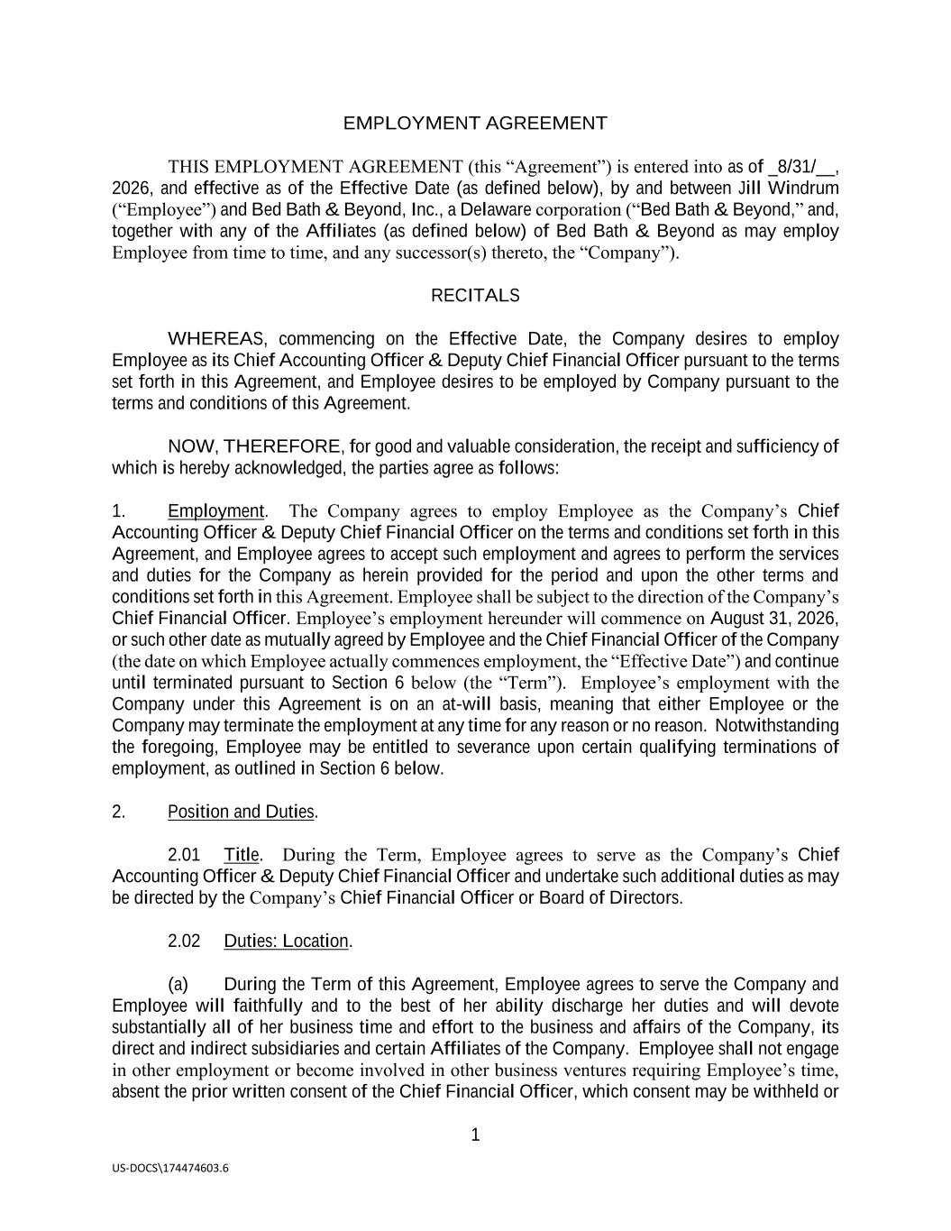
61
1 US-DOCS\174474603.6 EMPLOYMENT AGREEMENT THIS EMPLOYMENT AGREEMENT (this “Agreement”) is entered into as of _8/31/__, 2026, and effective as of the Effective Date (as defined below), by and between Jill Windrum (“Employee”) and Bed Bath & Beyond, Inc., a Delaware corporation (“Bed Bath & Beyond,” and, together with any of the Affiliates (as defined below) of Bed Bath & Beyond as may employ Employee from time to time, and any successor(s) thereto, the “Company”). RECITALS WHEREAS, commencing on the Effective Date, the Company desires to employ Employee as its Chief Accounting Officer & Deputy Chief Financial Officer pursuant to the terms set forth in this Agreement, and Employee desires to be employed by Company pursuant to the terms and conditions of this Agreement. NOW, THEREFORE, for good and valuable consideration, the receipt and sufficiency of which is hereby acknowledged, the parties agree as follows: 1. Employment. The Company agrees to employ Employee as the Company’s Chief Accounting Officer & Deputy Chief Financial Officer on the terms and conditions set forth in this Agreement, and Employee agrees to accept such employment and agrees to perform the services and duties for the Company as herein provided for the period and upon the other terms and conditions set forth in this Agreement. Employee shall be subject to the direction of the Company’s Chief Financial Officer. Employee’s employment hereunder will commence on August 31, 2026, or such other date as mutually agreed by Employee and the Chief Financial Officer of the Company (the date on which Employee actually commences employment, the “Effective Date”) and continue until terminated pursuant to Section 6 below (the “Term”). Employee’s employment with the Company under this Agreement is on an at-will basis, meaning that either Employee or the Company may terminate the employment at any time for any reason or no reason. Notwithstanding the foregoing, Employee may be entitled to severance upon certain qualifying terminations of employment, as outlined in Section 6 below. 2. Position and Duties. 2.01 Title. During the Term, Employee agrees to serve as the Company’s Chief Accounting Officer & Deputy Chief Financial Officer and undertake such additional duties as may be directed by the Company’s Chief Financial Officer or Board of Directors. 2.02 Duties: Location. (a) During the Term of this Agreement, Employee agrees to serve the Company and Employee will faithfully and to the best of her ability discharge her duties and will devote substantially all of her business time and effort to the business and affairs of the Company, its direct and indirect subsidiaries and certain Affiliates of the Company. Employee shall not engage in other employment or become involved in other business ventures requiring Employee’s time, absent the prior written consent of the Chief Financial Officer, which consent may be withheld or

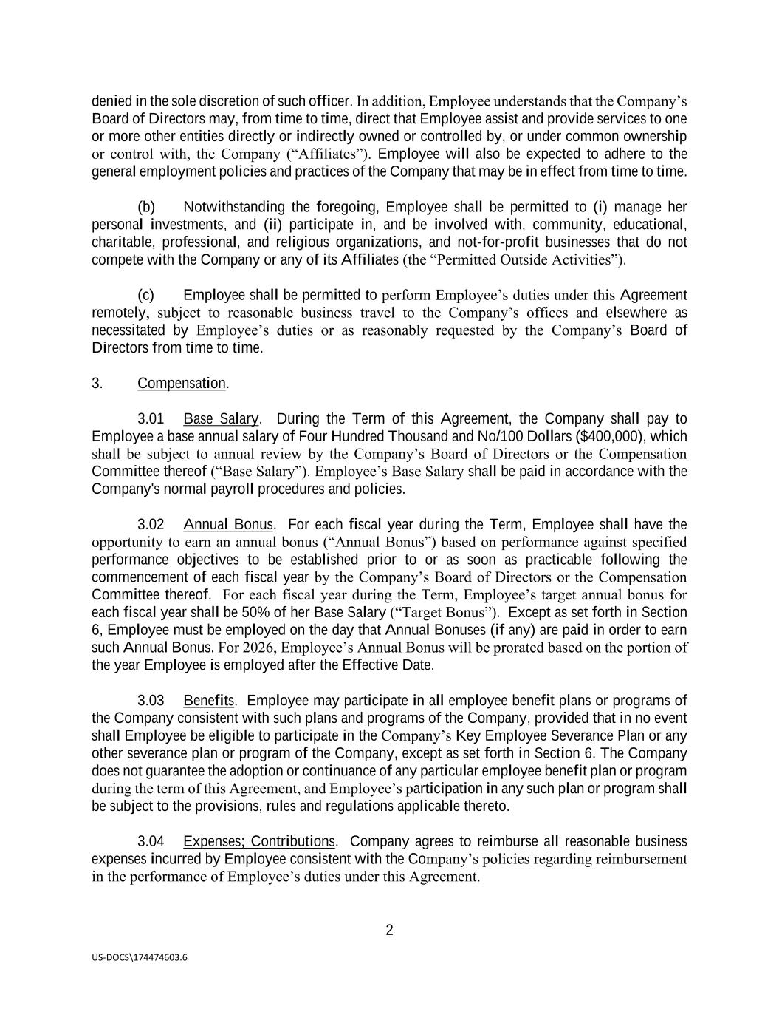
2 US-DOCS\174474603.6 denied in the sole discretion of such officer. In addition, Employee understands that the Company’s Board of Directors may, from time to time, direct that Employee assist and provide services to one or more other entities directly or indirectly owned or controlled by, or under common ownership or control with, the Company (“Affiliates”). Employee will also be expected to adhere to the general employment policies and practices of the Company that may be in effect from time to time. (b) Notwithstanding the foregoing, Employee shall be permitted to (i) manage her personal investments, and (ii) participate in, and be involved with, community, educational, charitable, professional, and religious organizations, and not-for-profit businesses that do not compete with the Company or any of its Affiliates (the “Permitted Outside Activities”). (c) Employee shall be permitted to perform Employee’s duties under this Agreement remotely, subject to reasonable business travel to the Company’s offices and elsewhere as necessitated by Employee’s duties or as reasonably requested by the Company’s Board of Directors from time to time. 3. Compensation. 3.01 Base Salary. During the Term of this Agreement, the Company shall pay to Employee a base annual salary of Four Hundred Thousand and No/100 Dollars ($400,000), which shall be subject to annual review by the Company’s Board of Directors or the Compensation Committee thereof (“Base Salary”). Employee’s Base Salary shall be paid in accordance with the Company's normal payroll procedures and policies. 3.02 Annual Bonus. For each fiscal year during the Term, Employee shall have the opportunity to earn an annual bonus (“Annual Bonus”) based on performance against specified performance objectives to be established prior to or as soon as practicable following the commencement of each fiscal year by the Company’s Board of Directors or the Compensation Committee thereof. For each fiscal year during the Term, Employee’s target annual bonus for each fiscal year shall be 50% of her Base Salary (“Target Bonus”). Except as set forth in Section 6, Employee must be employed on the day that Annual Bonuses (if any) are paid in order to earn such Annual Bonus. For 2026, Employee’s Annual Bonus will be prorated based on the portion of the year Employee is employed after the Effective Date. 3.03 Benefits. Employee may participate in all employee benefit plans or programs of the Company consistent with such plans and programs of the Company, provided that in no event shall Employee be eligible to participate in the Company’s Key Employee Severance Plan or any other severance plan or program of the Company, except as set forth in Section 6. The Company does not guarantee the adoption or continuance of any particular employee benefit plan or program during the term of this Agreement, and Employee’s participation in any such plan or program shall be subject to the provisions, rules and regulations applicable thereto. 3.04 Expenses; Contributions. Company agrees to reimburse all reasonable business expenses incurred by Employee consistent with the Company’s policies regarding reimbursement in the performance of Employee’s duties under this Agreement.

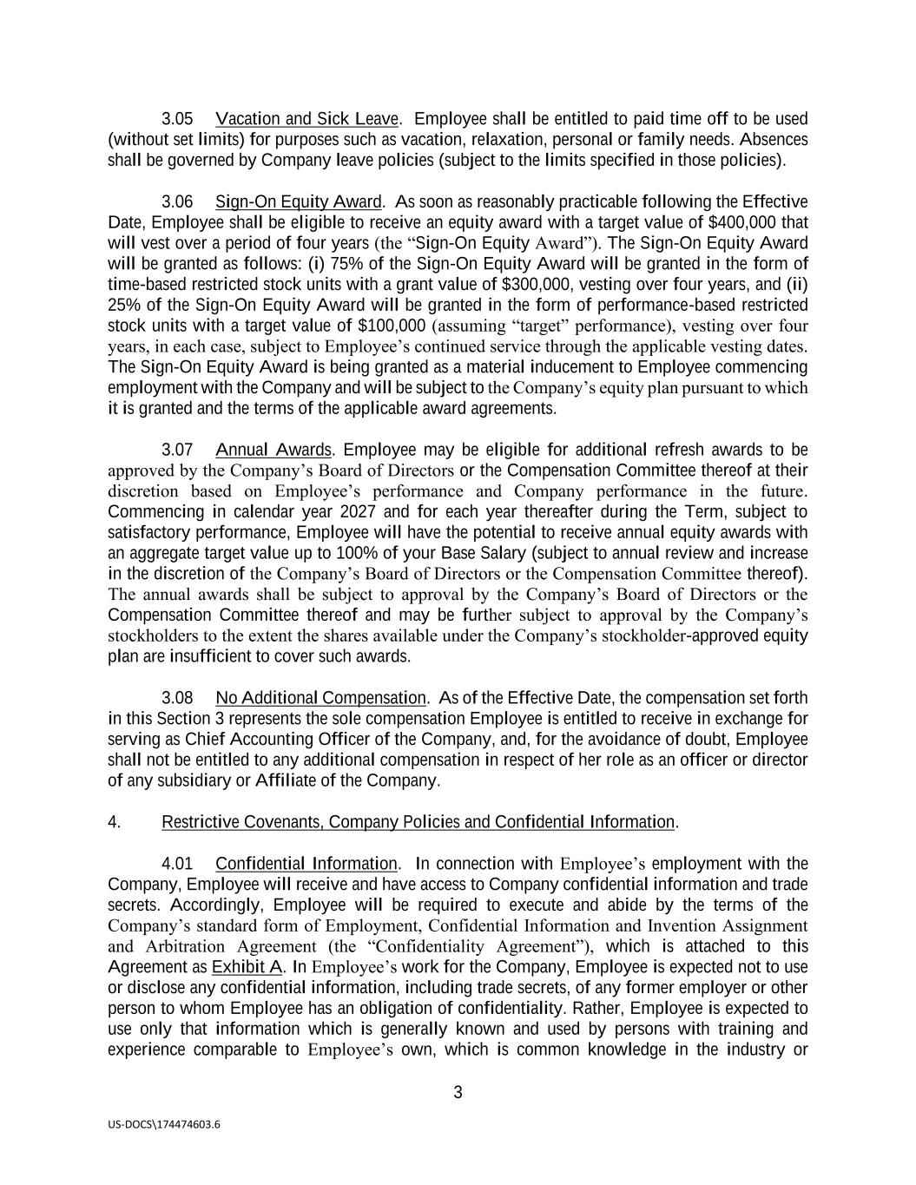
3 US-DOCS\174474603.6 3.05 Vacation and Sick Leave. Employee shall be entitled to paid time off to be used (without set limits) for purposes such as vacation, relaxation, personal or family needs. Absences shall be governed by Company leave policies (subject to the limits specified in those policies). 3.06 Sign-On Equity Award. As soon as reasonably practicable following the Effective Date, Employee shall be eligible to receive an equity award with a target value of $400,000 that will vest over a period of four years (the “Sign-On Equity Award”). The Sign-On Equity Award will be granted as follows: (i) 75% of the Sign-On Equity Award will be granted in the form of time-based restricted stock units with a grant value of $300,000, vesting over four years, and (ii) 25% of the Sign-On Equity Award will be granted in the form of performance-based restricted stock units with a target value of $100,000 (assuming “target” performance), vesting over four years, in each case, subject to Employee’s continued service through the applicable vesting dates. The Sign-On Equity Award is being granted as a material inducement to Employee commencing employment with the Company and will be subject to the Company’s equity plan pursuant to which it is granted and the terms of the applicable award agreements. 3.07 Annual Awards. Employee may be eligible for additional refresh awards to be approved by the Company’s Board of Directors or the Compensation Committee thereof at their discretion based on Employee’s performance and Company performance in the future. Commencing in calendar year 2027 and for each year thereafter during the Term, subject to satisfactory performance, Employee will have the potential to receive annual equity awards with an aggregate target value up to 100% of your Base Salary (subject to annual review and increase in the discretion of the Company’s Board of Directors or the Compensation Committee thereof). The annual awards shall be subject to approval by the Company’s Board of Directors or the Compensation Committee thereof and may be further subject to approval by the Company’s stockholders to the extent the shares available under the Company’s stockholder-approved equity plan are insufficient to cover such awards. 3.08 No Additional Compensation. As of the Effective Date, the compensation set forth in this Section 3 represents the sole compensation Employee is entitled to receive in exchange for serving as Chief Accounting Officer of the Company, and, for the avoidance of doubt, Employee shall not be entitled to any additional compensation in respect of her role as an officer or director of any subsidiary or Affiliate of the Company. 4. Restrictive Covenants, Company Policies and Confidential Information. 4.01 Confidential Information. In connection with Employee’s employment with the Company, Employee will receive and have access to Company confidential information and trade secrets. Accordingly, Employee will be required to execute and abide by the terms of the Company’s standard form of Employment, Confidential Information and Invention Assignment and Arbitration Agreement (the “Confidentiality Agreement”), which is attached to this Agreement as Exhibit A. In Employee’s work for the Company, Employee is expected not to use or disclose any confidential information, including trade secrets, of any former employer or other person to whom Employee has an obligation of confidentiality. Rather, Employee is expected to use only that information which is generally known and used by persons with training and experience comparable to Employee’s own, which is common knowledge in the industry or

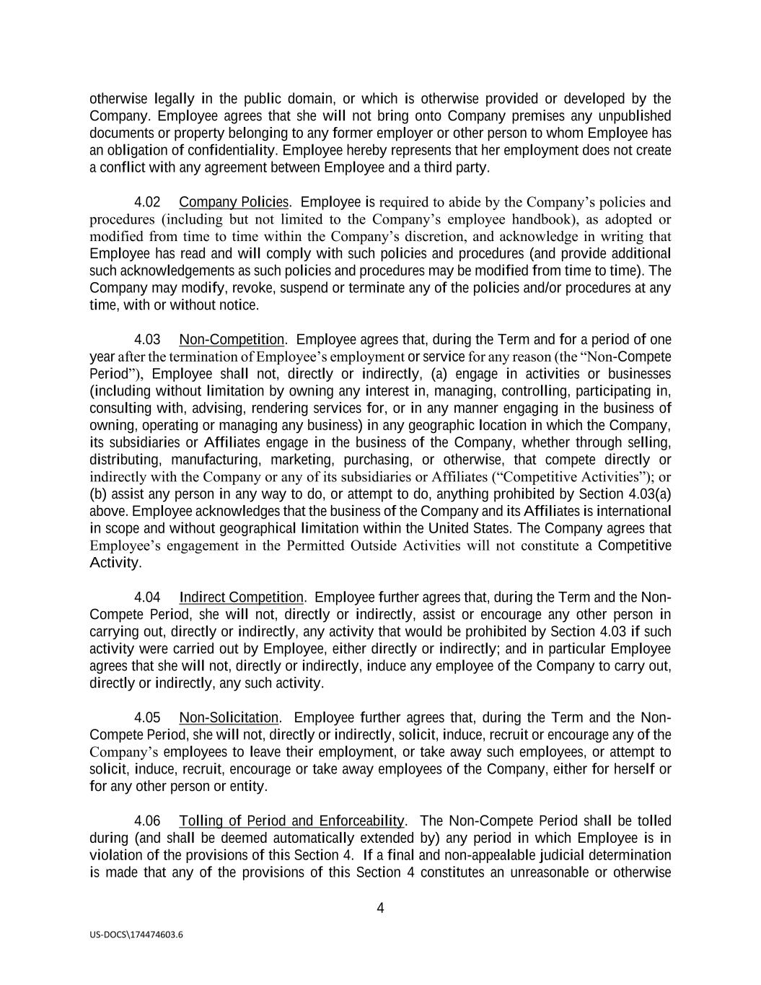
4 US-DOCS\174474603.6 otherwise legally in the public domain, or which is otherwise provided or developed by the Company. Employee agrees that she will not bring onto Company premises any unpublished documents or property belonging to any former employer or other person to whom Employee has an obligation of confidentiality. Employee hereby represents that her employment does not create a conflict with any agreement between Employee and a third party. 4.02 Company Policies. Employee is required to abide by the Company’s policies and procedures (including but not limited to the Company’s employee handbook), as adopted or modified from time to time within the Company’s discretion, and acknowledge in writing that Employee has read and will comply with such policies and procedures (and provide additional such acknowledgements as such policies and procedures may be modified from time to time). The Company may modify, revoke, suspend or terminate any of the policies and/or procedures at any time, with or without notice. 4.03 Non-Competition. Employee agrees that, during the Term and for a period of one year after the termination of Employee’s employment or service for any reason (the “Non-Compete Period”), Employee shall not, directly or indirectly, (a) engage in activities or businesses (including without limitation by owning any interest in, managing, controlling, participating in, consulting with, advising, rendering services for, or in any manner engaging in the business of owning, operating or managing any business) in any geographic location in which the Company, its subsidiaries or Affiliates engage in the business of the Company, whether through selling, distributing, manufacturing, marketing, purchasing, or otherwise, that compete directly or indirectly with the Company or any of its subsidiaries or Affiliates (“Competitive Activities”); or (b) assist any person in any way to do, or attempt to do, anything prohibited by Section 4.03(a) above. Employee acknowledges that the business of the Company and its Affiliates is international in scope and without geographical limitation within the United States. The Company agrees that Employee’s engagement in the Permitted Outside Activities will not constitute a Competitive Activity. 4.04 Indirect Competition. Employee further agrees that, during the Term and the Non- Compete Period, she will not, directly or indirectly, assist or encourage any other person in carrying out, directly or indirectly, any activity that would be prohibited by Section 4.03 if such activity were carried out by Employee, either directly or indirectly; and in particular Employee agrees that she will not, directly or indirectly, induce any employee of the Company to carry out, directly or indirectly, any such activity. 4.05 Non-Solicitation. Employee further agrees that, during the Term and the Non- Compete Period, she will not, directly or indirectly, solicit, induce, recruit or encourage any of the Company’s employees to leave their employment, or take away such employees, or attempt to solicit, induce, recruit, encourage or take away employees of the Company, either for herself or for any other person or entity. 4.06 Tolling of Period and Enforceability. The Non-Compete Period shall be tolled during (and shall be deemed automatically extended by) any period in which Employee is in violation of the provisions of this Section 4. If a final and non-appealable judicial determination is made that any of the provisions of this Section 4 constitutes an unreasonable or otherwise

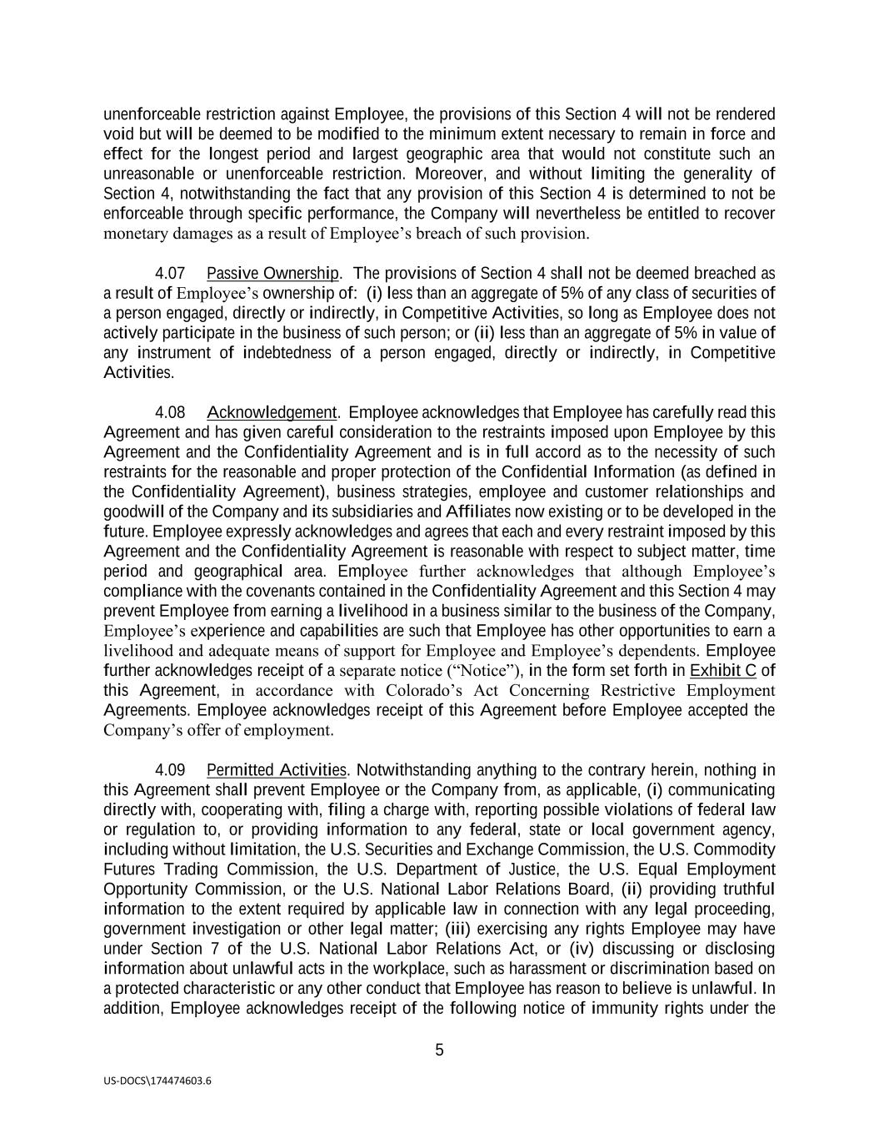
5 US-DOCS\174474603.6 unenforceable restriction against Employee, the provisions of this Section 4 will not be rendered void but will be deemed to be modified to the minimum extent necessary to remain in force and effect for the longest period and largest geographic area that would not constitute such an unreasonable or unenforceable restriction. Moreover, and without limiting the generality of Section 4, notwithstanding the fact that any provision of this Section 4 is determined to not be enforceable through specific performance, the Company will nevertheless be entitled to recover monetary damages as a result of Employee’s breach of such provision. 4.07 Passive Ownership. The provisions of Section 4 shall not be deemed breached as a result of Employee’s ownership of: (i) less than an aggregate of 5% of any class of securities of a person engaged, directly or indirectly, in Competitive Activities, so long as Employee does not actively participate in the business of such person; or (ii) less than an aggregate of 5% in value of any instrument of indebtedness of a person engaged, directly or indirectly, in Competitive Activities. 4.08 Acknowledgement. Employee acknowledges that Employee has carefully read this Agreement and has given careful consideration to the restraints imposed upon Employee by this Agreement and the Confidentiality Agreement and is in full accord as to the necessity of such restraints for the reasonable and proper protection of the Confidential Information (as defined in the Confidentiality Agreement), business strategies, employee and customer relationships and goodwill of the Company and its subsidiaries and Affiliates now existing or to be developed in the future. Employee expressly acknowledges and agrees that each and every restraint imposed by this Agreement and the Confidentiality Agreement is reasonable with respect to subject matter, time period and geographical area. Employee further acknowledges that although Employee’s compliance with the covenants contained in the Confidentiality Agreement and this Section 4 may prevent Employee from earning a livelihood in a business similar to the business of the Company, Employee’s experience and capabilities are such that Employee has other opportunities to earn a livelihood and adequate means of support for Employee and Employee’s dependents. Employee further acknowledges receipt of a separate notice (“Notice”), in the form set forth in Exhibit C of this Agreement, in accordance with Colorado’s Act Concerning Restrictive Employment Agreements. Employee acknowledges receipt of this Agreement before Employee accepted the Company’s offer of employment. 4.09 Permitted Activities. Notwithstanding anything to the contrary herein, nothing in this Agreement shall prevent Employee or the Company from, as applicable, (i) communicating directly with, cooperating with, filing a charge with, reporting possible violations of federal law or regulation to, or providing information to any federal, state or local government agency, including without limitation, the U.S. Securities and Exchange Commission, the U.S. Commodity Futures Trading Commission, the U.S. Department of Justice, the U.S. Equal Employment Opportunity Commission, or the U.S. National Labor Relations Board, (ii) providing truthful information to the extent required by applicable law in connection with any legal proceeding, government investigation or other legal matter; (iii) exercising any rights Employee may have under Section 7 of the U.S. National Labor Relations Act, or (iv) discussing or disclosing information about unlawful acts in the workplace, such as harassment or discrimination based on a protected characteristic or any other conduct that Employee has reason to believe is unlawful. In addition, Employee acknowledges receipt of the following notice of immunity rights under the

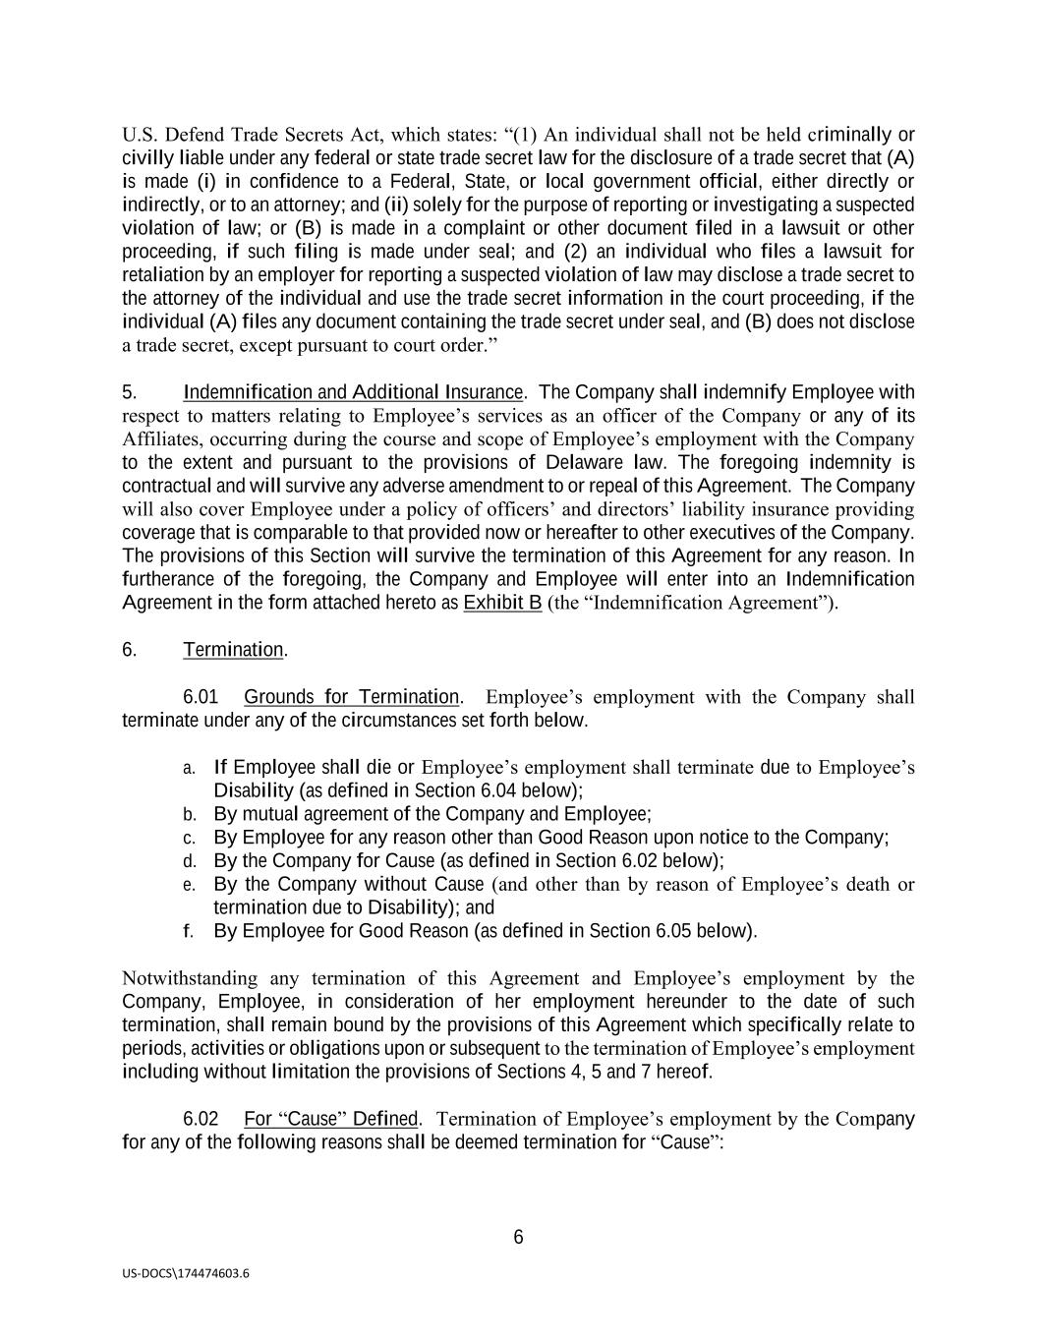
6 US-DOCS\174474603.6 U.S. Defend Trade Secrets Act, which states: “(1) An individual shall not be held criminally or civilly liable under any federal or state trade secret law for the disclosure of a trade secret that (A) is made (i) in confidence to a Federal, State, or local government official, either directly or indirectly, or to an attorney; and (ii) solely for the purpose of reporting or investigating a suspected violation of law; or (B) is made in a complaint or other document filed in a lawsuit or other proceeding, if such filing is made under seal; and (2) an individual who files a lawsuit for retaliation by an employer for reporting a suspected violation of law may disclose a trade secret to the attorney of the individual and use the trade secret information in the court proceeding, if the individual (A) files any document containing the trade secret under seal, and (B) does not disclose a trade secret, except pursuant to court order.” 5. Indemnification and Additional Insurance. The Company shall indemnify Employee with respect to matters relating to Employee’s services as an officer of the Company or any of its Affiliates, occurring during the course and scope of Employee’s employment with the Company to the extent and pursuant to the provisions of Delaware law. The foregoing indemnity is contractual and will survive any adverse amendment to or repeal of this Agreement. The Company will also cover Employee under a policy of officers’ and directors’ liability insurance providing coverage that is comparable to that provided now or hereafter to other executives of the Company. The provisions of this Section will survive the termination of this Agreement for any reason. In furtherance of the foregoing, the Company and Employee will enter into an Indemnification Agreement in the form attached hereto as Exhibit B (the “Indemnification Agreement”). 6. Termination. 6.01 Grounds for Termination. Employee’s employment with the Company shall terminate under any of the circumstances set forth below. a. If Employee shall die or Employee’s employment shall terminate due to Employee’s Disability (as defined in Section 6.04 below); b. By mutual agreement of the Company and Employee; c. By Employee for any reason other than Good Reason upon notice to the Company; d. By the Company for Cause (as defined in Section 6.02 below); e. By the Company without Cause (and other than by reason of Employee’s death or termination due to Disability); and f. By Employee for Good Reason (as defined in Section 6.05 below). Notwithstanding any termination of this Agreement and Employee’s employment by the Company, Employee, in consideration of her employment hereunder to the date of such termination, shall remain bound by the provisions of this Agreement which specifically relate to periods, activities or obligations upon or subsequent to the termination of Employee’s employment including without limitation the provisions of Sections 4, 5 and 7 hereof. 6.02 For “Cause” Defined. Termination of Employee’s employment by the Company for any of the following reasons shall be deemed termination for “Cause”:

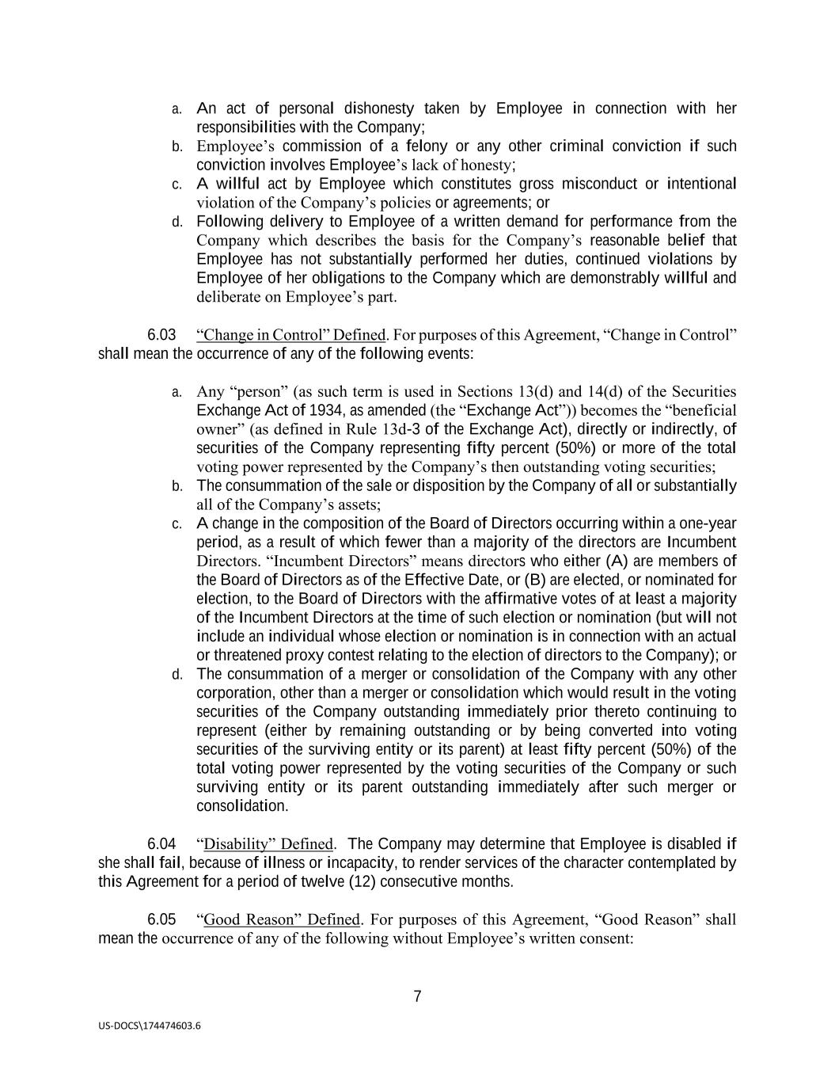
7 US-DOCS\174474603.6 a. An act of personal dishonesty taken by Employee in connection with her responsibilities with the Company; b. Employee’s commission of a felony or any other criminal conviction if such conviction involves Employee’s lack of honesty; c. A willful act by Employee which constitutes gross misconduct or intentional violation of the Company’s policies or agreements; or d. Following delivery to Employee of a written demand for performance from the Company which describes the basis for the Company’s reasonable belief that Employee has not substantially performed her duties, continued violations by Employee of her obligations to the Company which are demonstrably willful and deliberate on Employee’s part. 6.03 “Change in Control” Defined. For purposes of this Agreement, “Change in Control” shall mean the occurrence of any of the following events: a. Any “person” (as such term is used in Sections 13(d) and 14(d) of the Securities Exchange Act of 1934, as amended (the “Exchange Act”)) becomes the “beneficial owner” (as defined in Rule 13d-3 of the Exchange Act), directly or indirectly, of securities of the Company representing fifty percent (50%) or more of the total voting power represented by the Company’s then outstanding voting securities; b. The consummation of the sale or disposition by the Company of all or substantially all of the Company’s assets; c. A change in the composition of the Board of Directors occurring within a one-year period, as a result of which fewer than a majority of the directors are Incumbent Directors. “Incumbent Directors” means directors who either (A) are members of the Board of Directors as of the Effective Date, or (B) are elected, or nominated for election, to the Board of Directors with the affirmative votes of at least a majority of the Incumbent Directors at the time of such election or nomination (but will not include an individual whose election or nomination is in connection with an actual or threatened proxy contest relating to the election of directors to the Company); or d. The consummation of a merger or consolidation of the Company with any other corporation, other than a merger or consolidation which would result in the voting securities of the Company outstanding immediately prior thereto continuing to represent (either by remaining outstanding or by being converted into voting securities of the surviving entity or its parent) at least fifty percent (50%) of the total voting power represented by the voting securities of the Company or such surviving entity or its parent outstanding immediately after such merger or consolidation. 6.04 “Disability” Defined. The Company may determine that Employee is disabled if she shall fail, because of illness or incapacity, to render services of the character contemplated by this Agreement for a period of twelve (12) consecutive months. 6.05 “Good Reason” Defined. For purposes of this Agreement, “Good Reason” shall mean the occurrence of any of the following without Employee’s written consent:

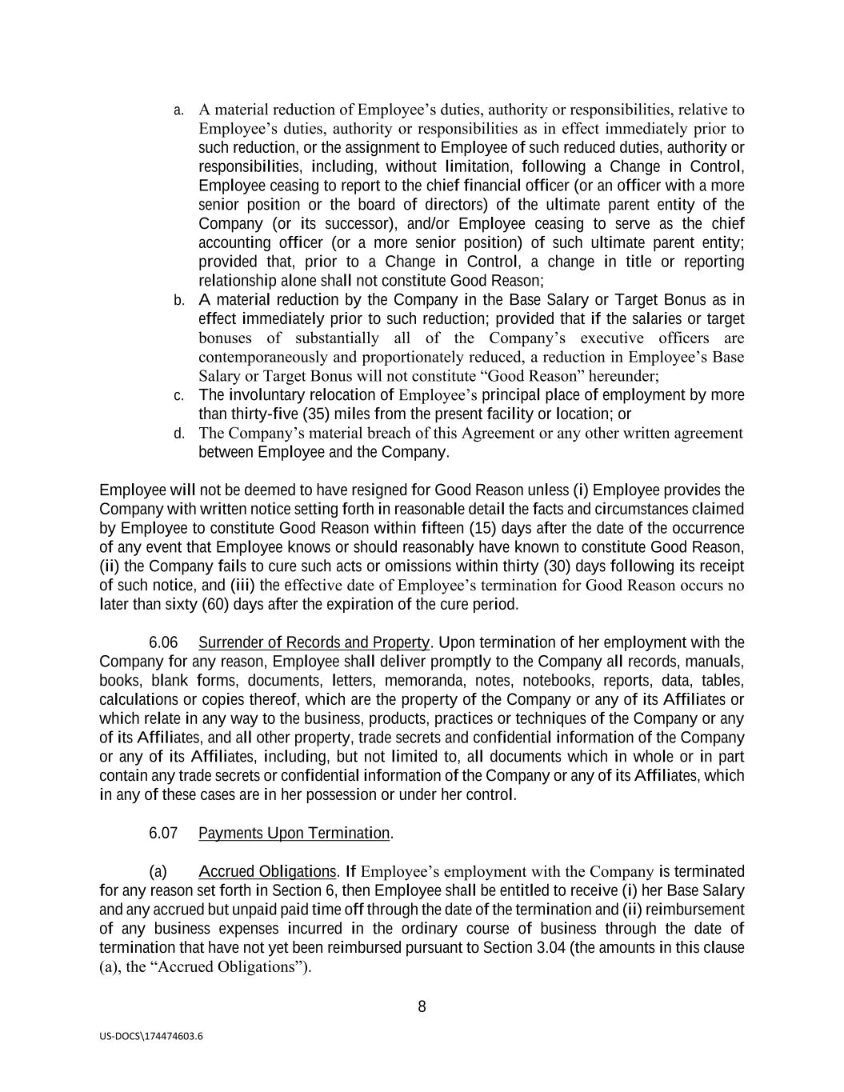
8 US-DOCS\174474603.6 a. A material reduction of Employee’s duties, authority or responsibilities, relative to Employee’s duties, authority or responsibilities as in effect immediately prior to such reduction, or the assignment to Employee of such reduced duties, authority or responsibilities, including, without limitation, following a Change in Control, Employee ceasing to report to the chief financial officer (or an officer with a more senior position or the board of directors) of the ultimate parent entity of the Company (or its successor), and/or Employee ceasing to serve as the chief accounting officer (or a more senior position) of such ultimate parent entity; provided that, prior to a Change in Control, a change in title or reporting relationship alone shall not constitute Good Reason; b. A material reduction by the Company in the Base Salary or Target Bonus as in effect immediately prior to such reduction; provided that if the salaries or target bonuses of substantially all of the Company’s executive officers are contemporaneously and proportionately reduced, a reduction in Employee’s Base Salary or Target Bonus will not constitute “Good Reason” hereunder; c. The involuntary relocation of Employee’s principal place of employment by more than thirty-five (35) miles from the present facility or location; or d. The Company’s material breach of this Agreement or any other written agreement between Employee and the Company. Employee will not be deemed to have resigned for Good Reason unless (i) Employee provides the Company with written notice setting forth in reasonable detail the facts and circumstances claimed by Employee to constitute Good Reason within fifteen (15) days after the date of the occurrence of any event that Employee knows or should reasonably have known to constitute Good Reason, (ii) the Company fails to cure such acts or omissions within thirty (30) days following its receipt of such notice, and (iii) the effective date of Employee’s termination for Good Reason occurs no later than sixty (60) days after the expiration of the cure period. 6.06 Surrender of Records and Property. Upon termination of her employment with the Company for any reason, Employee shall deliver promptly to the Company all records, manuals, books, blank forms, documents, letters, memoranda, notes, notebooks, reports, data, tables, calculations or copies thereof, which are the property of the Company or any of its Affiliates or which relate in any way to the business, products, practices or techniques of the Company or any of its Affiliates, and all other property, trade secrets and confidential information of the Company or any of its Affiliates, including, but not limited to, all documents which in whole or in part contain any trade secrets or confidential information of the Company or any of its Affiliates, which in any of these cases are in her possession or under her control. 6.07 Payments Upon Termination. (a) Accrued Obligations. If Employee’s employment with the Company is terminated for any reason set forth in Section 6, then Employee shall be entitled to receive (i) her Base Salary and any accrued but unpaid paid time off through the date of the termination and (ii) reimbursement of any business expenses incurred in the ordinary course of business through the date of termination that have not yet been reimbursed pursuant to Section 3.04 (the amounts in this clause (a), the “Accrued Obligations”).

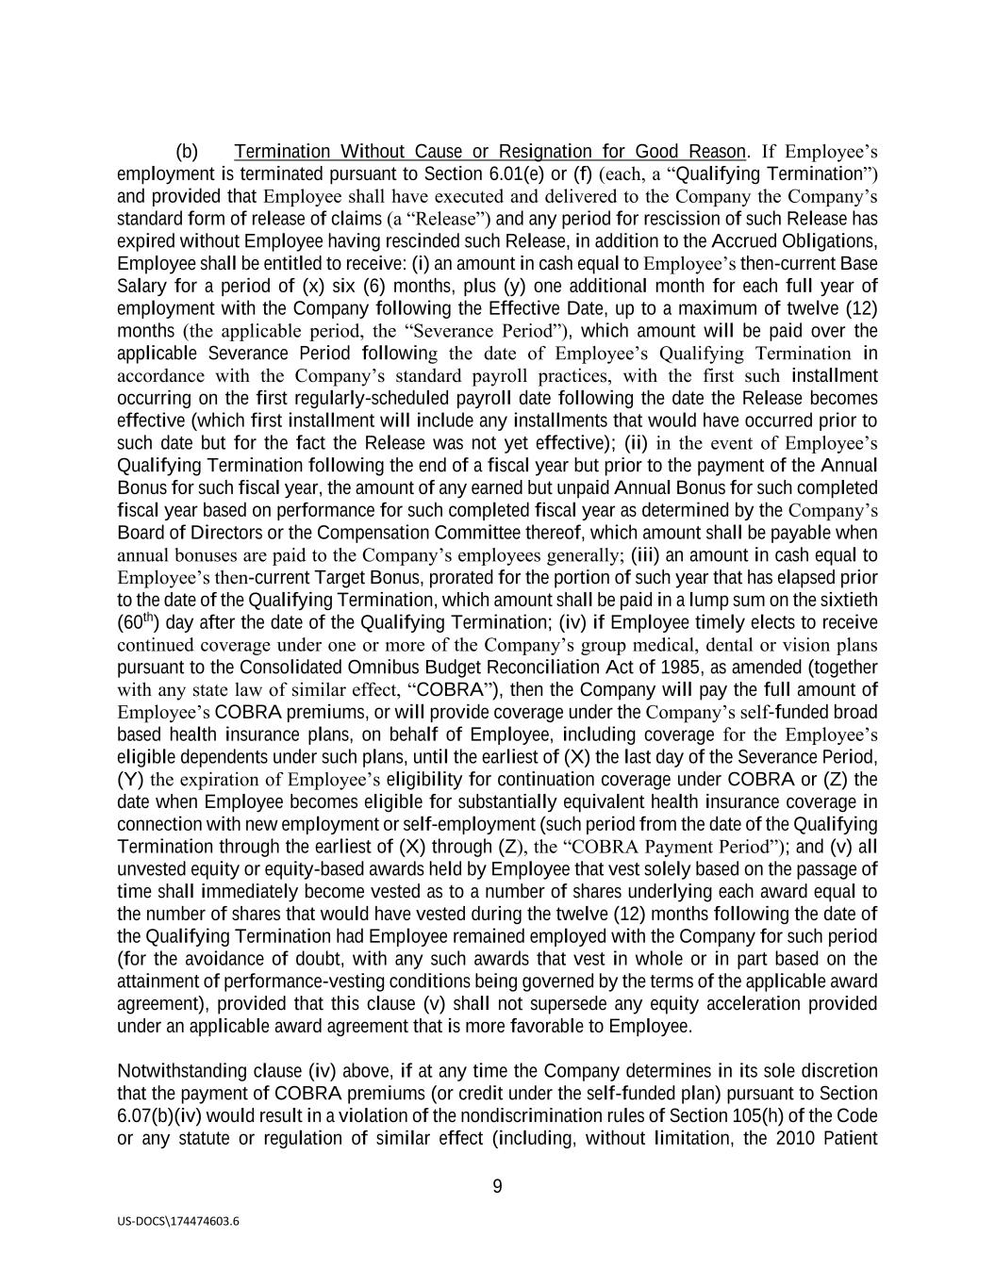
9 US-DOCS\174474603.6 (b) Termination Without Cause or Resignation for Good Reason. If Employee’s employment is terminated pursuant to Section 6.01(e) or (f) (each, a “Qualifying Termination”) and provided that Employee shall have executed and delivered to the Company the Company’s standard form of release of claims (a “Release”) and any period for rescission of such Release has expired without Employee having rescinded such Release, in addition to the Accrued Obligations, Employee shall be entitled to receive: (i) an amount in cash equal to Employee’s then-current Base Salary for a period of (x) six (6) months, plus (y) one additional month for each full year of employment with the Company following the Effective Date, up to a maximum of twelve (12) months (the applicable period, the “Severance Period”), which amount will be paid over the applicable Severance Period following the date of Employee’s Qualifying Termination in accordance with the Company’s standard payroll practices, with the first such installment occurring on the first regularly-scheduled payroll date following the date the Release becomes effective (which first installment will include any installments that would have occurred prior to such date but for the fact the Release was not yet effective); (ii) in the event of Employee’s Qualifying Termination following the end of a fiscal year but prior to the payment of the Annual Bonus for such fiscal year, the amount of any earned but unpaid Annual Bonus for such completed fiscal year based on performance for such completed fiscal year as determined by the Company’s Board of Directors or the Compensation Committee thereof, which amount shall be payable when annual bonuses are paid to the Company’s employees generally; (iii) an amount in cash equal to Employee’s then-current Target Bonus, prorated for the portion of such year that has elapsed prior to the date of the Qualifying Termination, which amount shall be paid in a lump sum on the sixtieth (60th) day after the date of the Qualifying Termination; (iv) if Employee timely elects to receive continued coverage under one or more of the Company’s group medical, dental or vision plans pursuant to the Consolidated Omnibus Budget Reconciliation Act of 1985, as amended (together with any state law of similar effect, “COBRA”), then the Company will pay the full amount of Employee’s COBRA premiums, or will provide coverage under the Company’s self-funded broad based health insurance plans, on behalf of Employee, including coverage for the Employee’s eligible dependents under such plans, until the earliest of (X) the last day of the Severance Period, (Y) the expiration of Employee’s eligibility for continuation coverage under COBRA or (Z) the date when Employee becomes eligible for substantially equivalent health insurance coverage in connection with new employment or self-employment (such period from the date of the Qualifying Termination through the earliest of (X) through (Z), the “COBRA Payment Period”); and (v) all unvested equity or equity-based awards held by Employee that vest solely based on the passage of time shall immediately become vested as to a number of shares underlying each award equal to the number of shares that would have vested during the twelve (12) months following the date of the Qualifying Termination had Employee remained employed with the Company for such period (for the avoidance of doubt, with any such awards that vest in whole or in part based on the attainment of performance-vesting conditions being governed by the terms of the applicable award agreement), provided that this clause (v) shall not supersede any equity acceleration provided under an applicable award agreement that is more favorable to Employee. Notwithstanding clause (iv) above, if at any time the Company determines in its sole discretion that the payment of COBRA premiums (or credit under the self-funded plan) pursuant to Section 6.07(b)(iv) would result in a violation of the nondiscrimination rules of Section 105(h) of the Code or any statute or regulation of similar effect (including, without limitation, the 2010 Patient

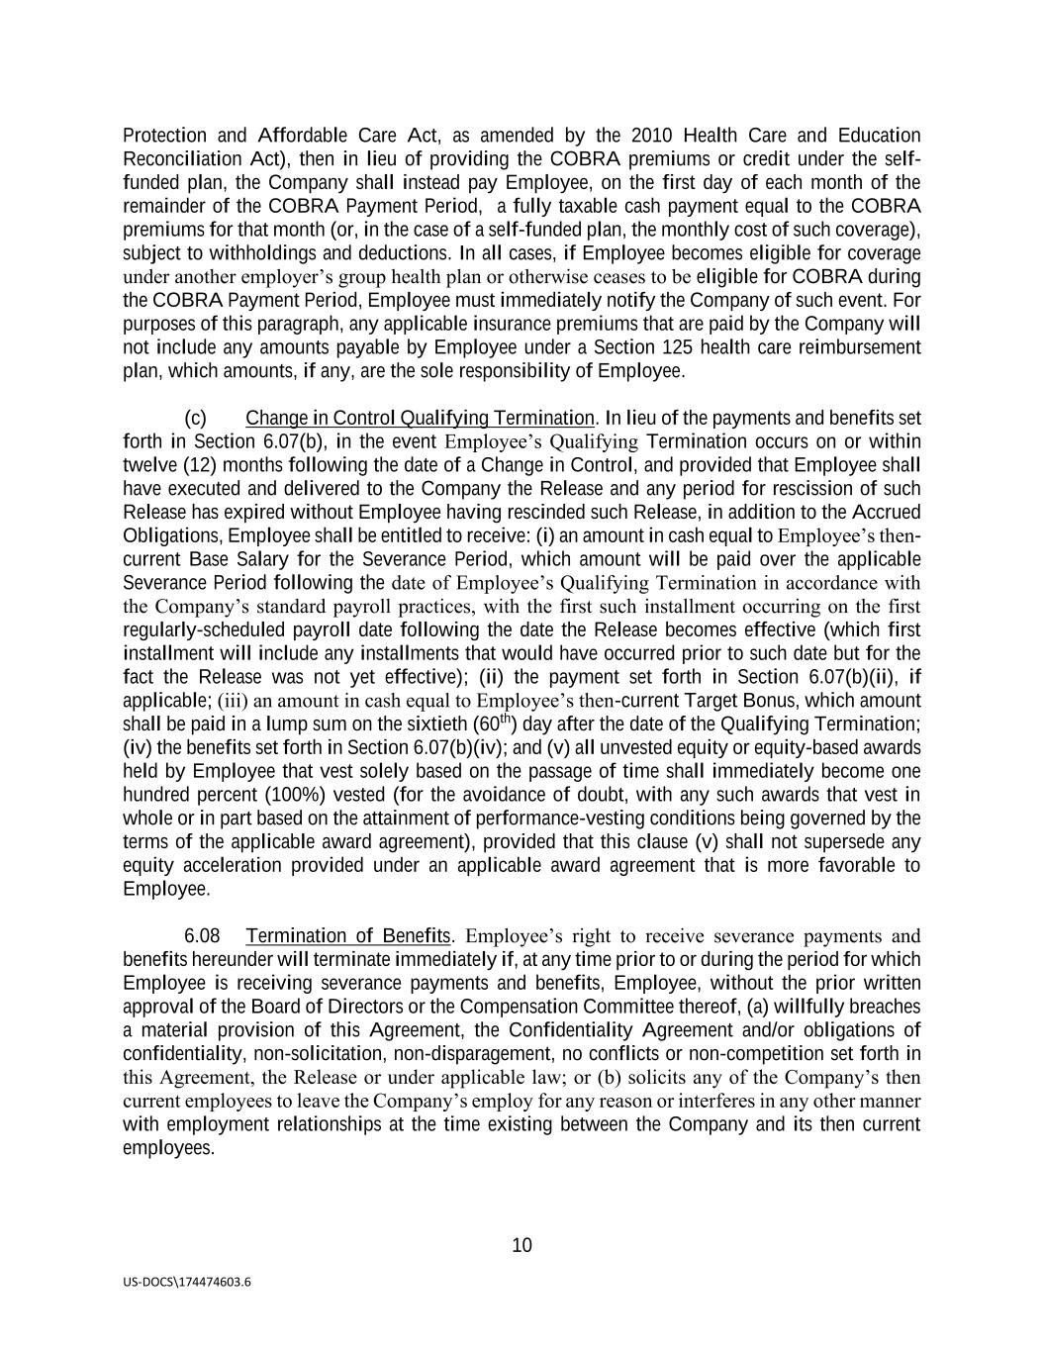
10 US-DOCS\174474603.6 Protection and Affordable Care Act, as amended by the 2010 Health Care and Education Reconciliation Act), then in lieu of providing the COBRA premiums or credit under the self- funded plan, the Company shall instead pay Employee, on the first day of each month of the remainder of the COBRA Payment Period, a fully taxable cash payment equal to the COBRA premiums for that month (or, in the case of a self-funded plan, the monthly cost of such coverage), subject to withholdings and deductions. In all cases, if Employee becomes eligible for coverage under another employer’s group health plan or otherwise ceases to be eligible for COBRA during the COBRA Payment Period, Employee must immediately notify the Company of such event. For purposes of this paragraph, any applicable insurance premiums that are paid by the Company will not include any amounts payable by Employee under a Section 125 health care reimbursement plan, which amounts, if any, are the sole responsibility of Employee. (c) Change in Control Qualifying Termination. In lieu of the payments and benefits set forth in Section 6.07(b), in the event Employee’s Qualifying Termination occurs on or within twelve (12) months following the date of a Change in Control, and provided that Employee shall have executed and delivered to the Company the Release and any period for rescission of such Release has expired without Employee having rescinded such Release, in addition to the Accrued Obligations, Employee shall be entitled to receive: (i) an amount in cash equal to Employee’s then- current Base Salary for the Severance Period, which amount will be paid over the applicable Severance Period following the date of Employee’s Qualifying Termination in accordance with the Company’s standard payroll practices, with the first such installment occurring on the first regularly-scheduled payroll date following the date the Release becomes effective (which first installment will include any installments that would have occurred prior to such date but for the fact the Release was not yet effective); (ii) the payment set forth in Section 6.07(b)(ii), if applicable; (iii) an amount in cash equal to Employee’s then-current Target Bonus, which amount shall be paid in a lump sum on the sixtieth (60th) day after the date of the Qualifying Termination; (iv) the benefits set forth in Section 6.07(b)(iv); and (v) all unvested equity or equity-based awards held by Employee that vest solely based on the passage of time shall immediately become one hundred percent (100%) vested (for the avoidance of doubt, with any such awards that vest in whole or in part based on the attainment of performance-vesting conditions being governed by the terms of the applicable award agreement), provided that this clause (v) shall not supersede any equity acceleration provided under an applicable award agreement that is more favorable to Employee. 6.08 Termination of Benefits. Employee’s right to receive severance payments and benefits hereunder will terminate immediately if, at any time prior to or during the period for which Employee is receiving severance payments and benefits, Employee, without the prior written approval of the Board of Directors or the Compensation Committee thereof, (a) willfully breaches a material provision of this Agreement, the Confidentiality Agreement and/or obligations of confidentiality, non-solicitation, non-disparagement, no conflicts or non-competition set forth in this Agreement, the Release or under applicable law; or (b) solicits any of the Company’s then current employees to leave the Company’s employ for any reason or interferes in any other manner with employment relationships at the time existing between the Company and its then current employees.

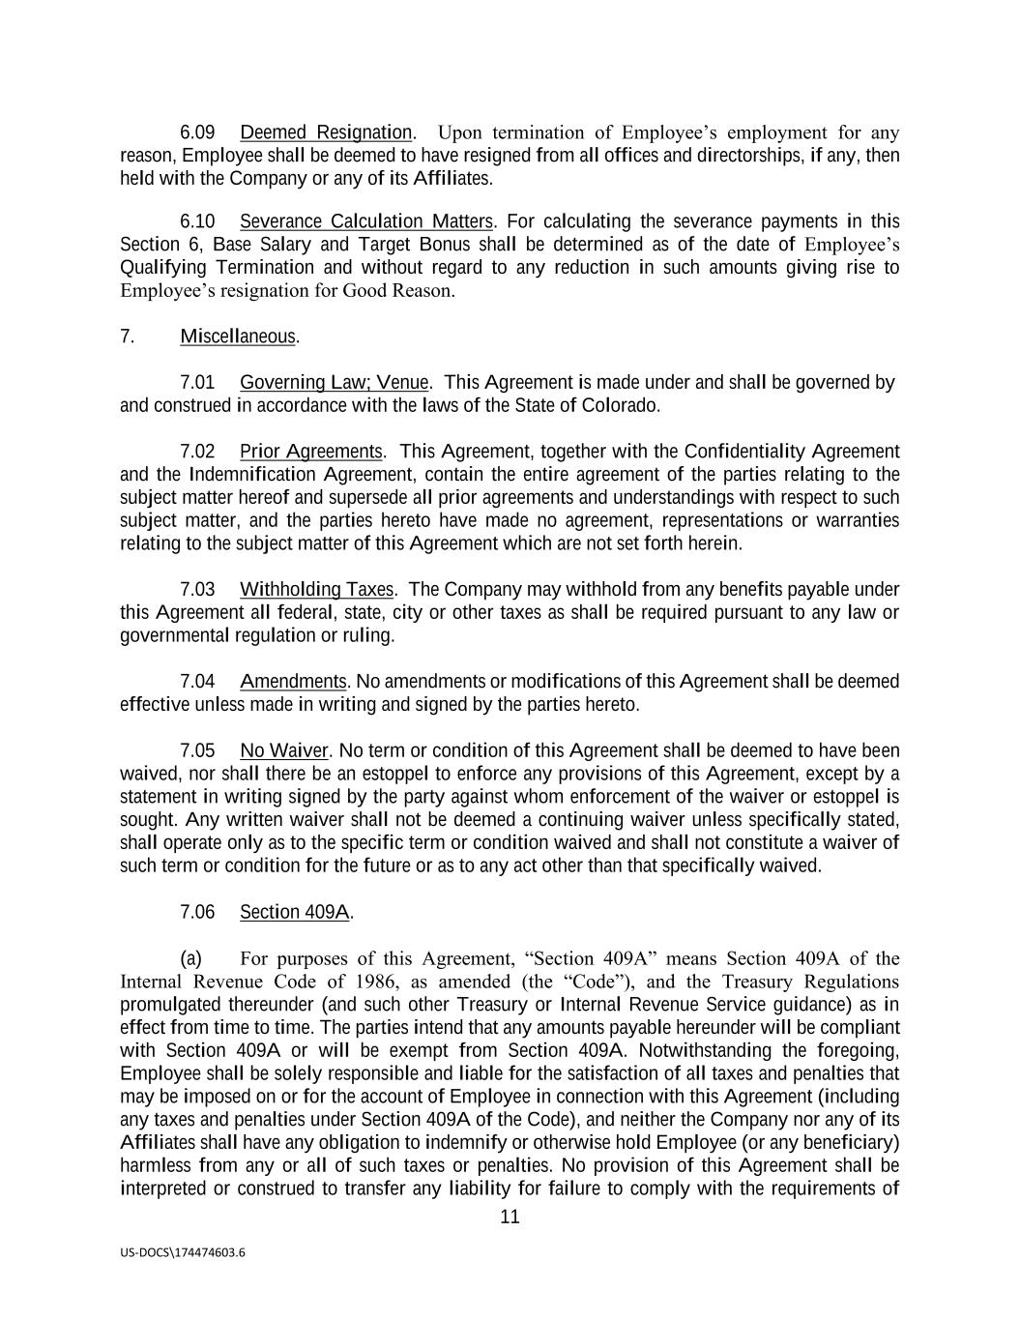
11 US-DOCS\174474603.6 6.09 Deemed Resignation. Upon termination of Employee’s employment for any reason, Employee shall be deemed to have resigned from all offices and directorships, if any, then held with the Company or any of its Affiliates. 6.10 Severance Calculation Matters. For calculating the severance payments in this Section 6, Base Salary and Target Bonus shall be determined as of the date of Employee’s Qualifying Termination and without regard to any reduction in such amounts giving rise to Employee’s resignation for Good Reason. 7. Miscellaneous. 7.01 Governing Law; Venue. This Agreement is made under and shall be governed by and construed in accordance with the laws of the State of Colorado. 7.02 Prior Agreements. This Agreement, together with the Confidentiality Agreement and the Indemnification Agreement, contain the entire agreement of the parties relating to the subject matter hereof and supersede all prior agreements and understandings with respect to such subject matter, and the parties hereto have made no agreement, representations or warranties relating to the subject matter of this Agreement which are not set forth herein. 7.03 Withholding Taxes. The Company may withhold from any benefits payable under this Agreement all federal, state, city or other taxes as shall be required pursuant to any law or governmental regulation or ruling. 7.04 Amendments. No amendments or modifications of this Agreement shall be deemed effective unless made in writing and signed by the parties hereto. 7.05 No Waiver. No term or condition of this Agreement shall be deemed to have been waived, nor shall there be an estoppel to enforce any provisions of this Agreement, except by a statement in writing signed by the party against whom enforcement of the waiver or estoppel is sought. Any written waiver shall not be deemed a continuing waiver unless specifically stated, shall operate only as to the specific term or condition waived and shall not constitute a waiver of such term or condition for the future or as to any act other than that specifically waived. 7.06 Section 409A. (a) For purposes of this Agreement, “Section 409A” means Section 409A of the Internal Revenue Code of 1986, as amended (the “Code”), and the Treasury Regulations promulgated thereunder (and such other Treasury or Internal Revenue Service guidance) as in effect from time to time. The parties intend that any amounts payable hereunder will be compliant with Section 409A or will be exempt from Section 409A. Notwithstanding the foregoing, Employee shall be solely responsible and liable for the satisfaction of all taxes and penalties that may be imposed on or for the account of Employee in connection with this Agreement (including any taxes and penalties under Section 409A of the Code), and neither the Company nor any of its Affiliates shall have any obligation to indemnify or otherwise hold Employee (or any beneficiary) harmless from any or all of such taxes or penalties. No provision of this Agreement shall be interpreted or construed to transfer any liability for failure to comply with the requirements of

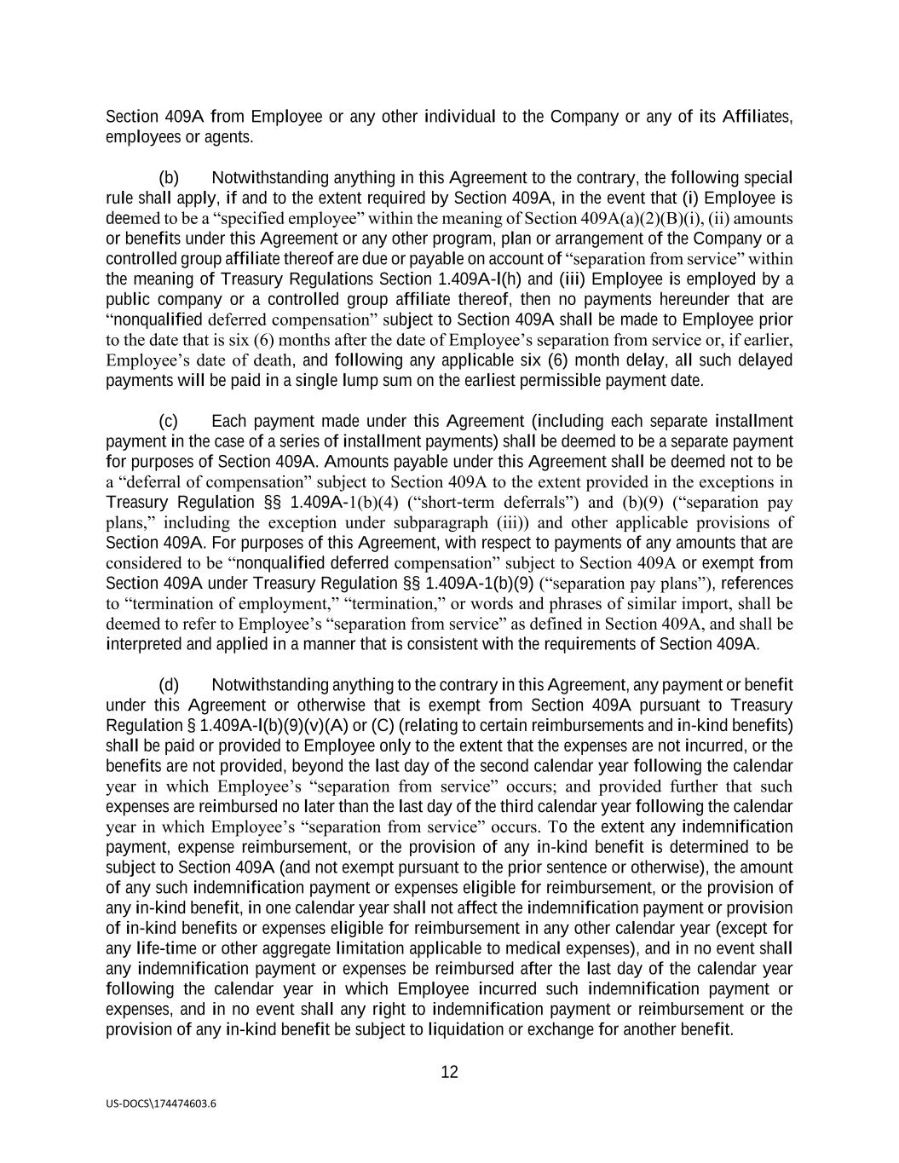
12 US-DOCS\174474603.6 Section 409A from Employee or any other individual to the Company or any of its Affiliates, employees or agents. (b) Notwithstanding anything in this Agreement to the contrary, the following special rule shall apply, if and to the extent required by Section 409A, in the event that (i) Employee is deemed to be a “specified employee” within the meaning of Section 409A(a)(2)(B)(i), (ii) amounts or benefits under this Agreement or any other program, plan or arrangement of the Company or a controlled group affiliate thereof are due or payable on account of “separation from service” within the meaning of Treasury Regulations Section 1.409A-l(h) and (iii) Employee is employed by a public company or a controlled group affiliate thereof, then no payments hereunder that are “nonqualified deferred compensation” subject to Section 409A shall be made to Employee prior to the date that is six (6) months after the date of Employee’s separation from service or, if earlier, Employee’s date of death, and following any applicable six (6) month delay, all such delayed payments will be paid in a single lump sum on the earliest permissible payment date. (c) Each payment made under this Agreement (including each separate installment payment in the case of a series of installment payments) shall be deemed to be a separate payment for purposes of Section 409A. Amounts payable under this Agreement shall be deemed not to be a “deferral of compensation” subject to Section 409A to the extent provided in the exceptions in Treasury Regulation §§ 1.409A-1(b)(4) (“short-term deferrals”) and (b)(9) (“separation pay plans,” including the exception under subparagraph (iii)) and other applicable provisions of Section 409A. For purposes of this Agreement, with respect to payments of any amounts that are considered to be “nonqualified deferred compensation” subject to Section 409A or exempt from Section 409A under Treasury Regulation §§ 1.409A-1(b)(9) (“separation pay plans”), references to “termination of employment,” “termination,” or words and phrases of similar import, shall be deemed to refer to Employee’s “separation from service” as defined in Section 409A, and shall be interpreted and applied in a manner that is consistent with the requirements of Section 409A. (d) Notwithstanding anything to the contrary in this Agreement, any payment or benefit under this Agreement or otherwise that is exempt from Section 409A pursuant to Treasury Regulation § 1.409A-l(b)(9)(v)(A) or (C) (relating to certain reimbursements and in-kind benefits) shall be paid or provided to Employee only to the extent that the expenses are not incurred, or the benefits are not provided, beyond the last day of the second calendar year following the calendar year in which Employee’s “separation from service” occurs; and provided further that such expenses are reimbursed no later than the last day of the third calendar year following the calendar year in which Employee’s “separation from service” occurs. To the extent any indemnification payment, expense reimbursement, or the provision of any in-kind benefit is determined to be subject to Section 409A (and not exempt pursuant to the prior sentence or otherwise), the amount of any such indemnification payment or expenses eligible for reimbursement, or the provision of any in-kind benefit, in one calendar year shall not affect the indemnification payment or provision of in-kind benefits or expenses eligible for reimbursement in any other calendar year (except for any life-time or other aggregate limitation applicable to medical expenses), and in no event shall any indemnification payment or expenses be reimbursed after the last day of the calendar year following the calendar year in which Employee incurred such indemnification payment or expenses, and in no event shall any right to indemnification payment or reimbursement or the provision of any in-kind benefit be subject to liquidation or exchange for another benefit.

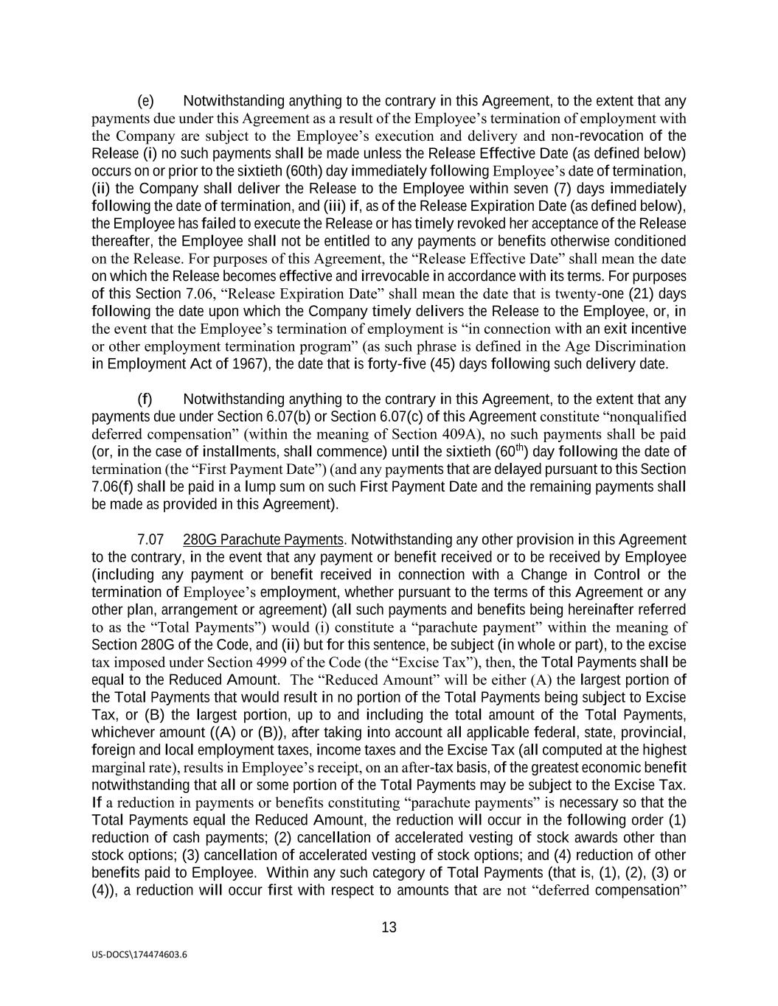
13 US-DOCS\174474603.6 (e) Notwithstanding anything to the contrary in this Agreement, to the extent that any payments due under this Agreement as a result of the Employee’s termination of employment with the Company are subject to the Employee’s execution and delivery and non-revocation of the Release (i) no such payments shall be made unless the Release Effective Date (as defined below) occurs on or prior to the sixtieth (60th) day immediately following Employee’s date of termination, (ii) the Company shall deliver the Release to the Employee within seven (7) days immediately following the date of termination, and (iii) if, as of the Release Expiration Date (as defined below), the Employee has failed to execute the Release or has timely revoked her acceptance of the Release thereafter, the Employee shall not be entitled to any payments or benefits otherwise conditioned on the Release. For purposes of this Agreement, the “Release Effective Date” shall mean the date on which the Release becomes effective and irrevocable in accordance with its terms. For purposes of this Section 7.06, “Release Expiration Date” shall mean the date that is twenty-one (21) days following the date upon which the Company timely delivers the Release to the Employee, or, in the event that the Employee’s termination of employment is “in connection with an exit incentive or other employment termination program” (as such phrase is defined in the Age Discrimination in Employment Act of 1967), the date that is forty-five (45) days following such delivery date. (f) Notwithstanding anything to the contrary in this Agreement, to the extent that any payments due under Section 6.07(b) or Section 6.07(c) of this Agreement constitute “nonqualified deferred compensation” (within the meaning of Section 409A), no such payments shall be paid (or, in the case of installments, shall commence) until the sixtieth (60th) day following the date of termination (the “First Payment Date”) (and any payments that are delayed pursuant to this Section 7.06(f) shall be paid in a lump sum on such First Payment Date and the remaining payments shall be made as provided in this Agreement). 7.07 280G Parachute Payments. Notwithstanding any other provision in this Agreement to the contrary, in the event that any payment or benefit received or to be received by Employee (including any payment or benefit received in connection with a Change in Control or the termination of Employee’s employment, whether pursuant to the terms of this Agreement or any other plan, arrangement or agreement) (all such payments and benefits being hereinafter referred to as the “Total Payments”) would (i) constitute a “parachute payment” within the meaning of Section 280G of the Code, and (ii) but for this sentence, be subject (in whole or part), to the excise tax imposed under Section 4999 of the Code (the “Excise Tax”), then, the Total Payments shall be equal to the Reduced Amount. The “Reduced Amount” will be either (A) the largest portion of the Total Payments that would result in no portion of the Total Payments being subject to Excise Tax, or (B) the largest portion, up to and including the total amount of the Total Payments, whichever amount ((A) or (B)), after taking into account all applicable federal, state, provincial, foreign and local employment taxes, income taxes and the Excise Tax (all computed at the highest marginal rate), results in Employee’s receipt, on an after-tax basis, of the greatest economic benefit notwithstanding that all or some portion of the Total Payments may be subject to the Excise Tax. If a reduction in payments or benefits constituting “parachute payments” is necessary so that the Total Payments equal the Reduced Amount, the reduction will occur in the following order (1) reduction of cash payments; (2) cancellation of accelerated vesting of stock awards other than stock options; (3) cancellation of accelerated vesting of stock options; and (4) reduction of other benefits paid to Employee. Within any such category of Total Payments (that is, (1), (2), (3) or (4)), a reduction will occur first with respect to amounts that are not “deferred compensation”

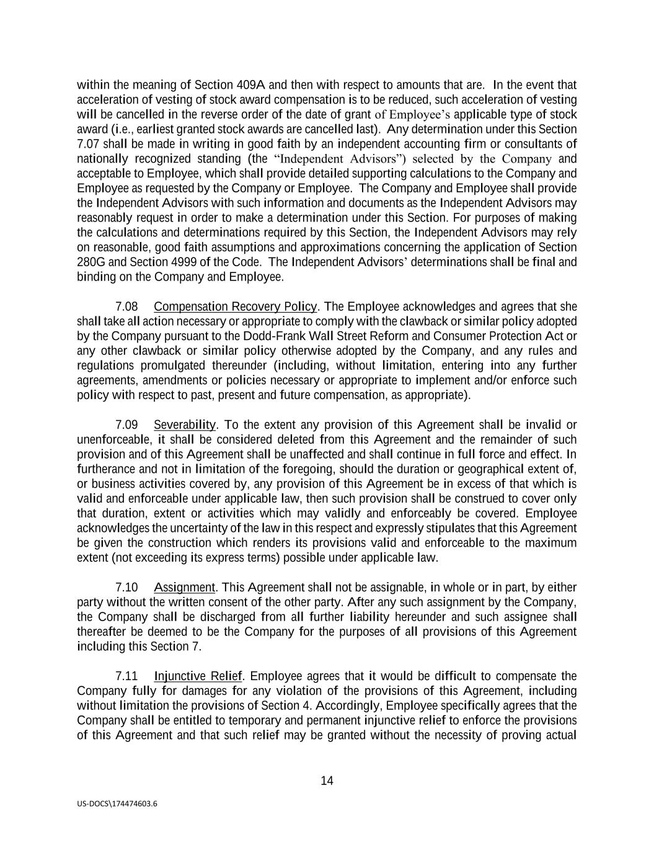
14 US-DOCS\174474603.6 within the meaning of Section 409A and then with respect to amounts that are. In the event that acceleration of vesting of stock award compensation is to be reduced, such acceleration of vesting will be cancelled in the reverse order of the date of grant of Employee’s applicable type of stock award (i.e., earliest granted stock awards are cancelled last). Any determination under this Section 7.07 shall be made in writing in good faith by an independent accounting firm or consultants of nationally recognized standing (the “Independent Advisors”) selected by the Company and acceptable to Employee, which shall provide detailed supporting calculations to the Company and Employee as requested by the Company or Employee. The Company and Employee shall provide the Independent Advisors with such information and documents as the Independent Advisors may reasonably request in order to make a determination under this Section. For purposes of making the calculations and determinations required by this Section, the Independent Advisors may rely on reasonable, good faith assumptions and approximations concerning the application of Section 280G and Section 4999 of the Code. The Independent Advisors’ determinations shall be final and binding on the Company and Employee. 7.08 Compensation Recovery Policy. The Employee acknowledges and agrees that she shall take all action necessary or appropriate to comply with the clawback or similar policy adopted by the Company pursuant to the Dodd-Frank Wall Street Reform and Consumer Protection Act or any other clawback or similar policy otherwise adopted by the Company, and any rules and regulations promulgated thereunder (including, without limitation, entering into any further agreements, amendments or policies necessary or appropriate to implement and/or enforce such policy with respect to past, present and future compensation, as appropriate). 7.09 Severability. To the extent any provision of this Agreement shall be invalid or unenforceable, it shall be considered deleted from this Agreement and the remainder of such provision and of this Agreement shall be unaffected and shall continue in full force and effect. In furtherance and not in limitation of the foregoing, should the duration or geographical extent of, or business activities covered by, any provision of this Agreement be in excess of that which is valid and enforceable under applicable law, then such provision shall be construed to cover only that duration, extent or activities which may validly and enforceably be covered. Employee acknowledges the uncertainty of the law in this respect and expressly stipulates that this Agreement be given the construction which renders its provisions valid and enforceable to the maximum extent (not exceeding its express terms) possible under applicable law. 7.10 Assignment. This Agreement shall not be assignable, in whole or in part, by either party without the written consent of the other party. After any such assignment by the Company, the Company shall be discharged from all further liability hereunder and such assignee shall thereafter be deemed to be the Company for the purposes of all provisions of this Agreement including this Section 7. 7.11 Injunctive Relief. Employee agrees that it would be difficult to compensate the Company fully for damages for any violation of the provisions of this Agreement, including without limitation the provisions of Section 4. Accordingly, Employee specifically agrees that the Company shall be entitled to temporary and permanent injunctive relief to enforce the provisions of this Agreement and that such relief may be granted without the necessity of proving actual

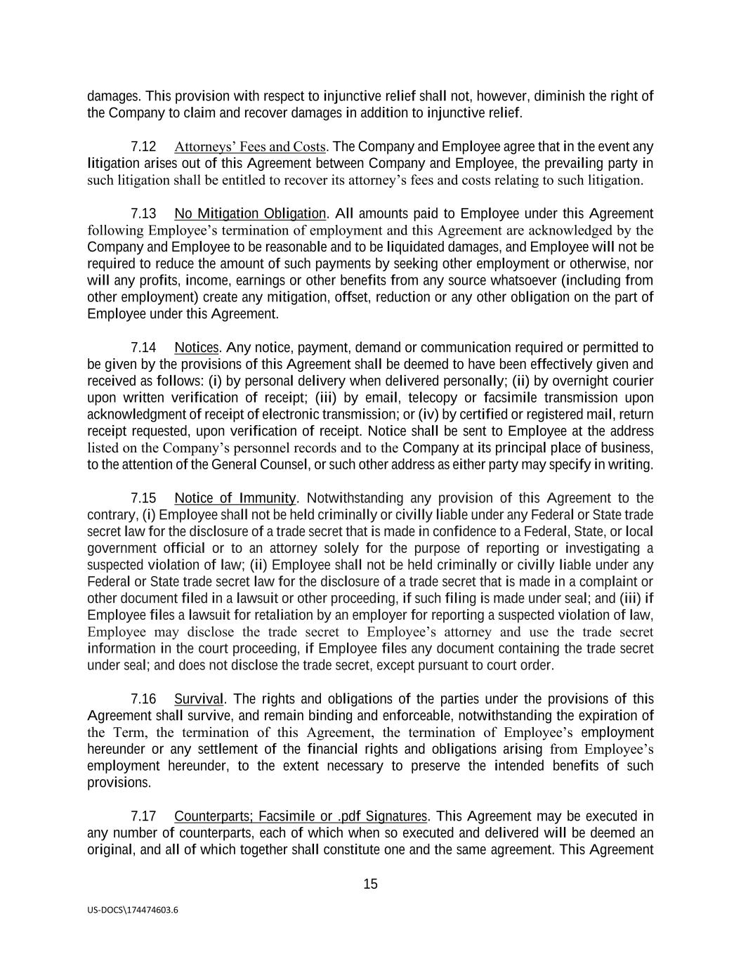
15 US-DOCS\174474603.6 damages. This provision with respect to injunctive relief shall not, however, diminish the right of the Company to claim and recover damages in addition to injunctive relief. 7.12 Attorneys’ Fees and Costs. The Company and Employee agree that in the event any litigation arises out of this Agreement between Company and Employee, the prevailing party in such litigation shall be entitled to recover its attorney’s fees and costs relating to such litigation. 7.13 No Mitigation Obligation. All amounts paid to Employee under this Agreement following Employee’s termination of employment and this Agreement are acknowledged by the Company and Employee to be reasonable and to be liquidated damages, and Employee will not be required to reduce the amount of such payments by seeking other employment or otherwise, nor will any profits, income, earnings or other benefits from any source whatsoever (including from other employment) create any mitigation, offset, reduction or any other obligation on the part of Employee under this Agreement. 7.14 Notices. Any notice, payment, demand or communication required or permitted to be given by the provisions of this Agreement shall be deemed to have been effectively given and received as follows: (i) by personal delivery when delivered personally; (ii) by overnight courier upon written verification of receipt; (iii) by email, telecopy or facsimile transmission upon acknowledgment of receipt of electronic transmission; or (iv) by certified or registered mail, return receipt requested, upon verification of receipt. Notice shall be sent to Employee at the address listed on the Company’s personnel records and to the Company at its principal place of business, to the attention of the General Counsel, or such other address as either party may specify in writing. 7.15 Notice of Immunity. Notwithstanding any provision of this Agreement to the contrary, (i) Employee shall not be held criminally or civilly liable under any Federal or State trade secret law for the disclosure of a trade secret that is made in confidence to a Federal, State, or local government official or to an attorney solely for the purpose of reporting or investigating a suspected violation of law; (ii) Employee shall not be held criminally or civilly liable under any Federal or State trade secret law for the disclosure of a trade secret that is made in a complaint or other document filed in a lawsuit or other proceeding, if such filing is made under seal; and (iii) if Employee files a lawsuit for retaliation by an employer for reporting a suspected violation of law, Employee may disclose the trade secret to Employee’s attorney and use the trade secret information in the court proceeding, if Employee files any document containing the trade secret under seal; and does not disclose the trade secret, except pursuant to court order. 7.16 Survival. The rights and obligations of the parties under the provisions of this Agreement shall survive, and remain binding and enforceable, notwithstanding the expiration of the Term, the termination of this Agreement, the termination of Employee’s employment hereunder or any settlement of the financial rights and obligations arising from Employee’s employment hereunder, to the extent necessary to preserve the intended benefits of such provisions. 7.17 Counterparts; Facsimile or .pdf Signatures. This Agreement may be executed in any number of counterparts, each of which when so executed and delivered will be deemed an original, and all of which together shall constitute one and the same agreement. This Agreement


16 US-DOCS\174474603.6 may be executed and delivered by facsimile or by .pdf file and upon such delivery the facsimile or .pdf signature will be deemed to have the same effect as if the original signature had been delivered to the other party. [Signatures on following page]


17 US-DOCS\174474603.6 IN WITNESS WHEREOF, the parties have executed this Agreement as of the date set forth in the first paragraph. BED BATH & BEYOND, INC. By: ______________________________ Amy Sullivan President EMPLOYEE By: ______________________________ Jill Windrum Jill Windrum Amy Sullivan


18 US-DOCS\174474603.6 EXHIBIT A Confidentiality Agreement [Attached]


19 US-DOCS\174474603.6 EXHIBIT B Indemnification Agreement [Attached]

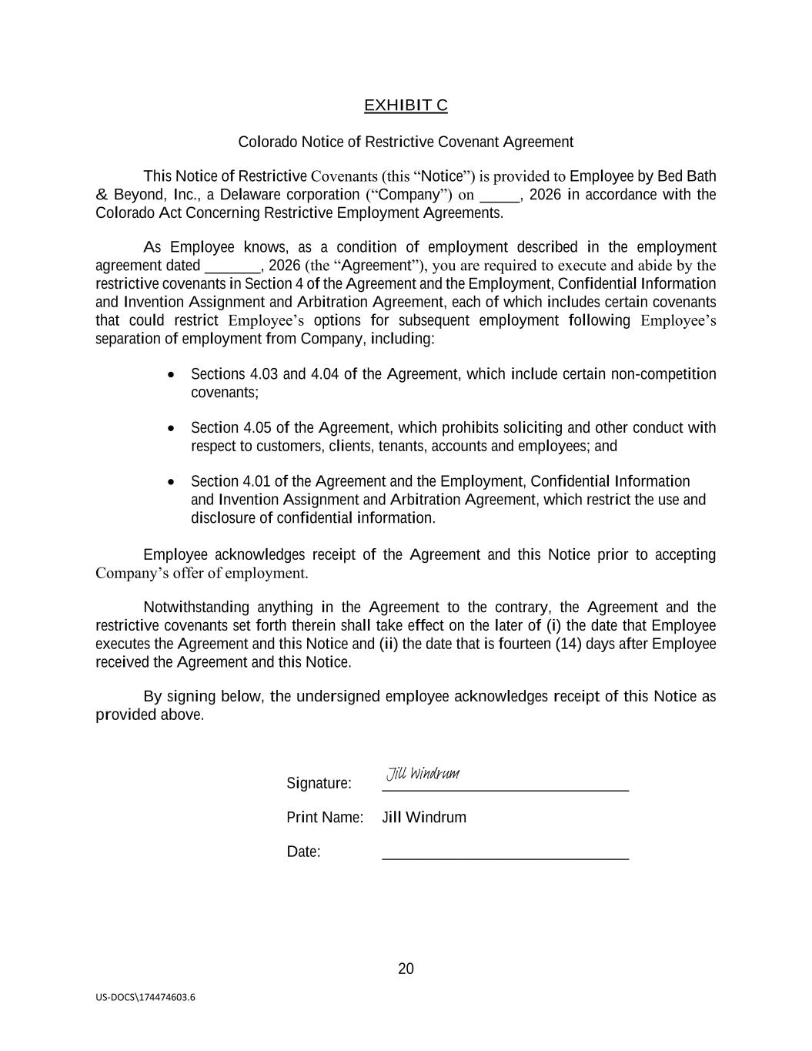
20 US-DOCS\174474603.6 EXHIBIT C Colorado Notice of Restrictive Covenant Agreement This Notice of Restrictive Covenants (this “Notice”) is provided to Employee by Bed Bath & Beyond, Inc., a Delaware corporation (“Company”) on _____, 2026 in accordance with the Colorado Act Concerning Restrictive Employment Agreements. As Employee knows, as a condition of employment described in the employment agreement dated _______, 2026 (the “Agreement”), you are required to execute and abide by the restrictive covenants in Section 4 of the Agreement and the Employment, Confidential Information and Invention Assignment and Arbitration Agreement, each of which includes certain covenants that could restrict Employee’s options for subsequent employment following Employee’s separation of employment from Company, including: • Sections 4.03 and 4.04 of the Agreement, which include certain non-competition covenants; • Section 4.05 of the Agreement, which prohibits soliciting and other conduct with respect to customers, clients, tenants, accounts and employees; and • Section 4.01 of the Agreement and the Employment, Confidential Information and Invention Assignment and Arbitration Agreement, which restrict the use and disclosure of confidential information. Employee acknowledges receipt of the Agreement and this Notice prior to accepting Company’s offer of employment. Notwithstanding anything in the Agreement to the contrary, the Agreement and the restrictive covenants set forth therein shall take effect on the later of (i) the date that Employee executes the Agreement and this Notice and (ii) the date that is fourteen (14) days after Employee received the Agreement and this Notice. By signing below, the undersigned employee acknowledges receipt of this Notice as provided above. Signature: _______________________________ Print Name: Jill Windrum Date: _______________________________ Jill Windrum

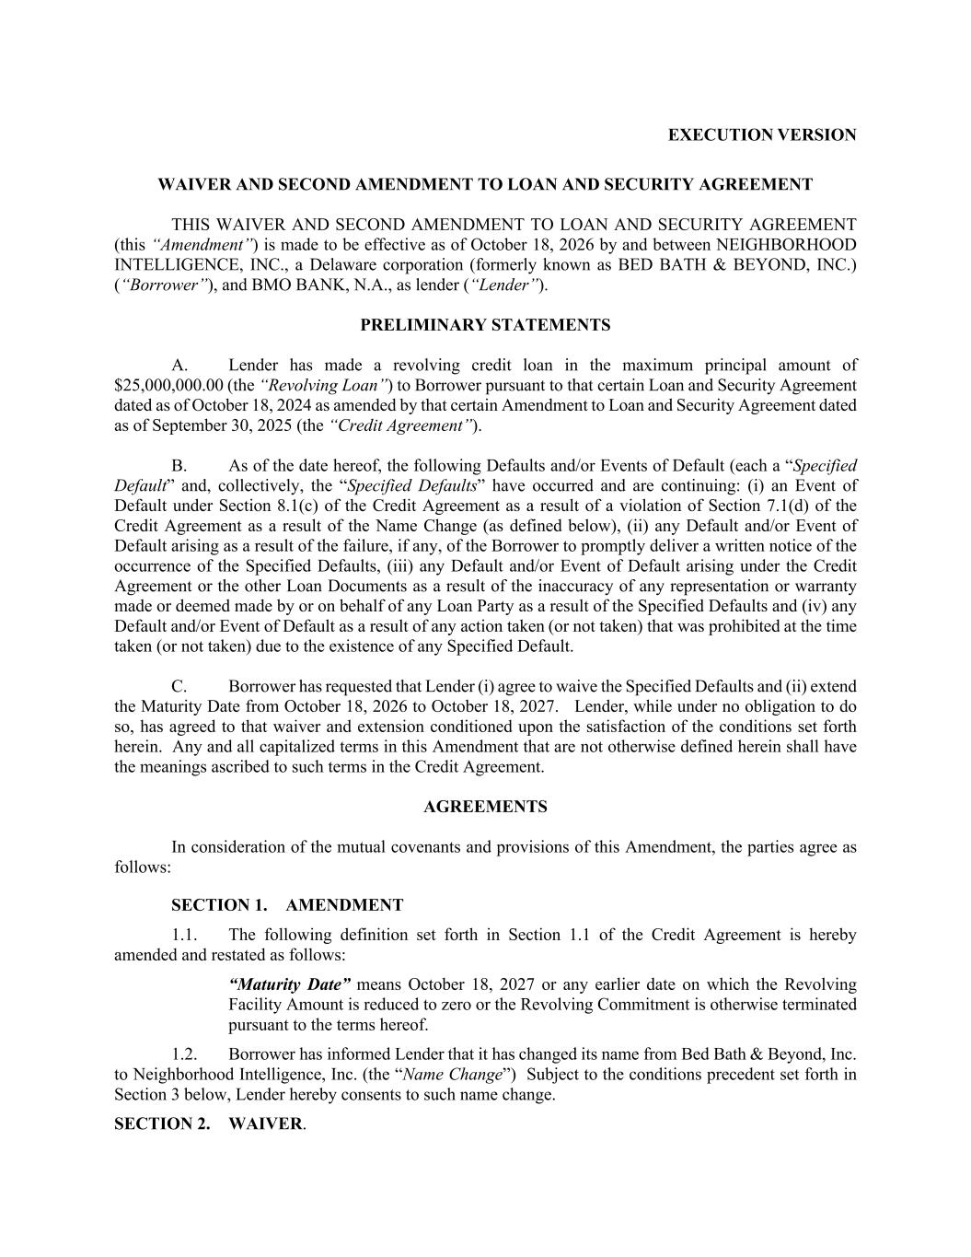
EXECUTION VERSION WAIVER AND SECOND AMENDMENT TO LOAN AND SECURITY AGREEMENT THIS WAIVER AND SECOND AMENDMENT TO LOAN AND SECURITY AGREEMENT (this “Amendment”) is made to be effective as of October 18, 2026 by and between NEIGHBORHOOD INTELLIGENCE, INC., a Delaware corporation (formerly known as BED BATH & BEYOND, INC.) (“Borrower”), and BMO BANK, N.A., as lender (“Lender”). PRELIMINARY STATEMENTS A. Lender has made a revolving credit loan in the maximum principal amount of $25,000,000.00 (the “Revolving Loan”) to Borrower pursuant to that certain Loan and Security Agreement dated as of October 18, 2024 as amended by that certain Amendment to Loan and Security Agreement dated as of September 30, 2025 (the “Credit Agreement”). B. As of the date hereof, the following Defaults and/or Events of Default (each a “Specified Default” and, collectively, the “Specified Defaults” have occurred and are continuing: (i) an Event of Default under Section 8.1(c) of the Credit Agreement as a result of a violation of Section 7.1(d) of the Credit Agreement as a result of the Name Change (as defined below), (ii) any Default and/or Event of Default arising as a result of the failure, if any, of the Borrower to promptly deliver a written notice of the occurrence of the Specified Defaults, (iii) any Default and/or Event of Default arising under the Credit Agreement or the other Loan Documents as a result of the inaccuracy of any representation or warranty made or deemed made by or on behalf of any Loan Party as a result of the Specified Defaults and (iv) any Default and/or Event of Default as a result of any action taken (or not taken) that was prohibited at the time taken (or not taken) due to the existence of any Specified Default. C. Borrower has requested that Lender (i) agree to waive the Specified Defaults and (ii) extend the Maturity Date from October 18, 2026 to October 18, 2027. Lender, while under no obligation to do so, has agreed to that waiver and extension conditioned upon the satisfaction of the conditions set forth herein. Any and all capitalized terms in this Amendment that are not otherwise defined herein shall have the meanings ascribed to such terms in the Credit Agreement. AGREEMENTS In consideration of the mutual covenants and provisions of this Amendment, the parties agree as follows: SECTION 1. AMENDMENT 1.1. The following definition set forth in Section 1.1 of the Credit Agreement is hereby amended and restated as follows: “Maturity Date” means October 18, 2027 or any earlier date on which the Revolving Facility Amount is reduced to zero or the Revolving Commitment is otherwise terminated pursuant to the terms hereof. 1.2. Borrower has informed Lender that it has changed its name from Bed Bath & Beyond, Inc. to Neighborhood Intelligence, Inc. (the “Name Change”) Subject to the conditions precedent set forth in Section 3 below, Lender hereby consents to such name change. SECTION 2. WAIVER.

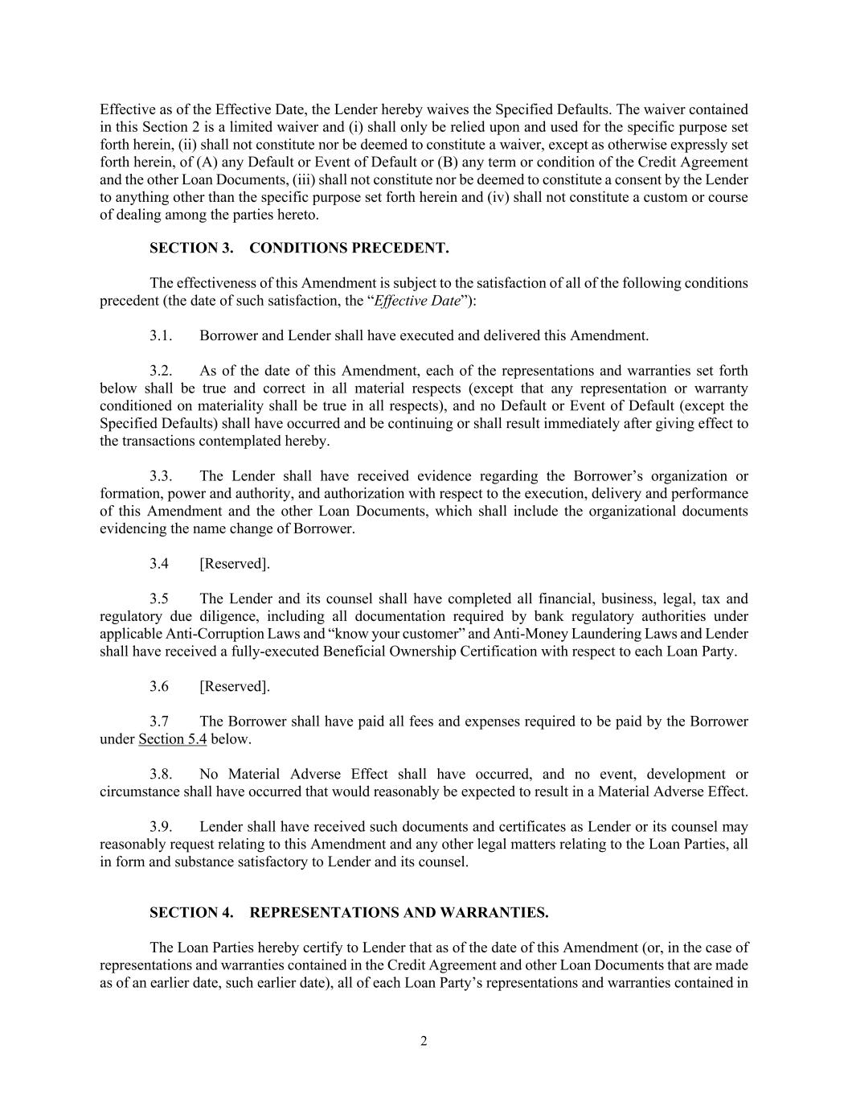
2 Effective as of the Effective Date, the Lender hereby waives the Specified Defaults. The waiver contained in this Section 2 is a limited waiver and (i) shall only be relied upon and used for the specific purpose set forth herein, (ii) shall not constitute nor be deemed to constitute a waiver, except as otherwise expressly set forth herein, of (A) any Default or Event of Default or (B) any term or condition of the Credit Agreement and the other Loan Documents, (iii) shall not constitute nor be deemed to constitute a consent by the Lender to anything other than the specific purpose set forth herein and (iv) shall not constitute a custom or course of dealing among the parties hereto. SECTION 3. CONDITIONS PRECEDENT. The effectiveness of this Amendment is subject to the satisfaction of all of the following conditions precedent (the date of such satisfaction, the “Effective Date”): 3.1. Borrower and Lender shall have executed and delivered this Amendment. 3.2. As of the date of this Amendment, each of the representations and warranties set forth below shall be true and correct in all material respects (except that any representation or warranty conditioned on materiality shall be true in all respects), and no Default or Event of Default (except the Specified Defaults) shall have occurred and be continuing or shall result immediately after giving effect to the transactions contemplated hereby. 3.3. The Lender shall have received evidence regarding the Borrower’s organization or formation, power and authority, and authorization with respect to the execution, delivery and performance of this Amendment and the other Loan Documents, which shall include the organizational documents evidencing the name change of Borrower. 3.4 [Reserved]. 3.5 The Lender and its counsel shall have completed all financial, business, legal, tax and regulatory due diligence, including all documentation required by bank regulatory authorities under applicable Anti-Corruption Laws and “know your customer” and Anti-Money Laundering Laws and Lender shall have received a fully-executed Beneficial Ownership Certification with respect to each Loan Party. 3.6 [Reserved]. 3.7 The Borrower shall have paid all fees and expenses required to be paid by the Borrower under Section 5.4 below. 3.8. No Material Adverse Effect shall have occurred, and no event, development or circumstance shall have occurred that would reasonably be expected to result in a Material Adverse Effect. 3.9. Lender shall have received such documents and certificates as Lender or its counsel may reasonably request relating to this Amendment and any other legal matters relating to the Loan Parties, all in form and substance satisfactory to Lender and its counsel. SECTION 4. REPRESENTATIONS AND WARRANTIES. The Loan Parties hereby certify to Lender that as of the date of this Amendment (or, in the case of representations and warranties contained in the Credit Agreement and other Loan Documents that are made as of an earlier date, such earlier date), all of each Loan Party’s representations and warranties contained in

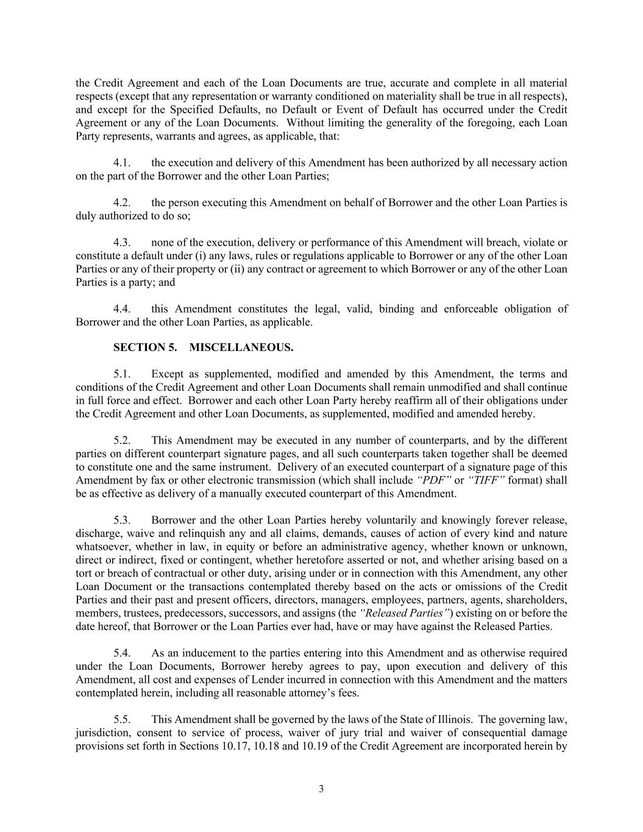
3 the Credit Agreement and each of the Loan Documents are true, accurate and complete in all material respects (except that any representation or warranty conditioned on materiality shall be true in all respects), and except for the Specified Defaults, no Default or Event of Default has occurred under the Credit Agreement or any of the Loan Documents. Without limiting the generality of the foregoing, each Loan Party represents, warrants and agrees, as applicable, that: 4.1. the execution and delivery of this Amendment has been authorized by all necessary action on the part of the Borrower and the other Loan Parties; 4.2. the person executing this Amendment on behalf of Borrower and the other Loan Parties is duly authorized to do so; 4.3. none of the execution, delivery or performance of this Amendment will breach, violate or constitute a default under (i) any laws, rules or regulations applicable to Borrower or any of the other Loan Parties or any of their property or (ii) any contract or agreement to which Borrower or any of the other Loan Parties is a party; and 4.4. this Amendment constitutes the legal, valid, binding and enforceable obligation of Borrower and the other Loan Parties, as applicable. SECTION 5. MISCELLANEOUS. 5.1. Except as supplemented, modified and amended by this Amendment, the terms and conditions of the Credit Agreement and other Loan Documents shall remain unmodified and shall continue in full force and effect. Borrower and each other Loan Party hereby reaffirm all of their obligations under the Credit Agreement and other Loan Documents, as supplemented, modified and amended hereby. 5.2. This Amendment may be executed in any number of counterparts, and by the different parties on different counterpart signature pages, and all such counterparts taken together shall be deemed to constitute one and the same instrument. Delivery of an executed counterpart of a signature page of this Amendment by fax or other electronic transmission (which shall include “PDF” or “TIFF” format) shall be as effective as delivery of a manually executed counterpart of this Amendment. 5.3. Borrower and the other Loan Parties hereby voluntarily and knowingly forever release, discharge, waive and relinquish any and all claims, demands, causes of action of every kind and nature whatsoever, whether in law, in equity or before an administrative agency, whether known or unknown, direct or indirect, fixed or contingent, whether heretofore asserted or not, and whether arising based on a tort or breach of contractual or other duty, arising under or in connection with this Amendment, any other Loan Document or the transactions contemplated thereby based on the acts or omissions of the Credit Parties and their past and present officers, directors, managers, employees, partners, agents, shareholders, members, trustees, predecessors, successors, and assigns (the “Released Parties”) existing on or before the date hereof, that Borrower or the Loan Parties ever had, have or may have against the Released Parties. 5.4. As an inducement to the parties entering into this Amendment and as otherwise required under the Loan Documents, Borrower hereby agrees to pay, upon execution and delivery of this Amendment, all cost and expenses of Lender incurred in connection with this Amendment and the matters contemplated herein, including all reasonable attorney’s fees. 5.5. This Amendment shall be governed by the laws of the State of Illinois. The governing law, jurisdiction, consent to service of process, waiver of jury trial and waiver of consequential damage provisions set forth in Sections 10.17, 10.18 and 10.19 of the Credit Agreement are incorporated herein by


4 reference and shall apply to this Amendment to the same extent as if fully set forth herein. This Amendment shall be binding upon and inure to the benefit of the parties hereto and their successors and permitted assigns. [THE REMAINDER OF THIS PAGE IS INTENTIONALLY LEFT BLANK]

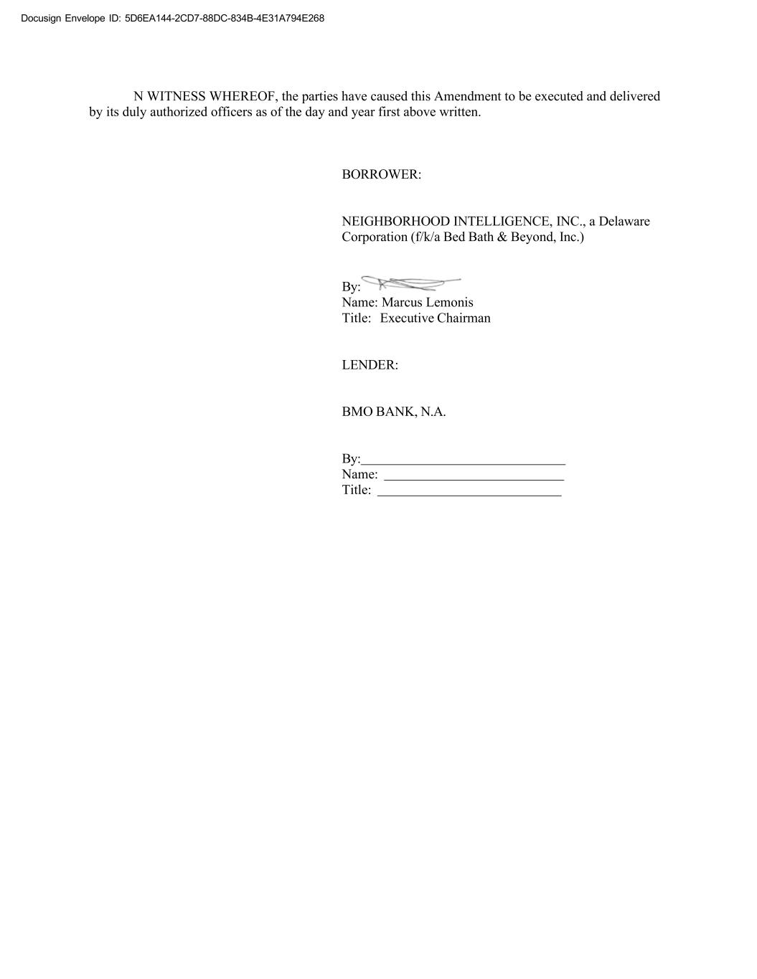
Docusign Envelope ID: 5D6EA144-2CD7-88DC-834B-4E31A794E268 N WITNESS WHEREOF, the parties have caused this Amendment to be executed and delivered by its duly authorized officers as of the day and year first above written. BORROWER: NEIGHBORHOOD INTELLIGENCE, INC., a Delaware Corporation (f/k/a Bed Bath & Beyond, Inc.) By: Name: Marcus Lemonis Title: Executive Chairman LENDER: BMO BANK, N.A. By: Name: Title:

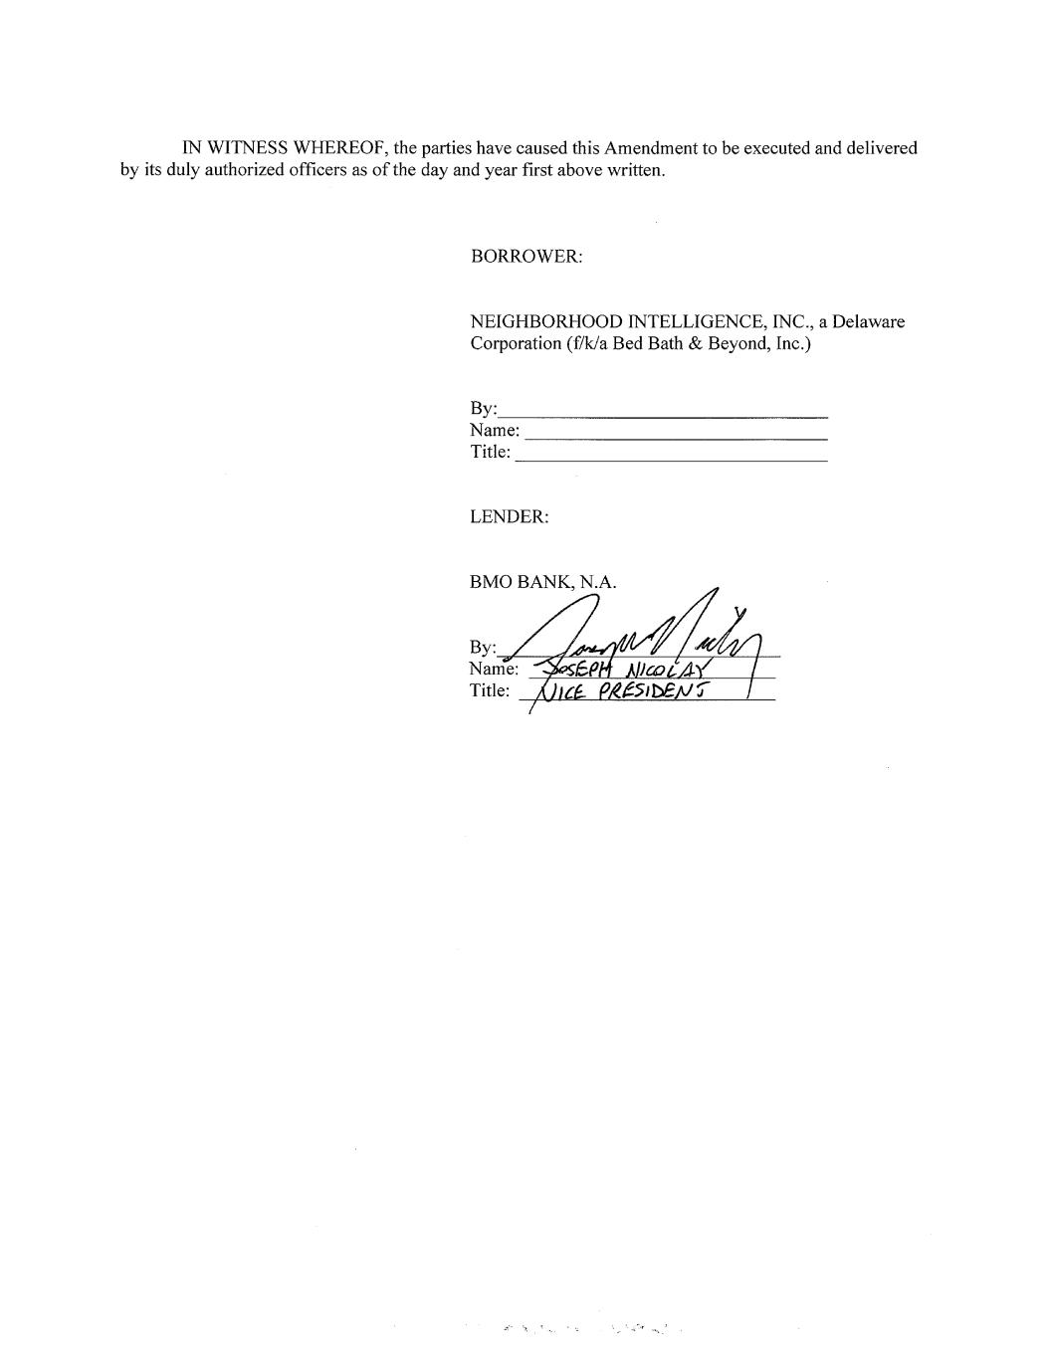

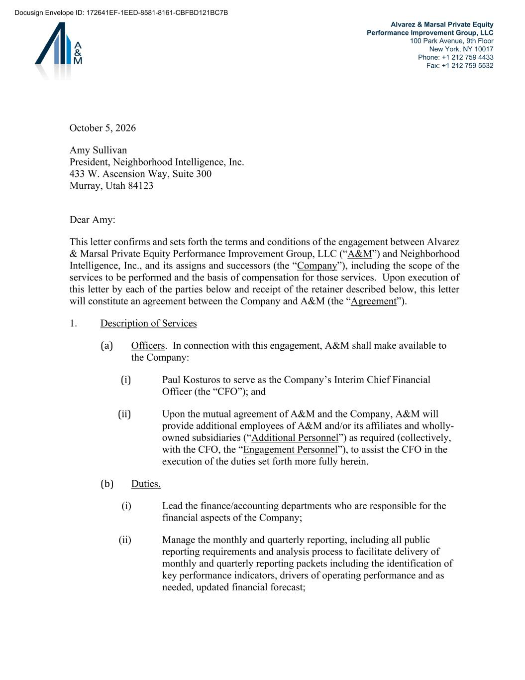
Alvarez & Marsal Private Equity Performance Improvement Group, LLC 100 Park Avenue, 9th Floor New York, NY 10017 Phone: +1 212 759 4433 Fax: +1 212 759 5532 October 5, 2026 Amy Sullivan President, Neighborhood Intelligence, Inc. 433 W. Ascension Way, Suite 300 Murray, Utah 84123 Dear Amy: This letter confirms and sets forth the terms and conditions of the engagement between Alvarez & Marsal Private Equity Performance Improvement Group, LLC (“A&M”) and Neighborhood Intelligence, Inc., and its assigns and successors (the “Company”), including the scope of the services to be performed and the basis of compensation for those services. Upon execution of this letter by each of the parties below and receipt of the retainer described below, this letter will constitute an agreement between the Company and A&M (the “Agreement”). 1. Description of Services (a) Officers. In connection with this engagement, A&M shall make available to the Company: (i) Paul Kosturos to serve as the Company’s Interim Chief Financial Officer (the “CFO”); and (ii) Upon the mutual agreement of A&M and the Company, A&M will provide additional employees of A&M and/or its affiliates and wholly- owned subsidiaries (“Additional Personnel”) as required (collectively, with the CFO, the “Engagement Personnel”), to assist the CFO in the execution of the duties set forth more fully herein. (b) Duties. (i) Lead the finance/accounting departments who are responsible for the financial aspects of the Company; (ii) Manage the monthly and quarterly reporting, including all public reporting requirements and analysis process to facilitate delivery of monthly and quarterly reporting packets including the identification of key performance indicators, drivers of operating performance and as needed, updated financial forecast; Docusign Envelope ID: 172641EF-1EED-8581-8161-CBFBD121BC7B

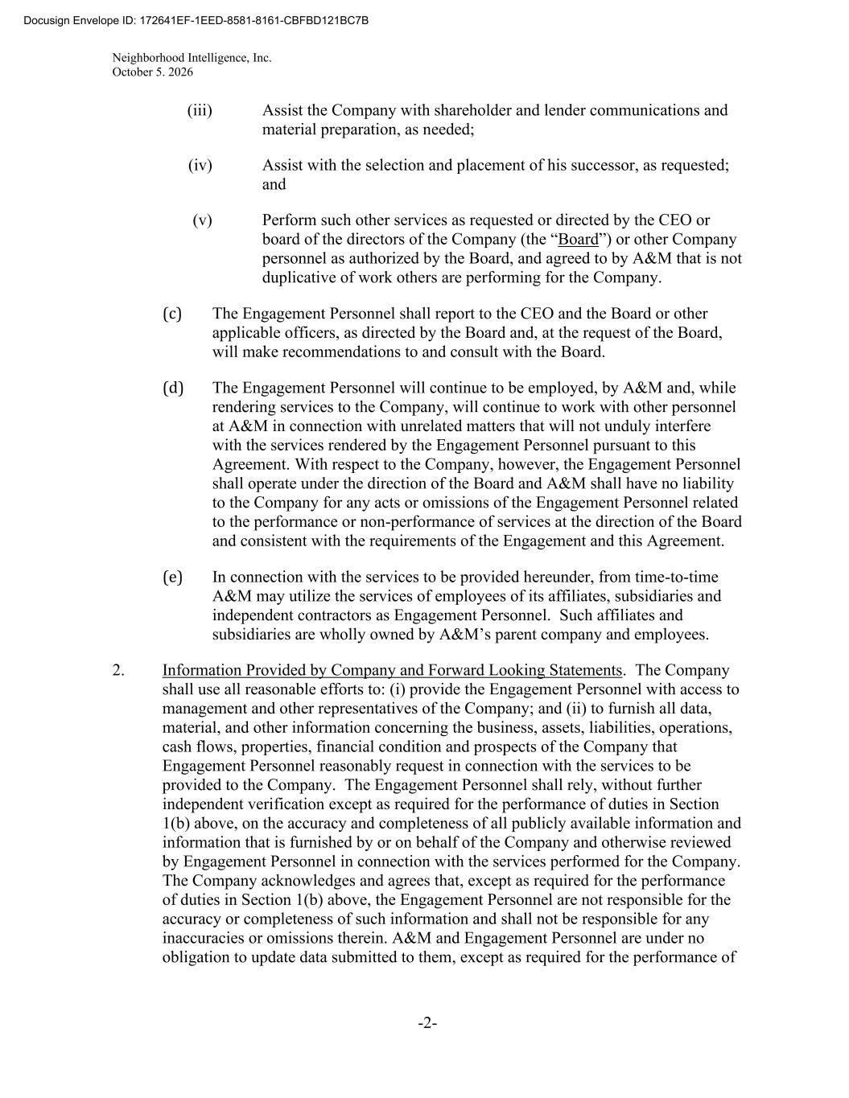
Neighborhood Intelligence, Inc. October 5. 2026 -2- (iii) Assist the Company with shareholder and lender communications and material preparation, as needed; (iv) Assist with the selection and placement of his successor, as requested; and (v) Perform such other services as requested or directed by the CEO or board of the directors of the Company (the “Board”) or other Company personnel as authorized by the Board, and agreed to by A&M that is not duplicative of work others are performing for the Company. (c) The Engagement Personnel shall report to the CEO and the Board or other applicable officers, as directed by the Board and, at the request of the Board, will make recommendations to and consult with the Board. (d) The Engagement Personnel will continue to be employed, by A&M and, while rendering services to the Company, will continue to work with other personnel at A&M in connection with unrelated matters that will not unduly interfere with the services rendered by the Engagement Personnel pursuant to this Agreement. With respect to the Company, however, the Engagement Personnel shall operate under the direction of the Board and A&M shall have no liability to the Company for any acts or omissions of the Engagement Personnel related to the performance or non-performance of services at the direction of the Board and consistent with the requirements of the Engagement and this Agreement. (e) In connection with the services to be provided hereunder, from time-to-time A&M may utilize the services of employees of its affiliates, subsidiaries and independent contractors as Engagement Personnel. Such affiliates and subsidiaries are wholly owned by A&M’s parent company and employees. 2. Information Provided by Company and Forward Looking Statements. The Company shall use all reasonable efforts to: (i) provide the Engagement Personnel with access to management and other representatives of the Company; and (ii) to furnish all data, material, and other information concerning the business, assets, liabilities, operations, cash flows, properties, financial condition and prospects of the Company that Engagement Personnel reasonably request in connection with the services to be provided to the Company. The Engagement Personnel shall rely, without further independent verification except as required for the performance of duties in Section 1(b) above, on the accuracy and completeness of all publicly available information and information that is furnished by or on behalf of the Company and otherwise reviewed by Engagement Personnel in connection with the services performed for the Company. The Company acknowledges and agrees that, except as required for the performance of duties in Section 1(b) above, the Engagement Personnel are not responsible for the accuracy or completeness of such information and shall not be responsible for any inaccuracies or omissions therein. A&M and Engagement Personnel are under no obligation to update data submitted to them, except as required for the performance of Docusign Envelope ID: 172641EF-1EED-8581-8161-CBFBD121BC7B

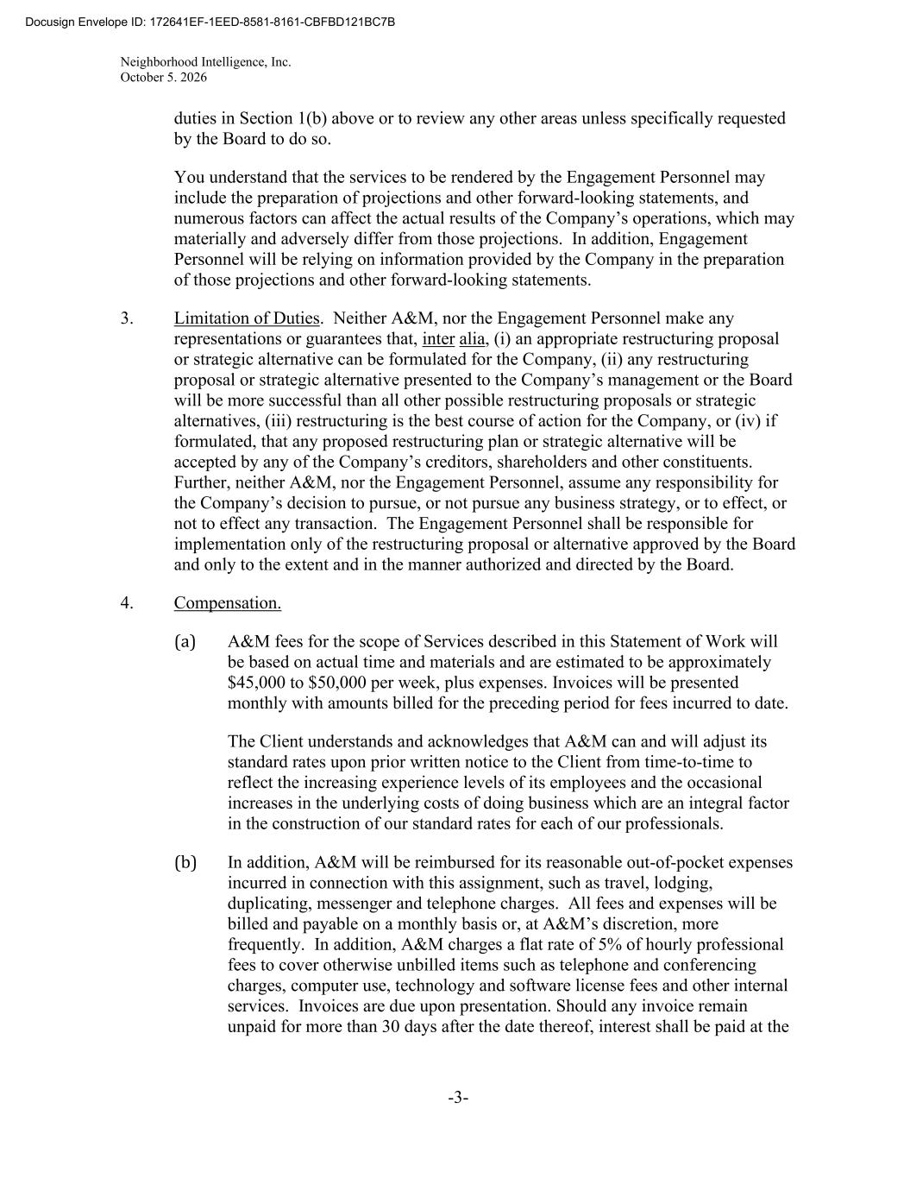
Neighborhood Intelligence, Inc. October 5. 2026 -3- duties in Section 1(b) above or to review any other areas unless specifically requested by the Board to do so. You understand that the services to be rendered by the Engagement Personnel may include the preparation of projections and other forward-looking statements, and numerous factors can affect the actual results of the Company’s operations, which may materially and adversely differ from those projections. In addition, Engagement Personnel will be relying on information provided by the Company in the preparation of those projections and other forward-looking statements. 3. Limitation of Duties. Neither A&M, nor the Engagement Personnel make any representations or guarantees that, inter alia, (i) an appropriate restructuring proposal or strategic alternative can be formulated for the Company, (ii) any restructuring proposal or strategic alternative presented to the Company’s management or the Board will be more successful than all other possible restructuring proposals or strategic alternatives, (iii) restructuring is the best course of action for the Company, or (iv) if formulated, that any proposed restructuring plan or strategic alternative will be accepted by any of the Company’s creditors, shareholders and other constituents. Further, neither A&M, nor the Engagement Personnel, assume any responsibility for the Company’s decision to pursue, or not pursue any business strategy, or to effect, or not to effect any transaction. The Engagement Personnel shall be responsible for implementation only of the restructuring proposal or alternative approved by the Board and only to the extent and in the manner authorized and directed by the Board. 4. Compensation. (a) A&M fees for the scope of Services described in this Statement of Work will be based on actual time and materials and are estimated to be approximately $45,000 to $50,000 per week, plus expenses. Invoices will be presented monthly with amounts billed for the preceding period for fees incurred to date. The Client understands and acknowledges that A&M can and will adjust its standard rates upon prior written notice to the Client from time-to-time to reflect the increasing experience levels of its employees and the occasional increases in the underlying costs of doing business which are an integral factor in the construction of our standard rates for each of our professionals. (b) In addition, A&M will be reimbursed for its reasonable out-of-pocket expenses incurred in connection with this assignment, such as travel, lodging, duplicating, messenger and telephone charges. All fees and expenses will be billed and payable on a monthly basis or, at A&M’s discretion, more frequently. In addition, A&M charges a flat rate of 5% of hourly professional fees to cover otherwise unbilled items such as telephone and conferencing charges, computer use, technology and software license fees and other internal services. Invoices are due upon presentation. Should any invoice remain unpaid for more than 30 days after the date thereof, interest shall be paid at the Docusign Envelope ID: 172641EF-1EED-8581-8161-CBFBD121BC7B

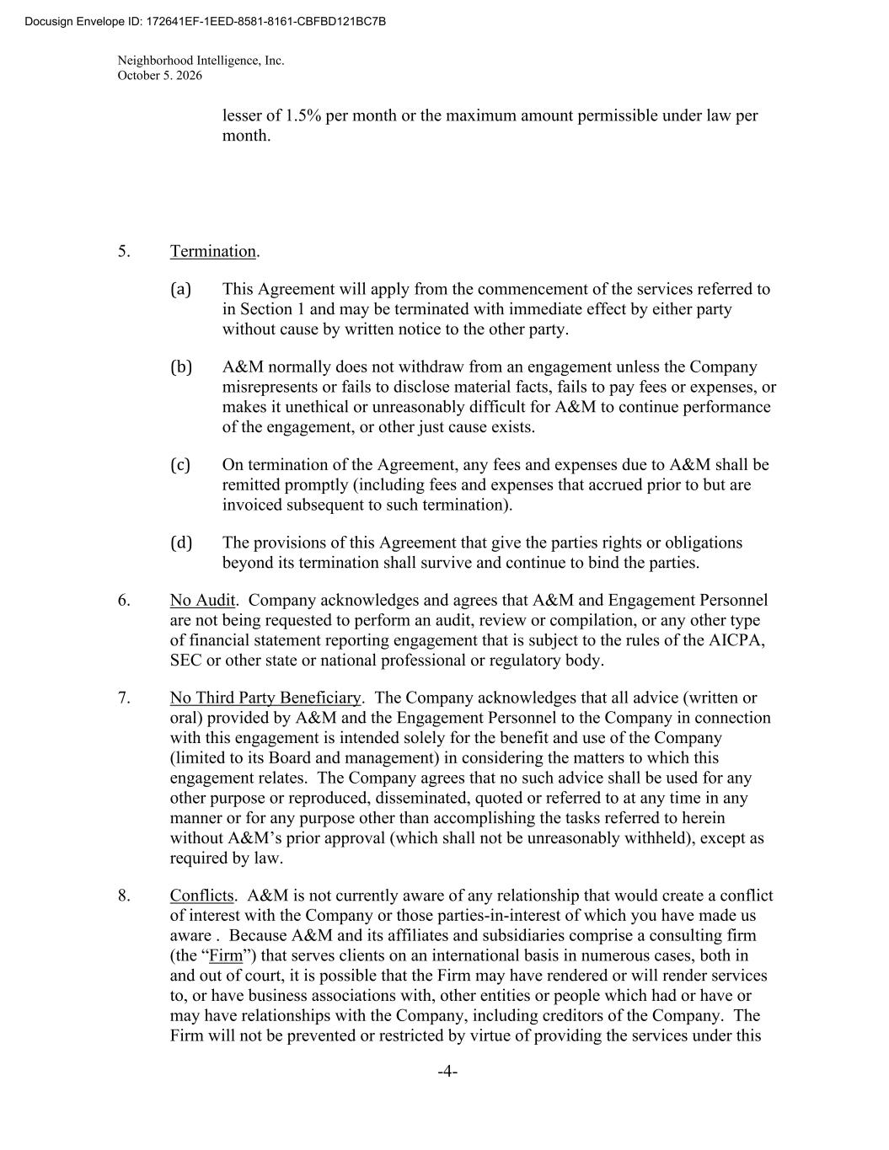
Neighborhood Intelligence, Inc. October 5. 2026 -4- lesser of 1.5% per month or the maximum amount permissible under law per month. 5. Termination. (a) This Agreement will apply from the commencement of the services referred to in Section 1 and may be terminated with immediate effect by either party without cause by written notice to the other party. (b) A&M normally does not withdraw from an engagement unless the Company misrepresents or fails to disclose material facts, fails to pay fees or expenses, or makes it unethical or unreasonably difficult for A&M to continue performance of the engagement, or other just cause exists. (c) On termination of the Agreement, any fees and expenses due to A&M shall be remitted promptly (including fees and expenses that accrued prior to but are invoiced subsequent to such termination). (d) The provisions of this Agreement that give the parties rights or obligations beyond its termination shall survive and continue to bind the parties. 6. No Audit. Company acknowledges and agrees that A&M and Engagement Personnel are not being requested to perform an audit, review or compilation, or any other type of financial statement reporting engagement that is subject to the rules of the AICPA, SEC or other state or national professional or regulatory body. 7. No Third Party Beneficiary. The Company acknowledges that all advice (written or oral) provided by A&M and the Engagement Personnel to the Company in connection with this engagement is intended solely for the benefit and use of the Company (limited to its Board and management) in considering the matters to which this engagement relates. The Company agrees that no such advice shall be used for any other purpose or reproduced, disseminated, quoted or referred to at any time in any manner or for any purpose other than accomplishing the tasks referred to herein without A&M’s prior approval (which shall not be unreasonably withheld), except as required by law. 8. Conflicts. A&M is not currently aware of any relationship that would create a conflict of interest with the Company or those parties-in-interest of which you have made us aware . Because A&M and its affiliates and subsidiaries comprise a consulting firm (the “Firm”) that serves clients on an international basis in numerous cases, both in and out of court, it is possible that the Firm may have rendered or will render services to, or have business associations with, other entities or people which had or have or may have relationships with the Company, including creditors of the Company. The Firm will not be prevented or restricted by virtue of providing the services under this Docusign Envelope ID: 172641EF-1EED-8581-8161-CBFBD121BC7B

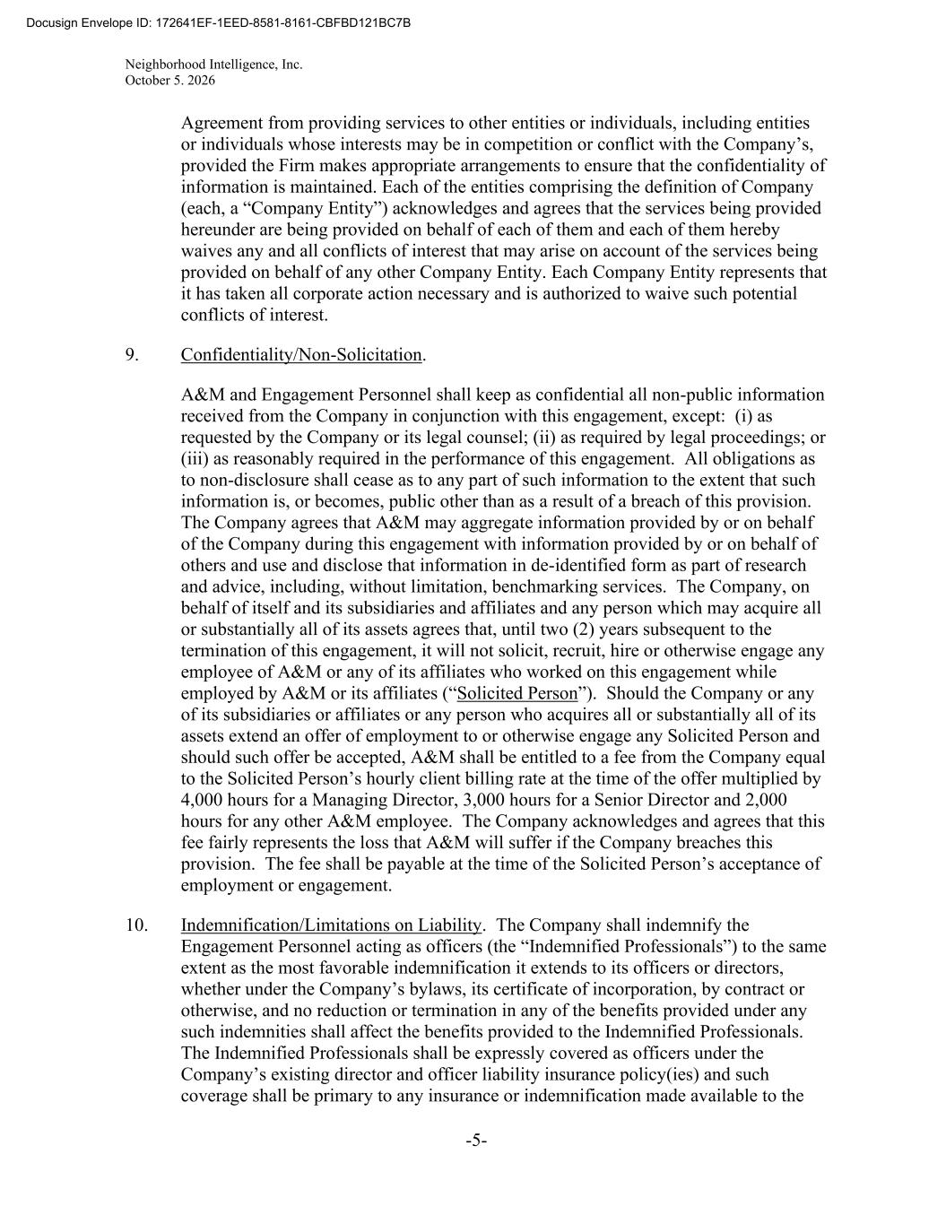
Neighborhood Intelligence, Inc. October 5. 2026 -5- Agreement from providing services to other entities or individuals, including entities or individuals whose interests may be in competition or conflict with the Company’s, provided the Firm makes appropriate arrangements to ensure that the confidentiality of information is maintained. Each of the entities comprising the definition of Company (each, a “Company Entity”) acknowledges and agrees that the services being provided hereunder are being provided on behalf of each of them and each of them hereby waives any and all conflicts of interest that may arise on account of the services being provided on behalf of any other Company Entity. Each Company Entity represents that it has taken all corporate action necessary and is authorized to waive such potential conflicts of interest. 9. Confidentiality/Non-Solicitation. A&M and Engagement Personnel shall keep as confidential all non-public information received from the Company in conjunction with this engagement, except: (i) as requested by the Company or its legal counsel; (ii) as required by legal proceedings; or (iii) as reasonably required in the performance of this engagement. All obligations as to non-disclosure shall cease as to any part of such information to the extent that such information is, or becomes, public other than as a result of a breach of this provision. The Company agrees that A&M may aggregate information provided by or on behalf of the Company during this engagement with information provided by or on behalf of others and use and disclose that information in de-identified form as part of research and advice, including, without limitation, benchmarking services. The Company, on behalf of itself and its subsidiaries and affiliates and any person which may acquire all or substantially all of its assets agrees that, until two (2) years subsequent to the termination of this engagement, it will not solicit, recruit, hire or otherwise engage any employee of A&M or any of its affiliates who worked on this engagement while employed by A&M or its affiliates (“Solicited Person”). Should the Company or any of its subsidiaries or affiliates or any person who acquires all or substantially all of its assets extend an offer of employment to or otherwise engage any Solicited Person and should such offer be accepted, A&M shall be entitled to a fee from the Company equal to the Solicited Person’s hourly client billing rate at the time of the offer multiplied by 4,000 hours for a Managing Director, 3,000 hours for a Senior Director and 2,000 hours for any other A&M employee. The Company acknowledges and agrees that this fee fairly represents the loss that A&M will suffer if the Company breaches this provision. The fee shall be payable at the time of the Solicited Person’s acceptance of employment or engagement. 10. Indemnification/Limitations on Liability. The Company shall indemnify the Engagement Personnel acting as officers (the “Indemnified Professionals”) to the same extent as the most favorable indemnification it extends to its officers or directors, whether under the Company’s bylaws, its certificate of incorporation, by contract or otherwise, and no reduction or termination in any of the benefits provided under any such indemnities shall affect the benefits provided to the Indemnified Professionals. The Indemnified Professionals shall be expressly covered as officers under the Company’s existing director and officer liability insurance policy(ies) and such coverage shall be primary to any insurance or indemnification made available to the Docusign Envelope ID: 172641EF-1EED-8581-8161-CBFBD121BC7B

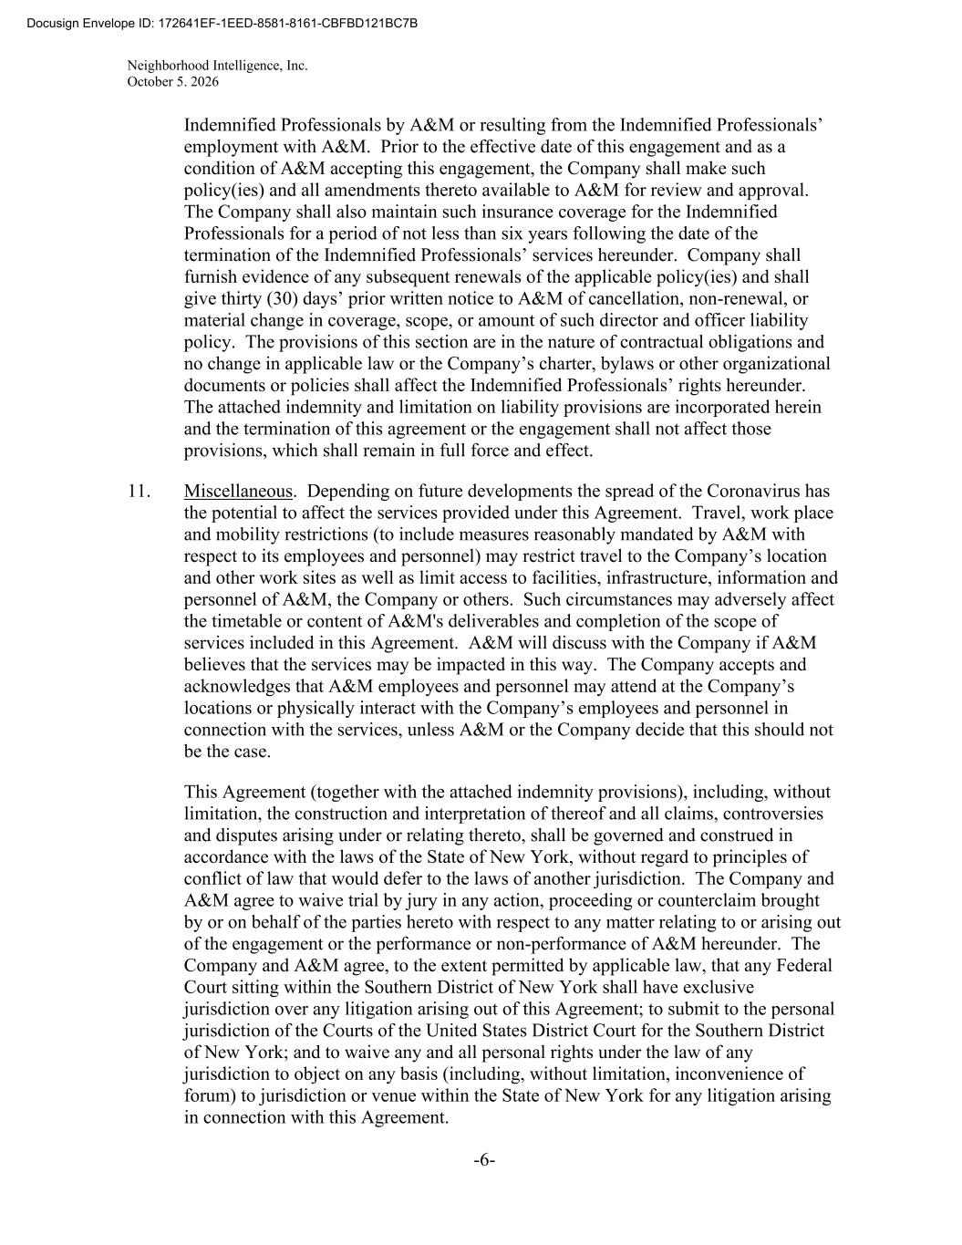
Neighborhood Intelligence, Inc. October 5. 2026 -6- Indemnified Professionals by A&M or resulting from the Indemnified Professionals’ employment with A&M. Prior to the effective date of this engagement and as a condition of A&M accepting this engagement, the Company shall make such policy(ies) and all amendments thereto available to A&M for review and approval. The Company shall also maintain such insurance coverage for the Indemnified Professionals for a period of not less than six years following the date of the termination of the Indemnified Professionals’ services hereunder. Company shall furnish evidence of any subsequent renewals of the applicable policy(ies) and shall give thirty (30) days’ prior written notice to A&M of cancellation, non-renewal, or material change in coverage, scope, or amount of such director and officer liability policy. The provisions of this section are in the nature of contractual obligations and no change in applicable law or the Company’s charter, bylaws or other organizational documents or policies shall affect the Indemnified Professionals’ rights hereunder. The attached indemnity and limitation on liability provisions are incorporated herein and the termination of this agreement or the engagement shall not affect those provisions, which shall remain in full force and effect. 11. Miscellaneous. Depending on future developments the spread of the Coronavirus has the potential to affect the services provided under this Agreement. Travel, work place and mobility restrictions (to include measures reasonably mandated by A&M with respect to its employees and personnel) may restrict travel to the Company’s location and other work sites as well as limit access to facilities, infrastructure, information and personnel of A&M, the Company or others. Such circumstances may adversely affect the timetable or content of A&M's deliverables and completion of the scope of services included in this Agreement. A&M will discuss with the Company if A&M believes that the services may be impacted in this way. The Company accepts and acknowledges that A&M employees and personnel may attend at the Company’s locations or physically interact with the Company’s employees and personnel in connection with the services, unless A&M or the Company decide that this should not be the case. This Agreement (together with the attached indemnity provisions), including, without limitation, the construction and interpretation of thereof and all claims, controversies and disputes arising under or relating thereto, shall be governed and construed in accordance with the laws of the State of New York, without regard to principles of conflict of law that would defer to the laws of another jurisdiction. The Company and A&M agree to waive trial by jury in any action, proceeding or counterclaim brought by or on behalf of the parties hereto with respect to any matter relating to or arising out of the engagement or the performance or non-performance of A&M hereunder. The Company and A&M agree, to the extent permitted by applicable law, that any Federal Court sitting within the Southern District of New York shall have exclusive jurisdiction over any litigation arising out of this Agreement; to submit to the personal jurisdiction of the Courts of the United States District Court for the Southern District of New York; and to waive any and all personal rights under the law of any jurisdiction to object on any basis (including, without limitation, inconvenience of forum) to jurisdiction or venue within the State of New York for any litigation arising in connection with this Agreement. Docusign Envelope ID: 172641EF-1EED-8581-8161-CBFBD121BC7B

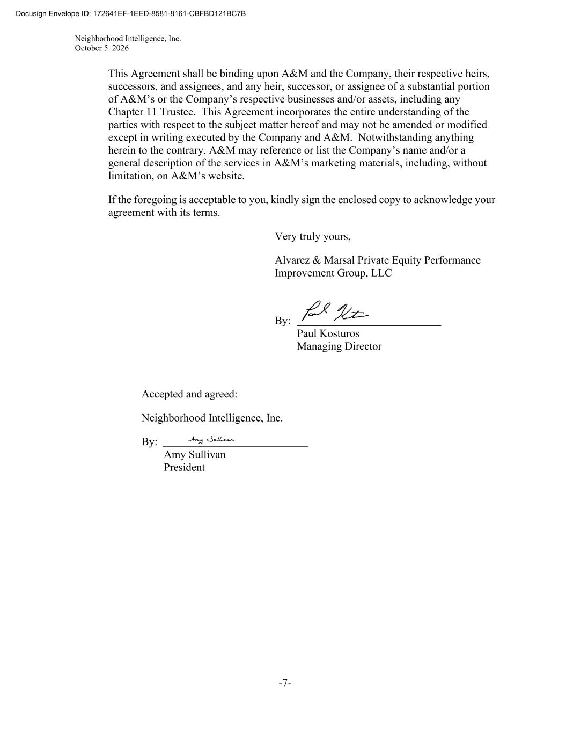
Neighborhood Intelligence, Inc. October 5. 2026 -7- This Agreement shall be binding upon A&M and the Company, their respective heirs, successors, and assignees, and any heir, successor, or assignee of a substantial portion of A&M’s or the Company’s respective businesses and/or assets, including any Chapter 11 Trustee. This Agreement incorporates the entire understanding of the parties with respect to the subject matter hereof and may not be amended or modified except in writing executed by the Company and A&M. Notwithstanding anything herein to the contrary, A&M may reference or list the Company’s name and/or a general description of the services in A&M’s marketing materials, including, without limitation, on A&M’s website. If the foregoing is acceptable to you, kindly sign the enclosed copy to acknowledge your agreement with its terms. Very truly yours, Alvarez & Marsal Private Equity Performance Improvement Group, LLC By: Paul Kosturos Managing Director Accepted and agreed: Neighborhood Intelligence, Inc. By: Amy Sullivan President Docusign Envelope ID: 172641EF-1EED-8581-8161-CBFBD121BC7B

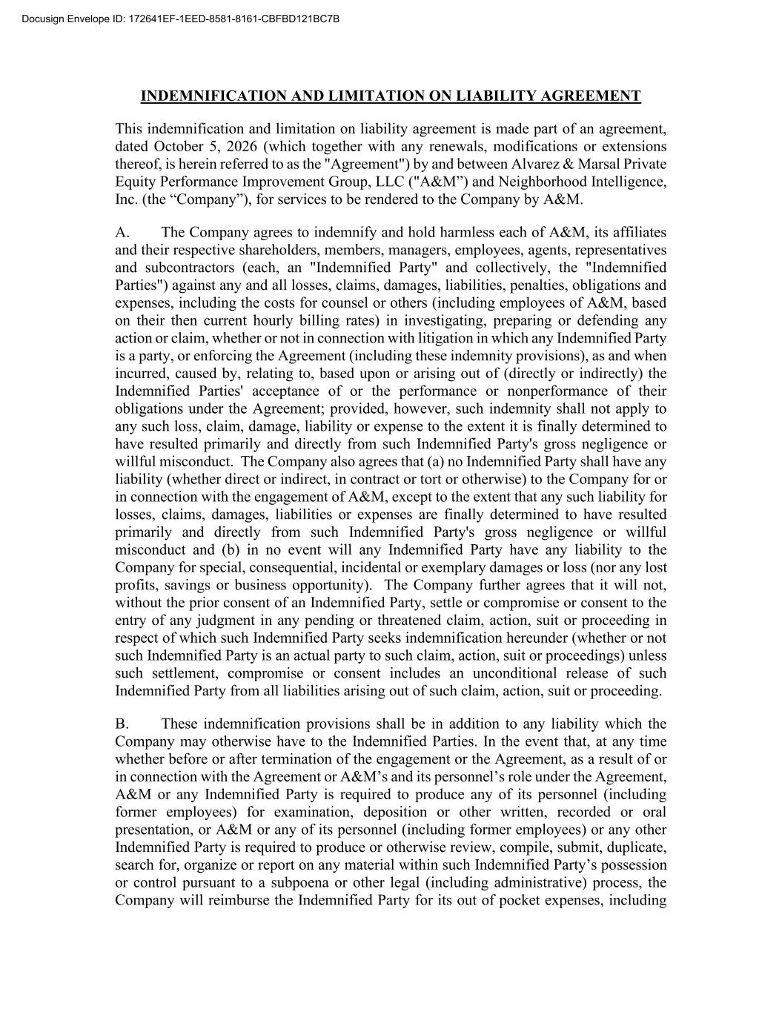
INDEMNIFICATION AND LIMITATION ON LIABILITY AGREEMENT This indemnification and limitation on liability agreement is made part of an agreement, dated October 5, 2026 (which together with any renewals, modifications or extensions thereof, is herein referred to as the "Agreement") by and between Alvarez & Marsal Private Equity Performance Improvement Group, LLC ("A&M”) and Neighborhood Intelligence, Inc. (the “Company”), for services to be rendered to the Company by A&M. A. The Company agrees to indemnify and hold harmless each of A&M, its affiliates and their respective shareholders, members, managers, employees, agents, representatives and subcontractors (each, an "Indemnified Party" and collectively, the "Indemnified Parties") against any and all losses, claims, damages, liabilities, penalties, obligations and expenses, including the costs for counsel or others (including employees of A&M, based on their then current hourly billing rates) in investigating, preparing or defending any action or claim, whether or not in connection with litigation in which any Indemnified Party is a party, or enforcing the Agreement (including these indemnity provisions), as and when incurred, caused by, relating to, based upon or arising out of (directly or indirectly) the Indemnified Parties' acceptance of or the performance or nonperformance of their obligations under the Agreement; provided, however, such indemnity shall not apply to any such loss, claim, damage, liability or expense to the extent it is finally determined to have resulted primarily and directly from such Indemnified Party's gross negligence or willful misconduct. The Company also agrees that (a) no Indemnified Party shall have any liability (whether direct or indirect, in contract or tort or otherwise) to the Company for or in connection with the engagement of A&M, except to the extent that any such liability for losses, claims, damages, liabilities or expenses are finally determined to have resulted primarily and directly from such Indemnified Party's gross negligence or willful misconduct and (b) in no event will any Indemnified Party have any liability to the Company for special, consequential, incidental or exemplary damages or loss (nor any lost profits, savings or business opportunity). The Company further agrees that it will not, without the prior consent of an Indemnified Party, settle or compromise or consent to the entry of any judgment in any pending or threatened claim, action, suit or proceeding in respect of which such Indemnified Party seeks indemnification hereunder (whether or not such Indemnified Party is an actual party to such claim, action, suit or proceedings) unless such settlement, compromise or consent includes an unconditional release of such Indemnified Party from all liabilities arising out of such claim, action, suit or proceeding. B. These indemnification provisions shall be in addition to any liability which the Company may otherwise have to the Indemnified Parties. In the event that, at any time whether before or after termination of the engagement or the Agreement, as a result of or in connection with the Agreement or A&M’s and its personnel’s role under the Agreement, A&M or any Indemnified Party is required to produce any of its personnel (including former employees) for examination, deposition or other written, recorded or oral presentation, or A&M or any of its personnel (including former employees) or any other Indemnified Party is required to produce or otherwise review, compile, submit, duplicate, search for, organize or report on any material within such Indemnified Party’s possession or control pursuant to a subpoena or other legal (including administrative) process, the Company will reimburse the Indemnified Party for its out of pocket expenses, including Docusign Envelope ID: 172641EF-1EED-8581-8161-CBFBD121BC7B

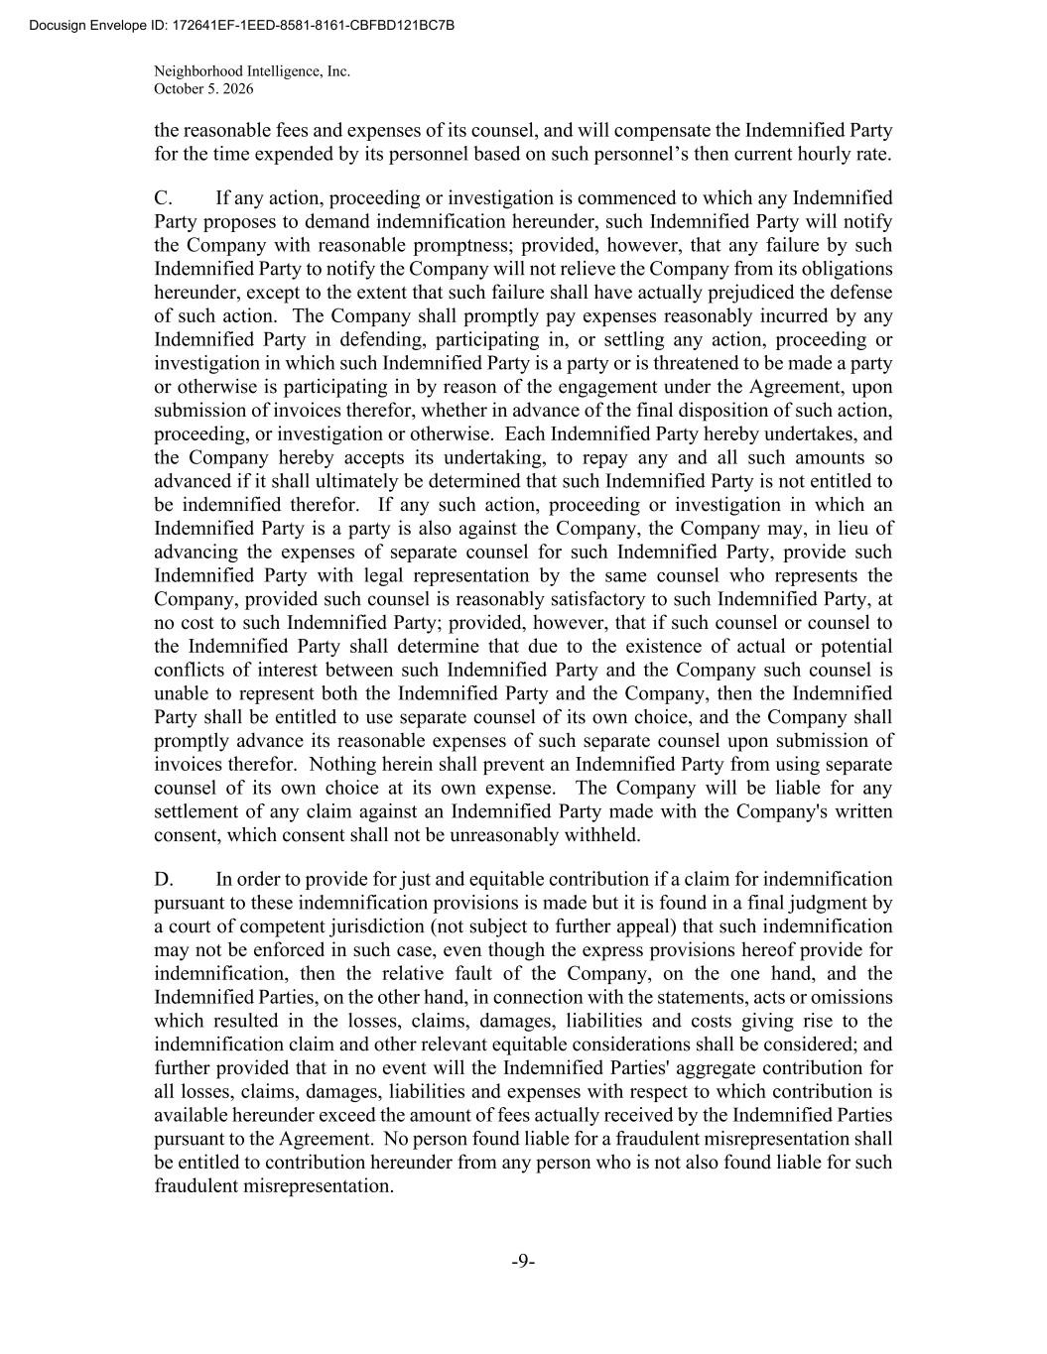
Neighborhood Intelligence, Inc. October 5. 2026 -9- the reasonable fees and expenses of its counsel, and will compensate the Indemnified Party for the time expended by its personnel based on such personnel’s then current hourly rate. C. If any action, proceeding or investigation is commenced to which any Indemnified Party proposes to demand indemnification hereunder, such Indemnified Party will notify the Company with reasonable promptness; provided, however, that any failure by such Indemnified Party to notify the Company will not relieve the Company from its obligations hereunder, except to the extent that such failure shall have actually prejudiced the defense of such action. The Company shall promptly pay expenses reasonably incurred by any Indemnified Party in defending, participating in, or settling any action, proceeding or investigation in which such Indemnified Party is a party or is threatened to be made a party or otherwise is participating in by reason of the engagement under the Agreement, upon submission of invoices therefor, whether in advance of the final disposition of such action, proceeding, or investigation or otherwise. Each Indemnified Party hereby undertakes, and the Company hereby accepts its undertaking, to repay any and all such amounts so advanced if it shall ultimately be determined that such Indemnified Party is not entitled to be indemnified therefor. If any such action, proceeding or investigation in which an Indemnified Party is a party is also against the Company, the Company may, in lieu of advancing the expenses of separate counsel for such Indemnified Party, provide such Indemnified Party with legal representation by the same counsel who represents the Company, provided such counsel is reasonably satisfactory to such Indemnified Party, at no cost to such Indemnified Party; provided, however, that if such counsel or counsel to the Indemnified Party shall determine that due to the existence of actual or potential conflicts of interest between such Indemnified Party and the Company such counsel is unable to represent both the Indemnified Party and the Company, then the Indemnified Party shall be entitled to use separate counsel of its own choice, and the Company shall promptly advance its reasonable expenses of such separate counsel upon submission of invoices therefor. Nothing herein shall prevent an Indemnified Party from using separate counsel of its own choice at its own expense. The Company will be liable for any settlement of any claim against an Indemnified Party made with the Company's written consent, which consent shall not be unreasonably withheld. D. In order to provide for just and equitable contribution if a claim for indemnification pursuant to these indemnification provisions is made but it is found in a final judgment by a court of competent jurisdiction (not subject to further appeal) that such indemnification may not be enforced in such case, even though the express provisions hereof provide for indemnification, then the relative fault of the Company, on the one hand, and the Indemnified Parties, on the other hand, in connection with the statements, acts or omissions which resulted in the losses, claims, damages, liabilities and costs giving rise to the indemnification claim and other relevant equitable considerations shall be considered; and further provided that in no event will the Indemnified Parties' aggregate contribution for all losses, claims, damages, liabilities and expenses with respect to which contribution is available hereunder exceed the amount of fees actually received by the Indemnified Parties pursuant to the Agreement. No person found liable for a fraudulent misrepresentation shall be entitled to contribution hereunder from any person who is not also found liable for such fraudulent misrepresentation. Docusign Envelope ID: 172641EF-1EED-8581-8161-CBFBD121BC7B

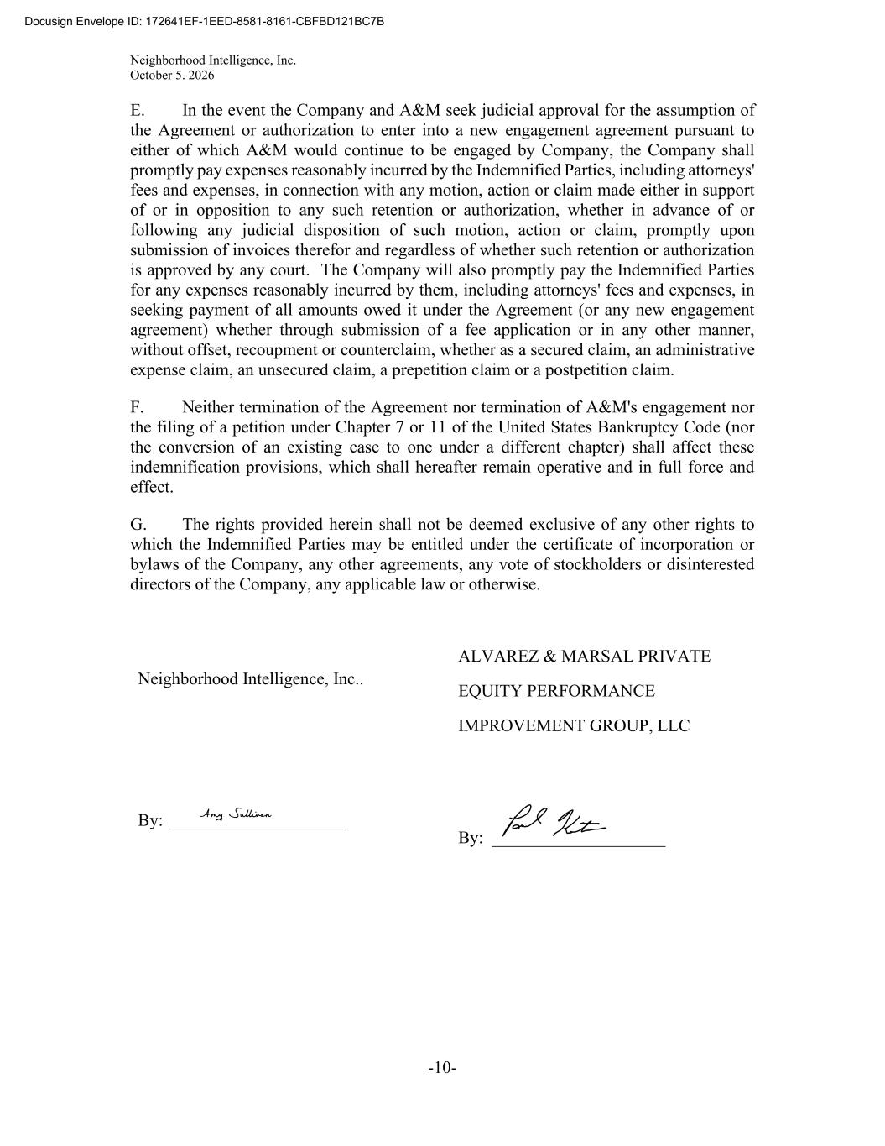
Neighborhood Intelligence, Inc. October 5. 2026 -10- E. In the event the Company and A&M seek judicial approval for the assumption of the Agreement or authorization to enter into a new engagement agreement pursuant to either of which A&M would continue to be engaged by Company, the Company shall promptly pay expenses reasonably incurred by the Indemnified Parties, including attorneys' fees and expenses, in connection with any motion, action or claim made either in support of or in opposition to any such retention or authorization, whether in advance of or following any judicial disposition of such motion, action or claim, promptly upon submission of invoices therefor and regardless of whether such retention or authorization is approved by any court. The Company will also promptly pay the Indemnified Parties for any expenses reasonably incurred by them, including attorneys' fees and expenses, in seeking payment of all amounts owed it under the Agreement (or any new engagement agreement) whether through submission of a fee application or in any other manner, without offset, recoupment or counterclaim, whether as a secured claim, an administrative expense claim, an unsecured claim, a prepetition claim or a postpetition claim. F. Neither termination of the Agreement nor termination of A&M's engagement nor the filing of a petition under Chapter 7 or 11 of the United States Bankruptcy Code (nor the conversion of an existing case to one under a different chapter) shall affect these indemnification provisions, which shall hereafter remain operative and in full force and effect. G. The rights provided herein shall not be deemed exclusive of any other rights to which the Indemnified Parties may be entitled under the certificate of incorporation or bylaws of the Company, any other agreements, any vote of stockholders or disinterested directors of the Company, any applicable law or otherwise. Neighborhood Intelligence, Inc.. By: ____________________ ALVAREZ & MARSAL PRIVATE EQUITY PERFORMANCE IMPROVEMENT GROUP, LLC By: ____________________ Docusign Envelope ID: 172641EF-1EED-8581-8161-CBFBD121BC7B

Exhibit 31.1

CERTIFICATION

I, Marcus A. Lemonis, certify that:

1. I have reviewed this Quarterly Report on Form 10-Q of Neighborhood Intelligence, Inc.;

2. Based on my knowledge, this report does not contain any untrue statement of a material fact or omit to state a material fact necessary to make the statements made, in light of the circumstances under which such statements were made, not misleading with respect to the period covered by this report;

3. Based on my knowledge, the financial statements, and other financial information included in this report, fairly present in all material respects the financial condition, results of operations and cash flows of the registrant as of, and for, the periods presented in this report;

4. The registrant’s other certifying officer(s) and I are responsible for establishing and maintaining disclosure controls and procedures (as defined in Exchange Act Rules 13a-15(e) and 15d-15(e)) and internal control over financial reporting (as defined in Exchange Act Rules 13a-15(f) and 15d-15(f)) for the registrant and have:

a. designed such disclosure controls and procedures, or caused such disclosure controls and procedures to be designed under our supervision, to ensure that material information relating to the registrant, including its consolidated subsidiaries, is made known to us by others within those entities, particularly during the period in which this report is being prepared;

b. designed such internal control over financial reporting, or caused such internal control over financial reporting to be designed under our supervision, to provide reasonable assurance regarding the reliability of financial reporting and the preparation of financial statements for external purposes in accordance with generally accepted accounting principles;

c. evaluated the effectiveness of the registrant’s disclosure controls and procedures and presented in this report our conclusions about the effectiveness of the disclosure controls and procedures, as of the end of the period covered by this report based on such evaluation; and

d. disclosed in this report any change in the registrant’s internal control over financial reporting that occurred during the registrant’s most recent fiscal quarter (the registrant’s fourth fiscal quarter in the case of an annual report) that has materially affected, or is reasonably likely to materially affect, the registrant’s internal control over financial reporting; and

5. The registrant’s other certifying officer(s) and I have disclosed, based on our most recent evaluation of internal control over financial reporting, to the registrant’s auditors and the audit committee of the registrant’s board of directors (or persons performing the equivalent functions):

a. all significant deficiencies and material weaknesses in the design or operation of internal control over financial reporting which are reasonably likely to adversely affect the registrant’s ability to record, process, summarize and report financial information; and

b. any fraud, whether or not material, that involves management or other employees who have a significant role in the registrant’s internal control over financial reporting.

Date: |  |  | November 5, 2026 |  |  | /s/ MARCUS A. LEMONIS
 |  |  |  |  |  | Marcus A. Lemonis
 |  |  |  |  |  | Executive Chairman and Chief Executive Officer
 |  |  |  |  |  | (Principal Executive Officer)

Exhibit 31.2

CERTIFICATION

I, Paul Kosturos, certify that:

1. I have reviewed this Quarterly Report on Form 10-Q of Neighborhood Intelligence, Inc.;

2. Based on my knowledge, this report does not contain any untrue statement of a material fact or omit to state a material fact necessary to make the statements made, in light of the circumstances under which such statements were made, not misleading with respect to the period covered by this report;

3. Based on my knowledge, the financial statements, and other financial information included in this report, fairly present in all material respects the financial condition, results of operations and cash flows of the registrant as of, and for, the periods presented in this report;

4. The registrant’s other certifying officer(s) and I are responsible for establishing and maintaining disclosure controls and procedures (as defined in Exchange Act Rules 13a-15(e) and 15d-15(e)) and internal control over financial reporting (as defined in Exchange Act Rules 13a-15(f) and 15d-15(f)) for the registrant and have:

a. designed such disclosure controls and procedures, or caused such disclosure controls and procedures to be designed under our supervision, to ensure that material information relating to the registrant, including its consolidated subsidiaries, is made known to us by others within those entities, particularly during the period in which this report is being prepared;

b. designed such internal control over financial reporting, or caused such internal control over financial reporting to be designed under our supervision, to provide reasonable assurance regarding the reliability of financial reporting and the preparation of financial statements for external purposes in accordance with generally accepted accounting principles;

c. evaluated the effectiveness of the registrant’s disclosure controls and procedures and presented in this report our conclusions about the effectiveness of the disclosure controls and procedures, as of the end of the period covered by this report based on such evaluation; and

d. disclosed in this report any change in the registrant’s internal control over financial reporting that occurred during the registrant’s most recent fiscal quarter (the registrant’s fourth fiscal quarter in the case of an annual report) that has materially affected, or is reasonably likely to materially affect, the registrant’s internal control over financial reporting; and

5. The registrant’s other certifying officer(s) and I have disclosed, based on our most recent evaluation of internal control over financial reporting, to the registrant’s auditors and the audit committee of the registrant’s board of directors (or persons performing the equivalent functions):

a. all significant deficiencies and material weaknesses in the design or operation of internal control over financial reporting which are reasonably likely to adversely affect the registrant’s ability to record, process, summarize and report financial information; and

b. any fraud, whether or not material, that involves management or other employees who have a significant role in the registrant’s internal control over financial reporting.

Date: |  |  | November 5, 2026 |  |  | /s/ PAUL KOSTUROS
 |  |  |  |  |  | Paul Kosturos
 |  |  |  |  |  | Interim Chief Financial Officer
 |  |  |  |  |  | (Principal Financial Officer)

Exhibit 32.1

CERTIFICATION OF PRINCIPAL EXECUTIVE OFFICER

PURSUANT TO

18 U.S.C. SECTION 1350,

AS ADOPTED PURSUANT TO

SECTION 906 OF THE SARBANES-OXLEY ACT OF 2002

I, Marcus A. Lemonis, certify, pursuant to 18 U.S.C. Section 1350, as adopted pursuant to Section 906 of the Sarbanes-Oxley Act of 2002, as amended, that the Quarterly Report on Form 10-Q of Neighborhood Intelligence, Inc. for the quarter ended September 30, 2026 (the "Report") fully complies with the requirements of Section 13(a) or 15(d) of the Securities Exchange Act of 1934, as amended, and that information contained in such Report fairly presents in all material respects the financial condition and results of operations of Neighborhood Intelligence, Inc.

Date: |  |  | November 5, 2026 |  |  | /s/ MARCUS A. LEMONIS
 |  |  |  |  |  | Marcus A. Lemonis
 |  |  |  |  |  | Executive Chairman and Chief Executive Officer
 |  |  |  |  |  | (Principal Executive Officer)

Exhibit 32.2

CERTIFICATION OF PRINCIPAL FINANCIAL OFFICER

PURSUANT TO

18 U.S.C. SECTION 1350,

AS ADOPTED PURSUANT TO

SECTION 906 OF THE SARBANES-OXLEY ACT OF 2002

I, Paul Kosturos, certify, pursuant to 18 U.S.C. Section 1350, as adopted pursuant to Section 906 of the Sarbanes-Oxley Act of 2002, as amended, that the Quarterly Report on Form 10-Q of Neighborhood Intelligence, Inc. for the quarter ended September 30, 2026 (the "Report") fully complies with the requirements of Section 13(a) or 15(d) of the Securities Exchange Act of 1934, as amended, and that information contained in such Report fairly presents in all material respects the financial condition and results of operations of Neighborhood Intelligence, Inc.

Date: |  |  | November 5, 2026 |  |  | /s/ PAUL KOSTUROS
 |  |  |  |  |  | Paul Kosturos
 |  |  |  |  |  | Interim Chief Financial Officer
 |  |  |  |  |  | (Principal Financial Officer)

