UNITED STATES
SECURITIES AND EXCHANGE COMMISSION
Washington, D.C. 20549

FORM 10-Q
(Mark One)
☒ |  |  | QUARTERLY REPORT PURSUANT TO SECTION 13 OR 15(d) OF THE SECURITIES EXCHANGE ACT OF 1934
For the quarterly period ended June 30, 2026

Or
☐ |  |  | TRANSITION REPORT PURSUANT TO SECTION 13 OR 15(d) OF THE SECURITIES EXCHANGE ACT OF 1934
For the transition period from to
Commission file number: 001-41850

BED BATH & BEYOND, INC.
(Exact name of registrant as specified in its charter)
Delaware |  |  |  |  |  |  |  |  | 87-0634302
(State or other jurisdiction of incorporation or organization) |  |  |  |  |  |  |  |  | (I.R.S. Employer Identification Number)
433 W. Ascension Way, 3rd Floor
Murray, |  |  | Utah |  |  |  |  |  | 84123
(Address of principal executive offices) |  |  |  |  |  |  |  |  | (Zip Code)
(801) 947-3100
(Registrant's telephone number, including area code)

Securities registered pursuant to Section 12(b) of the Act:
Title of each class |  |  |  |  |  | Trading Symbol(s) |  |  |  |  |  | Name of each exchange on which registered
Common Stock, $0.0001 par value |  |  |  |  |  | BBBY |  |  |  |  |  | New York Stock Exchange
Warrants to Purchase Shares of Common Stock |  |  |  |  |  | BBBY WS |  |  |  |  |  | New York Stock Exchange

Indicate by check mark whether the registrant (1) has filed all reports required to be filed by Section 13 or 15(d) of the Securities Exchange Act of 1934 during the preceding 12 months (or for such shorter period that the registrant was required to file such reports), and (2) has been subject to such filing requirements for the past 90 days. Yes ☒ No ☐

Indicate by check mark whether the registrant has submitted electronically every Interactive Data File required to be submitted pursuant to Rule 405 of Regulation S-T (§232.405 of this chapter) during the preceding 12 months (or for such shorter period that the registrant was required to submit such files). Yes ☒ No ☐

Indicate by check mark whether the registrant is a large accelerated filer, an accelerated filer, a non-accelerated filer, a smaller reporting company, or an emerging growth company. See the definitions of "large accelerated filer," "accelerated filer," "smaller reporting company," and "emerging growth company" in Rule 12b-2 of the Exchange Act.
Large accelerated filer |  |  | ☐ |  |  | Accelerated filer |  |  | ☒
Non-accelerated filer |  |  | ☐ |  |  | Smaller reporting company |  |  | ☐
 |  |  |  |  |  | Emerging growth company |  |  | ☐

If an emerging growth company, indicate by check mark if the registrant has elected not to use the extended transition period for complying with any new or revised financial accounting standards provided pursuant to Section 13(a) of the Exchange Act. ☐

Indicate by check mark whether the registrant is a shell company (as defined in Rule 12b-2 of the Exchange Act). Yes ☐ No ☒

95,330,379 shares of the registrant's common stock, par value $0.0001, were outstanding on July 31, 2026.

Table of Contents

BED BATH & BEYOND, INC.
TABLE OF CONTENTS TO QUARTERLY REPORT ON FORM 10-Q
For the Quarterly Period Ended June 30, 2026

 |  |  |  |  |  | Page
PART I. FINANCIAL INFORMATION
Item 1. |  |  | Financial Statements (Unaudited) |  |  | 5
 |  |  | Consolidated Balance Sheets |  |  | 5
 |  |  | Consolidated Statements of Operations |  |  | 7
 |  |  | Consolidated Statements of Changes in Stockholders' Equity |  |  | 8
 |  |  | Consolidated Statements of Cash Flows |  |  | 10
 |  |  | Notes to Unaudited Consolidated Financial Statements |  |  | 12
Item 2. |  |  | Management's Discussion and Analysis of Financial Condition and Results of Operations |  |  | 33
Item 3. |  |  | Quantitative and Qualitative Disclosures About Market Risk |  |  | 46
Item 4. |  |  | Controls and Procedures |  |  | 47
PART II. OTHER INFORMATION
Item 1. |  |  | Legal Proceedings |  |  | 48
Item 1A. |  |  | Risk Factors |  |  | 48
Item 2. |  |  | Unregistered Sales of Equity Securities and Use of Proceeds |  |  | 56
Item 3. |  |  | Defaults Upon Senior Securities |  |  | 56
Item 4. |  |  | Mine Safety Disclosures |  |  | 56
Item 5. |  |  | Other Information |  |  | 56
Item 6. |  |  | Exhibits |  |  | 57
Signatures |  |  |  |  |  | 59

2

Table of Contents

SPECIAL CAUTIONARY NOTE REGARDING FORWARD-LOOKING STATEMENTS
This Quarterly Report on Form 10-Q and the information incorporated herein by reference, and our other public documents and statements our officers and representatives may make from time to time, contain forward-looking statements within the meaning of the federal securities laws. These statements are intended to be covered by the safe harbor provisions of these laws. You can find many of these statements by looking for words such as "may," "would," "could," "should," "will," "expect," "anticipate," "predict," "project," "potential," "continue," "contemplate," "seek," "assume," "believe," "intend," "plan," "forecast," "goal," "estimate," or other similar terms or expressions or the negative of these terms or expressions, although not all forward-looking statements contain these identifying terms or expressions.

These forward-looking statements involve known and unknown risks and uncertainties and relate to future events or our future financial or operating performance. These forward-looking statements are not historical facts, and are based on current expectations, estimates and projections about our industry and business, and on management's beliefs and certain assumptions made by management, many of which, by their nature, are inherently uncertain and beyond our control. Accordingly, you are cautioned that any such forward-looking statements are not guarantees of future performance and are subject to assumptions, risks, uncertainties, and other important factors that are difficult to predict, and that actual results and outcomes may be materially different from the results, performance, achievements, or outcomes expressed or implied by any of our forward-looking statements for a variety of reasons, including among others:

•We depend on third-party companies to perform functions critical to our business, and any failure or increased cost on their part could have a material adverse effect on our business.
•We face intense competition and may not be able to compete successfully against existing or future competitors.
•We may not timely identify or effectively respond to consumer needs, expectations or trends, which could adversely affect our relationship with our customers, the demand for our products and services, and our market share.
•Our business depends on effective marketing, including marketing via email, search engine marketing, influencer marketing, and social media marketing. Our competitors have and may continue to cause us to increase our marketing costs and decrease certain other types of marketing, and have and may continue to outspend us on marketing or be more efficient in their spend.
•Economic factors, including recessions, other economic downturns, inflation, our exposure to the U.S. housing market, and decreases in consumer spending, have affected and could continue to adversely affect us.
•Tariffs, bans, or other measures or events that increase the effective price of products or limit our ability to access products we or our suppliers, fulfillment partners, or other third parties that import or export could have a material adverse effect on our business.
•Our changing business model and use of the Bed Bath & Beyond brand, Overstock brand, buybuy BABY brand, Kirkland's and Kirkland's Home brand, Beyond brand, and other brands of ours, could negatively impact our business.
•The changing job market, the changes in our leadership team, the change in our compensation approach, changing job structures, or any inability to attract, retain and engage key personnel could affect our ability to successfully grow our business.
•We rely upon paid and natural search engines to rank our product offerings, and our financial results may suffer if we are unable to maintain our prior rankings in natural searches.
•If we are not profitable and/or are unable to generate sufficient positive cash flow from operations, our ability to continue in business will depend on our ability to raise additional capital, obtain financing or monetize significant assets, and we may be unable to do so.
•Our business depends on the Internet, our infrastructure and transaction-processing systems, and catastrophic events could adversely affect our operating results.
•Compliance with ever-evolving federal, state, and foreign laws and other requirements relating to the handling of information about individuals necessitates significant expenditure and resources, and any failure by us, our vendors or our business partners to comply may result in significant liability, negative publicity, and/or an erosion of trust, which could materially adversely affect our business, results of operations, and financial condition.
•If we or our third-party providers experience cyberattacks or data security incidents, there may be damage to our brand and reputation, material financial penalties, and legal liability, which would materially adversely affect our business, results of operations, and financial condition.
•Failure to comply with, or changes in, laws, regulations and enforcement activities may adversely affect the products, services, and markets in which we operate.
•From time to time, we are subject to various legal proceedings which could adversely affect our business, financial condition or results of operations.
3

Table of Contents

•Damage to our reputation or brand image could adversely affect our sales and results of operations.
•If we do not successfully optimize and operate our fulfillment center or customer service operations, our business could be harmed.
•If we fail to effectively utilize technological advancements, including in artificial intelligence, our business and financial performance could be negatively impacted.
•Global conflict could negatively impact our business, results of operations, and financial condition.
•Product safety and quality concerns could have a material adverse impact on our revenue and profitability.
•We depend on our suppliers' and fulfillment partners' representations regarding product safety, content and quality, product compliance with various laws and regulations, including registration and/or reporting obligations, and for proper labeling of products.
•We have an evolving business model, which increases the complexity of our business.
•Exercising the Warrants is a risky investment and those who exercise their Warrants may not be able to recover the value of their investment in the common stock received upon such exercise. Warrant holders could sustain a total loss of the exercise price of any Warrants that they exercise.
•Investment in new business strategies, acquisitions, dispositions, partnerships, or other transactions could disrupt our ongoing business, present risks not originally contemplated and materially adversely affect our business, reputation, results of operations and financial condition.
•Regulatory changes or actions may alter the nature of an investment in us or restrict the use of digital assets, including tokens or blockchain technology in a manner that adversely affects our business, prospects, and operations.
•The mergers with Fathom Holdings, Inc. ("Fathom") and F9 Brands, Inc. ("F9") may not be completed and the Fathom Merger Agreement or the F9 Merger Agreement (each as defined herein) may be terminated in accordance with their terms.
•Combining our business with those of The Brand House Collective, Inc. ("TBHC") and The Container Store Holdings, LLC (“TCS”) may be more difficult, costly or time-consuming than expected and the combined company may fail to realize the anticipated benefits of the mergers with TBHC and TCS, which may adversely affect the combined company's business results and negatively affect the value of the combined company's common stock.

In evaluating all forward-looking statements, you should specifically consider the risks outlined above and in this report and our Annual Report on Form 10-K for the year ended December 31, 2025, and our Quarterly Report on Form 10-Q for the quarterly period ended March 31, 2026 under the headings, as applicable, "Special Cautionary Note Regarding Forward-Looking Statements," "Summary of Risk Factors," "Risk Factors," "Legal Proceedings," and "Management's Discussion and Analysis of Financial Condition and Results of Operations." These factors may cause our actual results and outcomes to differ materially from those contemplated by any forward-looking statement. Although we believe that our expectations reflected in the forward-looking statements are reasonable, we cannot guarantee or offer any assurance of future results, levels of activity, performance or achievements or other future events. Our forward-looking statements contained in this report speak only as of the date of this report and, except as required by law, we undertake no obligation to update forward-looking statements to reflect events or circumstances occurring after the date of this report or any changes in our expectations or any change in any events, conditions or circumstances on which any of our forward-looking statements are based.

4

Table of Contents

PART I. FINANCIAL INFORMATION

ITEM 1. FINANCIAL STATEMENTS (UNAUDITED)

Bed Bath & Beyond, Inc.
Consolidated Balance Sheets (Unaudited)
(in thousands, except per share data)
 |  |  | June 30,  2026 |  |  |  |  |  | December 31,  2025
Assets
Current assets:
Cash and cash equivalents |  |  | $ | 99,485 |  |  |  |  | $ | 175,295
Restricted cash |  |  | 26,891 |  |  |  |  |  | 26,924
Accounts receivable, net of allowance for credit losses of $2,716 and $3,377 |  |  | 29,797 |  |  |  |  |  | 20,829
Inventories |  |  | 52,157 |  |  |  |  |  | 5,162
Prepaids and other current assets |  |  | 29,037 |  |  |  |  |  | 11,905
Total current assets |  |  | 237,367 |  |  |  |  |  | 240,115
Property and equipment, net |  |  | 42,876 |  |  |  |  |  | 13,712
Intangible assets, net |  |  | 46,419 |  |  |  |  |  | 45,140
Goodwill |  |  | 101,946 |  |  |  |  |  | 6,160
Equity securities, including securities measured at fair value of $17,075 and $26,903 |  |  | 55,928 |  |  |  |  |  | 66,641
Operating lease right-of-use assets |  |  | 115,796 |  |  |  |  |  | 5,156
Other long-term assets, net, including securities measured at fair value of $26,033 and $42,394 |  |  | 33,819 |  |  |  |  |  | 48,554
Total assets |  |  | $ | 634,151 |  |  |  |  | $ | 425,478
Liabilities and Stockholders' Equity
Current liabilities:
Accounts payable |  |  | $ | 140,533 |  |  |  |  | $ | 89,992
Accrued liabilities |  |  | 68,251 |  |  |  |  |  | 51,297
Unearned revenue |  |  | 46,818 |  |  |  |  |  | 34,429
Operating lease liabilities, current |  |  | 33,565 |  |  |  |  |  | 928
Short-term debt, net |  |  | 23,000 |  |  |  |  |  | 15,500
Total current liabilities |  |  | 312,167 |  |  |  |  |  | 192,146
Long-term debt, net |  |  | 13,455 |  |  |  |  |  | —
Operating lease liabilities, non-current |  |  | 83,068 |  |  |  |  |  | 5,643
Other long-term liabilities, including commitments measured at fair value of $0 and $2,766 |  |  | 10,373 |  |  |  |  |  | 9,745
Total liabilities |  |  | $ | 419,063 |  |  |  |  | $ | 207,534
Commitments and contingencies (Note 10)
Continued on the following page

See accompanying notes to unaudited consolidated financial statements.
5

Table of Contents

Bed Bath & Beyond, Inc.
Consolidated Balance Sheets (Unaudited)
(in thousands, except per share data)
(Continued) |  |  | June 30,  2026 |  |  |  |  |  | December 31,  2025
Stockholders' equity:
Preferred stock, $0.0001 par value, authorized shares - 5,000, issued and outstanding - none |  |  | $ | — |  |  |  |  | $ | —
Common stock, $0.0001 par value, authorized shares - 200,000
Issued shares - 89,604 and 76,358
Outstanding shares - 81,760 and 68,863 |  |  | 9 |  |  |  |  |  | 8
Additional paid-in capital |  |  | 1,294,141 |  |  |  |  |  | 1,239,338
Accumulated deficit |  |  | (898,606) |  |  |  |  |  | (842,711)
Accumulated other comprehensive loss |  |  | (2,574) |  |  |  |  |  | (2,574)
Treasury stock at cost - 7,844 and 7,495 |  |  | (178,206) |  |  |  |  |  | (176,478)
Equity attributable to stockholders of Bed Bath & Beyond, Inc. |  |  | 214,764 |  |  |  |  |  | 217,583
Equity attributable to noncontrolling interests |  |  | 324 |  |  |  |  |  | 361
Total stockholders' equity |  |  | 215,088 |  |  |  |  |  | 217,944
Total liabilities and stockholders' equity |  |  | $ | 634,151 |  |  |  |  | $ | 425,478

See accompanying notes to unaudited consolidated financial statements.

6

Table of Contents

Bed Bath & Beyond, Inc.
Consolidated Statements of Operations (Unaudited)
(in thousands, except per share data)

 |  |  | Three months ended  June 30, |  |  |  |  |  |  |  |  |  |  |  | Six months ended  June 30,
 |  |  | 2026 |  |  |  |  |  | 2025 |  |  |  |  |  | 2026 |  |  |  |  |  | 2025
Net revenue |  |  | $ | 361,159 |  |  |  |  | $ | 282,251 |  |  |  |  | $ | 608,914 |  |  |  |  | $ | 513,999
Cost of goods sold |  |  | 264,478 |  |  |  |  |  | 215,282 |  |  |  |  |  | 453,035 |  |  |  |  |  | 388,898
Gross profit |  |  | 96,681 |  |  |  |  |  | 66,969 |  |  |  |  |  | 155,879 |  |  |  |  |  | 125,101
Operating expenses
Sales and marketing |  |  | 43,108 |  |  |  |  |  | 38,209 |  |  |  |  |  | 75,418 |  |  |  |  |  | 69,499
Technology |  |  | 24,334 |  |  |  |  |  | 23,221 |  |  |  |  |  | 45,548 |  |  |  |  |  | 49,939
General and administrative |  |  | 57,527 |  |  |  |  |  | 14,088 |  |  |  |  |  | 72,390 |  |  |  |  |  | 28,402
Customer service and merchant fees |  |  | 11,579 |  |  |  |  |  | 9,331 |  |  |  |  |  | 20,597 |  |  |  |  |  | 18,688
Other operating expense (income), net |  |  | 3,016 |  |  |  |  |  | (5,454) |  |  |  |  |  | 3,016 |  |  |  |  |  | (5,790)
Total operating expenses |  |  | 139,564 |  |  |  |  |  | 79,395 |  |  |  |  |  | 216,969 |  |  |  |  |  | 160,738
Operating loss |  |  | (42,883) |  |  |  |  |  | (12,426) |  |  |  |  |  | (61,090) |  |  |  |  |  | (35,637)
Interest income, net |  |  | 750 |  |  |  |  |  | 889 |  |  |  |  |  | 2,479 |  |  |  |  |  | 1,651
Other income (expense), net |  |  | 120 |  |  |  |  |  | (7,489) |  |  |  |  |  | 449 |  |  |  |  |  | (24,758)
Loss before income taxes |  |  | (42,013) |  |  |  |  |  | (19,026) |  |  |  |  |  | (58,162) |  |  |  |  |  | (58,744)
Provision (benefit) for income taxes |  |  | (2,516) |  |  |  |  |  | 287 |  |  |  |  |  | (2,267) |  |  |  |  |  | 481
Net loss |  |  | $ | (39,497) |  |  |  |  | $ | (19,313) |  |  |  |  | $ | (55,895) |  |  |  |  | $ | (59,225)
Net loss per share of common stock:
Basic |  |  | $ | (0.53) |  |  |  |  | $ | (0.34) |  |  |  |  | $ | (0.78) |  |  |  |  | $ | (1.07)
Diluted |  |  | $ | (0.53) |  |  |  |  | $ | (0.34) |  |  |  |  | $ | (0.78) |  |  |  |  | $ | (1.07)
Weighted average shares of common stock outstanding:
Basic |  |  | 74,308 |  |  |  |  |  | 57,503 |  |  |  |  |  | 71,693 |  |  |  |  |  | 55,593
Diluted |  |  | 74,308 |  |  |  |  |  | 57,503 |  |  |  |  |  | 71,693 |  |  |  |  |  | 55,593

See accompanying notes to unaudited consolidated financial statements.

7

Table of Contents

Bed Bath & Beyond, Inc.
Consolidated Statements of Changes in Stockholders' Equity (Unaudited)
(in thousands)

 |  |  | Three months ended  June 30, |  |  |  |  |  |  |  |  |  |  |  | Six months ended  June 30,
 |  |  | 2026 |  |  |  |  |  | 2025 |  |  |  |  |  | 2026 |  |  |  |  |  | 2025
Equity attributable to stockholders of Bed Bath & Beyond, Inc.
Shares of common stock issued
Balance at beginning of period |  |  | 77,045 |  |  |  |  |  | 63,413 |  |  |  |  |  | 76,358 |  |  |  |  |  | 59,560
Common stock issued upon vesting of restricted stock |  |  | 625 |  |  |  |  |  | 64 |  |  |  |  |  | 1,245 |  |  |  |  |  | 339
Common stock issued for ESPP purchases |  |  | — |  |  |  |  |  | — |  |  |  |  |  | 67 |  |  |  |  |  | 91
Common shares issued in the acquisition of TBHC |  |  | 4,734 |  |  |  |  |  | — |  |  |  |  |  | 4,734 |  |  |  |  |  | —
Common shares issued in the acquisition of SFV Services |  |  | 7,200 |  |  |  |  |  | — |  |  |  |  |  | 7,200 |  |  |  |  |  | —
Common stock sold through offerings |  |  | — |  |  |  |  |  | 845 |  |  |  |  |  | — |  |  |  |  |  | 4,332
Balance at end of period |  |  | 89,604 |  |  |  |  |  | 64,322 |  |  |  |  |  | 89,604 |  |  |  |  |  | 64,322
Shares of treasury stock
Balance at beginning of period |  |  | 7,689 |  |  |  |  |  | 6,581 |  |  |  |  |  | 7,495 |  |  |  |  |  | 6,491
Repurchases of common stock |  |  | — |  |  |  |  |  | 333 |  |  |  |  |  | — |  |  |  |  |  | 333
Tax withholding upon vesting of employee stock awards |  |  | 155 |  |  |  |  |  | 3 |  |  |  |  |  | 349 |  |  |  |  |  | 93
Balance at end of period |  |  | 7,844 |  |  |  |  |  | 6,917 |  |  |  |  |  | 7,844 |  |  |  |  |  | 6,917
Total shares of common stock outstanding |  |  | 81,760 |  |  |  |  |  | 57,405 |  |  |  |  |  | 81,760 |  |  |  |  |  | 57,405
Common stock
Balance at beginning of period |  |  | $ | 8 |  |  |  |  | $ | 6 |  |  |  |  | $ | 8 |  |  |  |  | $ | 5
Common shares issued in the acquisition of TBHC |  |  | — |  |  |  |  |  | — |  |  |  |  |  | — |  |  |  |  |  | —
Common shares issued in the acquisition of SFV Services |  |  | 1 |  |  |  |  |  | — |  |  |  |  |  | 1 |  |  |  |  |  | 1
Balance at end of period |  |  | $ | 9 |  |  |  |  | $ | 6 |  |  |  |  | $ | 9 |  |  |  |  | $ | 6
Additional paid-in capital
Balance at beginning of period |  |  | $ | 1,241,225 |  |  |  |  | $ | 1,093,943 |  |  |  |  | $ | 1,239,338 |  |  |  |  | $ | 1,072,869
Stock-based compensation to employees and directors |  |  | 2,075 |  |  |  |  |  | 3,386 |  |  |  |  |  | 3,608 |  |  |  |  |  | 4,480
Common stock issued for ESPP purchases |  |  | — |  |  |  |  |  | — |  |  |  |  |  | 354 |  |  |  |  |  | 509
Common stock sold through offerings, net |  |  | — |  |  |  |  |  | 4,750 |  |  |  |  |  | — |  |  |  |  |  | 24,221
Common shares issued in the acquisition of TBHC |  |  | 13,761 |  |  |  |  |  | — |  |  |  |  |  | 13,761 |  |  |  |  |  | —
Common shares issued in the acquisition of SFV Services |  |  | 37,080 |  |  |  |  |  | — |  |  |  |  |  | 37,080 |  |  |  |  |  | —
Balance at end of period |  |  | $ | 1,294,141 |  |  |  |  | $ | 1,102,079 |  |  |  |  | $ | 1,294,141 |  |  |  |  | $ | 1,102,079
Accumulated deficit
Balance at beginning of period |  |  | $ | (859,109) |  |  |  |  | $ | (780,378) |  |  |  |  | $ | (842,711) |  |  |  |  | $ | (740,466)
Net loss |  |  | (39,497) |  |  |  |  |  | (19,313) |  |  |  |  |  | (55,895) |  |  |  |  |  | (59,225)
Balance at end of period |  |  | $ | (898,606) |  |  |  |  | $ | (799,691) |  |  |  |  | $ | (898,606) |  |  |  |  | $ | (799,691)
Continued on the following page

See accompanying notes to unaudited consolidated financial statements.
8

Table of Contents

Bed Bath & Beyond, Inc.
Consolidated Statements of Changes in Stockholders' Equity (Unaudited)
(in thousands)

 |  |  | Three months ended  June 30, |  |  |  |  |  |  |  |  |  |  |  | Six months ended  June 30,
(Continued) |  |  | 2026 |  |  |  |  |  | 2025 |  |  |  |  |  | 2026 |  |  |  |  |  | 2025
Accumulated other comprehensive loss
Balance at beginning and end of period |  |  | $ | (2,574) |  |  |  |  | $ | — |  |  |  |  | $ | (2,574) |  |  |  |  | $ | —
Treasury stock
Balance at beginning of period |  |  | $ | (177,458) |  |  |  |  | $ | (170,203) |  |  |  |  | $ | (176,478) |  |  |  |  | $ | (169,676)
Repurchases of common stock |  |  | — |  |  |  |  |  | (1,311) |  |  |  |  |  | — |  |  |  |  |  | (1,311)
Tax withholding upon vesting of employee stock awards |  |  | (748) |  |  |  |  |  | (12) |  |  |  |  |  | (1,728) |  |  |  |  |  | (539)
Balance at end of period |  |  | $ | (178,206) |  |  |  |  | $ | (171,526) |  |  |  |  | $ | (178,206) |  |  |  |  | $ | (171,526)
Total equity attributable to stockholders of Bed Bath & Beyond, Inc. |  |  | $ | 214,764 |  |  |  |  | $ | 130,868 |  |  |  |  | $ | 214,764 |  |  |  |  | $ | 130,868
Equity attributable to noncontrolling interests
Balance at beginning of period |  |  | $ | 361 |  |  |  |  | $ | — |  |  |  |  | $ | 361 |  |  |  |  | $ | —
Proceeds from security token offering, net |  |  | — |  |  |  |  |  | 337 |  |  |  |  |  | — |  |  |  |  |  | 337
Dividends from token offering |  |  | (37) |  |  |  |  |  | — |  |  |  |  |  | (37) |  |  |  |  |  | —
Net loss attributable to noncontrolling interests |  |  | — |  |  |  |  |  | — |  |  |  |  |  | — |  |  |  |  |  | —
Total equity attributable to noncontrolling interests |  |  | $ | 324 |  |  |  |  | $ | 337 |  |  |  |  | $ | 324 |  |  |  |  | $ | 337
Total stockholders' equity |  |  | $ | 215,088 |  |  |  |  | $ | 131,205 |  |  |  |  | $ | 215,088 |  |  |  |  | $ | 131,205

See accompanying notes to unaudited consolidated financial statements.

9

Table of Contents

Bed Bath & Beyond, Inc.
Consolidated Statements of Cash Flows (Unaudited)
(in thousands)
Six months ended
June 30,
 |  |  |  | 2026 |  |  |  |  |  | 2025
Cash flows from operating activities:
Net loss |  |  |  | $ | (55,895) |  |  |  |  | $ | (59,225)
Adjustments to reconcile net loss to net cash used in operating activities:
Depreciation and amortization |  |  |  | 11,159 |  |  |  |  |  | 8,924
Stock-based compensation to employees and directors |  |  |  | 3,608 |  |  |  |  |  | 4,480
Gain on sale of intangible assets |  |  |  | — |  |  |  |  |  | (5,790)
Impairment of long-lived assets (including leases) |  |  |  | 5,247 |  |  |  |  |  | —
Gain on disposal of property and equipment |  |  |  | (22) |  |  |  |  |  | —
Loss from equity method securities |  |  |  | 2,405 |  |  |  |  |  | 23,649
Other non-cash adjustments |  |  |  | (4,651) |  |  |  |  |  | 1,545
Changes in operating assets and liabilities, net of acquisitions:
Accounts receivable, net |  |  |  | (7,133) |  |  |  |  |  | (2,500)
Inventories |  |  |  | 8,842 |  |  |  |  |  | 3,136
Prepaids and other current assets |  |  |  | (12,945) |  |  |  |  |  | (1,748)
Other long-term assets, net |  |  |  | 359 |  |  |  |  |  | (554)
Accounts payable |  |  |  | 1,761 |  |  |  |  |  | 29,368
Accrued liabilities |  |  |  | 709 |  |  |  |  |  | (28,477)
Unearned revenue |  |  |  | 1,521 |  |  |  |  |  | (5,433)
Operating lease assets and liabilities |  |  |  | (2,656) |  |  |  |  |  | 208
Other long-term liabilities |  |  |  | (2,349) |  |  |  |  |  | (2,675)
Net cash used in operating activities |  |  |  | (50,040) |  |  |  |  |  | (35,092)
Cash flows from investing activities:
Expenditures for property and equipment |  |  |  | (4,649) |  |  |  |  |  | (2,994)
Purchase of intangible assets |  |  |  | (1,600) |  |  |  |  |  | (5,214)
Acquisitions of businesses, net of cash acquired |  |  |  | (6,010) |  |  |  |  |  | —
Purchase of equity securities |  |  |  | — |  |  |  |  |  | (8,000)
Proceeds from the sale of intangible assets |  |  |  | — |  |  |  |  |  | 1,250
Proceeds from sale of property and equipment |  |  |  | 31 |  |  |  |  |  | —
Disbursement of notes receivable |  |  |  | (27,168) |  |  |  |  |  | (5,232)
Dividends from token offering |  |  |  | (37)
Other investing activities, net |  |  |  | — |  |  |  |  |  | 2
Net cash used in investing activities |  |  |  | (39,433) |  |  |  |  |  | (20,188)
Continued on the following page

See accompanying notes to unaudited consolidated financial statements.
10

Table of Contents

Bed Bath & Beyond, Inc.
Consolidated Statements of Cash Flows (Unaudited)
(in thousands)
Six months ended
June 30,
(Continued) |  |  |  | 2026 |  |  |  |  |  | 2025
Cash flows from financing activities:
Proceeds from sale of common stock, net of offering costs |  |  |  | $ | — |  |  |  |  | $ | 24,222
Payments on short-term debt |  |  |  | — |  |  |  |  |  | (6,500)
Proceeds from short-term debt |  |  |  | 7,500 |  |  |  |  |  | —
Repayments on revolving line of credit |  |  |  | (18,070) |  |  |  |  |  | —
Proceeds from revolving line of credit |  |  |  | 25,924 |  |  |  |  |  | —
Repurchase of shares |  |  |  | — |  |  |  |  |  | (1,311)
Payments of taxes withheld upon vesting of employee stock awards |  |  |  | (1,728) |  |  |  |  |  | (539)
Proceeds from employee stock purchase plan |  |  |  | 354 |  |  |  |  |  | —
Other financing activities, net |  |  |  | (350) |  |  |  |  |  | 846
Net cash provided by financing activities |  |  |  | 13,630 |  |  |  |  |  | 16,718
Net decrease in cash, cash equivalents, and restricted cash |  |  |  | (75,843) |  |  |  |  |  | (38,562)
Cash, cash equivalents, and restricted cash, beginning of period |  |  |  | 202,219 |  |  |  |  |  | 186,093
Cash, cash equivalents, and restricted cash, end of period |  |  |  | $ | 126,376 |  |  |  |  | $ | 147,531
Supplemental disclosures of cash flow information:
Non-cash investing and financing activities:
Non-cash acquisition of TBHC and SFV Services |  |  |  | $ | 94,979 |  |  |  |  | $ | —

See accompanying notes to unaudited consolidated financial statements.

11

Table of Contents

Bed Bath & Beyond, Inc.
Notes to Unaudited Consolidated Financial Statements

1. DESCRIPTION OF BUSINESS

Bed Bath & Beyond, Inc. is an omni-channel-focused retailer with an affinity model that owns or has ownership interests in various brands, offering a comprehensive array of products and services that enable its customers to enhance everyday life through quality, style, and value. The Company currently owns Bed Bath & Beyond, Overstock, buybuy BABY, the Kirkland's and Kirkland's Home brands, SFV Services, and now The Container Store (refer to Note 17—Subsequent Events), as well as other related brands and websites and a blockchain asset portfolio inclusive of tZERO, GrainChain, and other assets.

As used herein, "Bed Bath & Beyond," "the Company," "we," "our" and similar terms include Bed Bath & Beyond, Inc. and its controlled subsidiaries, unless the context indicates otherwise.

2. SUMMARY OF SIGNIFICANT ACCOUNTING POLICIES

Basis of presentation

The Company has prepared the accompanying unaudited consolidated financial statements pursuant to the rules and regulations of the Securities and Exchange Commission ("SEC") regarding interim financial reporting. Accordingly, certain information and footnote disclosures normally included in financial statements prepared in accordance with accounting principles generally accepted in the United States ("GAAP") have been omitted in accordance with the rules and regulations of the SEC. These financial statements should be read in conjunction with the audited annual consolidated financial statements and related notes included in the Company's Annual Report on Form 10-K for the year ended December 31, 2025. There have been no significant changes to the Company's significant accounting policies disclosed in Note 2—Accounting Policies and Supplemental Disclosures, included in Part II, Item 8, Financial Statements and Supplementary Data, of the Company's Annual Report on Form 10-K for the year ended December 31, 2025, except as disclosed below.

The accompanying unaudited consolidated financial statements include the Company's accounts and the accounts of the Company's wholly-owned subsidiaries and other subsidiaries for which the Company exercises control, and reflect all adjustments, consisting only of normal recurring adjustments, which are, in the Company's opinion, necessary for a fair presentation of results for the interim periods presented. All intercompany account balances and transactions have been eliminated in consolidation. The results of operations for the three and six months ended June 30, 2026, are not necessarily indicative of the results to be expected for any future period or the full fiscal year, due to seasonality and other factors.

Prior to April 2, 2026, The Brand House Collective, Inc. (formerly known as Kirkland’s Inc.) (“The Brand House Collective”) was not a consolidated subsidiary of the Company. Accordingly, transactions between the Company and The Brand House Collective prior to the acquisition date, including amounts advanced under the Amended Credit Agreement (as discussed further in this Note 2—Summary of Significant Accounting Policies) and related amendments, were accounted for as transactions with a non-consolidated entity and are reflected in the Company’s consolidated financial statements through the acquisition date in accordance with their nature.
As discussed further in Note 3—Business Combinations, on April 2, 2026 (the "Acquisition Date"), the Company completed its acquisition of The Brand House Collective. Beginning on the acquisition date, the results of operations, assets and liabilities of The Brand House Collective are included in the Company’s consolidated financial statements. Accordingly, balances and transactions between the Company and The Brand House Collective occurring after the acquisition date are eliminated in consolidation.

12

Table of Contents

Use of estimates

The preparation of financial statements in conformity with GAAP requires estimates and assumptions that affect the reported amounts of assets and liabilities, revenues and expenses, and related disclosures of contingent liabilities in the Company's consolidated financial statements and accompanying notes. Estimates are used for, but not limited to, receivables valuation, revenue recognition, loyalty program reward point and gift card breakage, sales returns, inventory valuation, asset useful lives, equity and debt securities valuation, income taxes, stock-based compensation, performance-based compensation, self-funded health insurance liabilities, contingencies, goodwill, and the fair value of assets acquired and liabilities assumed in acquisitions. Although these estimates are based on the Company's best knowledge of current events and actions that the Company may undertake in the future, the accounting of these estimates may change from period to period. To the extent there are differences between these estimates and actual results, the Company's consolidated financial statements may be materially affected.

Debt securities carried at fair value

On May 7, 2025, the Company entered into an Amended and Restated Term Loan Credit Agreement (the "Amended and Restated Credit Agreement"), which amended and restated the secured Term Loan Credit Agreement ("Existing Credit Agreement") entered on October 21, 2024 and pursuant to which the Company provided The Brand House Collective, Inc. (formerly known as Kirkland's Inc.) ("The Brand House Collective") with an additional term loan in an approximate aggregate original principal amount of $5.2 million (the "Additional Term Loan") and obligations arising under the Existing Credit Agreement in the aggregate amount of $8.5 million were rolled into the Amended and Restated Credit Agreement as obligations thereunder (collectively, the "Notes"). On September 15 and November 24, 2025, the Company entered into subsequent amendments to the Amended Credit Agreement (the "Delayed Draw Term Loan Commitments") that increased the Delayed Draw Term Loan Commitments to an aggregate principal amount of $30.0 million. Prior to the acquisition of The Brand House Collective, the Company had $30.0 million outstanding under the Delayed Draw Term Loan Commitments. Upon completion of the acquisition, the outstanding balance was included as a component of the purchase consideration transferred in the business combination. Refer to Note 3—Business Combinations for additional information regarding the acquisition of The Brand House Collective.

Business Combinations

Assets acquired and liabilities assumed as part of a business combination are recorded at their fair value at the date of acquisition. The excess of purchase price over the fair value of assets acquired and liabilities assumed is recorded as goodwill. Determining fair value of identifiable assets, particularly intangible assets and liabilities acquired requires management to make estimates, which are based on all available information and in some cases, assumptions, with respect to the timing and amount of future revenues and expenses associated with an asset or liability.

Noncontrolling interests

In April 2025, the Company's controlled subsidiary, Commercial Strategies, Inc. ("Commercial Strategies"), launched a crowdfunding offering (the "token offering") of the right to acquire a tokenized digital security linked to Overstock intellectual property and eligible for future dividends, if any, from the licensing revenue that Commercial Strategies earns from the Overstock intellectual property. The token offering closed on May 16, 2025, and Commercial Strategies issued the tokenized digital security in the form of Series A Preferred Stock. The holders of the preferred shares will be entitled to receive, out of funds and assets legally available for such purpose, an annual dividend that is derived from the royalty fee paid by Bed Bath & Beyond, Inc. to Commercial Strategies for licensing of the Overstock intellectual property. The holders of the preferred stock have no voting rights.

In May 2025, the Company's controlled subsidiary, Zion Peaks, Inc. ("Zion Peaks"), launched a crowdfunding offering (the "token offering") of the right to acquire a tokenized digital security linked to buybuy BABY intellectual property and eligible for future dividends, if any, from the licensing revenue that Zion Peaks earns from the buybuy BABY intellectual property. The token offering closed on August 11, 2025, and Zion Peaks issued the tokenized digital security in the form of Series A Preferred Stock. The holders of the preferred shares will be entitled to receive, out of funds and assets legally available for such purpose, an annual dividend that is derived from the royalty fee paid by Bed Bath & Beyond, Inc. to Zion Peaks for licensing of the buybuy BABY intellectual property.

As a result of these transactions in the second and third quarters of 2025, the Company recognized the amounts of contributions attributable to the noncontrolling interests on the Company's consolidated balance sheets. At June 30, 2026 and
13

Table of Contents

December 31, 2025, the Company's equity attributable to noncontrolling interests totaled $0.3 million and $0.4 million, respectively. For the six months ended June 30, 2026 and 2025, there was no activity attributable to noncontrolling interests, aside from the annual dividend paid by Commercial Strategies.

Recently issued accounting standards

In November 2024, the FASB issued ASU 2024-03, Income Statement—Reporting Comprehensive Income—Expense Disaggregation Disclosures (Subtopic 220-40), which requires public entities to disclose disaggregated information about certain income statement line items in the notes to the financial statements. For public entities, ASU 2024-03 is required to be adopted for annual periods beginning after December 15, 2026, and for interim periods beginning after December 15, 2027, with early adoption permitted. This ASU will result in the Company including the additional required disclosures when adopted and does not otherwise have a material impact on the Company's consolidated financial statements.

In September 2025, the FASB issued ASU 2025-06, Intangibles—Goodwill and Other—Internal-Use Software (Subtopic 350-40), Targeted Improvements to the Accounting for Internal-Use Software, which clarified and modernizes the accounting for costs related to internal-use software. The amendments in ASU 2025-06 remove all references to project stages throughout Subtopic 350-40 and clarify the threshold entities apply to begin capitalizing costs. ASU 2025-06 is effective for all entities for annual reporting periods beginning after December 15, 2027, and interim reporting periods within those annual reporting periods, with early adoption permitted. This ASU will result in the Company adopting the new threshold to apply to begin capitalizing costs and does not otherwise have a material impact on the Company's consolidated financial statements.

3. BUSINESS COMBINATIONS

Acquisition of The Brand House Collective, Inc.

On April 2, 2026 (the "Acquisition Date"), the Company completed the previously announced acquisition of The Brand House Collective, Inc. (“TBHC”) pursuant to the Agreement and Plan of Merger, dated as of November 24, 2025 (the “TBHC Merger Agreement”), by and among the Company, Knight Merger Sub II, Inc., a Delaware corporation and wholly owned subsidiary of the Company (“Knight Merger Sub”), and TBHC. Pursuant to the TBHC Merger Agreement, upon the terms and subject to the conditions set forth therein, Knight Merger Sub merged with and into TBHC, with TBHC surviving as a wholly owned subsidiary of the Company. The acquisition of TBHC strengthens the Company's presence in key categories of home décor and seasonal merchandise, while providing a flexible store base that can be integrated into the Company's broader platform.

Under the TBHC Merger Agreement, consideration includes conversion of each share of common stock, no par value, of TBHC (the "TBHC Common Stock") that was issued and outstanding immediately prior to the effective time of the TBHC Merger (the "TBHC Merger Effective Time") converted into the right to receive 0.1993 shares of a fully paid and non-assessable share of common stock, par value $0.0001 per share, of the Company ("BBBY Common Stock").

Each TBHC shareholder who would otherwise have been entitled to receive in the TBHC Merger a fractional share of TBHC Common Stock pursuant to the TBHC Merger Agreement was, in lieu of such fractional share and upon surrender of such holder's certificates representing shares of TBHC Common Stock outstanding prior to the TBHC Merger Effective Time, paid in cash the dollar amount (rounded to the nearest whole cent) without interest and subject to any required tax withholding, determined by multiplying such fraction by $4.62, the closing price of the BBBY Common Stock on the New York Stock Exchange on April 1, 2026, the trading day immediately prior to the TBHC Merger Effective Time.

At the TBHC Merger Effective Time, subject to and in accordance with the terms of TBHC's Amended and Restated 2002 Equity Incentive Plan (the “TBHC Incentive Plan”), each option to purchase shares of TBHC Common Stock (“Option”) that was outstanding as of immediately prior to the TBHC Merger Effective Time was automatically cancelled and converted into the right to receive, without interest and subject to applicable withholding taxes, a number of validly issued, fully paid and nonassessable shares of BBBY Common Stock equal to (i) the Net Option Share Amount (as defined in the TBHC Merger Agreement) multiplied by (ii) the Exchange Ratio, plus any Fractional Share Cash Consideration. Any Option with an exercise price equal to or in excess of $0.94, the closing price of TBHC Common Stock on April 1, 2026, the trading day immediately prior to the closing of the TBHC Merger, was cancelled and will have no further force or effect by virtue of the TBHC Merger, without any action on the part of the holder thereof and without any payment to the holder thereof.

14

Table of Contents

Subject to and in accordance with the terms of the TBHC Incentive Plan, each TBHC restricted stock unit (“RSU”) that was outstanding as of immediately prior to the TBHC Merger Effective Time, whether vested or unvested, automatically, without any action on the part of BBBY, Knight Merger Sub, TBHC or the holder thereof, fully vested and was converted into the right to receive, without interest and subject to applicable withholding taxes, a number of validly issued, fully paid and nonassessable shares of BBBY Common Stock equal to (i) the number of shares of TBHC Common Stock subject to such RSU immediately prior to the TBHC Merger Effective Time multiplied by (ii) the Exchange Ratio, plus any Fractional Share Cash Consideration.

The results of operations of TBHC have been included in the consolidated financial statements of the Company from April 2, 2026, the closing date of the acquisition (as discussed further in Note 2—Summary of Significant Accounting Policies). For the three and six months ended June 30, 2026, results of operations included $70.5 million in revenues and $18.9 million in net loss, respectively, attributable to TBHC.

The following table summarizes the components of the purchase consideration (in thousands):

Share consideration issued to TBHC shareholders (1) |  |  |  |  |  | $ | 12,498
Share consideration to TBHC's Incentive Plan (2) |  |  |  |  |  | 1,145
Settlement of existing TBHC indebtedness (3) |  |  |  |  |  | 10,000
Settlement of preexisting relationships (4) |  |  |  |  |  | 48,246
Total fair value of consideration paid |  |  |  |  |  | 71,889
Fair value of previously held equity interest in TBHC (5) |  |  |  |  |  | 8,398
Investment in TBHC |  |  |  |  |  | $ | 80,287
___________________________________________
(1) Represents the aggregate fair value of 2,705 common shares of the Company issued directly to the sellers based on the closing trading price of the Company's common shares of $4.62 per share on April 1, 2026
(2) Represents the aggregate fair value of 248 common shares of the Company issued in exchange for TBHC RSU equity awards that accelerated upon the change in control.
(3) Represents the settlement of TBHC existing indebtedness
(4) Represents the settlement of preexisting relationships comprised of 1) the settlement of Notes payable and accrued interest due to the Company of $43,732 and $473, respectively, 2) Accounts receivable from inventory sales of $3,836, and 3) Collaboration fee receivable of $205.
(5) Represents the reported amount of the Company’s previously held interests in TBHC.

Prior to the Acquisition Date, the Company owned 39.8% of the outstanding ownership interests in TBHC which it accounted for as an equity method security under the fair value option. The Acquisition Date fair value of the Company’s previously held ownership interest in TBHC was approximately $8.3 million and is included in the measurement of the investment in TBHC. The Company remeasured the previously held equity investment to its fair value, as of the date of acquisition, based on TBHC’s quoted market price as of April 1, 2026. The remeasurement resulted in an immaterial gain. Refer to Note 2—Summary of Significant Accounting Policies, basis of presentation, and Note 7—Equity Securities for further information.
15

Table of Contents

The Company has provisionally allocated the purchase price based on the fair values of the assets acquired and liabilities assumed at the TBHC acquisition date as follows (in thousands):

 |  |  |  |  |  | April 2, 2026
Cash and cash equivalents |  |  |  |  |  | $ | —
Inventories, net |  |  |  |  |  | 56,194
Prepaid expenses and other current |  |  |  |  |  | 7,076
Fixed assets, net |  |  |  |  |  | 34,128
Goodwill |  |  |  |  |  | 63,701
Operating lease right-of-use assets |  |  |  |  |  | 121,731
Other long-term assets, net including securities measured at fair value |  |  |  |  |  | 2,477
Total assets acquired |  |  |  |  |  | 285,307
Accounts payable |  |  |  |  |  | 53,887
Accrued liabilities |  |  |  |  |  | 18,643
Unearned revenue |  |  |  |  |  | 143
Operating lease liabilities, current |  |  |  |  |  | 33,520
Long-term debt, net |  |  |  |  |  | 6,811
Operating lease liabilities, non-current |  |  |  |  |  | 85,699
Other long-term liabilities, including commitments measured at fair value |  |  |  |  |  | 6,317
Total liabilities assumed |  |  |  |  |  | 205,020
Net assets acquired |  |  |  |  |  | 80,287
Less: Fair value of previously held equity interest |  |  |  |  |  | (8,398)
Total purchase consideration transferred |  |  |  |  |  | 71,889
Less: Cash acquired |  |  |  |  |  | —
Purchase price, net of cash acquired |  |  |  |  |  | $ | 71,889

The fair values presented were estimated by management. The excess of the cost of acquisition over the fair value of the net tangible assets acquired of $63.7 million has been allocated as goodwill. The goodwill recognized is attributable to TBHC’s assembled workforce and expected synergies from combining the operations of the Company and TBHC. Goodwill will not be amortized but will be reviewed annually for impairment. None of the goodwill is expected to be deductible for income tax purposes.

The initial accounting for the TBHC acquisition is incomplete as the valuation of the acquired assets has not yet been finalized. As such there may be adjustments to the purchase accounting and those adjustments could be material. Management is completing its evaluation during the measurement period, which will not exceed one year from the acquisition date. Any adjustments to the provisional amount arising from new information about facts and circumstances that existed as of the acquisition date will be recognized in the period the adjustment is determined, with a corresponding adjustment to goodwill.

Acquisition related costs of $1.5 million and $4.5 million were incurred for the three and six months ended June 30, 2026. These costs are reported in the Consolidated Statements of Operations as General and administrative and relate to professional expenses and other third-party costs.

16

Table of Contents

The following reflects the pro forma impact of the purchase of TBHC on the Company’s results of operations giving effect of the transaction if it had taken place on January 1, 2025 (in thousands):

 |  |  | Three months ended  June 30, |  |  |  |  |  |  |  |  |  |  |  | Six months ended  June 30,
 |  |  | 2026 |  |  |  |  |  | 2025 |  |  |  |  |  | 2026 |  |  |  |  |  | 2025
Revenue |  |  | $ | 361,159 |  |  |  |  | 333,786 |  |  |  |  |  | 652,732 |  |  |  |  |  | 647,037
Net income (loss) |  |  | (39,497) |  |  |  |  |  | (31,504) |  |  |  |  |  | (79,431) |  |  |  |  |  | (83,240)

Acquisition of SFV Services

On June 30, 2026 (the “Effective Date”), Bed Bath & Beyond, Inc., a Delaware corporation (the “Company”), acquired TwoPonds, Inc., a Delaware corporation (“SFV Services”) and the parent company of SFV-LLGC, LLC, a Florida limited liability company, pursuant to the terms of that certain Agreement and Plan of Merger, dated as of the Effective Date (the “Merger Agreement”), by and among the Company, Beyond Home Services, LLC, a Delaware limited liability company and wholly owned subsidiary of the Company (“Parent”), SFV Merger Sub, Inc., a Delaware corporation and wholly owned subsidiary of the Parent (“Merger Sub”), SFV Services, Mitchell Rosen Revocable Trust (“MR Trust”) and Sharon Rosen Revocable Trust (“SR Trust”, and together with MR Trust, collectively, “Sellers”). Pursuant to the Merger Agreement, Merger Sub merged with and into SFV Services (the “Merger”), with SFV Services surviving the Merger as a wholly owned subsidiary of Parent. SFV Services is a provider of installation and construction services.

The opening balances of SFV Services have been included in the consolidated balance sheet of the Company as of June 30, 2026, the closing date of the acquisition. For the three and six months ended June 30, 2026, the consolidated statement of operations did not include SFV Services results, as the transaction closed on the final day of the quarter.

The following table summarizes the components of the purchase consideration (in thousands):

Share consideration issued to SFV Services shareholders (1) |  |  |  |  |  | $ | 37,080
Investment in SFV Services |  |  |  |  |  | $ | 37,080
___________________________________________
(1) Represents the aggregate fair value of 7,200 unregistered shares of common stock of the Company issued directly to the sellers at price of $5.15 per share, based on the closing trading price of the Company's common stock of $5.79 per share on June 30, 2026, adjusted for discount for lack of marketability.

17

Table of Contents

The Company has provisionally allocated the purchase price based on the fair values of the assets acquired and liabilities assumed at the SFV Services acquisition date as follows (in thousands):

 |  |  |  |  |  | June 30, 2026
Cash and cash equivalents |  |  |  |  |  | $ | 3,990
Accounts receivable, net |  |  |  |  |  | 2,748
Prepaid expenses and other current |  |  |  |  |  | 758
Fixed assets, net |  |  |  |  |  | 35
Goodwill |  |  |  |  |  | 32,295
Operating lease right-of-use assets |  |  |  |  |  | 783
Other long-term assets, net including securities measured at fair value |  |  |  |  |  | 140
Total assets acquired |  |  |  |  |  | 40,749
Accounts payable |  |  |  |  |  | 1,432
Accrued liabilities |  |  |  |  |  | 284
Unearned revenue |  |  |  |  |  | 1,134
Operating lease liabilities, current |  |  |  |  |  | 214
Operating lease liabilities, non-current |  |  |  |  |  | 569
Other long-term liabilities, including commitments measured at fair value |  |  |  |  |  | 36
Total liabilities assumed |  |  |  |  |  | 3,669
Net assets acquired |  |  |  |  |  | 37,080
Less: Cash acquired |  |  |  |  |  | (3,990)
Purchase price, net of cash acquired |  |  |  |  |  | $ | 33,090

The fair values presented were estimated by management. The fair value of the assets acquired includes accounts receivable of $2.7 million, of which all is expected to be collectible. The excess of the cost of acquisition over the fair value of the net tangible assets acquired of $32.3 million has been allocated as goodwill. The goodwill recognized is attributable to SFV Services’ assembled workforce and expected synergies from combining the operations of the Company and SFV Services. The initial accounting for the SFV Services acquisition is incomplete as the valuation of the acquired assets has not yet been finalized. As such there may be adjustments to the purchase accounting and those adjustments could be material. Goodwill will not be amortized but will be reviewed annually for impairment. None of the goodwill is expected to be deductible for income tax purposes.

Acquisition related costs of $0.3 million and $0.8 million were incurred for the three and six months ended June 30, 2026, respectively. These costs are reported in the Consolidated Statements of Operations as General and administrative and relate to professional expenses and other third-party costs.

The following reflects the pro forma impact of the purchase of SFV Services on the Company’s results of operations giving effect of the transaction if it had taken place on January 1, 2025 (in thousands):

 |  |  | Three months ended  June 30, |  |  |  |  |  |  |  |  |  |  |  | Six months ended  June 30,
 |  |  | 2026 |  |  |  |  |  | 2025 |  |  |  |  |  | 2026 |  |  |  |  |  | 2025
Revenue |  |  | $ | 374,124 |  |  |  |  | $ | 298,003 |  |  |  |  | $ | 636,149 |  |  |  |  | $ | 543,865
Net income (loss) |  |  | (37,871) |  |  |  |  |  | (18,249) |  |  |  |  |  | (53,397) |  |  |  |  |  | (56,300)

18

Table of Contents

4. FAIR VALUE MEASUREMENT

The following tables summarize the Company's assets and liabilities measured at fair value on a recurring basis using the following levels of inputs (in thousands):
 |  |  | Fair Value Measurements at June 30, 2026
 |  |  | Total |  |  |  |  |  | Level 1 |  |  |  |  |  | Level 2 |  |  |  |  |  | Level 3
Assets:
Cash equivalents—Money market funds |  |  | $ | 23,135 |  |  |  |  | $ | 23,135 |  |  |  |  | $ | — |  |  |  |  | $ | —
Equity securities, at fair value |  |  | 17,075 |  |  |  |  |  | — |  |  |  |  |  | — |  |  |  |  |  | 17,075
Available-for-sale debt securities (1) |  |  | 26,033 |  |  |  |  |  | — |  |  |  |  |  | — |  |  |  |  |  | 26,033
Total assets |  |  | $ | 66,243 |  |  |  |  | $ | 23,135 |  |  |  |  | $ | — |  |  |  |  | $ | 43,108

 |  |  | Fair Value Measurements at December 31, 2025
 |  |  | Total |  |  |  |  |  | Level 1 |  |  |  |  |  | Level 2 |  |  |  |  |  | Level 3
Assets:
Cash equivalents—Money market funds |  |  | $ | 22,717 |  |  |  |  | $ | 22,717 |  |  |  |  | $ | — |  |  |  |  | $ | —
Equity securities, at fair value |  |  | 26,903 |  |  |  |  |  | 9,828 |  |  |  |  |  | — |  |  |  |  |  | 17,075
Available-for-sale debt securities (1) |  |  | 18,417 |  |  |  |  |  | — |  |  |  |  |  | — |  |  |  |  |  | 18,417
Debt securities, at fair value (1) |  |  | 23,977 |  |  |  |  |  | — |  |  |  |  |  | 23,977 |  |  |  |  |  | —
Total assets |  |  | $ | 92,014 |  |  |  |  | $ | 32,545 |  |  |  |  | $ | 23,977 |  |  |  |  | $ | 35,492
Liabilities:
Loan commitments, at fair value (2) |  |  | $ | 2,766 |  |  |  |  | $ | — |  |  |  |  | $ | — |  |  |  |  | $ | 2,766
Total liabilities |  |  | $ | 2,766 |  |  |  |  | $ | — |  |  |  |  | $ | — |  |  |  |  | $ | 2,766
___________________________________________
(1) Included in Other long-term assets, net in the consolidated balance sheets.
(2) Included in Other long-term liabilities in the consolidated balance sheets.

The following table provides activity for the Company's Level 3 investments (in thousands):
 |  |  | Amount
Level 3 investments at December 31, 2024 |  |  | $ | 47,439
Increase due to purchases of Level 3 investments |  |  | 16,266
Transfers out of Level 3 investments |  |  | (20,046)
Decrease in fair value of Level 3 investments |  |  | (8,711)
Accrued interest on Level 3 investments |  |  | 544
Level 3 investments at December 31, 2025 |  |  | 35,492
Increase due to purchases of Level 3 investments |  |  | 7,168
Accrued interest, net on Level 3 investments |  |  | 448
Level 3 investments at June 30, 2026 |  |  | $ | 43,108

The following table provides activity for the Company's Level 3 liabilities (in thousands):
 |  |  | Amount
Level 3 liabilities at December 31, 2024 |  |  | $ | —
Fair value of Level 3 liabilities assumed |  |  | 2,766
Level 3 liabilities at December 31, 2025 |  |  | 2,766
Derecognition of Level 3 liabilities assumed |  |  | (2,766)
Level 3 liabilities at June 30, 2026 |  |  | $ | —

19

Table of Contents

5. PROPERTY AND EQUIPMENT, NET

Property and equipment, net consist of the following (in thousands):
 |  |  | June 30,  2026 |  |  |  |  |  | December 31,  2025
Computer hardware and software, including internal-use software and website development |  |  | $ | 266,420 |  |  |  |  | $ | 186,022
Furniture and equipment |  |  | 77,786 |  |  |  |  |  | 1,630
Leasehold improvements |  |  | 93,146 |  |  |  |  |  | 1,159
 |  |  | 437,352 |  |  |  |  |  | 188,811
Less: accumulated depreciation |  |  | (394,476) |  |  |  |  |  | (175,099)
Total property and equipment, net |  |  | $ | 42,876 |  |  |  |  | $ | 13,712

Capitalized costs associated with internal-use software and website development, both developed internally and acquired externally, and depreciation of costs for the same periods associated with internal-use software and website development consist of the following (in thousands):
 |  |  | Three months ended  June 30, |  |  |  |  |  |  |  |  |  |  |  | Six months ended  June 30,
 |  |  | 2026 |  |  |  |  |  | 2025 |  |  |  |  |  | 2026 |  |  |  |  |  | 2025
Capitalized internal-use software and website development |  |  | $ | 3,356 |  |  |  |  | $ | 1,599 |  |  |  |  | $ | 4,729 |  |  |  |  | $ | 2,947
Depreciation of internal-use software and website development |  |  | 6,104 |  |  |  |  |  | 2,770 |  |  |  |  |  | 8,826 |  |  |  |  |  | 6,159

Depreciation expense is classified within the corresponding operating expense categories on the consolidated statements of operations as follows (in thousands):
 |  |  | Three months ended  June 30, |  |  |  |  |  |  |  |  |  |  |  | Six months ended  June 30,
 |  |  | 2026 |  |  |  |  |  | 2025 |  |  |  |  |  | 2026 |  |  |  |  |  | 2025
Cost of goods sold |  |  | $ | — |  |  |  |  | $ | 16 |  |  |  |  | $ | — |  |  |  |  | $ | 89
Technology |  |  | 4,223 |  |  |  |  |  | 3,787 |  |  |  |  |  | 7,176 |  |  |  |  |  | 8,250
Sales and marketing |  |  | 838 |  |  |  |  |  | — |  |  |  |  |  | 838 |  |  |  |  |  | —
General and administrative |  |  | 3,056 |  |  |  |  |  | 78 |  |  |  |  |  | 3,145 |  |  |  |  |  | 167
Total depreciation |  |  | $ | 8,117 |  |  |  |  | $ | 3,881 |  |  |  |  | $ | 11,159 |  |  |  |  | $ | 8,506

6. INTANGIBLE ASSETS, NET

Intangible assets, net consist of the following (in thousands):
 |  |  | June 30,  2026 |  |  |  |  |  | December 31,  2025
Intangible assets subject to amortization, gross (1) |  |  | $ | 5,644 |  |  |  |  | $ | 5,645
Less: accumulated amortization of intangible assets |  |  | (4,133) |  |  |  |  |  | (3,813)
Intangible assets subject to amortization, net |  |  | 1,511 |  |  |  |  |  | 1,832
Intangible assets not subject to amortization |  |  | 44,908 |  |  |  |  |  | 43,308
Total intangible assets, net |  |  | $ | 46,419 |  |  |  |  | $ | 45,140
___________________________________________
(1) At June 30, 2026, the weighted average remaining useful life for intangible assets subject to amortization, gross was 1.93 years.

7. EQUITY SECURITIES
20

Table of Contents

Equity securities consist of the following (in thousands):
 |  |  | June 30,  2026 |  |  |  |  |  | December 31,  2025
Equity securities accounted for under the equity method under ASC 323 |  |  | $ | 38,853 |  |  |  |  | $ | 39,738
Equity securities accounted for under the fair value option |  |  | 17,075 |  |  |  |  |  | 26,903
Total equity securities |  |  | $ | 55,928 |  |  |  |  | $ | 66,641

The Company's equity securities accounted for under the equity method under ASC 323 and fair value option include equity securities in which the Company can exercise significant influence, but not control, over these entities through holding more than a 20% voting interest in the entity.

The following table includes the Company's equity securities and related ownership interest as of June 30, 2026:
Ownership
interest
Medici Ventures, L.P. |  |  | 99%
tZERO Group, Inc. |  |  | 22%
Zulily Newco |  |  | 25%

On April 2, 2026, the Company completed the previously announced acquisition of TBHC and now effectively own 100% of TBHC's outstanding shares of common stock. See Note 3—Business Combinations for further information.

The carrying amount of the Company's equity method securities was $55.9 million at June 30, 2026, which is included in Equity securities on the consolidated balance sheets, of which $17.1 million was valued under the fair value option (tZERO and Zulily Newco). For the equity method investments, there was no difference in the carrying amount of the assets and liabilities and the maximum exposure to loss, and there was no difference between the carrying amount of the investment in Medici Ventures, L.P., and the amount of underlying equity the Company has in the entity's net assets.

The following table summarizes the net loss recognized on equity method securities recorded in Other income (expense), net in the consolidated statements of operations (in thousands):
 |  |  | Three months ended  June 30, |  |  |  |  |  |  |  |  |  |  |  | Six months ended  June 30,
 |  |  | 2026 |  |  |  |  |  | 2025 |  |  |  |  |  | 2026 |  |  |  |  |  | 2025
Net loss recognized on our proportionate share of the net assets of our equity method securities |  |  | $ | — |  |  |  |  | $ | (4,789) |  |  |  |  | $ | (884) |  |  |  |  | $ | (8,994)
Decrease in fair value of equity method securities held under fair value option |  |  | — |  |  |  |  |  | (1,787) |  |  |  |  |  | (1,521) |  |  |  |  |  | (14,655)

Upon obtaining control of TBHC, the Company discontinued its application of equity method accounting resulting in a decrease in the fair value of equity method securities held under the fair value option of $8.3 million. Refer to Note 3—Business Combinations for further information on consolidation of TBHC.
21

Table of Contents

TZROP Conversion

On April 29, 2026, tZERO Group, Inc. ("tZERO"), an investee of the Company in which the Company is the largest shareholder, announced that the required majority of holders of its TZROP security tokens had approved the proposal to convert each outstanding TZROP token into three shares of tZERO's Series B preferred stock and eight shares of tZERO's common stock. As a result of the conversion, the Company's combined direct and indirect ownership in tZERO, decreased from approximately 49.4% to 38.7%. The decrease in the Company's combined indirect and direct ownership did not have a material impact on the carrying value of the Company's investment in tZERO.

In connection with the proposed conversion, the Company entered into a non-binding Letter of Intent with tZERO pursuant to which the Company has indicated its intent to lead up to $10.0 million in additional financing through a convertible note financing. The proposed financing is expected to be funded in tranches subject to the achievement of specified operational and financial milestones. As of June 30, 2026, the proposed financing has not been funded or approved.

Regulation S-X Rule 10-01(b)(1)

In accordance with Rule 10-01(b)(1) of Regulation S-X, which applies to interim reports on Form 10-Q, the Company must determine if its equity method investees are considered "significant subsidiaries". Summarized income statement information of an equity method investee is required in an interim report if the significance criteria are met as defined under SEC guidance. For the periods ended June 30, 2026 and 2025, none of the Company's equity method investees met the significance criteria.

8. BORROWINGS

BMO Line of Credit

In October 2024, the Company entered into a Loan and Security Agreement (the "Loan Agreement") with BMO Bank N.A. (in such capacity, "BMO"), pursuant to which BMO agrees to lend the Company up to $25.0 million on a one-year revolving line of credit to aid the Company in securing strategic ventures. In connection with the Loan Agreement, BMO issued a revolving line of credit promissory note (the "Revolving Note") and granted a lien on the cash collateral account specified in the Loan Agreement (the "Cash Collateral Account"). The revolving line of credit bears interest on the unpaid principal balance at an annual rate equal to the Secured Overnight Financing Rate, or SOFR rate, for a one-month interest period plus 1.00%, established by the Federal Reserve Bank of New York. The Company is obligated to pay certain commitment fees on undrawn amounts under the Loan Agreement in amounts specified in the Loan Agreement. The Loan Agreement and Revolving Note was originally scheduled to terminate on October 18, 2025, and loans thereunder may be borrowed, repaid, and reborrowed up to such date. In September 2025, the Company and BMO extended the term of the Loan Agreement and Revolving Note for an additional year, which will now terminate in October 2026.

As of June 30, 2026, the Company had $9.5 million of outstanding standby letter of credits under the Revolving Note. As of June 30, 2026, the outstanding balance on the line of credit was $15.5 million. The total outstanding debt on the line of credit is included in Short-term debt, net on the consolidated balance sheets.

The Loan Agreement is subject to limited affirmative covenants and negative covenants, including the requirement that the Company maintain cash in the Cash Collateral Account in an amount that is three percent greater than BMO's aggregate commitments under the Loan Agreement. As of June 30, 2026, the Company was in compliance with its debt covenants and continues to monitor ongoing compliance with the debt covenants.

22

Table of Contents

Bank of America Revolver

On April 2, 2026, following the acquisition of TBHC, TBHC entered into a Sixth Amendment to Third Amended and Restated Credit Agreement (as the same has been amended from time to time, the “2023 Credit Agreement”) with Bank of America, N.A., as administrative agent and collateral agent, and lender, agrees to lend the Company up to $90.0 million. During the three and six months ended June 30, 2026, the Company borrowed $25.9 million and repaid $18.1 million under the 2023 Credit Agreement. As of June 30, 2026, the Company had $14.6 million in letters of credit outstanding under the 2023 Credit Agreements. For the three and six months ended June 30, 2026, the Company recorded interest expense of $1.0 million related to the 2023 Credit Agreement. The 2023 Credit facility matures on March 31, 2028 and bears interest at a fluctuating rate per annum equal to the highest of (a) the Federal Funds Rate plus 1/2 of 1%, (b) the rate of interest in effect for such day as publicly announced from time to time by Bank of America as its “prime rate,” and (c) Term SOFR plus 1.00%. The fee paid to the lenders on the unused portion of the 2023 Credit Agreement is 25 basis points when usage is greater than 50% of the total commitment amount; otherwise, the fee on the unused portion is 37.5 basis points per annum.

Pursuant to the 2023 Credit Agreement, the Company entered into a pledge and security agreement with the administrative agent to the 2023 Credit Agreement, pledging its equity interests in TBHC. The Company has not guaranteed the obligations under the 2023 Credit Agreement or pledged any assets, other than the pledged equity interests in TBHC as collateral.

Short-term Loan

On June 29, 2026, the Company entered into a Promissory Note Agreement (the "Promissory Note") with The Container Store, Inc. ("TCS Inc."), pursuant to which the Company issued the Promissory Note for a total principal amount of $7.5 million. The Promissory Note matures on July 31, 2026 and bears interest at a rate of 8.00% per annum. Refer to Note 17—Subsequent Events for additional information on the Company relationship with TCS Inc. and information on the subsequent repayment of the Promissory Note.

9. LEASES

The Company has operating leases for office space and a data center and, upon the completion of the merger with TBHC, certain retail store locations. The Company's leases have remaining lease terms of one year to seven years, some of which may include options to extend the leases perpetually, and some of which may include options to terminate the leases within one year. Variable lease costs include executory costs, such as taxes, insurance, and maintenance.

The components of lease expenses were as follows (in thousands):
 |  |  | Three months ended  June 30, |  |  |  |  |  |  |  |  |  |  |  | Six months ended  June 30,
 |  |  | 2026 |  |  |  |  |  | 2025 |  |  |  |  |  | 2026 |  |  |  |  |  | 2025
Operating lease cost |  |  | $ | 10,091 |  |  |  |  | $ | 521 |  |  |  |  | $ | 10,409 |  |  |  |  | $ | 1,433
Short-term lease cost |  |  | 226 |  |  |  |  |  | — |  |  |  |  |  | 226 |  |  |  |  |  | —
Variable lease cost |  |  | 20 |  |  |  |  |  | 308 |  |  |  |  |  | 32 |  |  |  |  |  | 617

The following table provides a summary of other information related to leases (in thousands):
Six months ended
June 30,
 |  |  | 2026 |  |  |  |  |  | 2025
Cash payments included in operating cash flows from lease arrangements |  |  | $ | 11,672 |  |  |  |  | $ | 1,226

23

Table of Contents

The following table provides supplemental balance sheet information related to leases:
 |  |  | June 30,  2026 |  |  |  |  |  | December 31,  2025
Weighted-average remaining lease term—operating leases |  |  | 3.97 years |  |  |  |  |  | 6.76 years
Weighted-average discount rate—operating leases |  |  | 10 |  | % |  |  |  | 7 |  | %

Maturity of lease liabilities under non-cancellable operating leases as of June 30, 2026, are as follows (in thousands):
Payments due by period |  |  |  |  |  | Amount
2026 (Remainder) |  |  |  |  |  | $ | 17,562
2027 |  |  |  |  |  | 37,546
2028 |  |  |  |  |  | 27,919
2029 |  |  |  |  |  | 19,789
2030 |  |  |  |  |  | 12,199
Thereafter |  |  |  |  |  | 10,919
Total lease payments |  |  |  |  |  | 125,934
Less interest |  |  |  |  |  | 9,301
Present value of lease liabilities |  |  |  |  |  | $ | 116,633
During the three and six months ended June 30, 2026, the Company recognized $5.2 million of impairment expense related to right-of-use assets and related long-lived store assets arising from store-closure decisions. Impairment expense is recognized in the consolidated statement of operations as other operating expense (income), net.

10. COMMITMENTS AND CONTINGENCIES

Legal proceedings and contingencies

From time to time, the Company is involved in litigation concerning consumer protection, employment, intellectual property, claims under the securities laws, and other commercial matters related to the conduct and operation of the business and the sale of products on the Company's websites. In connection with such litigation, the Company has been in the past and may be in the future subject to judgments requiring the Company to pay significant damages or associated costs. In some instances, other parties may have contractual indemnification obligations to the Company. However, such contractual obligations may prove unenforceable or non-collectible, and if the Company cannot enforce or collect on indemnification obligations, the Company may bear the full responsibility for damages, fees, and costs resulting from such litigation. As a result of such litigation, the Company may also be subject to penalties and equitable remedies that could force the Company to alter important business practices. Such litigation could be costly and time consuming and could divert or distract the Company's management and key personnel from the business operations. Due to the uncertainty of litigation and depending on the amount and the timing, an unfavorable resolution of some or all of such matters could materially affect the Company's business, results of operations, financial position, or cash flows.

The Company establishes liabilities when a particular contingency is probable and estimable which are included in Accrued liabilities on the consolidated balance sheets. At June 30, 2026 and December 31, 2025, the Company's established liabilities were not material.

Tariffs
The International Emergency Economic Powers Act (IEEPA) was used by the Trump administration to impose tariffs on imports. The U.S. Supreme Court ruled on February 20, 2026, that IEEPA does not authorize the President to impose tariffs, and as a result, on March 4, 2026, the Court of International Trade (CIT) ordered the Trump administration to begin refunding all tariffs imposed under IEEPA. On May 29, 2026, the administration appealed the CIT's ruling requiring universal refunds and reliquidation of finally liquidated entries. However, other entries, that are not finally liquidated are already being processed by U.S. Customs and Border Protection (CBP). The Company participated in the phase one IEEPA claim submissions, which began on April 20, 2026, and submitted a refund request for tariffs previously paid. During May and June 2026, the Company was informed that entries that paid tariffs of $9.2 million were approved for refunds and that the Company would also be paid $0.3 million of accrued interest. The Company received a nominal initial payment in July 2026.
24

Table of Contents

The Company believes it is appropriate to apply a loss recovery model to account for the tariff refunds and a gain contingency model to account for the accrued interest, as under the loss recovery model, the amount recognized is limited to the amount of the loss incurred.

Under the loss recovery model, a recovery is recognized when it is probable and reasonably estimable. A gain contingency is not recognized until realization, with realization achieved upon resolution of all uncertainties. The administration's appeal relates to finally liquidated entries and does not affect phase one submissions. Therefore, with CBP having confirmed to the Company the specific entries to be refunded and the exact amount of accrued interest to be paid, the total amounts to be received from CBP are probable, estimable, and realized. There are no further uncertainties.

As of June 30, 2026, the Company has recorded $9.5 million of tariff refund claims and accrued interest as a component of prepaid and other current assets on the Company's consolidated balance sheet, with no amounts recorded in prior periods. The $9.2 million of tariff refund claims is offset against cost of goods sold, the financial statement caption in which the original tariff cost was recognized, and the $0.3 million of interest income is recorded in interest income, net, on the Company's consolidated statement of operations.

11. INDEMNIFICATIONS AND GUARANTEES

During the normal course of business, the Company has made certain indemnities, commitments, and guarantees under which the Company may be required to make payments in relation to certain transactions. These indemnities include, but are not limited to, indemnities to various lessors in connection with facility leases for certain claims arising from such facility or lease, the environmental indemnity the Company entered into in favor of the lenders under its prior loan agreements, customary indemnification arrangements in underwriting agreements and similar agreements, and indemnities to its directors and officers to the maximum extent permitted under the laws of the State of Delaware. The duration of these indemnities, commitments, and guarantees varies, and in certain cases, is indefinite. In addition, the majority of these indemnities, commitments, and guarantees do not provide for any limitation of the maximum potential future payments the Company could be obligated to make. As such, the Company is unable to estimate with any reasonableness its potential exposure under these items. The Company has not recorded any liability for these indemnities, commitments, and guarantees in the accompanying consolidated balance sheets. The Company does, however, accrue losses for any known contingent liability, including those that may arise from indemnification provisions, when future payment is both probable and reasonably estimable.

12. STOCKHOLDERS' EQUITY

Common Stock

Each share of common stock has the right to one vote. The holders of common stock are also entitled to receive dividends declared by the Board of Directors out of funds legally available, subject to prior rights of holders of all classes of stock outstanding having priority rights as to dividends.

JonesTrading Sales Agreement

The Company entered into a Capital on DemandTM Sales Agreement (the "Sales Agreement") dated June 10, 2024 with JonesTrading Institutional Services LLC ("JonesTrading"), under which the Company has conducted and may in the future conduct "at the market" public offerings of its common stock. Under the Sales Agreement, JonesTrading, acting as the Company's sales agent or principal, may offer the Company's common stock in the market on a daily basis or otherwise as the Company requests from time to time. The Company has no obligation to sell shares under the Sales Agreement, but it may do so from time to time. For the six months ended June 30, 2026, the Company did not sell any shares of its common stock pursuant to the Sales Agreement. For the six months ended June 30, 2025, the Company sold 4,331,713 shares of its common stock pursuant to the Sales Agreement and has recognized $24.2 million in proceeds, net of $0.5 million of offering costs, including commissions paid to JonesTrading. As of June 30, 2026, the Company had $16.0 million remaining available under its "at the market" sales program.

25

Table of Contents

Warrants

On September 22, 2025, the Company announced that its Board of Directors had declared a warrant dividend distribution (the "Warrant Distribution") to the record holders of the Company's common stock (the "Common Stock"), in the form of warrants to purchase Common Stock (the "Warrants"). Holders of Common Stock at the close of business on October 2, 2025 (the "Record Date") received one warrant for each ten shares of Common Stock then owned, rounded down to the nearest whole number. The Warrants were distributed to holders of Common Stock on the terms and conditions described in the Warrant Agreement, dated as of October 7, 2025, between the Company, Computershare, Inc., a Delaware corporation, and its affiliate, Computershare Trust Company, N.A., as Warrant Agent. The Warrants have a cash exercise price of $15.50, and will expire on October 7, 2026, unless the Early Expiration Price Condition (as defined in the Warrant Agreement) is met.

For the six months ended June 30, 2026, 195 warrants were exercised. As of June 30, 2026, 6.9 million Warrants remained outstanding.

13. STOCK-BASED AWARDS

The Company has equity incentive and compensatory plans that provide for the grant of stock-based awards, including restricted stock and performance shares to employees and board members, and provide employees with the ability to purchase shares of its common stock through an employee stock purchase plan. Employee accounting applies to equity incentives and compensation granted by the Company to its own employees. When an award is forfeited prior to the vesting date, the Company recognizes an adjustment for the previously recognized expense in the period of the forfeiture.

Stock-based compensation expense is classified within the corresponding operating expense categories on the consolidated statements of operations as follows (in thousands):
 |  |  | Three months ended  June 30, |  |  |  |  |  |  |  |  |  |  |  | Six months ended  June 30,
 |  |  | 2026 |  |  |  |  |  | 2025 |  |  |  |  |  | 2026 |  |  |  |  |  | 2025
Cost of goods sold |  |  | $ | — |  |  |  |  | $ | 1 |  |  |  |  | $ | — |  |  |  |  | $ | 2
Sales and marketing |  |  | (203) |  |  |  |  |  | 42 |  |  |  |  |  | (133) |  |  |  |  |  | 145
Technology |  |  | 27 |  |  |  |  |  | 662 |  |  |  |  |  | 381 |  |  |  |  |  | 719
General and administrative |  |  | 2,249 |  |  |  |  |  | 2,681 |  |  |  |  |  | 3,357 |  |  |  |  |  | 3,614
Customer service and merchant fees |  |  | 2 |  |  |  |  |  | — |  |  |  |  |  | 3 |  |  |  |  |  | —
Total stock-based compensation |  |  | $ | 2,075 |  |  |  |  | $ | 3,386 |  |  |  |  | $ | 3,608 |  |  |  |  | $ | 4,480

Restricted stock unit awards

The Company's Amended and Restated 2005 Equity Incentive Plan (the "Plan") provides for the grant of restricted stock units and other types of equity awards to employees and directors of the Company. The Compensation Committee of the Board of Directors approves grants of restricted stock unit awards to the Company's officers, board members, and employees. These restricted stock unit awards generally vest over a period of three years to four years, subject to the recipient's continuing service to us.

The cost of restricted stock units is determined using the fair value of the Company's common stock on the date of the grant and compensation expense is either recognized on a straight-line basis over the vesting schedule or on an accelerated schedule when vesting of restricted stock awards exceeds a straight-line basis. The cumulative amount of compensation expense recognized at any point in time is at least equal to the portion of the grant date fair value of the award that is vested at that date.

26

Table of Contents

Performance Shares

Performance-based shares ("PSUs") granted to the Company's executive management team under the Plan are eligible to vest based on achieving specific performance metrics. To the extent any of the PSUs become earned based on the Company's achievement of the aforementioned performance metrics, such earned PSUs will vest as to one-third of the earned PSUs on each of the first, second, and third anniversaries of the grant date, subject to the recipient’s continued service through the vesting date. To be eligible to vest in any tranche of the PSUs, the Company must meet the threshold performance metrics established for the performance period. Expense is recognized as compensation cost based on the fair value on the date of grant over the performance period, taking into account the probability that the Company will satisfy the performance goals.

Stock-based compensation related to the PSUs is included in the stock-based compensation expense table above combined with the expense associated with the Company's restricted stock units, performance share options, and employee stock purchase plan. Stock-based compensation related to the PSUs was a credit of $1.8 million due to staff-related reductions and $0.8 million for the three months ended June 30, 2026 and 2025, respectively, and credits of $2.4 million and $1.3 million due to staff related reductions for the six months ended June 30, 2026 and 2025, respectively.

The following table summarizes restricted stock unit and PSU award activity (in thousands, except per share data):
Six months ended
June 30, 2026
 |  |  | Units |  |  |  |  |  | Weighted  Average  Grant Date  Fair Value
Outstanding—beginning of year |  |  | 3,037 |  |  |  |  |  | $ | 8.21
Granted at fair value |  |  | 3,677 |  |  |  |  |  | 4.87
Vested |  |  | (1,245) |  |  |  |  |  | 7.64
Forfeited |  |  | (995) |  |  |  |  |  | 9.80
Outstanding—end of period |  |  | 4,474 |  |  |  |  |  | $ | 6.18

Share Options

Stock-based compensation related to the Performance Share Option is included in stock-based compensation expense table above combined with the expense associated with the Company's restricted stock units, PSUs, and employee stock purchase plan. Stock-based compensation related to the performance share options was $0.4 million and $0.8 million for the three months ended June 30, 2026 and 2025, respectively, and $0.9 million and $1.8 million for the six months ended June 30, 2026 and 2025, respectively.

The following table summarizes Share Options award activity for the six months ended June 30, 2026 (in thousands, except fair value data and remaining contractual term):
 |  |  | Units |  |  |  |  |  | Weighted  Average  Exercise Price Per Share |  |  |  |  |  | Weighted Average Contractual Term Remaining (Years) |  |  |  |  |  | Aggregate Intrinsic Value
Outstanding—beginning of year |  |  | 2,250 |  |  |  |  |  | $ | 53.33
Granted at fair value |  |  | — |  |  |  |  |  | —
Vested |  |  | — |  |  |  |  |  | —
Forfeited |  |  | (500) |  |  |  |  |  | 45.00
Outstanding—end of period |  |  | 1,750 |  |  |  |  |  | $ | 55.71 |  |  |  |  | 1.22 |  |  |  |  |  | $ | —
Vested and expected to vest as of June 30, 2026 |  |  | 1,750 |  |  |  |  |  | $ | 55.71 |  |  |  |  | 1.22 |  |  |  |  |  | $ | —
Vested and exercisable as of June 30, 2026 |  |  | — |  |  |  |  |  | $ | — |  |  |  |  | — |  |  |  |  |  | $ | —

27

Table of Contents

Employee Stock Purchase Plan

Purchases under the 2021 Employee Stock Purchase Plan (the "ESPP") during the six months ended June 30, 2026 and 2025 were 67,219 shares and 90,921 shares, respectively, at an average purchase price per share of $4.53 and $5.43, respectively. At June 30, 2026, approximately 2.5 million shares of common stock remained available under the ESPP.

Stock-based compensation related to the ESPP is included in the stock-based compensation expense table above combined with the expense associated with the Company's restricted stock units, PSUs, and performance share options. Stock-based compensation related to the ESPP was $0.1 million and $0.2 million for the three months ended June 30, 2026 and 2025, respectively and $0.3 million and $0.4 million for the six months ended June 30, 2026 and 2025, respectively.

14. REVENUE AND CONTRACT LIABILITY

Unearned Revenue

The following table provides information about unearned revenue from contracts with customers, including significant changes in unearned revenue balances during the periods presented (in thousands):
 |  |  | Amount
Unearned revenue at December 31, 2024 |  |  | $ | 43,095
Increase due to deferral of revenue at period end, net |  |  | 24,725
Decrease due to beginning contract liabilities recognized as revenue |  |  | (33,391)
Unearned revenue at December 31, 2025 |  |  | 34,429
Increase due to deferral of revenue at period end, net |  |  | 29,665
Increase due to business combinations |  |  | 1,277
Decrease due to beginning contract liabilities recognized as revenue |  |  | (18,553)
Unearned revenue at June 30, 2026 |  |  | $ | 46,818

The Company's total unearned revenue related to outstanding loyalty program rewards was $4.7 million and $4.1 million at June 30, 2026 and December 31, 2025, respectively. Breakage income related to loyalty program rewards and gift cards is recognized in Net revenue in the consolidated statements of operations. Breakage recognized in revenue was $0.8 million and $1.1 million for the three months ended June 30, 2026 and 2025, respectively and $1.6 million and $7.7 million for the six months ended June 30, 2026 and 2025, respectively. The timing of revenue recognition of these reward dollars is driven by actual customer activities, such as redemptions and expirations. At June 30, 2026 and December 31, 2025, the Company had an additional $2.3 million and $2.4 million, respectively, of unearned contract revenue classified within Other long-term liabilities on the consolidated balance sheets.

Sales returns allowance

The following table provides additions to and deductions from the sales returns allowance, which is included in the Accrued liabilities balance in the consolidated balance sheets (in thousands):
 |  |  | Amount
Allowance for returns at December 31, 2024 |  |  | $ | 9,526
Additions to the allowance |  |  | 87,835
Deductions from the allowance |  |  | (89,639)
Allowance for returns at December 31, 2025 |  |  | 7,722
Additions due to business combinations |  |  | 649
Additions to the allowance |  |  | 39,386
Deductions from the allowance |  |  | (39,929)
Allowance for returns at June 30, 2026 |  |  | $ | 7,828

28

Table of Contents

15. NET LOSS PER SHARE

The following table sets forth the computation of basic and diluted net loss per common share for the periods indicated (in thousands, except per share data):
 |  |  | Three months ended  June 30, |  |  |  |  |  |  |  |  |  |  |  | Six months ended  June 30,
 |  |  | 2026 |  |  |  |  |  | 2025 |  |  |  |  |  | 2026 |  |  |  |  |  | 2025
Numerator:
Net loss attributable to common stockholders |  |  | $ | (39,497) |  |  |  |  | $ | (19,313) |  |  |  |  | $ | (55,895) |  |  |  |  | $ | (59,225)
Denominator:
Weighted average shares of common stock outstanding—basic |  |  | 74,308 |  |  |  |  |  | 57,503 |  |  |  |  |  | 71,693 |  |  |  |  |  | 55,593
Weighted average shares of common stock outstanding—diluted |  |  | 74,308 |  |  |  |  |  | 57,503 |  |  |  |  |  | 71,693 |  |  |  |  |  | 55,593
Net loss per share of common stock:
Basic |  |  | $ | (0.53) |  |  |  |  | $ | (0.34) |  |  |  |  | $ | (0.78) |  |  |  |  | $ | (1.07)
Diluted |  |  | $ | (0.53) |  |  |  |  | $ | (0.34) |  |  |  |  | $ | (0.78) |  |  |  |  | $ | (1.07)

The following shares were excluded from the calculation of diluted shares outstanding as their effect would have been anti-dilutive (in thousands):
 |  |  | Three months ended  June 30, |  |  |  |  |  |  |  |  |  |  |  | Six months ended  June 30,
 |  |  | 2026 |  |  |  |  |  | 2025 |  |  |  |  |  | 2026 |  |  |  |  |  | 2025
Restricted stock units, PSUs, and Share Options |  |  | 1,863 |  |  |  |  |  | 3,344 |  |  |  |  |  | 1,863 |  |  |  |  |  | 3,344
Employee Stock Purchase Plan |  |  | — |  |  |  |  |  | 340 |  |  |  |  |  | — |  |  |  |  |  | 340
Warrants |  |  | 6,884 |  |  |  |  |  | — |  |  |  |  |  | 6,884 |  |  |  |  |  | —

16. BUSINESS SEGMENTS

Segment Operations: The Company currently has one reportable segment, which is its Retail business. The reportable segment is comprised of the Company's Bed Bath & Beyond operating segment, Overstock.com operating segment, and TBHC operating segment which primarily sells home goods products to customers. Across each operating segment, the Company offers customers similar products, source from overlapping suppliers, the same customer type, have similar distribution methods, and operate under the same regulatory environment. The Company has determined that each of its operating segments share similar economic characteristics and business activities and are aggregated into a single reportable Retail segment. The Bed Bath & Beyond operating segment includes results from its buybuy BABY brand, which are not material to the business and are not separately reviewed by the Chief Operating Decision Maker. The Retail segment primarily derives revenues from omni-channel sales of home furnishing merchandise through its suite of websites and mobile applications.

The accounting policies of the Retail segment are the same as those described in the summary of significant accounting policies. The Chief Operating Decision Maker (CODM), who is the Company's Principal Executive Officer, assesses performance for the Retail segment and decides how to allocate resources based on Operating Income (loss) that also is reported on the Consolidated Statements of Operations. The measure of segment assets is Cash and Cash Equivalents, as reported on the Consolidated Balance Sheet.

The CODM uses Operating Income (Loss) to evaluate income generated from segment resources in deciding whether to reinvest profits into the Retail segment or for other uses, such as to make acquisitions or investments. The CODM also uses Operating Income (Loss) to monitor budget versus actual results. The monitoring of budgeted versus actual results is used in assessing performance of the segment and in establishing bonus metrics.

29

Table of Contents

The following table summarizes the Company's segment revenue, significant segment expenses, other segment items, and segment loss (in thousands):
 |  |  | Three months ended  June 30, |  |  |  |  |  |  |  |  |  |  |  | Six months ended  June 30,
 |  |  | 2026 |  |  |  |  |  | 2025 |  |  |  |  |  | 2026 |  |  |  |  |  | 2025
Net revenue |  |  | $ | 361,159 |  |  |  |  | $ | 282,251 |  |  |  |  | $ | 608,914 |  |  |  |  | $ | 513,999
Less:
Cost of goods sold (as adjusted) (1) |  |  | 264,303 |  |  |  |  |  | 215,264 |  |  |  |  |  | 452,862 |  |  |  |  |  | 388,695
Sales and marketing expense (as adjusted) (1) |  |  | 42,894 |  |  |  |  |  | 38,122 |  |  |  |  |  | 75,117 |  |  |  |  |  | 69,229
Technology expense (as adjusted) (1) |  |  | 15,971 |  |  |  |  |  | 17,493 |  |  |  |  |  | 33,084 |  |  |  |  |  | 37,329
General and administrative (as adjusted) (1) |  |  | 41,439 |  |  |  |  |  | 10,115 |  |  |  |  |  | 50,144 |  |  |  |  |  | 21,364
Customer service and merchant fees (as adjusted) (1) |  |  | 11,578 |  |  |  |  |  | 9,331 |  |  |  |  |  | 20,595 |  |  |  |  |  | 18,688
Other segment items (2) |  |  | 27,857 |  |  |  |  |  | 4,352 |  |  |  |  |  | 38,202 |  |  |  |  |  | 14,331
Operating loss |  |  | $ | (42,883) |  |  |  |  | $ | (12,426) |  |  |  |  | $ | (61,090) |  |  |  |  | $ | (35,637)
___________________________________________
(1) Significant segment expense categories are adjusted to exclude costs related to depreciation and amortization, stock-based compensation, acquisition-related costs, and brand integration and restructuring costs which are included in the Other segment items line.
(2) Other segment items includes other operating expense (income), net, depreciation and amortization, stock-based compensation, acquisition-related costs, and brand integration and restructuring costs.

30

Table of Contents

17. SUBSEQUENT EVENTS

Completion of the Acquisition of The Container Store Holdings, LLC

On July 8, 2026 the Company completed the previously announced acquisition of The Container Store Holdings, LLC, a Delaware limited liability company (“TCS”), pursuant to the Agreement and Plan of Merger (the “TCS Merger Agreement”), date April 2, 2026, by and among the Company, Falcon Merger Sub, LLC, a Delaware limited liability company and wholly owned subsidiary of the Company (“TCS Merger Sub”) and TCS. Pursuant to the Merger Agreement, upon the terms and subject to the conditions set forth therein, Merger Sub merged with and into TCS, with TCS surviving as a wholly owned subsidiary of the Company (the “Merger”).

Pursuant to the terms and conditions of the Merger Agreement, the Company issued an aggregate number of 13,714,287 shares of Common Stock and $112.6 million aggregate principal amount of Convertible Notes to holders of outstanding TCS indebtedness as merger consideration.

On the Closing Date, the Company entered into an indenture (the “Indenture”), among the Company, the guarantors from time to time party thereto and Computershare Trust Company, National Association, as trustee, with respect to $112.6 million aggregate principal amount of the Company’s 5.00% Convertible Senior Notes due 2033 (the “Convertible Notes”) to be issued pursuant to the Merger Agreement. The Convertible Notes are senior, unsecured obligations of the Company and accrue interest payable semiannually in arrears at a rate of 5.00% per year on April 1 and October 1 of each year, beginning April 1, 2027. The Convertible Notes mature on July 8, 2033, unless earlier converted or repurchased. The Convertible Notes are guaranteed by certain subsidiaries of the Company.

Under the Indenture, the Company agrees to use its reasonable best efforts to obtain the approval of its stockholders that is required under the applicable NYSE rules and regulations in connection with the issuance of its Common Stock. The Indenture provides that if the Company has not obtained such stockholder approval on or before the three-month anniversary of the Closing Date, the interest payable on the Convertible Notes will increase to 10.00% per year until such stockholder approval is obtained and if the Company has not obtained such stockholder approval on or before the six-month anniversary of the Closing Date, the interest payable on the Convertible Notes will increase to 12.00% per year until such stockholder approval is obtained.

The conversion rate is initially 109.8901 shares of Common Stock per $1,000 principal amount of Convertible Notes (equivalent to an initial conversion price of approximately $9.10 per share of Common Stock). The conversion rate is subject to adjustment in some events but will not be adjusted for any accrued and unpaid interest. In addition, following certain corporate events that occur prior to the maturity date, the Company will, in certain circumstances, increase the conversion rate for a holder who elects to convert its Convertible Notes in connection with such a corporate event.

The total preliminary purchase price consideration amounted to $168.6 million, representing (i) 13,714,287 shares of the Company’s common stock with a preliminary fair value of $67.7 million or $4.94 per share, based on the Company's closing share price of $5.37 on July 8, 2026, adjusted for a discount for lack of marketability of $0.43 per share due to the unregistered status of the shares issued, (ii) debt incurred for the issuance of Convertible Notes with a preliminary fair value of $108.4 million, (iii) less $7.5 million for the effective settlement of a pre-existing relationship short-term loan due to TCS Inc.

The acquisition is being accounted for as a business combination in accordance with ASC 805, Business Combinations. The preliminary allocation of the purchase price to the assets acquired and liabilities assumed is currently being finalized. Management’s initial estimates of the fair value of identified intangible assets and other purchase accounting adjustments are reflected in the unaudited pro forma condensed combined financial information included in the Company’s Current Report on Form 8-K, filed concurrently with this Quarterly Report. The Company will disclose its formalized preliminary purchase price allocation and the required supplemental pro forma financial disclosures within its Note for Business Combinations in the Quarterly Report on Form 10-Q for the period ending September 30, 2026.

Short-term Loan

On July 10, 2026, the Company repaid the $7.5 million short-term loan to TCS Inc. Refer to Note 8—Borrowings for additional information on this transaction.

31

Table of Contents

Participation Agreement

In January 2026 and November 2025, the Company purchased from certain lenders, via participation agreements for par/near par trades, a portion of the loans issued by TCS Inc. pursuant to the Term Loan Credit Agreement, dated as of January 28, 2025, as subsequently amended (“TCS Credit Agreement”). The aggregate purchase price for the Company’s participation in certain loans issued pursuant to the TCS Credit Agreement was $8.6 million. As a result of these transactions, the Company participated in the rights to the payment of interest and repayment of the loans and any exercise of rights or remedies related thereto.

Immediately after the closing of the Merger on July 8, 2026, the participation agreements between the Company and certain lenders were settled. The carrying value of the participation on that date was $9.1 million, representing an aggregate purchase price of $8.6 million and accrued interest of $0.5 million. In connection with the settlement, the Company (i) received cash of $6.4 million, (ii) repurchased 286,663 shares of Common Stock with a fair value of $1.4 million and will hold those shares in treasury, and (iii) cancelled $1.3 million aggregate principal amount of Convertible Notes with a fair value of $1.3 million.

Merger Agreement with F9 Brands, Inc.

On July 23, 2026 (the “Effective Date”), the Company entered into an Agreement and Plan of Merger (the “F9 Merger Agreement”) by and among the Company, Beyond Home Services, LLC, a Delaware limited liability company and wholly owned subsidiary of the Company (“Purchaser”), F9 Merger Sub 1, Inc., a Delaware corporation and wholly owned subsidiary of Purchaser (“Merger Sub 1”), F9 Merger Sub 2, LLC, a Delaware limited liability company and wholly owned subsidiary of Purchaser (“Merger Sub 2”), F9 Investments, LLC, a Florida limited liability company (“Seller”), F9 Brands, Inc., a Delaware corporation (“F9”), and, solely for certain provisions thereof, Tom Sullivan, the indirect owner of Seller. Pursuant to the F9 Merger Agreement, and subject to the terms and conditions set forth therein, Merger Sub 1 will merge with and into F9 (the “First Merger”), immediately followed by the merger of F9 with and into Merger Sub 2 (the “Second Merger” and, together with the First Merger, the “Mergers”), with Merger Sub 2 surviving the Mergers as a wholly owned subsidiary of the Company. As this transaction has not closed prior to the issuance of these financial statements, the initial accounting for the business combination under ASC 805 has not yet been determined.
Pursuant to the terms of the F9 Merger Agreement, the aggregate merger consideration expected to be delivered at closing includes (i) $7.0 million in cash, (ii) approximately 18.1 million shares of the Company’s common stock, subject to certain adjustments, including reductions related to cash payments under employee incentive arrangements, (iii) the transfer of certain real estate assets consisting of two manufacturing facilities in Sweden and one manufacturing facility in Poland, (iv) a promissory note in the principal amount of $4.6 million, repayable by the Company within 90 days following closing and guaranteed by the Company, and (v) earnout consideration of up to $12.5 million, payable upon the achievement of specified trailing twelve-month EBITDA targets at the end of any fiscal quarter beginning with the quarter ending September 30, 2026 through December 31, 2031.
The completion of the Mergers is subject to customary closing conditions, including, among other things, (i) the absence of legal restraints or orders prohibiting the transaction, (ii) the absence of pending or threatened proceedings that would reasonably be expected to materially impair consummation of the transaction, (iii) the absence of a Material Adverse Effect as defined in the F9 Merger Agreement, (iv) the delivery of customary closing documents by the parties, (v) receipt of specified audited and unaudited financial statements of F9, and (vi) the accuracy of representations and warranties and compliance with covenants by the respective parties.
In connection with the F9 Merger Agreement, the Company and Seller are expected to enter into a registration rights and lock-up agreement at closing. Under the contemplated arrangement, the Company will be required to file a resale shelf registration statement covering the shares issued as merger consideration following closing and will grant Seller customary registration rights. In addition, 50% of the shares issued as merger consideration will be subject to transfer restrictions for a period of twelve months following the closing date, subject to certain customary exceptions. Seller and its affiliates will also be subject to certain standstill restrictions for a period of twenty-four months following closing.
The F9 Merger Agreement may be terminated under certain circumstances, including at the election of either party on or after October 31, 2026, subject to specified exceptions, by mutual written consent of the parties, or upon certain breaches of
32

Table of Contents

representations, warranties, or covenants that are not timely cured. The transaction is expected to close during the third quarter of 2026.

ITEM 2. MANAGEMENT'S DISCUSSION AND ANALYSIS OF FINANCIAL CONDITION AND RESULTS OF OPERATIONS

The following discussion provides information that we believe to be relevant to an understanding of our unaudited consolidated financial condition and results of operations. The statements in this section regarding industry outlook, our expectations regarding the performance of our business and any other non-historical statements are forward-looking statements. Our actual results and outcomes may differ materially from those contained in or implied by any forward-looking statements contained herein. These forward-looking statements are subject to numerous risks, uncertainties, and other important factors, including, but not limited to, those described in "Special Cautionary Note Regarding Forward Looking Statements" and in Part II, Item 1A, "Risk Factors" included in this Quarterly Report on Form 10-Q. You should read the following discussion together with our unaudited consolidated financial statements and related notes included in this Quarterly Report on Form 10-Q and with the sections entitled "Special Cautionary Note Regarding Forward-Looking Statements," Part I, Item 1A, "Risk Factors," and our consolidated financial statements and related notes included in our Annual Report on Form 10-K for the year ended December 31, 2025 and with the sections entitled "Special Cautionary Note Regarding Forward-Looking Statements," Part II, Item 1A, "Risk Factors" included in our Quarterly Report on Form 10-Q for the quarterly period ended March 31, 2026.

Overview

We are an omni-channel-focused retailer with an affinity model that owns or has ownership interests in various brands, offering a comprehensive array of products and services that enable its customers to enhance everyday life through quality, style, and value. In addition, we also offer an increasing number of add-on services across our platforms, including warranties, shipping insurance, and installation services. Our customer engagement and retention are bolstered by our welcome rewards+ membership program, enhancing the overall value proposition for our customers. We currently own Bed Bath & Beyond, Overstock, buybuy BABY, the Kirkland's and Kirkland's Home brands, SFV Services, and now The Container Store, among other brands. As used herein, "Bed Bath & Beyond," "the Company," "we," "our" and similar terms include Bed Bath & Beyond, Inc. and its controlled subsidiaries, unless the context indicates otherwise.

Through our Bed Bath & Beyond brand, we provide an extensive array of home-related products tailored specifically for our target customers - consumers who seek comprehensive support throughout their shopping journey, aspiring to discover quality, stylish products at competitive prices that align with their budget requirements. We regularly refresh our product assortment to reflect the evolving preferences of our customers and aim to stay aligned with current trends. Furniture across all rooms continues to play a critical role in our strategy. Leveraging an asset-light supply chain, direct shipping is offered to customers from both our suppliers and third-party logistics providers.

Bed Bath & Beyond's strategic priorities include curating stylish, high-quality assortments to make product selection intuitive and affordable, in addition to enhancing offerings with trusted aspirational brands. We transform the customer experience by building trust, creating life-stage experiences, and consistently delivering inspiration, quality, and value.

Through our Overstock brand, we aim to provide a wide array of quality goods at discounted prices, and a treasure hunt-like experience for our target customers - consumers who are highly engaged, very accustomed to purchasing online, and actively seeking great deals. The mission of this brand is to delight our customers by offering them deals on products they will love. Our product assortment includes home categories such as indoor and outdoor furniture, rugs, décor, and lighting, as well as lifestyle categories such as jewelry and watches, apparel and accessories, and designer shoes and handbags.

The buybuy BABY brand acquisition allows us to reunite two traditionally related brands, Bed Bath & Beyond and buybuy BABY, and support our customers through key life stage shopping moments.

Through our Kirkland's and Kirkland's Home brands acquisition, we believe this addition strengthens our presence in key categories that drive both traffic and margin, while providing a flexible store base that can be integrated into our broader platform.

The acquisition of SFV Services adds installation, renovation, construction and project-execution capabilities that further differentiate Bed Bath & Beyond from traditional retailers.
33

Table of Contents

The Container Store acquisition (refer to Note 17—Subsequent Events) combines the best of organizing solutions, design services and expertise with the best of Bed Bath & Beyond's home essentials. The result is a more complete home destination that combines organization, essentials, decor and services in one convenient shopping experience.

Recent Developments

Acquisition of The Brand House Collective, Inc.

On April 2, 2026, we completed the previously announced acquisition of The Brand House Collective, Inc. (“TBHC” or “The Brand House Collective”) pursuant to the Agreement and Plan of Merger, dated as of November 24, 2025 (the “TBHC Merger Agreement”), by and among the Company, Knight Merger Sub II, Inc., a Delaware corporation and wholly owned subsidiary of the Company (“Knight Merger Sub”), and TBHC. Pursuant to the TBHC Merger Agreement, upon the terms and subject to the conditions set forth therein, Knight Merger Sub merged with and into TBHC, with TBHC surviving as a wholly owned subsidiary of the Company. We believe the acquisition of TBHC will allow us to strengthen our presence in key categories of home décor and seasonal merchandise, while providing a flexible store base that can be integrated into our broader platform.

Acquisition of SFV Services

On June 30, 2026, we completed the previously announced acquisition of SFV Services. SFV Services provides renovation, construction, demolition, facilities and project management services across residential and commercial markets. Core offerings include residential renovations and remodeling, commercial renovations and tenant improvements, demolition and white-box services, construction management, general contracting, facilities maintenance programs, franchise and multi-unit rollouts, program management, project management, and owner's representation.

Acquisition of The Container Store Holdings, LLC

On July 8, 2026 we completed the previously announced acquisition of The Container Store Holdings, LLC, a Delaware limited liability company (“TCS”), pursuant to the Agreement and Plan of Merger (the “TCS Merger Agreement”), date April 2, 2026, by and among the Company, Falcon Merger Sub, LLC, a Delaware limited liability company and wholly owned subsidiary of the Company (“TCS Merger Sub”) and TCS. Pursuant to the Merger Agreement, upon the terms and subject to the conditions set forth therein, Merger Sub merged with and into TCS, with TCS surviving as a wholly owned subsidiary of the Company (the “Merger”).

Merger Agreement with Fathom Holdings

On June 16, 2026, we entered into a Merger Agreement and Plan of Reorganization (the “Fathom Merger Agreement”), by and among the Company, Fathom Merger Sub, Inc., a North Carolina corporation and wholly owned subsidiary of the Company (“FTHM Merger Sub”), and Fathom Holdings, Inc., a North Carolina Corporation (“FTHM”), pursuant to which, subject to the terms and conditions set forth therein, FTHM Merger Sub will merge with and into FTHM, with FTHM surviving such Merger as a wholly owned subsidiary of the Company.

Merger Agreement with F9

On July 23, 2026, we entered into an Agreement and Plan of Merger (the “Merger Agreement”) with Beyond Home Services, LLC, a Delaware limited liability company and wholly owned subsidiary of the Company (“Purchaser”), F9 Merger Sub 1, Inc., a Delaware corporation and wholly owned subsidiary of Purchaser (“Merger Sub 1”), F9 Merger Sub 2, LLC, a Delaware limited liability company and wholly owned subsidiary of Purchaser (“Merger Sub 2”), F9 Investments, LLC, a Florida limited liability company (“Seller”), F9 Brands, Inc., a Delaware corporation (the “Target”), and, solely for the purposes of Sections 3.6, 3.7, 3.8 and 5.1 of the Merger Agreement, Tom Sullivan, the indirect owner of Seller (“Sullivan”), pursuant to which, subject to the terms and conditions set forth therein, Merger Sub 1 will merge with and into the Target (the “First Merger”), immediately followed by the merger of the Target with and into Merger Sub 2 (the “Second Merger” and, together with the First Merger, the “Mergers”), with Merger Sub 2 surviving as a wholly owned subsidiary of Purchaser.

34

Table of Contents

Executive Commentary

This executive commentary is intended to provide investors with a view of our business through the eyes of our management. As an executive commentary, it necessarily focuses on selected aspects of our business. This executive commentary is intended as a supplement to, but not a substitute for, the more detailed discussion of our business included elsewhere herein. Investors are cautioned to read our entire "Management's Discussion and Analysis of Financial Condition and Results of Operations," our interim and audited financial statements, and the discussion of our business and risk factors and other information included elsewhere or incorporated in this report. This executive commentary includes forward-looking statements, and investors are cautioned to read "Special Cautionary Note Regarding Forward-Looking Statements."

Revenue for the three months ended June 30, 2026, was $361.2 million, compared to $282.3 million for the three months ended June 30, 2025, representing an increase of $78.9 million, or 28.0%. The increase was primarily due to the inclusion of The Brand House Collective. In other respects, revenue increased, largely driven by an increase in average order value, partially offset by a decrease in number of orders delivered.

Gross profit for three months ended June 30, 2026, was $96.7 million, or 26.8% of revenue, compared to $67.0 million, or 23.7% of revenue, for the three months ended June 30, 2025. This represents an increase of $29.7 million, or 44.4%. The increase in gross profit was primarily attributable to the acquisition of The Brand House Collective, including the effect of tariff refunds. Gross margin increased by 310 basis points year-over-year, primarily due to positive mix associated with the acquisition of The Brand House Collective, including the effect of tariff refunds.

Sales and marketing expenses were $43.1 million, or 11.9% of revenue, for the three months ended June 30, 2026, compared to $38.2 million, or 13.5% of revenue, for the three months ended June 30, 2025. This represents an increase of $4.9 million, or 12.8%. The increase was primarily driven by higher revenue and related performance marketing expenses, partially offset by improved marketing efficiency.

Technology expenses increased by $1.1 million for the three months ended June 30, 2026, compared to the prior period. The increase was primarily due to severance, driven by the workforce optimization as part of our technology transformation efforts, including the adoption of evolving technological advancements such as artificial intelligence.

General and administrative expenses increased by $43.4 million for the three months ended June 30, 2026, compared to the prior period. The increase primarily reflected the expansion of our physical retail footprint, including store labor, occupancy, distribution, and other operating costs associated with The Brand House Collective, as well as $7.3 million of acquisition-related professional fees.

Customer service and merchant fees increased by $2.2 million for the three months ended June 30, 2026, compared to the prior period. The increase was primarily driven by an increase in credit card costs, primarily due to increased volume.

Other operating expense (income), net increased by $8.5 million for the three months ended June 30, 2026, compared to the prior period. The increase reflects the $5.2 million loss from The Brand House Collective's impairment of leased assets due to store closures and the non-recurrence of the $5.0 million gain from the 2025 sale of Bed Bath & Beyond trademarks in Canada and the United Kingdom, partially offset by $2.2 million gains from lease termination.

Consolidated cash and cash equivalents decreased from $175.3 million as of December 31, 2025, to $99.5 million as of June 30, 2026, a decrease of $75.8 million, primarily as a result of disbursement for notes receivable of $20.0 million to TBHC, and net cash outflows from operating activities of $50.0 million.

Key Operating Metrics

We review a number of metrics, including the following key operating and financial metrics, to evaluate our business, measure our performance, identify trends in our business, prepare financial forecasts and make strategic decisions. We believe these operational measures are useful in evaluating our performance, in addition to our financial results prepared in accordance with U.S. GAAP. You should read the key operating and financial metrics in conjunction with the following discussion of our results of operations and together with our consolidated financial statements and related notes included elsewhere in this Quarterly Report on Form 10-Q.

35

Table of Contents

We use the following key operating metrics to assess the performance of our business (in thousands, except for LTM net revenue per active customer, average order value and orders per active customer):
Three months ended
June 30,
 |  |  | 2026 |  |  |  |  |  | 2025
Active customers (1) |  |  | 6,389 |  |  |  |  |  | 4,356
LTM net revenue per active customer (2) |  |  | $ | 178 |  |  |  |  | $ | 259
Orders delivered (3) |  |  | 2,797 |  |  |  |  |  | 1,289
Average order value (4) |  |  | $ | 129 |  |  |  |  | $ | 219
Orders per active customer (5) |  |  | 1.79 |  |  |  |  |  | 1.32
___________________________________________
(1) Active customers represent the total number of unique customers who have made at least one purchase during the prior twelve-month period. This metric captures both the inflow of new customers and the outflow of existing customers who have not made a purchase during the prior twelve-month period. We view active customers as a key indicator of our growth.
(2) Last twelve months (LTM) net revenue per active customer represents total net revenue in a twelve-month period divided by the total number of active customers for the same twelve-month period. We view LTM net revenue per active customer as a key indicator of our customers' purchasing patterns, including their initial and repeat purchase behavior.
(3) Orders delivered represents the total number of orders fulfilled in any given period, including orders that may eventually be returned. As we ship a large volume of packages related to e-commerce orders through multiple carriers, actual delivery dates for e-commerce orders may not always be available, and in those circumstances, we estimate delivery dates based on historical data. Typically, brick and mortar store orders will be fulfilled on-site at the time of the order. We view the orders delivered metric as a key indicator of our growth.
(4) Average order value is defined as total net revenue in any given period divided by the total number of orders delivered in that period. We view average order value as a key indicator of the mix of products on our sites, the mix of offers and promotions and the purchasing behavior of our customers.
(5) Orders per active customer is defined as orders delivered in a twelve-month period divided by active customers for the same twelve-month period. We view orders per active customer as a key indicator of our customers' purchasing patterns, including their initial and repeat purchase behavior.

Macroeconomic Trends

We continue to monitor recent macroeconomic trends and geopolitical events, including, without limitation, ongoing global conflicts, trade barriers including tariffs, financial and stock market volatility, higher interest rates, inflation, and their impacts. These events have and may continue to negatively impact consumer confidence and consumer spending, which have and may continue to adversely affect our business and our results of operations. Many of our suppliers source from other countries and may be negatively affected by increased tariffs or other import/export controls by the United States and foreign governments, as well as uncertainty in the market as it responds to global macroeconomic factors. Due to the uncertain and constantly evolving nature and volatility of these trends and events, we cannot currently predict their long-term impact on our operations and financial results. As of June 30, 2026, the challenges arising from these events have not adversely affected our liquidity or capacity to service our debt, nor have these conditions required us to reduce our capital expenditures.

36

Table of Contents

Results of Operations

Comparisons of Three Months Ended June 30, 2026 to Three Months Ended June 30, 2025, and Six Months Ended June 30, 2026 to Six Months Ended June 30, 2025

Net revenue, cost of goods sold, gross profit and gross margin

The following table summarizes our net revenue, cost of goods sold, and gross profit (in thousands):
 |  |  | Three months ended  June 30, |  |  |  |  |  |  |  |  |  |  |  | Six months ended  June 30,
 |  |  | 2026 |  |  |  |  |  | 2025 |  |  |  |  |  | 2026 |  |  |  |  |  | 2025
Net revenue |  |  | $ | 361,159 |  |  |  |  | $ | 282,251 |  |  |  |  | $ | 608,914 |  |  |  |  | $ | 513,999
Cost of goods sold
Product costs and other costs of goods sold |  |  | 264,478 |  |  |  |  |  | 215,282 |  |  |  |  |  | 453,035 |  |  |  |  |  | 388,898
Gross profit |  |  | $ | 96,681 |  |  |  |  | $ | 66,969 |  |  |  |  | $ | 155,879 |  |  |  |  | $ | 125,101
Year-over-year percentage change
Net revenue |  |  | 28.0 |  | % |  |  |  |  |  |  |  |  |  | 18.5 |  | %
Gross profit |  |  | 44.4 |  | % |  |  |  |  |  |  |  |  |  | 24.6 |  | %
Percent of net revenue
Cost of goods sold
Product costs and other costs of goods sold |  |  | 73.2 |  | % |  |  |  | 76.3 |  | % |  |  |  | 74.4 |  | % |  |  |  | 75.7 |  | %
Gross margin |  |  | 26.8 |  | % |  |  |  | 23.7 |  | % |  |  |  | 25.6 |  | % |  |  |  | 24.3 |  | %

Revenue for the three months ended June 30, 2026, was $361.2 million, compared to $282.3 million for the three months ended June 30, 2025, representing an increase of $78.9 million, or 28.0%. The increase was primarily due to the inclusion of The Brand House Collective. In other respects, revenue increased, largely driven by an increase in average order value, partially offset by a decrease in number of orders delivered.

Revenue for the six months ended June 30, 2026, was $608.9 million, compared to $514.0 million for the six months ended June 30, 2025, representing an increase of $95 million or 18.5%. The increase was primarily due to the inclusion of The Brand House Collective. Bed Bath & Beyond revenue also increased, largely driven by an increase in average order value, partially offset by a decrease in number of orders delivered.

Change in estimate of average transit times (days)

Our revenue related to merchandise sales is recognized upon delivery to our customers. Typically, brick and mortar store orders will be fulfilled on-site at the time of the order. As we ship a large volume of packages related to e-commerce orders through multiple carriers, it is not practical for us to track the actual delivery date for each of those shipments. We use estimates to determine which shipments are delivered and, therefore, recognized as revenue at the end of the period. Our delivery date estimates are based on average shipping transit times. We review and update our estimates on a quarterly basis based on our actual transit time experience. However, actual shipping times may differ from our estimates, which can be further impacted by uncertainty, volatility, and any disruption to our carriers caused by certain macroeconomic conditions, such as supply chain challenges, trade barriers including tariffs, inflation, rising interest rates, climate and weather events, or geopolitical events.

37

Table of Contents

The following table shows the effect that hypothetical changes in the estimate of average shipping transit times would have had on the reported amount of revenue and income before income taxes (in thousands):
Three months ended
June 30, 2026
Change in the Estimate of Average Transit Times (Days) |  |  |  |  |  | Increase (Decrease)  Revenue |  |  |  |  |  | Increase (Decrease)  Income Before Income Taxes
2 |  |  |  |  |  | $ | (6,700) |  |  |  |  | $ | (1,053)
1 |  |  |  |  |  | $ | (3,172) |  |  |  |  | $ | (498)
As reported |  |  |  |  |  | As reported |  |  |  |  |  | As reported
-1 |  |  |  |  |  | $ | 4,866 |  |  |  |  | $ | 765
-2 |  |  |  |  |  | $ | 10,848 |  |  |  |  | $ | 1,705

Gross profit and gross margin

Our overall gross margins fluctuate based on factors such as competitive pricing; product costs including the effect of tariffs; discounting; product mix of sales; advertising revenue and our marketing allowance program; and operational and fulfillment costs which include costs incurred to operate and staff warehouses, including rent and depreciation expense associated with these facilities, and costs to receive, inspect, pick, and prepare customer order for delivery, all of which we include as costs in calculating gross margin.

Gross margins for the past six quarterly periods and fiscal year ending 2025 were:
 |  |  | Q1 2025 |  |  |  |  |  | Q2 2025 |  |  |  |  |  | Q3 2025 |  |  |  |  |  | Q4 2025 |  |  |  |  |  | FY 2025 |  |  |  |  |  | Q1 2026 |  |  |  |  |  | Q2 2026
Gross margin |  |  | 25.1 |  | % |  |  |  | 23.7 |  | % |  |  |  | 25.3 |  | % |  |  |  | 24.6 |  | % |  |  |  | 24.7 |  | % |  |  |  | 23.9 |  | % |  |  |  | 26.8 |  | %

Gross profit for the three months ended June 30, 2026, was $96.7 million, or 26.8% of revenue, compared to $67.0 million, or 23.7% of revenue, for the three months ended June 30, 2025. This represents an increase of $29.7 million, or 44.4%. The increase in gross profit was primarily attributable to the acquisition of The Brand House Collective, including the effect of tariff refunds. Gross margin increased by 310 basis points year-over-year, primarily due to positive mix associated with the acquisition of The Brand House Collective, including the effect of tariff refunds.

Gross profit for the six months ended June 30, 2026, was $155.9 million or 25.6%, compared to $125.1 million, or 24.3% of revenue, for the six months ended June 30, 2025. This represents an increase of $30.8 million, or 24.6%. The increase in gross profit was primarily attributable to the acquisition of The Brand House Collective, including the effect of tariff refunds Gross margin increased by 130 basis points year-over-year, primarily due to positive mix associated with the acquisition of The Brand House Collective, including the effect of tariff refunds.

Operating expenses

Sales and marketing expenses

We use a variety of online advertising channels to attract new and repeat customers, including search engine marketing, personalized emails, mobile app, loyalty program, affiliate marketing, display banners, and social media. We also build our brand awareness through linear and streaming TV advertising.

Costs associated with our discounted shipping and other promotions, such as coupons, are not included in sales and marketing expenses. Rather, they are accounted for as a reduction in revenue as they reduce the amount of consideration we expect to receive in exchange for goods or services and therefore affect net revenues and gross margin. We consider these promotions to be an effective marketing tool.

38

Table of Contents

The following table summarizes our sales and marketing expenses (in thousands):
 |  |  | Three months ended  June 30, |  |  |  |  |  |  |  |  |  |  |  | Six months ended  June 30,
 |  |  | 2026 |  |  |  |  |  | 2025 |  |  |  |  |  | 2026 |  |  |  |  |  | 2025
Sales and marketing expenses
Sales and marketing expenses |  |  | $ | 43,108 |  |  |  |  | $ | 38,209 |  |  |  |  | $ | 75,418 |  |  |  |  | $ | 69,499
Advertising expense included in sales and marketing expenses |  |  | 40,591 |  |  |  |  |  | 36,653 |  |  |  |  |  | 71,605 |  |  |  |  |  | 66,030
Year-over-year percentage change
Sales and marketing expenses |  |  | 12.8 |  | % |  |  |  |  |  |  |  |  |  | 8.5 |  | %
Advertising expense included in sales and marketing expenses |  |  | 10.7 |  | % |  |  |  |  |  |  |  |  |  | 8.4 |  | %
Percent of net revenue
Sales and marketing expenses |  |  | 11.9 |  | % |  |  |  | 13.5 |  | % |  |  |  | 12.4 |  | % |  |  |  | 13.5 |  | %
Advertising expense included in sales and marketing expenses |  |  | 11.2 |  | % |  |  |  | 13.0 |  | % |  |  |  | 11.8 |  | % |  |  |  | 12.8 |  | %

Sales and marketing expenses were $43.1 million, or 11.9% of revenue, for the three months ended June 30, 2026, compared to $38.2 million, or 13.5% of revenue, for the three months ended June 30, 2025. This represents an increase of $4.9 million, or 12.8%. The increase was primarily driven by higher revenue and related performance marketing expenses, partially offset by improved marketing efficiency.

Sales and marketing expenses were $75.4 million, or 12.4% of revenue, for the six months ended June 30, 2026, compared to $69.5 million, or 13.5% of revenue, for the six months ended June 30, 2025. The increase was driven by higher revenue and related performance marketing expenses, partially offset by improved marketing efficiency.

Technology expenses

We seek to deploy our capital resources efficiently in technology to support operations, including private and public cloud, web services, customer support solutions, and product search. We aim to enhance the customer experience by investing in technology, including investing in machine learning algorithms and generative AI, improving our process automation and efficiency, modernizing and enhancing our systems, and supporting and expanding our logistics infrastructure. We expect to continue to incur technology expenses to support these efforts and these expenditures may continue to be material.

The frequency and variety of cyberattacks on our websites, enterprise systems, services, and on third parties we use to support our technology continues to increase. The impact of such attacks, their costs, and the costs we incur to protect ourselves against future attacks, have not been material to date. However, we consider the risk introduced by cyberattacks to be serious and will continue to incur costs related to efforts to protect ourselves against them.

The following table summarizes our technology expenses (in thousands):
 |  |  | Three months ended  June 30, |  |  |  |  |  |  |  |  |  |  |  | Six months ended  June 30,
 |  |  | 2026 |  |  |  |  |  | 2025 |  |  |  |  |  | 2026 |  |  |  |  |  | 2025
Technology expenses |  |  | $ | 24,334 |  |  |  |  | $ | 23,221 |  |  |  |  | $ | 45,548 |  |  |  |  | $ | 49,939
Year-over-year percentage change
Technology expenses |  |  | 4.8 |  | % |  |  |  |  |  |  |  |  |  | (8.8) |  | %
Technology expenses as a percent of net revenue |  |  | 6.7 |  | % |  |  |  | 8.2 |  | % |  |  |  | 7.5 |  | % |  |  |  | 9.7 |  | %

Technology expenses increased by $1.1 million for the three months ended June 30, 2026, compared to the prior period. The increase was primarily due to severance, driven by the workforce optimization as part of our technology transformation efforts, including the adoption of evolving technological advancements such as artificial intelligence.

Technology expenses decreased by $4.4 million for the six months ended June 30, 2026, compared to the prior period. The decrease was primarily due to a reduction in staff related expenses, and a reduction in depreciation and amortization, driven
39

Table of Contents

by our technology transformation efforts, including the adoption of evolving technological advancements such as artificial intelligence.

General and administrative expenses

The following table summarizes our general and administrative expenses (in thousands):
 |  |  | Three months ended  June 30, |  |  |  |  |  |  |  |  |  |  |  | Six months ended  June 30,
 |  |  | 2026 |  |  |  |  |  | 2025 |  |  |  |  |  | 2026 |  |  |  |  |  | 2025
General and administrative expenses |  |  | $ | 57,527 |  |  |  |  | $ | 14,088 |  |  |  |  | $ | 72,390 |  |  |  |  | $ | 28,402
Year-over-year percentage change
General and administrative expenses |  |  | 308.3 |  | % |  |  |  |  |  |  |  |  |  | 154.9 |  | %
General and administrative expenses as a percent of net revenue |  |  | 15.9 |  | % |  |  |  | 5.0 |  | % |  |  |  | 11.9 |  | % |  |  |  | 5.5 |  | %

General and administrative expenses increased by $43.4 million for the three months ended June 30, 2026, compared to the prior period. The increase primarily reflected the expansion of our physical retail footprint, including store labor, occupancy, distribution, and other operating costs associated with The Brand House Collective, as well as $7.3 million of acquisition-related professional fees.

General and administrative expenses increased by $44.0 million for the six months ended June 30, 2026, compared to the prior period. The increase primarily reflects the expansion of our physical retail footprint, including store labor, occupancy, distribution, and other operating costs associated with The Brand House Collective, as well as $11.0 million of acquisition-related professional fees.

Customer service and merchant fees

Customer service and merchant fees include customer service costs and merchant processing fees associated with customer payments made by credit cards and other payment methods and other variable fees. Customer service and merchant fees as a percent of net revenue may vary due to several factors, such as our ability to effectively manage customer service costs and merchant fees.

The following table summarizes our customer service and merchant fees (in thousands):
 |  |  | Three months ended  June 30, |  |  |  |  |  |  |  |  |  |  |  | Six months ended  June 30,
 |  |  | 2026 |  |  |  |  |  | 2025 |  |  |  |  |  | 2026 |  |  |  |  |  | 2025
Customer service and merchant fees |  |  | $ | 11,579 |  |  |  |  | $ | 9,331 |  |  |  |  | $ | 20,597 |  |  |  |  | $ | 18,688
Year-over-year percentage change
Customer service and merchant fees |  |  | 24.1 |  | % |  |  |  |  |  |  |  |  |  | 10.2 |  | %
Customer service and merchant fees as a percent of net revenue |  |  | 3.2 |  | % |  |  |  | 3.3 |  | % |  |  |  | 3.4 |  | % |  |  |  | 3.6 |  | %

Customer service and merchant fees increased by $2.2 million for the three months ended June 30, 2026, compared to the prior period. The increase was primarily driven by an increase in credit card costs, primarily due to increased volume.

Customer service and merchant fees increased by $1.9 million for the six months ended June 30, 2026, compared to the prior period. The increase was primarily driven by a $3.0 million increase in credit card costs, primarily due to increased order volume, partially offset by a $1.1 million decrease in customer service outsourced labor.

40

Table of Contents

Other operating (expense) income, net

The following table summarizes our other operating income, net (in thousands):

 |  |  | Three months ended  June 30, |  |  |  |  |  |  |  |  |  |  |  | Six months ended  June 30,
 |  |  | 2026 |  |  |  |  |  | 2025 |  |  |  |  |  | 2026 |  |  |  |  |  | 2025
Other operating expense (income), net |  |  | $ | 3,016 |  |  |  |  | $ | (5,454) |  |  |  |  | $ | 3,016 |  |  |  |  | $ | (5,790)
Year-over-year percentage change
Other operating expense (income), net |  |  | (155.3) |  | % |  |  |  |  |  |  |  |  |  | (152.1) |  | %
Other operating expense (income), net as a percent of net revenue |  |  | 0.8 |  | % |  |  |  | (1.9) |  | % |  |  |  | 0.5 |  | % |  |  |  | (1.1) |  | %

Other operating expense (income), net increased by $8.5 million for the three months ended June 30, 2026, compared to the prior period. The increase reflects the $5.2 million loss from The Brand House Collective's impairment of leased assets due to store closures and the non-recurrence of the $5.0 million gain from the 2025 sale of Bed Bath & Beyond trademarks in Canada and the United Kingdom, partially offset by $2.2 million gains from lease termination.

Other operating expense (income), net increased by $8.8 million for the six months ended June 30, 2026, compared to the prior period. The increase reflects the $5.2 million loss from The Brand House Collective's impairment of leased assets due to store closures and the non-recurrence of the $5.0 million gain from the 2025 sale of Bed Bath & Beyond trademarks in Canada and the United Kingdom, partially offset by $2.2 million of gains from lease terminations.

Other income (expense), net

The $7.6 million favorable change in other income (expense), net for the three months ended June 30, 2026, as compared to the same period in 2025, was primarily attributable to a $6.6 million decrease in loss recognized from our equity method securities and a $0.7 million loss from TBHC promissory convertible notes.

The $25.2 million favorable change in other income (expense), net for the six months ended June 30, 2026, as compared to the same period in 2025, was primarily attributable to a $21.2 million decrease in loss recognized from our equity method securities, a gain of $2.8 million gain recognized on the loan commitment in 2026, and a $0.7 million non-recurring loss recognized from TBHC convertible promissory notes in 2025. The decrease in loss recognized from our equity method securities reflects the change from a recognized loss on equity method securities of $23.6 million for the six months ended June 30, 2025 to a recognized loss on equity method securities of $2.4 million for the six months ended June 30, 2026. The gain recognized on the loan commitment was driven by the fact that The Brand House Collective had drawn the entire available balance from the Delayed Draw Loan Commitment.

Income taxes

Our income tax provision for interim periods is determined using an estimate of our annual effective tax rate adjusted for discrete items, if any, for relevant interim periods. We update our estimate of the annual effective tax rate each quarter and make cumulative adjustments if our estimated annual effective tax rate changes.

Our quarterly tax provision and our quarterly estimate of our annual effective tax rate are subject to significant variations due to several factors including: variability in predicting our pre-tax and taxable income, the mix of jurisdictions to which those items relate, relative changes in expenses or losses for which tax benefits are limited or not recognized, how we do business, fluctuations in our stock price, economic outlook, political climate, and other conditions such as supply chain challenges, inflation, rising interest rates, and geopolitical events. In addition, changes in laws, regulations, and administrative practices will impact our rate. Our effective tax rate can be volatile based on the amount of pre-tax income. For example, the impact of discrete items on our effective tax rate is greater when pre-tax income is lower.

During the three months ended June 30, 2026, we completed the acquisition of The Brand House Collective, Inc. (“TBHC”). In connection with the preliminary purchase price allocation, we recognized deferred tax liabilities primarily related to differences between the financial reporting carrying amounts and the tax bases of acquired assets.

41

Table of Contents

The deferred tax liabilities recognized in the acquisition provided a source of future taxable income that management considered in assessing the realizability of deferred tax assets. Based on this additional positive evidence, we released a portion of our valuation allowance during the second quarter of 2026. The release was recorded as a discrete income tax benefit in the period of the acquisition and reduced income tax expense for the three and six months ended June 30, 2026, by approximately $3.1 million.

Our provision for income tax for the three months ended June 30, 2026 and 2025 was $2.5 million benefit and $0.3 million expense, respectively. The effective tax rate for the three months ended June 30, 2026 and 2025 was 6.0% and (1.5)%, respectively. Our provision for income tax for the six months ended June 30, 2026 and 2025 was $2.3 million benefit and $0.5 million expense, respectively. The effective tax rate for the six months ended June 30, 2026 and 2025 was 3.9% and (0.8)% benefit, respectively. Our tax provision and rate differs from the statutory federal income tax rate of 21% primarily due to year-to-date losses on our retail operations for which tax benefits are limited and the release of a portion of our valuation allowance.

Each quarter we assess on a jurisdictional basis whether it is more likely than not that our deferred tax assets will be realized under ASC Topic 740. We have no carryback ability, and therefore we must rely on future taxable income, including tax planning strategies and future reversals of taxable temporary differences, to recover our deferred tax assets. We assess available positive and negative evidence to estimate whether we will generate sufficient future taxable income to use our existing deferred tax assets. A significant piece of objective negative evidence evaluated as of June 30, 2026, is the cumulative loss position over a three-year period generated by our U.S. retail operations. On the basis of this evaluation, we continue to maintain a valuation allowance against our deferred tax assets for the U.S. jurisdiction, not supported by reversals of taxable temporary differences. We intend to continue maintaining a valuation allowance on our net U.S. deferred tax assets until there is sufficient evidence to support the reversal of all or some portion of these allowances. We will continue to monitor the need for a valuation allowance against our deferred tax assets on a quarterly basis.

As we repatriate foreign earnings for use in the United States, the distributions are generally exempt from federal and foreign income taxes but may be subject to certain state taxes. As of June 30, 2026, the cumulative amount of foreign earnings considered permanently reinvested upon which taxes have not been provided, and the corresponding unrecognized deferred tax liability was not material.

We are subject to taxation in the United States and multiple state and foreign jurisdictions. Tax years beginning in 2020 are subject to examination by taxing authorities, although net operating loss and credit carryforwards from all years are subject to examinations and adjustments for at least three years following the year in which the attributes are used.

Liquidity and Capital Resources

Overview

We believe that our cash and cash equivalents currently on hand and expected cash flows from future operations will be sufficient to continue operations for at least the next twelve months. We continue to monitor, evaluate, and manage our operating plans, forecasts, and liquidity considering the most recent developments driven by macroeconomic conditions, such as supply chain challenges, inflation, rising interest rates, tariffs, bans, or other measures or events that increase the effective price of products, and other geopolitical events. We proactively seek opportunities to improve the efficiency of our operations and have in the past and may in the future take steps to realize internal cost savings, including aligning our staffing needs, creating a more variable cost structure to better support our current and expected future levels of operations and process streamlining.

We periodically evaluate opportunities to repurchase our equity securities, obtain credit facilities, or issue additional debt or equity securities, which may impact our future operations and liquidity. In addition, we may, from time to time, consider the investment in, or acquisition of, complementary businesses, products, services, or technologies to expand our business, any of which might affect our liquidity requirements or cause us to issue additional debt or equity securities that would be dilutive to stockholders.

Our future capital requirements will depend on many factors, including, but not limited to, our growth, our ability to execute on our business strategy, our ability to integrate and realize synergies from investments in new business strategies, acquisitions, or other transactions, and consumer sentiment towards our offerings. In the event that additional liquidity is required from outside sources, we may not be able to raise the capital on terms acceptable to us or at all. If we are unable to raise additional capital when desired, our business, financial condition, and results of operations could be adversely affected.
42

Table of Contents

Current sources of liquidity

Our principal sources of liquidity are existing cash and cash equivalents and accounts receivable, net. At June 30, 2026, we had $99.5 million of cash and cash equivalents and $29.8 million of accounts receivable, net of allowance for credit losses.

During the six months ended June 30, 2026, the Company entered into standby letter of credits with BMO Bank N.A. valued at $9.5 million. The letter of credits were issued in favor of the Company's payment processors as a financial guarantee in connection with ongoing payment processing operations.

On June 29, 2026 and in connection with the acquisition of TCS, the Company entered into a promissory note agreement with TCS in the amount of $7.5 million. The promissory note bears interest at 8.0% per annum and matures on July 31, 2026. The Company entered into the financing arrangement to provide additional short-term liquidity and support working capital needs. The note was repaid in full prior to its contractual maturity date.

We entered into a Sales Agreement dated June 10, 2024 with JonesTrading, under which we have conducted and may in the future conduct "at the market" public offerings of our common stock. Under the Sales Agreement, JonesTrading, acting as our sales agent or principal, may offer our common stock in the market on a daily basis or otherwise as we request from time to time. At June 30, 2026, we had $16.0 million available under our "at the market" sales program. We have no obligation to sell additional shares under the Sales Agreement, but we may do so from time to time. Under the agreement, we will pay JonesTrading up to a 2% sales commission on all sales. For the six months ended June 30, 2026, we did not sell any shares of our common stock pursuant to the Sales Agreement.

Cash flow information is as follows (in thousands):
Six months ended
June 30,
 |  |  | 2026 |  |  |  |  |  | 2025
Cash (used in) provided by:
Operating activities |  |  | $ | (50,040) |  |  |  |  | $ | (35,092)
Investing activities |  |  | (39,433) |  |  |  |  |  | (20,188)
Financing activities |  |  | 13,630 |  |  |  |  |  | 16,718

Operating activities

Cash received from customers generally corresponds to our net revenues as our customers primarily use credit cards to buy from us, causing our receivables from these sales transactions to settle quickly. We have payment terms with our partners that generally extend beyond the amount of time necessary to collect proceeds from our customers.

The $50.0 million of net cash used in operating activities during the six months ended June 30, 2026, was primarily due to loss from operating activities adjusted for non-cash items of $38.1 million and cash used by changes in operating assets and liabilities of $11.9 million.

The $35.1 million of net cash used in operating activities during the six months ended June 30, 2025, was primarily due to loss from operating activities adjusted for non-cash items of $25.3 million and cash used by changes in operating assets and liabilities of $9.8 million.

Investing activities

For the six months ended June 30, 2026, investing activities resulted in a net cash outflow of $39.4 million, primarily due to $27.2 million for the disbursement of notes receivable, $6.0 million related to the acquisitions of business, $4.6 million expenditures for property and equipment, and $1.6 million purchases of intangible assets.

43

Table of Contents

For the six months ended June 30, 2025, investing activities resulted in a net cash outflow of $20.2 million, primarily due to $8.0 million for purchases of equity securities, $5.2 million for disbursement of notes receivable to Kirkland's, $5.2 million for purchases of intangible assets, and $3.0 million of expenditures for property and equipment, offset by $1.3 million of proceeds received from the sale of intangible assets.

Financing activities

For the six months ended June 30, 2026, financing activities resulted in a net cash inflow of $13.6 million, primarily due to $25.9 million from borrowings of revolving line of credits, $7.5 million proceeds from short-term debt, and $0.4 million purchases from ESPP, which was offset by $18.1 million repayments on revolving line of credits, purchase of treasury stock.

For the six months ended June 30, 2025, financing activities resulted in a net cash inflow of $16.7 million, primarily due to $24.2 million in net proceeds from the sales of our common stock pursuant to our "at the market" public offering, net of offering costs, offset by $6.5 million payments on short-term debt.

Future liquidity commitments

We expect to fund the ongoing operations, capital requirements, and working capital needs of TBHC, TCS, and SFV Services through existing cash balances, cash flows from operations, and available credit facilities.

Contractual Obligations and Commitments

The following table summarizes our contractual obligations as of June 30, 2026, and the effect such obligations and commitments are expected to have on our liquidity and cash flow in future periods (in thousands):
Contractual Obligations |  |  |  |  |  | Total |  |  |  |  |  | Less than  1 year |  |  |  |  |  | 1-3  years |  |  |  |  |  | 3-5  years |  |  |  |  |  | More than 5 years
Operating leases (1) |  |  |  |  |  | $ | 125,934 |  |  |  |  | $ | 37,124 |  |  |  |  | $ | 56,338 |  |  |  |  | $ | 28,295 |  |  |  |  | $ | 4,177
Total contractual cash obligations |  |  |  |  |  | $ | 125,934 |  |  |  |  | $ | 37,124 |  |  |  |  | $ | 56,338 |  |  |  |  | $ | 28,295 |  |  |  |  | $ | 4,177
__________________________________________
(1) Represents the future minimum lease payments under non-cancellable operating leases. For information regarding our operating lease obligations, see Note 9—Leases, in the Notes to Unaudited Consolidated Financial Statements included in Item 1, Part I, Financial Statements (Unaudited) of this Quarterly Report on Form 10-Q.

Tax contingencies

We are involved in various tax matters, the outcomes of which are uncertain. As of June 30, 2026, accrued tax contingencies were $3.6 million. Changes in federal, foreign, state, and local tax laws may increase our tax contingencies. The timing of the resolution of income tax contingencies is highly uncertain, and the amounts ultimately paid, if any, upon resolution of issues raised by the taxing authorities may differ from the amounts accrued. It is reasonably possible that within the next 12 months we will receive additional assessments by various tax authorities. These assessments may or may not result in changes to our contingencies related to positions on prior years' tax filings.

Critical Accounting Policies and Estimates

During the period we completed the acquisitions of TBHC and SFV Services, we allocated the fair value of purchase consideration to the tangible assets acquired and liabilities assumed. The excess of the fair value of purchase consideration over the fair values of these identifiable assets and liabilities is recorded as goodwill. Our valuation procedures include consultation with an independent adviser, as appropriate. When determining the fair values of assets acquired and liabilities assumed, management makes significant estimates and assumptions, especially with respect to inventories, fixed assets and operating right-of-use assets and lease liabilities. Critical estimates in valuing certain assets include but are not limited to projected future cash flows, comparable assets, and discount rates. Management’s estimates of fair value are based upon assumptions believed to be reasonable, but which are inherently uncertain and unpredictable and, as a result, actual results may differ from estimates and changes could be significant. We expect to finalize these amounts during the one-year measurement period starting from the date of each acquisition.

44

Table of Contents

Other estimates associated with the accounting for acquisitions may change as additional information becomes available regarding the assets acquired and liabilities assumed, as more fully discussed in Note 3—Business Combinations of our unaudited consolidated financial statements included elsewhere in this Quarterly Report.

As of June 30, 2026, there were no significant changes in the application of our critical accounting policies or estimation procedures from those presented in Annual Report on Form 10-K for the year ended December 31, 2025.

45

Table of Contents

ITEM 3. QUANTITATIVE AND QUALITATIVE DISCLOSURES ABOUT MARKET RISK

We are exposed to market risk from interest rate changes, foreign currency fluctuations, and changes in the market values of our securities. Information relating to quantitative and qualitative disclosures about these market risks is set forth below.

Interest Rate Sensitivity

The fair value of our cash and cash equivalents (highly liquid instruments with a remaining maturity of 90 days or less at the date of purchase) would not be significantly affected by either an increase or decrease in interest rates due mainly to the short-term nature of these instruments.

Interest on the revolving line of credit pursuant to the Loan Agreement described herein would accrue based on market rates plus 1.00%, for a one-month interest period; however, we do not expect that any changes in prevailing interest rates will have a material impact on our results of operations.

The Delayed Draw Term Loan Commitments require the Company to originate a loan at a floating interest rate plus an agreed margin upon request from the borrower, so long as the conditions specified in the Amended Credit Agreement with respect to the origination of such loan are satisfied. The outstanding Delayed Draw Term Loan Commitments expose the Company to the risk that the price of the loans arising from the exercise of the instrument might change from the inception to funding of the loan due to changes in loan interest rate margins; however, we do not expect that any changes in prevailing interest rates will have a material impact on our results of operations.

Foreign Currency Risk

Most of our sales and operating expenses are denominated in U.S. dollars, and therefore, our net revenue and operating expenses are not currently subject to significant foreign currency risk. As we grow our operations, our exposure to foreign currency risk could become more significant.

Inflation

Increases in commodity and shipping prices and energy and labor costs have resulted in inflationary pressures across various parts of our business and operations, including our partners and supply chain. We continue to monitor the impact of inflation to minimize its effects on our customers. We work with our partners to limit the amount of cost increases that are passed on through higher pricing. If costs borne by the Company or our partners were to be subject to incremental inflationary pressures, we may not be able to fully offset such higher costs through pricing actions or other cost efficiency measures. Our inability or failure to do so could harm our business, financial condition, and results of operations. While it is difficult to accurately measure the impact of inflation due to the imprecise nature of the estimates required, we believe the effects of inflation, if any, on our historical results of operations and financial condition have been immaterial. We cannot assure you, however, that our results of operations and financial condition will not be materially impacted by inflation in the future.

Investment Risk

The fair values of the equity and debt securities may be subject to fluctuations due to volatility of the stock market in general, investment-specific circumstances, and changes in general economic conditions. At June 30, 2026, the recorded value in equity securities of private companies was $55.9 million. At June 30, 2026, $17.1 million of the equity securities and $26.0 million of the debt securities were measured at fair value using Level 3 inputs. The fair value assessment of private companies includes a review of recent operating results and trends, recent sales/acquisitions of the securities, and other publicly available data. Valuations of private companies are inherently more complex due to the lack of readily available market data. As such, we believe that providing a sensitivity analysis is not practicable. These investments valued using Level 3 inputs represent 65.1% of assets measured at fair value. See Note 4—Fair Value Measurement included in Item 1, Part I, Financial Statements (Unaudited) of this Quarterly Report on Form 10-Q for further information. For the equity interest in Medici Ventures, L.P., we record our proportionate share of the entity's reported net income or loss, which reflects the fair value changes of the underlying investments of the entity and any other income or losses of the entity.

46

Table of Contents

ITEM 4. CONTROLS AND PROCEDURES

Evaluation of Disclosure Controls and Procedures

We carried out an evaluation of the effectiveness of our disclosure controls and procedures as required by Rule 13a-15(e) and 15d-15(e) of the Securities Exchange Act of 1934, as amended (the "Exchange Act") under the supervision and with the participation of our principal executive officer and principal financial officer, as of the end of the period covered by this report. Based on this evaluation, our principal executive officer and principal financial officer concluded that our disclosure controls and procedures were effective at the reasonable assurance level.

On April 2, 2026, the Company completed the acquisition of The Brand House Collective (“TBHC”). On June 30, 2026, the Company completed the acquisition of TwoPonds, Inc. (“SFV Services”). As permitted by the Securities and Exchange Commission’s guidance regarding recently acquired businesses, management has excluded the internal controls over financial reporting of TBHC and SFV Services from its evaluation of disclosure controls. TBHC accounted for 21% of our total assets and 20% of our net revenue as of and for the three months ended June 30, 2026.

Limitations on Disclosure Controls and Procedures

In designing and evaluating our disclosure controls and procedures, management recognizes that any controls and procedures, no matter how well designed and operated, can provide only reasonable assurance of achieving the desired control objectives. Management does not expect, however, that our disclosure controls and procedures will prevent or detect all errors and fraud. Any control system, no matter how well designed and operated, is based upon certain assumptions and can provide only reasonable, not absolute, assurance that its objectives will be met. Further, no evaluation of controls can provide absolute assurance that misstatements due to error or fraud will not occur or that all control issues and instances of fraud, if any, within the Company have been detected.

Changes in Internal Control Over Financial Reporting

Except for the acquisition of TBHC and SFV Services discussed above, there were no changes in our internal control over financial reporting that occurred during the quarter June 30, 2026, that have materially affected, or are reasonably likely to materially affect, our internal control over financial reporting. We are currently in the process of incorporating TBHC’s and SFV’s business processes and systems into our internal control over financial reporting structures.

47

Table of Contents

PART II. OTHER INFORMATION

ITEM 1. LEGAL PROCEEDINGS

From time to time, we are involved in, or become subject to litigation or other legal proceedings concerning consumer protection, employment, privacy, intellectual property, claims under the securities laws, and other commercial matters related to the conduct and operation of our business and the sale of products on our websites. We also prosecute lawsuits to enforce our legal rights. In connection with such litigation or other legal proceedings, we have been in the past and we may be in the future subject to equitable remedies relating to the operation of our business or judgments requiring us to pay significant damages or associated costs. Such litigation could be costly and time consuming and could divert or distract our management and key personnel from our business operations. Due to the uncertainty of litigation and depending on the amount and the timing, an unfavorable resolution of some or all of such matters could materially affect our business, results of operations, financial position, or cash flows. For additional details, see the information set forth under Item I of Part I, Financial Statements (Unaudited)—Note 10—Commitments and Contingencies, subheading Legal Proceedings and Contingencies, contained in the Notes to Unaudited Consolidated Financial Statements of this Quarterly Report on Form 10-Q, which is incorporated by reference in answer to this Item.

ITEM 1A. RISK FACTORS

Any investment in our securities involves a high degree of risk. Please consider the following risk factors and the risk factors previously disclosed in Part 1, Item 1A, "Risk Factors," of our Annual Report on Form 10-K for the year ended December 31, 2025 carefully. If any one or more of such risks were to occur, it could have a material adverse effect on our business, prospects, financial condition and results of operations, and the market price of our securities could decrease significantly. Statements to the effect that an event could or would harm our business (or have an adverse effect on our business or similar statements) mean that the event could or would have a material adverse effect on our business, prospects, financial condition and results of operations, which in turn could or would have a material adverse effect on the market price of our securities. Many of the risks we face involve more than one type of risk. Consequently, you should carefully read all of the risk factors below, the risk factors described in our Form 10-K for the year ended December 31, 2025, and in any reports we file with the SEC after we file this Form 10-Q, before making any decision to acquire or hold our securities.

Other than the risk factors set forth below, there are no material changes from the risk factors previously disclosed in Part I, Item 1A, "Risk Factors," of our Annual Report on Form 10-K for the year ended December 31, 2025.

Future sales or other distributions of our stock may depress our stock price or subject us to limitations on our ability to use our net operating loss and tax credit carryforwards.

Sales or other distributions of a substantial number of shares of our common stock, in the public market or otherwise, by us or by a significant stockholder, have in the past and could in the future, depress the trading price of our common stock and impair our ability to raise capital through the sale of additional equity securities.

In addition, we have in the past and may in the future issue additional shares of our common or preferred stock from time to time in amounts that may be significant. We have sold common stock including under our "at the market" sales agreement and in follow-on underwritten offerings in the past and may do so in the future. We also previously issued a class of preferred stock that was publicly traded and may in the future issue preferred stock that is publicly traded. The sale of substantial amounts of our common or any preferred stock, by us or a significant stockholder, or the perception that these sales may occur, could adversely affect the trading prices of our securities.

Under Section 382 and Section 383 of the Internal Revenue Code of 1986, as amended, if a corporation undergoes an “ownership change,” the corporation may be limited in its ability to use its pre-ownership change net operating loss carryforwards and certain other tax attributes to offset its post-ownership change taxable income or otherwise reduce its income tax liabilities. In general, an “ownership change” will occur if the ownership of our stock by certain stockholders or groups of stockholders changes by more than 50% over a rolling three-year period. Similar rules may apply under state tax laws. Changes in the ownership of our stock, including as a result of issuances of stock in connection with the proposed TCS Merger, our merger with TBHC and other transactions (some of which may be beyond our control), may result in an ownership change, which could result in increased future income tax liability to us.

48

Table of Contents

Risks Related to the Combined Company with TCS

The TCS Merger will involve substantial costs.

We and TCS have incurred and expect to incur non-recurring costs associated with combining the operations of the two companies, as well as transaction fees and other costs related to the TCS Merger. These costs and expenses include fees paid to financial, legal, accounting and other advisors, and other related charges.

The combined company will also incur restructuring and integration costs in connection with the TCS Merger. The costs related to restructuring will be expensed as a cost of the ongoing results of operations of the combined company. There are processes, policies, procedures, operations, technologies and systems that must be integrated in connection with the TCS Merger and the integration of TCS’s business with our business. We expect that the elimination of duplicative costs, strategic benefits, and additional income, as well as the realization of other efficiencies related to the integration of the businesses, may offset incremental transaction, TCS Merger-related and restructuring costs over time. However, any net benefit may not be achieved in the near term or at all. While we have assumed that certain expenses would be incurred in connection with the TCS Merger and the other transactions pursuant to the TCS Merger Agreement, there are many factors beyond our control that could affect the total amount or the timing of the integration and implementation expenses.

Lawsuits may in the future be filed against us or TCS, or against our directors or TCS’s principals, challenging the TCS Merger.
Transactions such as the TCS Merger are frequently subject to litigation or other legal proceedings, including actions alleging that our board of directors or the TCS principals breached their respective fiduciary duties to their stockholders or equity holders by entering into the TCS Merger Agreement, by failing to obtain a greater value in the transaction or otherwise. Neither we nor TCS can provide assurance that such litigation or other legal proceedings will not be brought. If litigation or other legal proceedings are in fact brought against us or TCS, or against our board of directors or the TCS principals, we and they will defend against them, but might not be successful in doing so. An adverse outcome in such matters, as well as the costs and efforts of a defense even if successful, could have a material adverse effect on our business, results of operations or financial position or that of the combined company, including through the possible diversion of either company’s resources or distraction of key personnel.

We and TCS have each incurred significant losses in recent years, and we cannot be certain when or if our operations will generate sufficient cash to fully fund our ongoing operations or the growth of the combined company.

We and TCS have each historically used significant amounts of cash in operating activities, and we expect the combined company to continue to use significant amounts of cash to fund ongoing operations, capital requirements, working capital needs, and debt service obligations for the foreseeable future. If the combined company do not achieve profitability as anticipated, we may be required to allocate additional financial resources, which could adversely affect liquidity, results of operations, or the ability to pursue other strategic initiatives. The incurrence of indebtedness for such purposes would result in increased payment obligations and could also result in certain restrictive covenants, such as limitations on our ability to incur additional debt or secure such debt, limitations on our ability to acquire, sell or license intellectual property rights and other operating restrictions that could adversely impact our liquidity, financial condition, or ability to conduct our business. We cannot be certain when or if the combined company’s operations will generate sufficient cash to fully fund ongoing operations or the growth of the combined company.

Combining our business with that of TCS may be more difficult, costly or time-consuming than expected and the combined company may fail to realize the anticipated benefits of the TCS Merger, which may adversely affect the combined company’s business results and negatively affect the value of the combined company’s common stock.

The success of the TCS Merger will depend on, among other things, the ability of us and TCS to combine our businesses in a manner that facilitates growth opportunities. We and TCS have entered into the TCS Merger Agreement because we believe that the TCS Merger and the other transactions contemplated by the TCS Merger Agreement are in the best interests of our respective stockholders and that combining our businesses will produce benefits.

However, we and TCS must successfully combine and integrate our businesses in a manner that permits these benefits to be realized. In addition, the combined company must achieve the anticipated growth without adversely affecting current revenues, liquidity, customer and vendor relationships, and investments in future growth. If the combined company is not able
49

Table of Contents

to successfully achieve these objectives, the anticipated benefits of the TCS Merger may not be realized fully, or at all, or may take longer to realize than expected.

An inability to realize the full extent of the anticipated benefits of the TCS Merger and the other transactions under the TCS Merger Agreement, as well as any delays encountered in the integration process, could have an adverse effect upon the revenues, level of expenses and operating results of the combined company, which may adversely affect the value of the common stock of the combined company.

In addition, the actual integration may result in additional and unforeseen expenses, and the anticipated benefits of the integration plan may not be realized. Actual growth and any potential cost savings, if achieved, may be lower than what we and TCS expect and may take longer to achieve than anticipated. If we and TCS are not able to adequately address integration challenges, we may be unable to successfully integrate operations or realize the anticipated benefits of the integration of the two companies.

The failure to successfully integrate TCS with our businesses and operations in the expected time frame may adversely affect the combined company’s future results.

We and TCS have operated will continue to operate independently. There can be no assurance that our businesses can be integrated successfully. It is possible that the integration process could result in the loss of key employees of either company, the loss of customers, the disruption of either company’s or both companies’ ongoing businesses, inconsistencies in standards, controls, procedures and policies, unexpected integration issues, higher than expected integration costs and an overall post-completion integration process that takes longer than originally anticipated. Specifically, the following issues, among others, must be addressed in integrating our operations in order to realize the anticipated benefits of the TCS Merger so the combined company performs as expected:

•combining the companies’ operations and corporate functions;
•combining the businesses and meeting the capital requirements of the combined company, in a manner that permits the combined company to achieve any cost savings or other synergies anticipated to result from the TCS Merger, the failure of which would result in the anticipated benefits of the TCS Merger not being realized in the time frame currently anticipated or at all;
•integrating the companies’ technologies and technologies licensed from third parties;
•integrating and unifying the offerings and services available to customers;
•identifying and eliminating redundant and underperforming functions and assets;
•harmonizing the companies’ operating practices, employee development and compensation programs, internal controls and other policies, procedures and processes;
•maintaining existing agreements with customers, suppliers, distributors, vendors, landlords, and other counterparties, avoiding delays in entering into new agreements with prospective counterparties, and leveraging relationships with such third parties for the benefit of the combined company;
•addressing possible differences in business backgrounds, corporate cultures and management philosophies;
•consolidating the companies’ administrative and information technology infrastructure;
•coordinating distribution and marketing efforts;
•managing the movement of certain positions to different locations;
•coordinating geographically dispersed organizations; and
•effecting actions that may be required in connection with obtaining regulatory or other governmental approvals and consents.

In addition, at times the attention of certain members of our management and resources may be focused on the integration of the businesses of the two companies and diverted from day-to-day business operations or other opportunities that may have been beneficial to such company, which may disrupt the business of the combined company.

The combined company may not be able to retain customers or other business relationships, which could have an adverse effect on the combined company’s business and operations. Third parties may terminate or alter existing contracts or relationships with us or TCS.

The combined company may experience impacts on relationships with customers, suppliers, vendors, landlords, and other counterparties that may harm the combined company’s business and results of operations. Certain counterparties may no longer desire to do business with the combined company following the TCS Merger, may seek to renegotiate commercial terms,
50

Table of Contents

or may terminate, reduce, or fail to renew existing relationships. There can be no guarantee that customers and other third parties will remain with or continue to have a relationship with the combined company following the TCS Merger. If any customers or other counterparties stop doing business with the combined company, then the combined company’s business and results of operations may be harmed.

We and TCS also have contracts with landlords, licensors and other business partners which may contain limitations applicable to such contracts following the TCS Merger. If these consents cannot be obtained, the combined company may suffer a loss of potential future revenue, incur costs and lose rights that may be material to the combined company’s business. In addition, third parties with whom we or TCS currently have relationships may terminate or otherwise reduce the scope of their relationship with either party following the TCS Merger. Any such disruptions could limit the combined company’s ability to achieve the anticipated benefits of the TCS Merger.

The combined company may be exposed to increased litigation, which could have an adverse effect on the combined company’s business and operations.

The combined company may be exposed to increased litigation from stockholders, customers, suppliers, distributors, consumers and other third parties due to the combination of our and TCS’s businesses following the TCS Merger. Such litigation may have an adverse impact on the combined company’s business and results of operations or may cause disruptions to the combined company’s operations.

Due to the TCS Merger, we may be required to recognize impairment charges for goodwill and other intangible assets.

We anticipate that we will have a significant amount of goodwill and other intangible assets on our consolidated balance sheet following the TCS Merger. Goodwill represents the excess of the purchase price paid over the fair value of the net assets acquired in business combinations, such as the TCS Merger. If the carrying amount exceeds fair value, an impairment loss is recognized. Goodwill is tested for impairment at least annually, or when we determine that a triggering event has occurred. Significant negative industry or economic trends, disruptions to our business, the impact of acquired businesses (including an inability to effectively integrate acquired businesses), unexpected significant changes, planned changes in use of the assets, divestitures and market capitalization declines may impair goodwill and other intangible assets. We may recognize impairment charges for goodwill and other intangible assets. Any charges relating to such impairments could materially and adversely affect our results of operations in the periods recognized, which could result in an adverse effect on the market price of our common stock.

The market price for shares of our common stock following the TCS Merger may be affected by factors different from, or in addition to, those that historically have affected or currently affect the market prices of shares of our common stock.

Our stockholders and the former equity holders and creditors of TCS were entitled to receive merger consideration under the TCS Merger Agreement now hold shares of common stock in the combined company. The business of TCS differs from our business, and, accordingly, the results of operations and prospects of the combined company will be affected by some factors that are different from those currently or historically affecting our results of operations and the market price of our common stock.

Former TCS equity holders and creditors who received shares of our common stock or the Convertible Notes in the TCS Merger may decide not to hold such securities following the TCS Merger, and our existing stockholders before the TCS Merger may decide to reduce their investment in us as a result of changes to our investment profile following the TCS Merger. Sales of our common stock after the closing, or the perception that such sales may occur, as well as future conversion of the Convertible Notes into shares of our common stock, could have the effect of depressing the market price of the common stock of the combined company.

Risks Related to the Fathom and F9 Mergers

The Pending Mergers may not be completed and the Merger Agreements may be terminated in accordance with their terms.

The Fathom Merger Agreement and the F9 Merger Agreement (together with the Fathom Merger Agreement, the “Merger Agreements”) are subject to a number of conditions that must be satisfied or waived (to the extent permitted) prior to the completion of our proposed merger with, as applicable, FTHM and F9 (together, the “Pending Mergers”). The conditions to the completion of the Pending Mergers, some of which are beyond the control of the Company, Fathom and F9, may not be
51

Table of Contents

satisfied or waived in a timely manner or at all, and, accordingly, the Pending Mergers may be delayed or not completed. Additionally, either the Company or Fathom and F9 may terminate the Pending Merger Agreements, as applicable, under certain circumstances.

The termination of the Merger Agreements could negatively impact our business and the trading prices of our common stock.

If the Merger Agreements are not completed, the ongoing business of the Company may be adversely affected and, without realizing any of the expected benefits of having completed the Pending Mergers, we would be subject to a number of risks, including the following:
•failure to complete the proposed Pending Mergers may result in negative publicity and a negative impression of us in the investment community;
•we may experience negative reactions from our customers, employees, and other counterparties;
•we will be required to pay our costs relating to the Pending Mergers, such as financial advisory, legal, financing and accounting costs and associated fees and expenses, whether or not the Pending Mergers are completed; and
•matters relating to the Pending Mergers (including integration planning) will require substantial commitments of time and resources by management, which could otherwise have been devoted to day-to-day operations or to other opportunities that may have been beneficial to us.

Our current stockholders will have a reduced ownership and voting interest in us after the Pending Mergers compared to their current ownership and will exercise less influence over management.

Based on the number of issued and outstanding shares of common stock as of June 30, 2026, it is expected that Fathom and F9 equity holders and creditors entitled to receive merger consideration will collectively own up to approximately 21%, of our outstanding shares of common stock after giving effect to the Pending Mergers. As a result of the Pending Mergers, assuming consummated, our current stockholders will own a smaller percentage of the combined company than they currently own, and as a result will have less influence on our management and policies of the combined company than they now have on our management and policies, as the case may be.

Obtaining required approvals and satisfying closing conditions may prevent or delay completion of the Pending Mergers.

The Pending Mergers are subject to a number of conditions to closing as specified in the respective Merger Agreements. No assurance can be given that these approvals, financings, consents and other required conditions to closing will be obtained or satisfied, and, if they are obtained or satisfied, no assurance can be given as to their timing or the terms on which they are obtained. Any delay in completing the Pending Mergers could cause the combined company not to realize, or to be delayed in realizing, some or all of the benefits that we expect to achieve if the Pending Mergers are successfully completed within the expected time frame.

Failure to attract, motivate and retain executives and other key employees could diminish the anticipated benefits of the Pending Mergers.

The success of the Pending Mergers will depend in part on the combined company’s ability to retain the talents and dedication of the professionals currently employed by us and Fathom and F9. It is possible that these employees may decide not to remain with us or Fathom or F9, as applicable, while the Pending Mergers are pending, or with the combined company if the mergers are consummated. If key employees terminate their employment, or if an insufficient number of employees are retained to maintain effective operations, the combined company’s business activities may be adversely affected and management’s attention may be diverted from successfully integrating us and Fathom or F9 to hiring suitable replacements, all of which may cause the combined company’s business to suffer. In addition, we and Fathom or F9 may not be able to locate suitable replacements for any key employees who leave either company or offer employment to potential replacements on reasonable terms. In addition, there could be disruptions to or distractions for the workforce and management, including disruptions associated with integrating employees into the combined company. No assurance can be given that the combined company will be able to attract or retain key employees of ours and Fathom or F9 to the same extent that those companies have been able to attract or retain their own employees in the past.

The Pending Mergers, and uncertainty regarding the Pending Mergers, may cause customers, strategic partners and others to delay or defer decisions concerning us or Fathom or F9 and adversely affect each company’s ability to effectively manage its respective business.

52

Table of Contents

The Pending Mergers will occur only if the stated conditions are met, including the receipt of required approvals, and consents among other conditions. Many of these conditions are beyond our control and Fathom and F9’s control, and all parties also have certain rights to terminate the Pending Merger Agreements under certain circumstances.

Accordingly, there may be uncertainty regarding the completion of the Pending Mergers. This uncertainty may cause customers, strategic partners or others that deal with us or Fathom or F9 to delay or defer entering into contracts with us or making other decisions concerning us or seek to change or cancel existing business relationships with us, which could negatively affect the business of either company. Any delay or deferral of those decisions or changes in existing agreements could have an adverse impact on our business, regardless of whether the Pending Mergers are ultimately completed.

Whether or not the Pending Mergers are completed, the announcement and pendency of the Pending Mergers could cause disruptions in our business, which could have an adverse effect on our business and financial results.

Whether or not the Pending Mergers are completed, the announcement and pendency of the Pending Mergers could cause disruptions in our business, including by diverting the attention of our management away from day-to-day business operations and toward the completion of the Pending Mergers. In addition, we have diverted significant management resources in an effort to complete the Pending Mergers. If the Pending Mergers are not completed, we will have incurred significant costs, including the diversion of management resources, for which we will have received little or no benefit. These disruptions could adversely affect our business and financial results.

The Pending Mergers will involve substantial costs.

We, Fathom and F9 have incurred and expect to incur non-recurring costs associated with combining the operations of the companies, as well as transaction fees and other costs related to the Pending Mergers. These costs and expenses include fees paid to financial, legal, accounting and other advisors, and other related charges. Some of these costs are payable by us regardless of whether the Pending Mergers are completed.

The combined company will also incur restructuring and integration costs in connection with the Pending Mergers. The costs related to restructuring will be expensed as a cost of the ongoing results of operations of the combined company. There are processes, policies, procedures, operations, technologies and systems that must be integrated in connection with the Pending Mergers and the integration of Fathom and F9’s businesses with our business. We expect that the elimination of duplicative costs, strategic benefits, and additional income, as well as the realization of other efficiencies related to the integration of the businesses, may offset incremental transaction, merger related and restructuring costs over time. However, any net benefit may not be achieved in the near term or at all. Many of these costs will be borne by us even if the Pending Mergers are not completed. While we have assumed that certain expenses would be incurred in connection with the Pending Mergers and the other transactions contemplated by the Merger Agreements, there are many factors beyond our control that could affect the total amount or the timing of the integration and implementation expenses.

Lawsuits may in the future be filed against us or Fathom or F9, or against our directors or Fathom or F9’s principals, challenging the Pending Mergers, and an adverse ruling in any such lawsuit may prevent the Pending Mergers from becoming effective or from becoming effective within the expected time frame.

Transactions such as the proposed Pending Mergers are frequently subject to litigation or other legal proceedings, including actions alleging that the respective board of directors breached their respective fiduciary duties to their stockholders or equity holders by entering into the Merger Agreements, by failing to obtain a greater value in the transaction or otherwise. Neither we nor Fathom or F9 can provide assurance that such litigation or other legal proceedings will not be brought. If litigation or other legal proceedings are in fact brought against us, Fathom or F9, or against the respective board of directors, we and they will defend against them, but might not be successful in doing so. An adverse outcome in such matters, as well as the costs and efforts of a defense even if successful, could have a material adverse effect on our business, results of operations or financial position or that of the combined company, including through the possible diversion of either company’s resources or distraction of key personnel.

Furthermore, one of the conditions to the completion of each of the Pending Mergers is that no law or order restraining, enjoining, making illegal, or otherwise prohibiting the consummation of the Pending Mergers be in effect. As such, if any plaintiff or governmental authority is successful in obtaining such relief, that relief may prevent the Pending Mergers from becoming effective or from becoming effective within the expected time frame.

Future sales or other distributions of our stock may depress our stock price or subject us to limitations on our ability to use our net operating loss and tax credit carryforwards.

53

Table of Contents

Sales or other distributions of a substantial number of shares of our common stock, in the public market or otherwise, by us or by a significant stockholder, have in the past and could in the future, depress the trading price of our common stock and impair our ability to raise capital through the sale of additional equity securities.

In addition, we have in the past and may in the future issue additional shares of our common or preferred stock from time to time in amounts that may be significant. We have sold common stock including under our "at the market" sales agreement and in follow-on underwritten offerings in the past and may do so in the future. We also previously issued a class of preferred stock that was publicly traded and may in the future issue preferred stock that is publicly traded. The sale of substantial amounts of our common or any preferred stock, by us or a significant stockholder, or the perception that these sales may occur, could adversely affect the trading prices of our securities.

Under Section 382 and Section 383 of the Internal Revenue Code of 1986, as amended, if a corporation undergoes an “ownership change,” the corporation may be limited in its ability to use its pre-ownership change net operating loss carryforwards and certain other tax attributes to offset its post-ownership change taxable income or otherwise reduce its income tax liabilities. In general, an “ownership change” will occur if the ownership of our stock by certain stockholders or groups of stockholders changes by more than 50% over a rolling three-year period. Similar rules may apply under state tax laws. Changes in the ownership of our stock, including as a result of issuances of stock in connection with the Pending Mergers, our merger with TCS, our merger with TBHC and other transactions (some of which may be beyond our control), may result in an ownership change, which could result in increased future income tax liability to us.

Risks Related to the Combined Company with Fathom and F9

We have incurred significant losses in recent years, and we cannot be certain when or if our operations will generate sufficient cash to fully fund our ongoing operations or the growth of the combined company.

We have historically used significant amounts of cash in operating activities, and we expect the combined company to continue to use significant amounts of cash to fund ongoing operations, capital requirements, working capital needs, and debt service obligations for the foreseeable future. If we, Fathom, F9, or the combined company do not achieve profitability as anticipated, we may be required to allocate additional financial resources, which could adversely affect liquidity, results of operations, or the ability to pursue other strategic initiatives. The incurrence of indebtedness for such purposes would result in increased payment obligations and could also result in certain restrictive covenants, such as limitations on our ability to incur additional debt or secure such debt, limitations on our ability to acquire, sell or license intellectual property rights and other operating restrictions that could adversely impact our liquidity, financial condition, or ability to conduct our business. We cannot be certain when or if our, Fathom’s, F9’s, or the combined company’s operations will generate sufficient cash to fully fund ongoing operations or the growth of the combined company.

Combining our business with that of Fathom or F9 may be more difficult, costly or time-consuming than expected and the combined company may fail to realize the anticipated benefits of the Pending Mergers, which may adversely affect the combined company’s business results and negatively affect the value of the combined company’s common stock.

The success of the Pending Mergers, if consummated, will depend on, among other things, the ability of us, Fathom and F9 to combine our businesses in a manner that facilitates growth opportunities. We, Fathom and F9 have entered into the respective Merger Agreements because we believe that the Pending Mergers and the other transactions contemplated by the Merger Agreements are in the best interests of our respective stockholders and that combining our businesses will produce benefits.

However, we, Fathom and F9 must successfully combine and integrate our businesses in a manner that permits these benefits to be realized. In addition, the combined company must achieve the anticipated growth without adversely affecting current revenues, liquidity, customer and vendor relationships, and investments in future growth. If the combined company is not able to successfully achieve these objectives, the anticipated benefits of the Pending Mergers may not be realized fully, or at all, or may take longer to realize than expected.

An inability to realize the full extent of the anticipated benefits of the Pending Mergers and the other transactions contemplated by the Merger Agreements, as well as any delays encountered in the integration process, could have an adverse effect upon the revenues, level of expenses and operating results of the combined company, which may adversely affect the value of the common stock of the combined company.

In addition, the actual integration may result in additional and unforeseen expenses, and the anticipated benefits of the integration plan may not be realized. Actual growth and any potential cost savings, if achieved, may be lower than what we, Fathom and F9 expect and may take longer to achieve than anticipated. If we, Fathom and F9 are not able to adequately address
54

Table of Contents

integration challenges, we may be unable to successfully integrate operations or realize the anticipated benefits of the integration of the companies.

The failure to successfully integrate Fathom or F9 with our businesses and operations in the expected time frame may adversely affect the combined company’s future results.

We, Fathom and F9 have operated and, until the completion of the Pending Mergers, will continue to operate independently. There can be no assurance that our businesses can be integrated successfully. It is possible that the integration process could result in the loss of key employees of either company, the loss of customers, the disruption of either company’s or both companies’ ongoing businesses, inconsistencies in standards, controls, procedures and policies, unexpected integration issues, higher than expected integration costs and an overall post-completion integration process that takes longer than originally anticipated. Specifically, the following issues, among others, must be addressed in integrating our operations in order to realize the anticipated benefits of the Pending Mergers so the combined company performs as expected:
•combining the companies’ operations and corporate functions;
•combining the businesses and meeting the capital requirements of the combined company, in a manner that permits the combined company to achieve any cost savings or other synergies anticipated to result from the Pending Mergers, the failure of which would result in the anticipated benefits of the Pending Mergers not being realized in the time frame currently anticipated or at all;
•integrating the companies’ technologies and technologies licensed from third parties;
•integrating and unifying the offerings and services available to customers;
•identifying and eliminating redundant and underperforming functions and assets;
•harmonizing the companies’ operating practices, employee development and compensation programs, internal controls and other policies, procedures and processes;
•maintaining existing agreements with customers, suppliers, distributors, vendors, landlords, and other counterparties, avoiding delays in entering into new agreements with prospective counterparties, and leveraging relationships with such third parties for the benefit of the combined company;
•addressing possible differences in business backgrounds, corporate cultures and management philosophies;
•consolidating the companies’ administrative and information technology infrastructure;
•coordinating distribution and marketing efforts;
•managing the movement of certain positions to different locations;
•coordinating geographically dispersed organizations; and
•effecting actions that may be required in connection with obtaining regulatory or other governmental approvals and consents.

In addition, at times the attention of certain members of our Fathom’s and F9’s management and each company’s respective resources may be focused on completion of the Pending Mergers and the integration of the businesses of the companies and diverted from day-to-day business operations or other opportunities that may have been beneficial to such company, which may disrupt each company’s ongoing business and the business of the combined company.

The combined company may not be able to retain customers or other business relationships, which could have an adverse effect on the combined company’s business and operations. Third parties may terminate or alter existing contracts or relationships with us, Fathom or F9.

If the Pending Mergers are consummated, the combined company may experience impacts on relationships with customers, suppliers, vendors, landlords, and other counterparties that may harm the combined company’s business and results of operations. Certain counterparties may no longer desire to do business with the combined company following the Pending Mergers, may seek to renegotiate commercial terms, or may terminate, reduce, or fail to renew existing relationships. There can be no guarantee that customers and other third parties will remain with or continue to have a relationship with the combined company following the Pending Mergers. If any customers or other counterparties stop doing business with the combined company, then the combined company’s business and results of operations may be harmed.

Contracts with landlords, licensors and other business partners may require us, Fathom or F9, as applicable, to obtain consent from these other parties in connection with the Pending Mergers, or which may otherwise contain limitations applicable to such contracts following the Pending Mergers. If these consents cannot be obtained, the combined company may suffer a loss of potential future revenue, incur costs and lose rights that may be material to the combined company’s business. In addition, third parties with whom we, Fathom or F9 currently have relationships may terminate or otherwise reduce the scope of their relationship with either party in anticipation of the Pending Mergers. Any such disruptions could limit the combined company’s ability to achieve the anticipated benefits of the Pending Mergers. The adverse effect of any such disruptions could also be exacerbated by a delay in the completion of the Pending Mergers or by a termination of the Merger Agreements.

55

Table of Contents

The combined company may be exposed to increased litigation, which could have an adverse effect on the combined company’s business and operations.

The combined company may be exposed to increased litigation from stockholders, customers, suppliers, distributors, consumers and other third parties due to the combination of our, Fathom’s and F9’s businesses following the Pending Mergers. Such litigation may have an adverse impact on the combined company’s business and results of operations or may cause disruptions to the combined company’s operations.

Due to the Pending Mergers, we may be required to recognize impairment charges for goodwill and other intangible assets.

Upon and subject to closing the Pending Mergers, we anticipate that we will have a significant amount of goodwill and other intangible assets on our consolidated balance sheet. Goodwill represents the excess of the purchase price paid over the fair value of the net assets acquired in business combinations, such as the Pending Mergers. If the carrying amount exceeds fair value, an impairment loss is recognized. Goodwill is tested for impairment at least annually, or when we determine that a triggering event has occurred. Significant negative industry or economic trends, disruptions to our business, the impact of acquired businesses (including an inability to effectively integrate acquired businesses), unexpected significant changes, planned changes in use of the assets, divestitures and market capitalization declines may impair goodwill and other intangible assets. If the Pending Mergers are consummated, we may recognize impairment charges for goodwill and other intangible assets. Any charges relating to such impairments could materially and adversely affect our results of operations in the periods recognized, which could result in an adverse effect on the market price of our common stock.

The market price for shares of our common stock following the Pending Mergers may be affected by factors different from, or in addition to, those that historically have affected or currently affect the market prices of shares of our common stock.

If the Pending Mergers are consummated, our stockholders and the current equity holders and creditors of Fathom and F9 entitled to receive merger consideration under the respective Merger Agreements will hold shares of common stock in the combined company. The business of Fathom and F9 differs from our business, and, accordingly, the results of operations and prospects of the combined company will be affected by some factors that are different from those currently or historically affecting our results of operations and the market price of our common stock.

Former Fathom and F9 equity holders and creditors who receive shares of our common stock in the Pending Mergers may decide not to hold such securities following the Pending Mergers, and our existing stockholders may decide to reduce their investment in us as a result of changes to our investment profile following the Pending Mergers. Sales of our common stock after the closing, or the perception that such sales may occur could have the effect of depressing the market price of the common stock of the combined company.

ITEM 2. UNREGISTERED SALES OF EQUITY SECURITIES AND USE OF PROCEEDS

None not otherwise reported on a Current Report on Form 8-K.

ITEM 3. DEFAULTS UPON SENIOR SECURITIES

None.

ITEM 4. MINE SAFETY DISCLOSURES

Not applicable.

ITEM 5. OTHER INFORMATION

(a) Disclosure in lieu of reporting on a Current Report on Form 8-K.

None.

(b) Material changes to the procedures by which security holders may recommend nominees to the board of directors

None.

56

Table of Contents

(c) Insider trading arrangements and policies.

During the three months ended June 30, 2026, no director or officer of the Company adopted or terminated a "Rule 10b5-1 trading arrangement" or "non-Rule 10b5-1 trading arrangement," as each term is defined in Item 408(a) of Regulation S-K.

ITEM 6. EXHIBITS

(a) |  |  |  |  |  | Exhibit Number |  |  |  |  |  | Exhibit Description
 |  |  |  |  |  | 2.1*** |  |  |  |  |  | Asset Purchase Agreement, dated June 12, 2023, by and among Overstock.com, Inc., Bed Bath & Beyond Inc. and certain subsidiaries of Bed Bath & Beyond Inc., incorporated by reference to Exhibit 2.1 to the Company's Current Report on Form 8-K filed on June 13, 2023
 |  |  |  |  |  | 2.2*** |  |  |  |  |  | Agreement and Plan of Merger, dated as of November 24, 2025, by and among Bed Bath & Beyond, Inc., Knight Merger Sub II, Inc., and The Brand House Collective, Inc. (incorporated by reference to Exhibit 2.1 to the Company's Current Report on Form 8-K filed by the Company with the SEC on November 25, 2025).
 |  |  |  |  |  | 2.3*** |  |  |  |  |  | Agreement and Plan of Merger, dated as of April 2, 2026, by and among Bed Bath and Beyond, Inc., Falcon Merger Sub, LLC and The Container Store Holdings, LLC (incorporated by reference to Exhibit 2.1 to the Company’s Current Report on Form 8-K filed by the Company with the SEC on April 2, 2026)
 |  |  |  |  |  | 2.4*** |  |  |  |  |  | Merger Agreement and Plan of Reorganization, dated as of June 16, 2026, by and among Bed Bath & Beyond, Inc., Fathom Merger Sub, Inc., and Fathom Holdings Inc. (incorporated by reference to Exhibit 2.1 to the Company’s Current Report on Form 8-K filed by the Company with the SEC on June 17, 2026)
 |  |  |  |  |  | 2.5*** |  |  |  |  |  | Agreement and Plan of Merger, dated as of June 30, 2026, by and among Bed Bath & Beyond, Inc., Beyond Home Services, LLC, SFV Merger Sub, Inc., TwoPonds, Inc., Mitchell Rosen Revocable Trust and Sharon Rosen Revocable Trust (incorporated by reference to Exhibit 2.1 to the Company’s Current Report on Form 8-K filed by the Company with the SEC on July 1, 2026)
 |  |  |  |  |  | 3.1 |  |  |  |  |  | Amended and Restated Certificate of Incorporation, incorporated by reference to Exhibit 3.1 to the Company's Quarterly Report on Form 10-Q filed on July 29, 2014
 |  |  |  |  |  | 3.2 |  |  |  |  |  | Certificate of Amendment to Amended and Restated Certificate of Incorporation, incorporated by reference to Exhibit 3.2 to the Company's Current Report on Form 8-K filed on November 6, 2023
 |  |  |  |  |  | 3.3 |  |  |  |  |  | Certificate of Amendment to Amended and Restated Certificate of Incorporation, incorporated by reference to Exhibit 3.1 to the Company's Current Report on Form 8-K filed on May 24, 2024
 |  |  |  |  |  | 3.4 |  |  |  |  |  | Certificate of Amendment to Amended and Restated Certificate of Incorporation, incorporated by reference to Exhibit 3.1 to the Company's Current Report on Form 8-K filed on August 22, 2025
 |  |  |  |  |  | 3.5 |  |  |  |  |  | Certificate of Amendment to Amended and Restated Certificate of Incorporation, incorporated by reference to Exhibit 3.1 to the Company’s Current Report on Form 8-K filed on May 19, 2026
 |  |  |  |  |  | 3.6 |  |  |  |  |  | Sixth Amended and Restated Bylaws, incorporated by reference to Exhibit 3.5 to the Company's Annual Report on Form 10-K filed on February 24, 2026
 |  |  |  |  |  | 10.1*** |  |  |  |  |  | Transaction Support Agreement, dated as of April 2, 2026, by and among, Bed Bath and Beyond, Inc., The Container Store Holdings, LLC and the other persons party thereto (incorporated by reference to Exhibit 10.1 to the Company’s Current Report on Form 8-K filed by the Company with the SEC on April 2, 2026)
 |  |  |  |  |  | 10.2 |  |  |  |  |  | Put Agreement, dated as of April 2, 2026, by and among Bed Bath and Beyond, Inc., and the Specified Lenders (incorporated by reference to Exhibit 10.2 to the Company’s Current Report on Form 8-K filed by the Company with the SEC on April 2, 2026)
 |  |  |  |  |  | 10.3 |  |  |  |  |  | Form of Voting and Support Agreement, dated as of June 16, 2026, by and among Bed Bath & Beyond, Inc., Fathom Holdings Inc., and certain stockholders of Fathom Holdings Inc. (incorporated by reference to Exhibit 10.1 to the Company’s Current Report on Form 8-K filed by the Company with the SEC on June 17, 2026)
 |  |  |  |  |  | 10.4 |  |  |  |  |  | Registration Rights, Lock-Up and Voting Agreement, dated as of June 30, 2026, by and among Bed Bath & Beyond, Inc., Mitchell Rosen Revocable Trust and Sharon Rosen Revocable Trust (incorporated by reference to Exhibit 10.1 to the Company’s Current Report on Form 8-K filed by the Company with the SEC on July 1, 2026)
 |  |  |  |  |  | 10.5 |  |  |  |  |  | Amended and Restated 2005 Equity Incentive Plan, Amended and Restated Effective March 10, 2026 (incorporated by reference to Exhibit 99.1 to the Company's Registration Statement on Form S-8 filed by the Company with the SEC on March 11, 2026)
57

Table of Contents

 |  |  |  |  |  | 10.6* |  |  |  |  |  | Employment Letter Agreement, dated as of April 2, 2026, by and between Amy Sullivan and Bed Bath & Beyond, Inc.
 |  |  |  |  |  | 10.7* |  |  |  |  |  | Employment Letter Agreement, dated as of April 2, 2026, by and between Brian LaRose and Bed Bath & Beyond, Inc.
 |  |  |  |  |  | 10.8* |  |  |  |  |  | Employment Letter Agreement, dated as of April 2, 2026, by and between Lisa Foley and Bed Bath & Beyond, Inc.
 |  |  |  |  |  | 10.9* |  |  |  |  |  | Release Agreement, dated as of April 27, 2026, by and between Adrianne Lee and Bed Bath & Beyond, Inc.
 |  |  |  |  |  | 10.10* |  |  |  |  |  | Severance Agreement and Release, dated as of May 15, 2026, by and between Leah Putnam and Bed Bath & Beyond, Inc.
 |  |  |  |  |  | 31.1* |  |  |  |  |  | Rule 13a-14(a)/15d-14(a) Certification of Principal Executive Officer
 |  |  |  |  |  | 31.2* |  |  |  |  |  | Rule 13a-14(a)/15d-14(a) Certification of Principal Financial Officer
 |  |  |  |  |  | 32.1** |  |  |  |  |  | Section 1350 Certification of Principal Executive Officer
 |  |  |  |  |  | 32.2** |  |  |  |  |  | Section 1350 Certification of Principal Financial Officer
 |  |  |  |  |  | 101 |  |  |  |  |  | Attached as Exhibit 101 to this report are the following documents formatted in Inline XBRL (Extensible Business Reporting Language): (i) Consolidated Balance Sheets, (ii) Consolidated Statements of Operations, (iii) Consolidated Statements of Cash Flows, (iv) Consolidated Statements of Stockholders' Equity, and (v) Notes to Consolidated Financial Statements.
 |  |  |  |  |  | 104 |  |  |  |  |  | The cover page from the Company's Quarterly Report on Form 10-Q for the quarter ended June 30, 2026, formatted in Inline XBRL (included as Exhibit 101).
______________________________________
* Filed herewith.
** Furnished herewith.
*** Certain schedules and exhibits have been omitted pursuant to Item 601(a)(5) of Regulation S-K. The Reporting Company agrees to furnish supplementally a copy of any omitted schedule or exhibit to the SEC upon request.

58

Table of Contents

SIGNATURES

Pursuant to the requirements of the Securities Exchange Act of 1934, the registrant has duly caused this report to be signed on its behalf by the undersigned thereunto duly authorized.

Date: |  |  | August 4, 2026 |  |  | BED BATH & BEYOND, INC.
 |  |  |  |  |  | /s/ BRIAN LAROSE
 |  |  |  |  |  | Brian LaRose
Chief Financial Officer
(Principal Financial Officer)
(Principal Accounting Officer)

59
EMPLOYMENT AGREEMENT
THIS EMPLOYMENT AGREEMENT (this “Agreement”) is entered into as of April 2, 2026 and effective as of April 2, 2026 (the “Effective Date”), by and between Amy Sullivan (“Employee”) and Bed Bath & Beyond, Inc., a Delaware corporation (“Bed Bath & Beyond,” and, together with any of the Affiliates of Bed Bath & Beyond as may employ Employee from time to time, and any successor(s) thereto, the “Company”).
RECITALS
WHEREAS, commencing on the Effective Date, the Company desires to employ Employee as its President pursuant to the terms set forth in this Agreement, and Employee desires to be employed by Company pursuant to the terms and conditions of this Agreement.
NOW, THEREFORE, for good and valuable consideration, the receipt and sufficiency of which is hereby acknowledged, the parties agree as follows:
1. Employment. The Company agrees to employ Employee as the Company’s President on the terms and conditions set forth in this Agreement, and Employee agrees to accept such employment and agrees to perform the services and duties for the Company as herein provided for the period and upon the other terms and conditions set forth in this Agreement. Employee shall be subject to the direction of the Company’s Executive Chairman and Chief Executive Officer or the Board of Directors. Employee’s employment hereunder will commence on the Effective Date and continue until terminated pursuant to Section 6 below (the “Term”). Employee’s employment with the Company under this Agreement is on an at-will basis, meaning that either Employee or the Company may terminate the employment at any time for any reason or no reason. Notwithstanding the foregoing, Employee may be entitled to severance upon certain qualifying terminations of employment, as outlined in Section 6 below.
2. Position and Duties.
2.01 Title. During the Term, Employee agrees to serve as the Company’s President and undertake such additional duties as may be directed by the Company’s Board of Directors.
2.02 Duties: Location.
(a) During the Term of this Agreement, Employee agrees to serve the Company and Employee will faithfully and to the best of her ability discharge her duties and will devote such portion of her business time and effort to the business and affairs of the Company, its direct and indirect subsidiaries and certain Affiliates (as defined below) of the Company as is necessary to perform such duties. In addition, Employee understands that the Company’s Board of Directors may, from time to time, direct that Employee assist and provide services to one or more other entities directly or indirectly owned or controlled by, or under common ownership or control with, the Company (“Affiliates”).
(b) Notwithstanding the foregoing, Employee shall be permitted to (i) manage her personal investments, and (ii) participate in, and be involved with, community, educational, charitable, professional, and religious organizations, and not-for-profit businesses that do not compete with the Company or any of its Affiliates (the “Permitted Outside Activities”).
(c) Employee shall be permitted to perform Employee’s duties under this Agreement remotely, subject to reasonable business travel to the Company’s offices and elsewhere as
1

|
|US-DOCS\169680600.3|| | 08-02-2026 076745-0006|
necessitated by Employee’s duties or as reasonably requested by the Company’s Board of Directors from time to time.
3. Compensation.
3.01 Base Salary. During the Term of this Agreement, the Company shall pay to Employee a base annual salary of Seven Hundred Thousand and No/100 Dollars ($700,000), which shall be subject to annual review by the Company’s Board of Directors or the Compensation Committee thereof (“Base Salary”). Employee’s Base Salary shall be paid in accordance with the Company's normal payroll procedures and policies.
3.02 Annual Bonus. For each fiscal year during the Term, Employee shall have the opportunity to earn an annual bonus (“Annual Bonus”) based on performance against specified performance objectives to be established prior to or as soon as practicable following the commencement of each fiscal year by the Company’s Board of Directors or the Compensation Committee thereof. For each fiscal year during the Term, Employee’s target annual bonus for each fiscal year shall be 100% of her Base Salary (“Target Bonus”), with the opportunity to earn an Annual Bonus of up to 150% of Employee’s Target Bonus based upon the achievement of maximum performance targets to be established each year by the Company’s Board of Directors or the Compensation Committee thereof. Except as set forth in Section 6, Employee must be employed on the day that Annual Bonuses (if any) are paid in order to earn such Annual Bonus.
3.03 Benefits. Employee may participate in all employee benefit plans or programs of the Company consistent with such plans and programs of the Company, provided that in no event shall Employee be eligible to participate in the Company’s Key Employee Severance Plan or any other severance plan or program of the Company, except as set forth in Section 6. The Company does not guarantee the adoption or continuance of any particular employee benefit plan or program during the term of this Agreement, and Employee’s participation in any such plan or program shall be subject to the provisions, rules and regulations applicable thereto.
3.04 Expenses; Contributions. Company agrees to reimburse all reasonable business expenses incurred by Employee consistent with the Company’s policies regarding reimbursement in the performance of Employee’s duties under this Agreement.
3.05 Vacation and Sick leave. Employee shall be entitled to paid time off to be used (without set limits) for purposes such as vacation, relaxation, personal or family needs. Absences shall be governed by Company leave policies (subject to the limits specified in those policies).
3.06 Sign-On Equity Award. As soon as reasonably practicable following the Effective Date, Employee shall be eligible to receive an equity award with a target value of $3,000,000 that will vest over a period of four years (the “Sign-On Equity Award”). The Sign-On Equity Award will be granted as follows: (i) 70% of the Sign-On Equity Award will be granted in the form of time-based restricted stock units with a grant value of $2,100,000, vesting in four equal installments on each of the first, second, third, and fourth anniversaries of the Effective Date, and (ii) 30% of the Sign-On Equity Award will be granted in the form of performance-based restricted stock units with a target value of $900,000 (assuming “target” performance), vesting over four years, with 25% of the award eligible to vest during each of 2026, 2027, 2028 and 2029 based on annual performance metrics to be established at the beginning of each year by the Board of Directors, in each case, subject to Employee’s continued
2

|
|US-DOCS\169680600.3|| | 08-02-2026 076745-0006|
service through the applicable vesting dates. For the avoidance of doubt, the annual performance metrics for 2026 shall be the same as those metrics established by the Board of Directors or the Compensation Committee for purposes of the performance-based restricted stock units granted to the Company’s other executive officers for such year. The Sign-On Equity Award will be granted pursuant to the 2005 Plan, or a successor equity plan, and the terms of an applicable award agreement.
3.07 Annual Awards. Employee may be eligible for additional refresh awards to be approved by the Company’s Board of Directors or the Compensation Committee thereof at their discretion based on Employee’s performance and Company performance in the future. Commencing in calendar year 2027 and for each year thereafter during the Term, subject to satisfactory performance, Employee will have the potential to receive annual equity awards with an aggregate target value equal to a minimum of $1,000,000 (subject to annual review and increase in the discretion of the Company’s Board of Directors or the Compensation Committee thereof), comprised of restricted stock units and performance stock units in the same proportions as other senior executives of the Company, or such other equity vehicle mix as is applicable to other similarly-situated executives of the Company. The annual awards shall be subject to approval by the Company’s Board of Directors or the Compensation Committee thereof and may be further subject to approval by the Company’s stockholders to the extent the shares available under the Company’s stockholder-approved equity plan are insufficient to cover such awards.
3.08 No Additional Compensation. As of the Effective Date, the compensation set forth in this Section 3 represents the sole compensation Employee is entitled to receive in exchange for serving as President of the Company, and, for the avoidance of doubt, Employee shall not be entitled to any additional compensation in respect of her role as an officer or director of any subsidiary or affiliate of the Company.
4. Restrictive Covenants, Company Policies and Confidential Information.
4.01 Confidential Information. In connection with Employee’s employment with the Company, Employee will receive and have access to Company confidential information and trade secrets. Accordingly, Employee will be required to execute and abide by the terms of the Company’s standard form of Employment, Confidential Information and Invention Assignment and Arbitration Agreement (the “Confidentiality Agreement”), which is attached to this Agreement as Exhibit A. In Employee’s work for the Company, Employee is expected not to use or disclose any confidential information, including trade secrets, of any former employer or other person to whom Employee has an obligation of confidentiality. Rather, Employee is expected to use only that information which is generally known and used by persons with training and experience comparable to Employee’s own, which is common knowledge in the industry or otherwise legally in the public domain, or which is otherwise provided or developed by the Company. Employee agrees that she will not bring onto Company premises any unpublished documents or property belonging to any former employer or other person to whom Employee has an obligation of confidentiality. Employee hereby represents that her employment does not create a conflict with any agreement between Employee and a third party.
4.02 Company Policies. Employee is required to abide by the Company’s policies and procedures (including but not limited to the Company’s employee handbook), as adopted or modified from time to time within the Company’s discretion, and acknowledge in writing that
3

|
|US-DOCS\169680600.3|| | 08-02-2026 076745-0006|
Employee has read and will comply with such policies and procedures (and provide additional such acknowledgements as such policies and procedures may be modified from time to time). The Company may modify, revoke, suspend or terminate any of the policies and/or procedures at any time, with or without notice.
4.03 Non-Competition. Employee agrees that, during the Term and for a period of one year after the termination of Employee’s employment or service for any reason (the “Non-Compete Period”), Employee shall not, directly or indirectly, (a) engage in activities or businesses (including without limitation by owning any interest in, managing, controlling, participating in, consulting with, advising, rendering services for, or in any manner engaging in the business of owning, operating or managing any business) in any geographic location in which the Company, its subsidiaries or Affiliates engage in the business of the Company, whether through selling, distributing, manufacturing, marketing, purchasing, or otherwise, that compete directly or indirectly with the Company or any of its subsidiaries or Affiliates (“Competitive Activities”); or (b) assist any person in any way to do, or attempt to do, anything prohibited by Section 4.03(a) above. Employee acknowledges that the business of the Company and its Affiliates is international in scope and without geographical limitation within the United States. The Company agrees that Employee’s engagement in the Permitted Outside Activities will not constitute a Competitive Activity.
4.04 Indirect Competition. Employee further agrees that, during the Term and the Non-Compete Period, she will not, directly or indirectly, assist or encourage any other person in carrying out, direct or indirectly, any activity that would be prohibited by Section 4.03 if such activity were carried out by Employee, either directly or indirectly; and in particular Employee agrees that she will not, directly or indirectly, induce any employee of the Company to carry out, directly or indirectly, any such activity.
4.05 Non-Solicitation. Employee further agrees that, during the Term and the Non-Compete Period, she will not, directly or indirectly, solicit, induce, recruit or encourage any of the Company’s employees to leave their employment, or take away such employees, or attempt to solicit, induce, recruit, encourage or take away employees of the Company, either for herself or for any other person or entity.
4.06 Tolling of Period and Enforceability. The Non-Compete Period shall be tolled during (and shall be deemed automatically extended by) any period in which Employee is in violation of the provisions of this Section 4. If a final and non-appealable judicial determination is made that any of the provisions of this Section 4 constitutes an unreasonable or otherwise unenforceable restriction against Employee, the provisions of this Section 4 will not be rendered void but will be deemed to be modified to the minimum extent necessary to remain in force and effect for the longest period and largest geographic area that would not constitute such an unreasonable or unenforceable restriction. Moreover, and without limiting the generality of Section 4, notwithstanding the fact that any provision of this Section 4 is determined to not be enforceable through specific performance, the Company will nevertheless be entitled to recover monetary damages as a result of Employee’s breach of such provision.
4.07 Passive Ownership. The provisions of Section 4 shall not be deemed breached as a result of Employee’s ownership of: (i) less than an aggregate of 5% of any class of securities of a person engaged, directly or indirectly, in Competitive Activities, so long as Employee does
4

|
|US-DOCS\169680600.3|| | 08-02-2026 076745-0006|
not actively participate in the business of such person; or (ii) less than an aggregate of 5% in value of any instrument of indebtedness of a person engaged, directly or indirectly, in Competitive Activities.
4.08 Acknowledgement. Employee acknowledges that Employee has carefully read this Agreement and has given careful consideration to the restraints imposed upon Employee by this Agreement and the Confidentiality Agreement and is in full accord as to the necessity of such restraints for the reasonable and proper protection of the Confidential Information (as defined in the Confidentiality Agreement), business strategies, employee and customer relationships and goodwill of the Company and its subsidiaries and Affiliates now existing or to be developed in the future. Employee expressly acknowledges and agrees that each and every restraint imposed by this Agreement and the Confidentiality Agreement is reasonable with respect to subject matter, time period and geographical area. Employee further acknowledges that although Employee’s compliance with the covenants contained in the Confidentiality Agreement and this Section 4 may prevent Employee from earning a livelihood in a business similar to the business of the Company, Employee’s experience and capabilities are such that Employee has other opportunities to earn a livelihood and adequate means of support for Employee and Employee’s dependents.
4.09 Permitted Activities. Notwithstanding anything to the contrary herein, nothing in this Agreement shall prevent Employee or the Company from, as applicable, (i) communicating directly with, cooperating with, filing a charge with, reporting possible violations of federal law or regulation to, or providing information to any federal, state or local government agency, including without limitation, the U.S. Securities and Exchange Commission, the U.S. Commodity Futures Trading Commission, the U.S. Department of Justice, the U.S. Equal Employment Opportunity Commission, or the U.S. National Labor Relations Board, (ii) providing truthful information to the extent required by applicable law in connection with any legal proceeding, government investigation or other legal matter; (iii) exercising any rights Employee may have under Section 7 of the U.S. National Labor Relations Act, or (iv) discussing or disclosing information about unlawful acts in the workplace, such as harassment or discrimination based on a protected characteristic or any other conduct that Employee has reason to believe is unlawful. In addition, Employee acknowledges receipt of the following notice of immunity rights under the U.S. Defend Trade Secrets Act, which states: “(1) An individual shall not be held criminally or civilly liable under any federal or state trade secret law for the disclosure of a trade secret that (A) is made (i) in confidence to a Federal, State, or local government official, either directly or indirectly, or to an attorney; and (ii) solely for the purpose of reporting or investigating a suspected violation of law; or (B) is made in a complaint or other document filed in a lawsuit or other proceeding, if such filing is made under seal; and (2) an individual who files a lawsuit for retaliation by an employer for reporting a suspected violation of law may disclose a trade secret to the attorney of the individual and use the trade secret information in the court proceeding, if the individual (A) files any document containing the trade secret under seal, and (B) does not disclose a trade secret, except pursuant to court order.”
5. Indemnification and Additional Insurance. The Company shall indemnify Employee with respect to matters relating to Employee’s services as an officer of the Company or any of its Affiliates, occurring during the course and scope of Employee’s employment with the Company to the extent and pursuant to the provisions of Delaware law. The foregoing indemnity is
5

|
|US-DOCS\169680600.3|| | 08-02-2026 076745-0006|
contractual and will survive any adverse amendment to or repeal of this Agreement. The Company will also cover Employee under a policy of officers’ and directors’ liability insurance providing coverage that is comparable to that provided now or hereafter to other senior executives of the Company. The provisions of this Section will survive the termination of this Agreement for any reason. In furtherance of the foregoing, the Company and Employee will enter into an Indemnification Agreement in the form attached hereto as Exhibit B (the “Indemnification Agreement”).
6. Termination.
6.01 Grounds for Termination. Employee’s employment with the Company shall terminate under any of the circumstances set forth below.
a.If Employee shall die or due to Employee’s Disability (as defined in Section 6.04 below);
b.By mutual agreement of the Company and Employee;
c.By Employee for any reason other than Good Reason upon notice to the Company;
d.By the Company for Cause (as defined in Section 6.02 below);
e.By the Company without Cause (and other than by reason of Employee’s death or termination due to Disability); and
f.By Employee for Good Reason (as defined in Section 6.04 below).
Notwithstanding any termination of this Agreement and Employee’s employment by the Company, Employee, in consideration of her employment hereunder to the date of such termination, shall remain bound by the provisions of this Agreement which specifically relate to periods, activities or obligations upon or subsequent to the termination of Employee’s employment including without limitation the provisions of Sections 4, 5 and 7 hereof.
6.02 For “Cause” Defined. Termination of Employee’s employment by the Company for any of the following reasons shall be deemed termination for “Cause”:
a.An act of personal dishonesty taken by Employee in connection with her responsibilities with the Company;
b.Employee’s commission of a felony or any other criminal conviction if such conviction involves Employee’s lack of honesty;
c.A willful act by Employee which constitutes gross misconduct or intentional violation of the Company’s policies or agreements; or
d.following delivery to Employee of a written demand for performance from the Company which describes the basis for the Company’s reasonable belief that Employee has not substantially performed her duties, continued violations by Employee of her obligations to the Company which are demonstrably willful and deliberate on Employee’s part.
6.03 “Change in Control” Defined. For purposes of this Agreement, “Change in Control” shall mean the occurrence of any of the following events:
a.Any “person” (as such term is used in Sections 13(d) and 14(d) of the Securities Exchange Act of 1934, as amended (the “Exchange Act”)) becomes the “beneficial owner” (as defined in Rule 13d-3 of the Exchange Act), directly or indirectly, of securities of the Company representing fifty percent (50%) or more
6

|
|US-DOCS\169680600.3|| | 08-02-2026 076745-0006|
of the total voting power represented by the Company’s then outstanding voting securities;
b.The consummation of the sale or disposition by the Company of all or substantially all of the Company’s assets;
c.A change in the composition of the Board of Directors occurring within a one-year period, as a result of which fewer than a majority of the directors are Incumbent Directors. “Incumbent Directors” means directors who either (A) are members of the Board of Directors as of the Effective Date, or (B) are elected, or nominated for election, to the Board of Directors with the affirmative votes of at least a majority of the Incumbent Directors at the time of such election or nomination (but will not include an individual whose election or nomination is in connection with an actual or threatened proxy contest relating to the election of directors to the Company); or
d.The consummation of a merger or consolidation of the Company with any other corporation, other than a merger or consolidation which would result in the voting securities of the Company outstanding immediately prior thereto continuing to represent (either by remaining outstanding or by being converted into voting securities of the surviving entity or its parent) at least fifty percent (50%) of the total voting power represented by the voting securities of the Company or such surviving entity or its parent outstanding immediately after such merger or consolidation.
6.04 “Disability” Defined. The Company may determine that Employee is disabled if she shall fail, because of illness or incapacity, to render services of the character contemplated by this Agreement for a period of twelve (12) consecutive months.
6.05 “Good Reason” Defined. For purposes of this Agreement, “Good Reason” shall mean the occurrence of any of the following without Employee’s written consent:
a.A material reduction of Employee’s duties, title, authority or responsibilities, relative to Employee’s duties, title, authority or responsibilities as in effect immediately prior to such reduction, or the assignment to Employee of such reduced duties, title, authority or responsibilities, including, without limitation, following a Change in Control, Employee ceasing to report to the chief executive officer of the ultimate parent entity of the Company (or its successor), and/or Employee ceasing to serve as the president of such ultimate parent entity;
b.A material reduction by the Company in the Base Salary or Target Bonus as in effect immediately prior to such reduction;
c.The involuntary relocation of Employee’s principal place of employment by more than thirty-five (35) miles from the present facility or location (which, in the case of remote employment, shall be the Employee’s residence); or
d.The Company’s material breach of this Agreement or any other written agreement between Employee and the Company.

Employee will not be deemed to have resigned for Good Reason unless (i) Employee provides the Company with written notice setting forth in reasonable detail the facts and circumstances claimed by Employee to constitute Good Reason within fifteen (15) days after the date of the
7

|
|US-DOCS\169680600.3|| | 08-02-2026 076745-0006|
occurrence of any event that Employee knows or should reasonably have known to constitute Good Reason, (ii) the Company fails to cure such acts or omissions within thirty (30) days following its receipt of such notice, and (iii) the effective date of Employee’s termination for Good Reason occurs no later than sixty (60) days after the expiration of the cure period.
6.06 Surrender of Records and Property. Upon termination of her employment with the Company for any reason, Employee shall deliver promptly to the Company all records, manuals, books, blank forms, documents, letters, memoranda, notes, notebooks, reports, data, tables, calculations or copies thereof, which are the property of the Company or any of its Affiliates or which relate in any way to the business, products, practices or techniques of the Company or any of its Affiliates, and all other property, trade secrets and confidential information of the Company or any of its Affiliates, including, but not limited to, all documents which in whole or in part contain any trade secrets or confidential information of the Company or any of its Affiliates, which in any of these cases are in her possession or under her control.
6.07 Payments Upon Termination.
(a)Accrued Obligations. If Employee’s employment with the Company is terminated for any reason set forth in Section 6, then Employee shall be entitled to receive (i) her Base Salary and any accrued but unpaid paid time off through the date of the termination and (ii) reimbursement of any business expenses incurred in the ordinary course of business through the date of termination that have not yet been reimbursed pursuant to Section 3.04 (the amounts in this clause (a), the “Accrued Obligations”).

(b)Termination Without Cause or Resignation for Good Reason. If Employee’s employment is terminated pursuant to Section 6.01(e) or (f) (each, a “Qualifying Termination”) and provided that Employee shall have executed and delivered to the Company the Company’s standard form of release of claims (a “Release”) and any period for rescission of such Release has expired without Employee having rescinded such Release, in addition to the Accrued Obligations, Employee shall be entitled to receive: (i) an amount in cash equal to Employee’s then-current Base Salary, which amount will be paid over a period of twelve (12) months following the date of Employee’s Qualifying Termination in accordance with the Company’s standard payroll practices, with the first such installment occurring on the first regularly-scheduled payroll date following the date the Release becomes effective (which first installment will include any installments that would have occurred prior to such date but for the fact the Release was not yet effective); (ii) in the event of Employee’s Qualifying Termination following the end of a fiscal year but prior to the payment of the Annual Bonus for such fiscal year, the amount of any earned but unpaid Annual Bonus for such completed fiscal year based on performance for such completed fiscal year as determined by the Company’s Board of Directors or the Compensation Committee thereof, which amount shall be payable when annual bonuses are paid to the Company’s employees generally; (iii) an amount in cash equal to Employee’s then-current Target Bonus, prorated for the portion of such year that has elapsed prior to the date of the Qualifying Termination, which amount shall be paid in a lump sum on the sixtieth (60th) day after the date of the Qualifying Termination; (iv) if Employee timely elects to receive continued coverage under one or more of the Company’s group medical, dental or vision plans pursuant to the Consolidated Omnibus Budget Reconciliation Act of 1985, as amended (together with any state law of similar effect, “COBRA”), then the Company will pay the full amount of
8

|
|US-DOCS\169680600.3|| | 08-02-2026 076745-0006|
Employee’s COBRA premiums, or will provide coverage under the Company’s self-funded broad based health insurance plans, on behalf of Employee, including coverage for the Employee’s eligible dependents under such plans, until the earliest of (X) twelve (12) months following the date of the Qualifying Termination, (Y) the expiration of Employee’s eligibility for continuation coverage under COBRA or (Z) the date when Employee becomes eligible for substantially equivalent health insurance coverage in connection with new employment or self-employment (such period from the date of the Qualifying Termination through the earliest of (X) through (Z), the “COBRA Payment Period”); and (v) all unvested equity or equity-based awards held by Employee that vest solely based on the passage of time shall immediately become vested as to a number of shares underlying each award equal to the number of shares that would have vested during the twelve (12) months following the date of the Qualifying Termination had Employee remained employed with the Company for such period (for the avoidance of doubt, with any such awards that vest in whole or in part based on the attainment of performance-vesting conditions being governed by the terms of the applicable award agreement), provided that this clause (v) shall not supersede any equity acceleration provided under an applicable award agreement that is more favorable to Employee.

Notwithstanding clause (iv) above, if at any time the Company determines in its sole discretion that the payment of COBRA premiums (or credit under the self-funded plan) pursuant to Section 6.07(b)(iv) would result in a violation of the nondiscrimination rules of Section 105(h) of the Code or any statute or regulation of similar effect (including, without limitation, the 2010 Patient Protection and Affordable Care Act, as amended by the 2010 Health Care and Education Reconciliation Act), then in lieu of providing the COBRA premiums or credit under the self-funded plan, the Company shall instead pay Employee, on the first day of each month of the remainder of the COBRA Payment Period, a fully taxable cash payment equal to the COBRA premiums for that month (or, in the case of a self-funded plan, the monthly cost or such coverage), subject to withholdings and deductions. In all cases, if Employee becomes eligible for coverage under another employer’s group health plan or otherwise ceases to be eligible for COBRA during the COBRA Payment Period, Employee must immediately notify the Company of such event. For purposes of this paragraph, any applicable insurance premiums that are paid by the Company will not include any amounts payable by Employee under a Section 125 health care reimbursement plan, which amounts, if any, are the sole responsibility of Employee.

(c)Change in Control Qualifying Termination. In lieu of the payments and benefits set forth in Section 6.07(b), in the event Employee’s Qualifying Termination occurs on or within twelve (12) months following the date of a Change in Control, and provided that Employee shall have executed and delivered to the Company the Release and any period for rescission of such Release has expired without Employee having rescinded such Release, in addition to the Accrued Obligations, Employee shall be entitled to receive: (i) an amount in cash equal to Employee’s then-current Base Salary, which amount will be paid over a period of twelve (12) months following the date of Employee’s Qualifying Termination in accordance with the Company’s standard payroll practices, with the first such installment occurring on the first regularly-scheduled payroll date following the date the Release becomes effective (which first installment will include any installments that would have occurred prior to such date but for the fact the Release was not yet effective); (ii) the payment set forth in Section 6.07(b)(ii), if applicable; (iii)
9

|
|US-DOCS\169680600.3|| | 08-02-2026 076745-0006|
an amount in cash equal to Employee’s then-current Target Bonus, which amount shall be paid in a lump sum on the sixtieth (60th) day after the date of the Qualifying Termination; (iv) the benefits set forth in Section 6.07(b)(iv); and (v) all unvested equity or equity-based awards held by Employee that vest solely based on the passage of time shall immediately become one hundred percent (100%) vested (for the avoidance of doubt, with any such awards that vest in whole or in part based on the attainment of performance-vesting conditions being governed by the terms of the applicable award agreement), provided that this clause (v) shall not supersede any equity acceleration provided under an applicable award agreement that is more favorable to Employee.

1.08Termination of Benefits. Employee’s right to receive severance payments and benefits hereunder will terminate immediately if, at any time prior to or during the period for which Employee is receiving severance payments and benefits, Employee, without the prior written approval of the Board of Directors or the Compensation Committee thereof, (a) willfully breaches a material provision of this Agreement, the Confidentiality Agreement and/or obligations of confidentiality, non-solicitation, non-disparagement, no conflicts or non-competition set forth in this Agreement, the Release or under applicable law; or (b) solicits any of the Company’s then current employees to leave the Company’s employ for any reason or interferes in any other manner with employment relationships at the time existing between the Company and its then current employees.

1.09Deemed Resignation. Upon termination of Employee’s employment for any reason, Employee shall be deemed to have resigned from all offices and directorships, if any, then held with the Company or any of its Affiliates.
1.10Severance Calculation Matters. For calculating the severance payments in this Section 6, Base Salary, and Target Bonus shall be determined as of the date of Employee’s Qualifying Termination and without regard to any reduction in such amounts giving rise to Employee’s resignation for Good Reason.

7. Miscellaneous.

7.01 Governing Law; Venue. This Agreement is made under and shall be governed by and construed in accordance with the laws of the State of Tennessee.

7.02 Prior Agreements. This Agreement, together with the Confidentiality Agreement and the Indemnification Agreement, contain the entire agreement of the parties relating to the subject matter hereof and supersede all prior agreements and understandings with respect to such subject matter, and the parties hereto have made no agreement, representations or warranties relating to the subject matter of this Agreement which are not set forth herein. Specifically, on the Effective Date, that certain Employment Agreement dated as of January 19, 2024, between Employee and Kirkland’s, Inc. (the “Prior Agreement”) is hereby terminated and shall be of no further force or effect. Employee hereby acknowledges and agrees that the termination of the Prior Agreement is done with her written consent and shall in no way give rise to any claim of Good Reason by Employee.
10

|
|US-DOCS\169680600.3|| | 08-02-2026 076745-0006|

7.03 Withholding Taxes. The Company may withhold from any benefits payable under this Agreement all federal, state, city or other taxes as shall be required pursuant to any law or governmental regulation or ruling.

7.04 Amendments. No amendments or modifications of this Agreement shall be deemed effective unless made in writing and signed by the parties hereto.
7.05 No Waiver. No term or condition of this Agreement shall be deemed to have been waived, nor shall there by an estoppel to enforce any provisions of this Agreement, except by a statement in writing signed by the party against whom enforcement of the waiver or estoppel is sought. Any written waiver shall not be deemed a continuing waiver unless specifically stated, shall operate only as to the specific term or condition waived and shall not constitute a waiver of such term or condition for the future or as to any act other than that specifically waived.
7.06 Section 409A.
(a) For purposes of this Agreement, “Section 409A” means Section 409A of the Internal Revenue Code of 1986, as amended (the “Code”), and the Treasury Regulations promulgated thereunder (and such other Treasury or Internal Revenue Service guidance) as in effect from time to time. The parties intend that any amounts payable hereunder will be compliant with Section 409A or will be exempt from Section 409A. Notwithstanding the foregoing, Employee shall be solely responsible and liable for the satisfaction of all taxes and penalties that may be imposed on or for the account of Employee in connection with this Agreement (including any taxes and penalties under Section 409A of the Code), and neither the Company nor any of its Affiliates shall have any obligation to indemnify or otherwise hold Employee (or any beneficiary) harmless from any or all of such taxes or penalties. No provision of this Agreement shall be interpreted or construed to transfer any liability for failure to comply with the requirements of Section 409A from Employee or any other individual to the Company or any of its affiliates, employees or agents.
(b) Notwithstanding anything in this Agreement to the contrary, the following special rule shall apply, if and to the extent required by Section 409A, in the event that (i) Employee is deemed to be a “specified employee” within the meaning of Section 409A(a)(2)(B)(i), (ii) amounts or benefits under this Agreement or any other program, plan or arrangement of the Company or a controlled group affiliate thereof are due or payable on account of “separation from service” within the meaning of Treasury Regulations Section 1.409A-l(h) and (iii) Employee is employed by a public company or a controlled group affiliate thereof, then no payments hereunder that are “nonqualified deferred compensation” subject to Section 409A shall be made to Employee prior to the date that is six (6) months after the date of Employee’s separation from service or, if earlier, Employee’s date of death, and following any applicable six (6) month delay, all such delayed payments will be paid in a single lump sum on the earliest permissible payment date.
(c) Each payment made under this Agreement (including each separate installment payment in the case of a series of installment payments) shall be deemed to be a separate payment for purposes of Section 409A. Amounts payable under this Agreement shall be deemed not to be a “deferral of compensation” subject to Section 409A to the extent provided in the
11

|
|US-DOCS\169680600.3|| | 08-02-2026 076745-0006|
exceptions in Treasury Regulation §§ 1.409A-1(b)(4) (“short-term deferrals”) and (b)(9) (“separation pay plans,” including the exception under subparagraph (iii)) and other applicable provisions of Section 409A. For purposes of this Agreement, with respect to payments of any amounts that are considered to be “nonqualified deferred compensation” subject to Section 409A or exempt from Section 409A under Treasury Regulation §§ 1.409A-1(b)(9) (“separation pay plans”), references to “termination of employment,” “termination,” or words and phrases of similar import, shall be deemed to refer to Employee’s “separation from service” as defined in Section 409A, and shall be interpreted and applied in a manner that is consistent with the requirements of Section 409A.
(d) Notwithstanding anything to the contrary in this Agreement, any payment or benefit under this Agreement or otherwise that is exempt from Section 409A pursuant to Treasury Regulation § 1.409A-l(b)(9)(v)(A) or (C) (relating to certain reimbursements and in-kind benefits) shall be paid or provided to Employee only to the extent that the expenses are not incurred, or the benefits are not provided, beyond the last day of the second calendar year following the calendar year in which Employee’s “separation from service” occurs; and provided further that such expenses are reimbursed no later than the last day of the third calendar year following the calendar year in which Employee’s “separation from service” occurs. To the extent any indemnification payment, expense reimbursement, or the provision of any in-kind benefit is determined to be subject to Section 409A (and not exempt pursuant to the prior sentence or otherwise), the amount of any such indemnification payment or expenses eligible for reimbursement, or the provision of any in-kind benefit, in one calendar year shall not affect the indemnification payment or provision of in-kind benefits or expenses eligible for reimbursement in any other calendar year (except for any life-time or other aggregate limitation applicable to medical expenses), and in no event shall any indemnification payment or expenses be reimbursed after the last day of the calendar year following the calendar year in which Employee incurred such indemnification payment or expenses, and in no event shall any right to indemnification payment or reimbursement or the provision of any in-kind benefit be subject to liquidation or exchange for another benefit.
(e) Notwithstanding anything to the contrary in this Agreement, to the extent that any payments due under this Agreement as a result of the Employee’s termination of employment with the Company are subject to the Employee’s execution and delivery and non-revocation of the Release (i) no such payments shall be made unless the Release Effective Date (as defined below) occurs on or prior to the sixtieth (60th) day immediately following Employee’s date of termination, (ii) the Company shall deliver the Release to the Employee within seven (7) days immediately following the date of termination, and (iii) if, as of the Release Expiration Date (as defined below), the Employee has failed to execute the Release or has timely revoked her acceptance of the Release thereafter, the Employee shall not be entitled to any payments or benefits otherwise conditioned on the Release. For purposes of this Agreement, the “Release Effective Date” shall mean the date on which the Release becomes effective and irrevocable in accordance with its terms. For purposes of this Section 7.06, “Release Expiration Date” shall mean the date that is twenty-one (21) days following the date upon which the Company timely delivers the Release to the Employee, or, in the event that the Employee’s termination of employment is “in connection with an exit incentive or other employment termination
12

|
|US-DOCS\169680600.3|| | 08-02-2026 076745-0006|
program” (as such phrase is defined in the Age Discrimination in Employment Act of 1967), the date that is forty-five (45) days following such delivery date.
7.07 280G Parachute Payments. Notwithstanding any other provision in this Agreement to the contrary, in the event that any payment or benefit received or to be received by Employee (including any payment or benefit received in connection with a Change in Control or the termination of Employee’s employment, whether pursuant to the terms of this Agreement or any other plan, arrangement or agreement) (all such payments and benefits being hereinafter referred to as the “Total Payments”) would (i) constitute a “parachute payment” within the meaning of Section 280G of the Code , and (ii) but for this sentence, be subject (in whole or part), to the excise tax imposed under Section 4999 of the Code (the “Excise Tax”), then, the Total Payments shall be equal to the Reduced Amount. The “Reduced Amount” will be either (A) the largest portion of the Total Payments that would result in no portion of the Total Payments being subject to Excise Tax, or (B) the largest portion, up to and including the total amount of the Total Payments, whichever amount ((A) or (B)), after taking into account all applicable federal, state, provincial, foreign and local employment taxes, income taxes and the Excise Tax (all computed at the highest marginal rate), results in Employee’s receipt, on an after-tax basis, of the greatest economic benefit notwithstanding that all or some portion of the Total Payments may be subject to the Excise Tax. If a reduction in payments or benefits constituting “parachute payments” is necessary so that the Total Payments equal the Reduced Amount, the reduction will occur in the following order (1) reduction of cash payments; (2) cancelation of accelerated vesting of stock awards other than stock options; (3) cancellation of accelerated vesting of stock options; and (4) reduction of other benefits paid to Employee. Within any such category of Total Payments (that is, (1), (2), (3) or (4)), a reduction will occur first with respect to amounts that are not “deferred compensation” within the meaning of Section 409A and then with respect to amounts that are. In the event that acceleration of vesting of stock award compensation is to be reduced, such acceleration of vesting will be cancelled in the reverse order of the date of grant of Employee’s applicable type of stock award (i.e., earliest granted stock awards are cancelled last). Any determination under this Section 7.07 shall be made in writing in good faith by an independent accounting firm or consultants of nationally recognized standing (the “Independent Advisors”) selected by the Company and acceptable to Employee, which shall provide detailed supporting calculations to the Company and Employee as requested by the Company or Employee. The Company and Employee shall provide the Independent Advisors with such information and documents as the Independent Advisors may reasonably request in order to make a determination under this Section. For purposes of making the calculations and determinations required by this Section, the Independent Advisors may rely on reasonable, good faith assumptions and approximations concerning the application of Section 280G and Section 4999 of the Code. The Independent Advisors’ determinations shall be final and binding on the Company and Employee.
7.08 Compensation Recovery Policy. The Employee acknowledges and agrees that she shall take all action necessary or appropriate to comply with the clawback or similar policy adopted by the Company pursuant to the Dodd-Frank Wall Street Reform and Consumer Protection Act or any other clawback or similar policy otherwise adopted by the Company, and any rules and regulations promulgated thereunder (including, without limitation, entering into
13

|
|US-DOCS\169680600.3|| | 08-02-2026 076745-0006|
any further agreements, amendments or policies necessary or appropriate to implement and/or enforce such policy with respect to past, present and future compensation, as appropriate).
7.09 Severability. To the extent any provision of this Agreement shall be invalid or unenforceable, it shall be considered deleted from this Agreement and the remainder of such provision and of this Agreement shall be unaffected and shall continue in full force and effect. In furtherance and not in limitation of the foregoing, should the duration or geographical extent of, or business activities covered by, any provision of this Agreement be in excess of that which is valid and enforceable under applicable law, then such provision shall be construed to cover only that duration, extent or activities which may validly and enforceably be covered. Employee acknowledges the uncertainty of the law in this respect and expressly stipulates that this Agreement be given the construction which renders its provisions valid and enforceable to the maximum extent (not exceeding its express terms) possible under applicable law.
7.10 Assignment. This Agreement shall not be assignable, in whole or in part, by either party without the written consent of the other party. After any such assignment by the Company, the Company shall be discharged from all further liability hereunder and such assignee shall thereafter be deemed to be the Company for the purposes of all provisions of this Agreement including this Section 7.
7.11 Injunctive Relief. Employee agrees that it would be difficult to compensate the Company fully for damages for any violation of the provisions of this Agreement, including without limitation the provisions of Sections 4. Accordingly, Employee specifically agrees that the Company shall be entitled to temporary and permanent injunctive relief to enforce the provisions of this Agreement and that such relief may be granted without the necessity of proving actual damages. This provision with respect to injunctive relief shall not, however, diminish the right of the Company to claim and recover damages in addition to injunctive relief.
7.12 Attorneys’ Fees and Costs. The Company and Employee agree that in the event any litigation arises out of this Agreement between Company and Employee, the prevailing party in such litigation shall be entitled to recover its attorney’s fees and costs brought relating to such litigation.
7.13 No Mitigation Obligation. All amounts paid to Employee under this Agreement following Employee’s termination of employment and this Agreement are acknowledged by the Company and Employee to be reasonable and to be liquidated damages, and Employee will not be required to reduce the amount of such payments by seeking other employment or otherwise, nor will any profits, income, earnings or other benefits from any source whatsoever (including from other employment) create any mitigation, offset, reduction or any other obligation on the part of Employee under this Agreement.
7.14 Notices. Any notice, payment, demand or communication required or permitted to be given by the provisions of this Agreement shall be deemed to have been effectively given and received as follows: (i) by personal delivery when delivered personally; (ii) by overnight courier upon written verification of receipt; (iii) by email, telecopy or facsimile transmission upon acknowledgment of receipt of electronic transmission; or (iv) by certified or registered mail, return receipt requested, upon verification of receipt. Notice shall be sent to Employee at the address listed on the Company’s personnel records and to the Company at its principal place of
14

|
|US-DOCS\169680600.3|| | 08-02-2026 076745-0006|
business, to the attention of the General Counsel, or such other address as either party may specify in writing.
7.15 Notice of Immunity. Notwithstanding any provision of this Agreement to the contrary, (i) Employee shall not be held criminally or civilly liable under any Federal or State trade secret law for the disclosure of a trade secret that is made in confidence to a Federal, State, or local government official or to an attorney solely for the purpose of reporting or investigating a suspected violation of law; (ii) Employee shall not be held criminally or civilly liable under any Federal or State trade secret law for the disclosure of a trade secret that is made in a complaint or other document filed in a lawsuit or other proceeding, if such filing is made under seal; and (iii) if Employee files a lawsuit for retaliation by an employer for reporting a suspected violation of law, Employee may disclose the trade secret to Employee’s attorney and use the trade secret information in the court proceeding, if Employee files any document containing the trade secret under seal; and does not disclose the trade secret, except pursuant to court order.
7.16 Survival. The rights and obligations of the parties under the provisions of this Agreement shall survive, and remain binding and enforceable, notwithstanding the expiration of the Term, the termination of this Agreement, the termination of Employee’s employment hereunder or any settlement of the financial rights and obligations arising from Employee’s employment hereunder, to the extent necessary to preserve the intended benefits of such provisions.
7.17 Counterparts; Facsimile or .pdf Signatures. This Agreement may be executed in any number of counterparts, each of which when so executed and delivered will be deemed an original, and all of which together shall constitute one and the same agreement. This Agreement may be executed and delivered by facsimile or by .pdf file and upon such delivery the facsimile or .pdf signature will be deemed to have the same effect as if the original signature had been delivered to the other party.
[Signatures on following page]
15

|
|US-DOCS\169680600.3|| | 08-02-2026 076745-0006|
IN WITNESS WHEREOF, the parties have executed this Agreement as of the date set forth in the first paragraph.

BED BATH & BEYOND, INC.

By: /s/ Marcus Lemonis
Marcus Lemonis
Executive Chairman and Chief Executive Officer

EMPLOYEE

By: /s/ Amy Sullivan
Amy Sullivan

16

|
|US-DOCS\169680600.3|| | 08-02-2026 076745-0006|
EXHIBIT A

Confidentiality Agreement

[Attached]

17

|
|US-DOCS\169680600.3|| | 08-02-2026 076745-0006|
EXHIBIT B

Indemnification Agreement

[Attached]

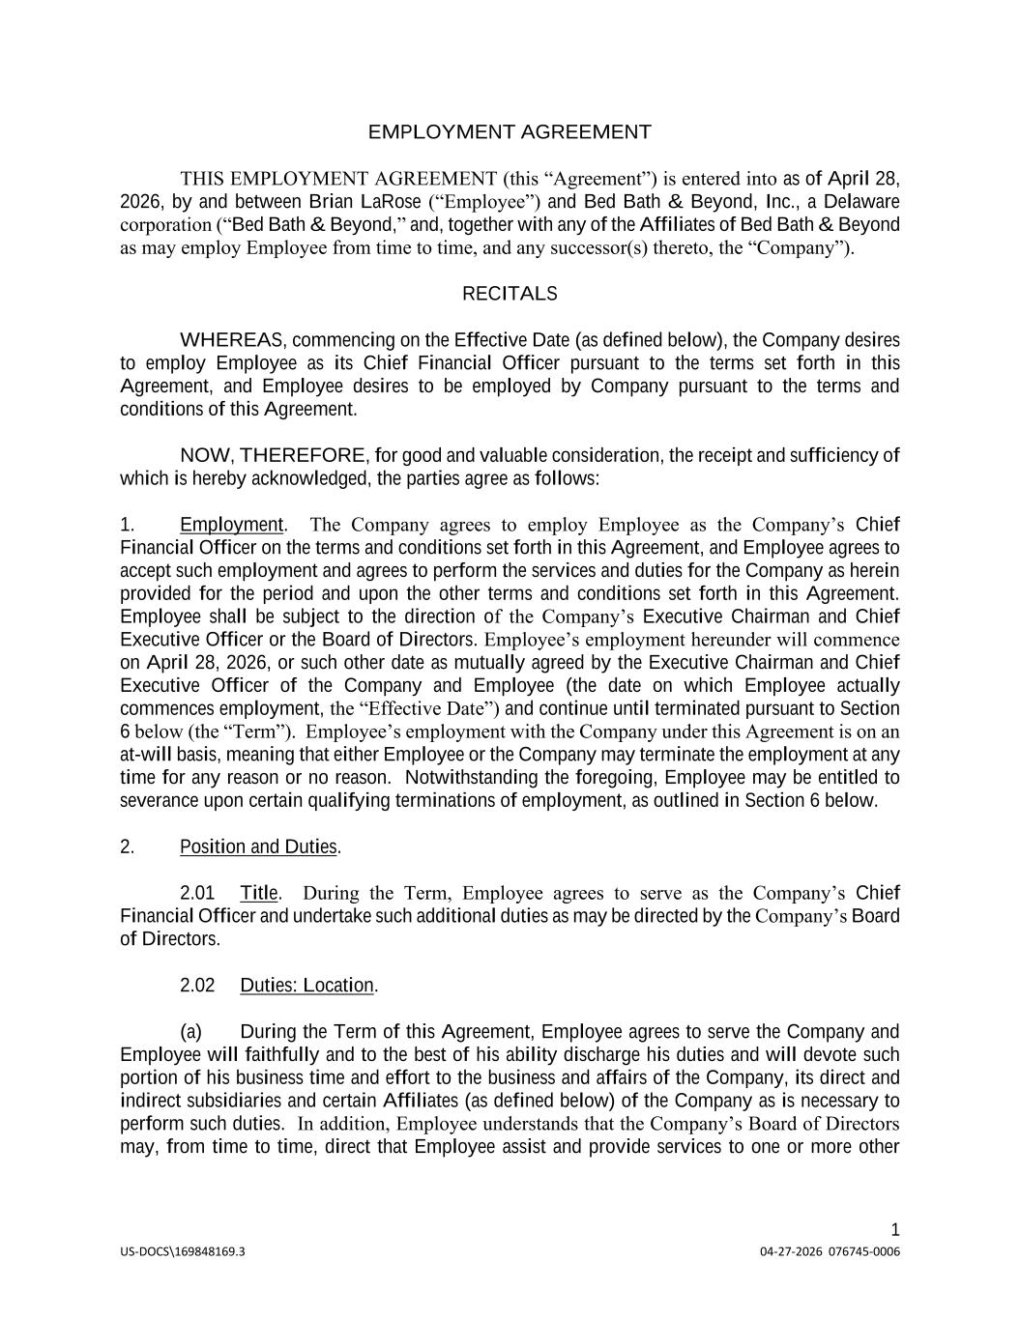
18

|
|US-DOCS\169680600.3|| | 08-02-2026 076745-0006|
US-DOCS\169848169.3 04-27-2026 076745-0006 1 EMPLOYMENT AGREEMENT THIS EMPLOYMENT AGREEMENT (this “Agreement”) is entered into as of April 28, 2026, by and between Brian LaRose (“Employee”) and Bed Bath & Beyond, Inc., a Delaware corporation (“Bed Bath & Beyond,” and, together with any of the Affiliates of Bed Bath & Beyond as may employ Employee from time to time, and any successor(s) thereto, the “Company”). RECITALS WHEREAS, commencing on the Effective Date (as defined below), the Company desires to employ Employee as its Chief Financial Officer pursuant to the terms set forth in this Agreement, and Employee desires to be employed by Company pursuant to the terms and conditions of this Agreement. NOW, THEREFORE, for good and valuable consideration, the receipt and sufficiency of which is hereby acknowledged, the parties agree as follows: 1. Employment. The Company agrees to employ Employee as the Company’s Chief Financial Officer on the terms and conditions set forth in this Agreement, and Employee agrees to accept such employment and agrees to perform the services and duties for the Company as herein provided for the period and upon the other terms and conditions set forth in this Agreement. Employee shall be subject to the direction of the Company’s Executive Chairman and Chief Executive Officer or the Board of Directors. Employee’s employment hereunder will commence on April 28, 2026, or such other date as mutually agreed by the Executive Chairman and Chief Executive Officer of the Company and Employee (the date on which Employee actually commences employment, the “Effective Date”) and continue until terminated pursuant to Section 6 below (the “Term”). Employee’s employment with the Company under this Agreement is on an at-will basis, meaning that either Employee or the Company may terminate the employment at any time for any reason or no reason. Notwithstanding the foregoing, Employee may be entitled to severance upon certain qualifying terminations of employment, as outlined in Section 6 below. 2. Position and Duties. 2.01 Title. During the Term, Employee agrees to serve as the Company’s Chief Financial Officer and undertake such additional duties as may be directed by the Company’s Board of Directors. 2.02 Duties: Location. (a) During the Term of this Agreement, Employee agrees to serve the Company and Employee will faithfully and to the best of his ability discharge his duties and will devote such portion of his business time and effort to the business and affairs of the Company, its direct and indirect subsidiaries and certain Affiliates (as defined below) of the Company as is necessary to perform such duties. In addition, Employee understands that the Company’s Board of Directors may, from time to time, direct that Employee assist and provide services to one or more other

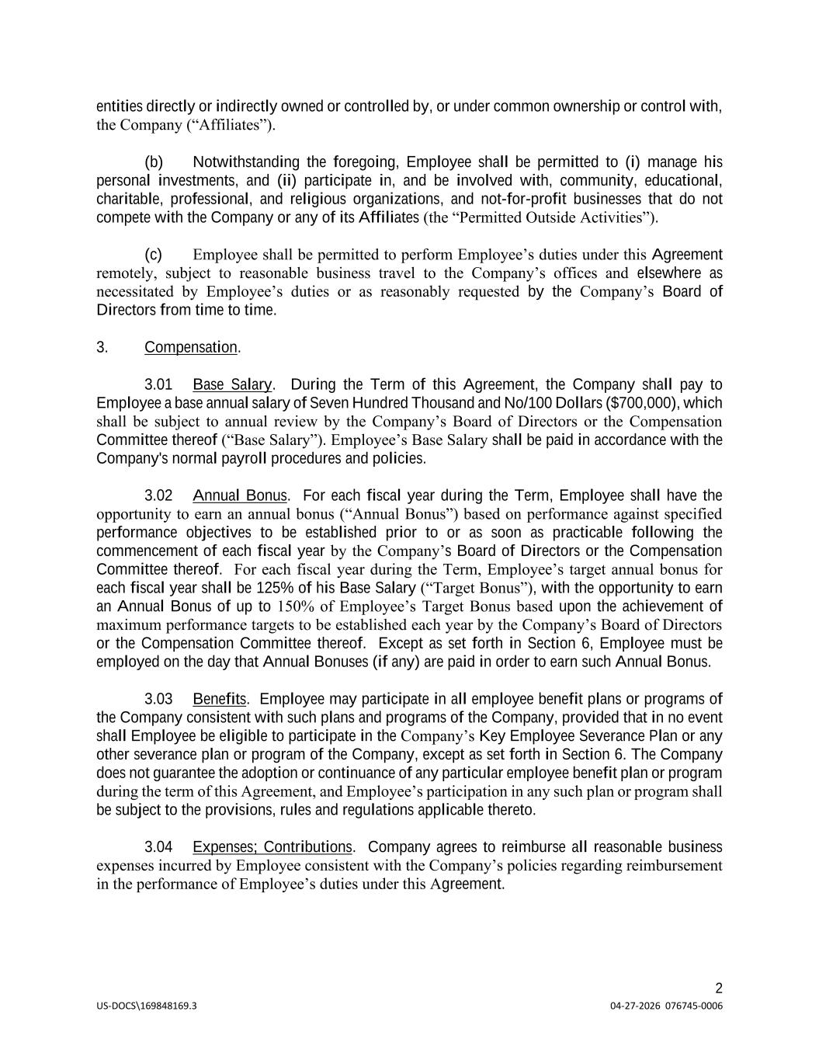
US-DOCS\169848169.3 04-27-2026 076745-0006 2 entities directly or indirectly owned or controlled by, or under common ownership or control with, the Company (“Affiliates”). (b) Notwithstanding the foregoing, Employee shall be permitted to (i) manage his personal investments, and (ii) participate in, and be involved with, community, educational, charitable, professional, and religious organizations, and not-for-profit businesses that do not compete with the Company or any of its Affiliates (the “Permitted Outside Activities”). (c) Employee shall be permitted to perform Employee’s duties under this Agreement remotely, subject to reasonable business travel to the Company’s offices and elsewhere as necessitated by Employee’s duties or as reasonably requested by the Company’s Board of Directors from time to time. 3. Compensation. 3.01 Base Salary. During the Term of this Agreement, the Company shall pay to Employee a base annual salary of Seven Hundred Thousand and No/100 Dollars ($700,000), which shall be subject to annual review by the Company’s Board of Directors or the Compensation Committee thereof (“Base Salary”). Employee’s Base Salary shall be paid in accordance with the Company's normal payroll procedures and policies. 3.02 Annual Bonus. For each fiscal year during the Term, Employee shall have the opportunity to earn an annual bonus (“Annual Bonus”) based on performance against specified performance objectives to be established prior to or as soon as practicable following the commencement of each fiscal year by the Company’s Board of Directors or the Compensation Committee thereof. For each fiscal year during the Term, Employee’s target annual bonus for each fiscal year shall be 125% of his Base Salary (“Target Bonus”), with the opportunity to earn an Annual Bonus of up to 150% of Employee’s Target Bonus based upon the achievement of maximum performance targets to be established each year by the Company’s Board of Directors or the Compensation Committee thereof. Except as set forth in Section 6, Employee must be employed on the day that Annual Bonuses (if any) are paid in order to earn such Annual Bonus. 3.03 Benefits. Employee may participate in all employee benefit plans or programs of the Company consistent with such plans and programs of the Company, provided that in no event shall Employee be eligible to participate in the Company’s Key Employee Severance Plan or any other severance plan or program of the Company, except as set forth in Section 6. The Company does not guarantee the adoption or continuance of any particular employee benefit plan or program during the term of this Agreement, and Employee’s participation in any such plan or program shall be subject to the provisions, rules and regulations applicable thereto. 3.04 Expenses; Contributions. Company agrees to reimburse all reasonable business expenses incurred by Employee consistent with the Company’s policies regarding reimbursement in the performance of Employee’s duties under this Agreement.

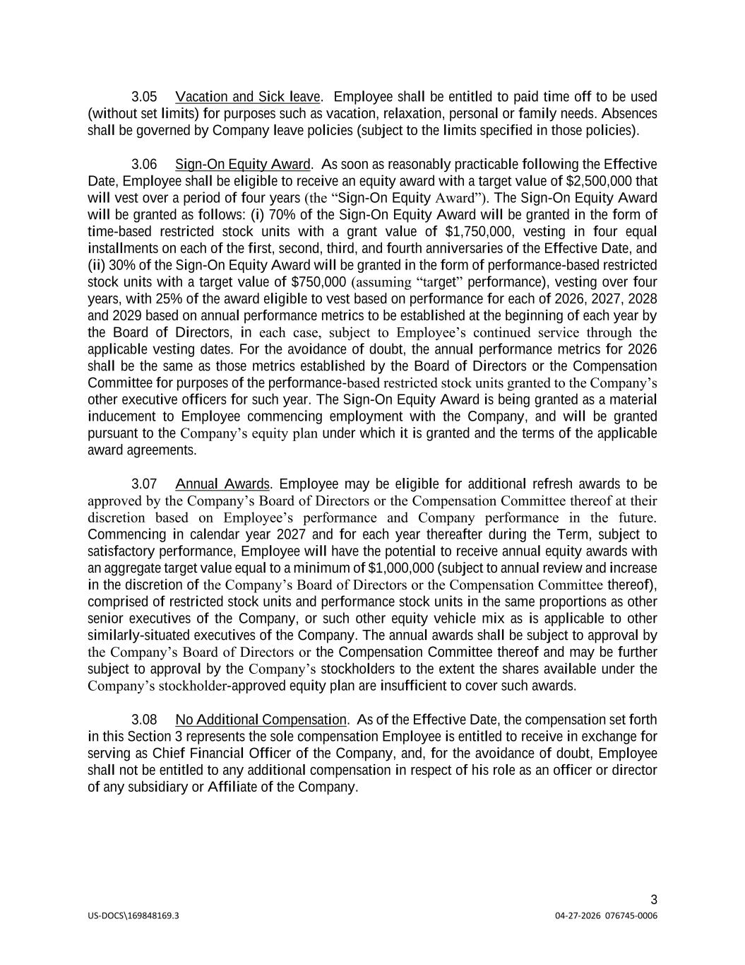
US-DOCS\169848169.3 04-27-2026 076745-0006 3 3.05 Vacation and Sick leave. Employee shall be entitled to paid time off to be used (without set limits) for purposes such as vacation, relaxation, personal or family needs. Absences shall be governed by Company leave policies (subject to the limits specified in those policies). 3.06 Sign-On Equity Award. As soon as reasonably practicable following the Effective Date, Employee shall be eligible to receive an equity award with a target value of $2,500,000 that will vest over a period of four years (the “Sign-On Equity Award”). The Sign-On Equity Award will be granted as follows: (i) 70% of the Sign-On Equity Award will be granted in the form of time-based restricted stock units with a grant value of $1,750,000, vesting in four equal installments on each of the first, second, third, and fourth anniversaries of the Effective Date, and (ii) 30% of the Sign-On Equity Award will be granted in the form of performance-based restricted stock units with a target value of $750,000 (assuming “target” performance), vesting over four years, with 25% of the award eligible to vest based on performance for each of 2026, 2027, 2028 and 2029 based on annual performance metrics to be established at the beginning of each year by the Board of Directors, in each case, subject to Employee’s continued service through the applicable vesting dates. For the avoidance of doubt, the annual performance metrics for 2026 shall be the same as those metrics established by the Board of Directors or the Compensation Committee for purposes of the performance-based restricted stock units granted to the Company’s other executive officers for such year. The Sign-On Equity Award is being granted as a material inducement to Employee commencing employment with the Company, and will be granted pursuant to the Company’s equity plan under which it is granted and the terms of the applicable award agreements. 3.07 Annual Awards. Employee may be eligible for additional refresh awards to be approved by the Company’s Board of Directors or the Compensation Committee thereof at their discretion based on Employee’s performance and Company performance in the future. Commencing in calendar year 2027 and for each year thereafter during the Term, subject to satisfactory performance, Employee will have the potential to receive annual equity awards with an aggregate target value equal to a minimum of $1,000,000 (subject to annual review and increase in the discretion of the Company’s Board of Directors or the Compensation Committee thereof), comprised of restricted stock units and performance stock units in the same proportions as other senior executives of the Company, or such other equity vehicle mix as is applicable to other similarly-situated executives of the Company. The annual awards shall be subject to approval by the Company’s Board of Directors or the Compensation Committee thereof and may be further subject to approval by the Company’s stockholders to the extent the shares available under the Company’s stockholder-approved equity plan are insufficient to cover such awards. 3.08 No Additional Compensation. As of the Effective Date, the compensation set forth in this Section 3 represents the sole compensation Employee is entitled to receive in exchange for serving as Chief Financial Officer of the Company, and, for the avoidance of doubt, Employee shall not be entitled to any additional compensation in respect of his role as an officer or director of any subsidiary or Affiliate of the Company.

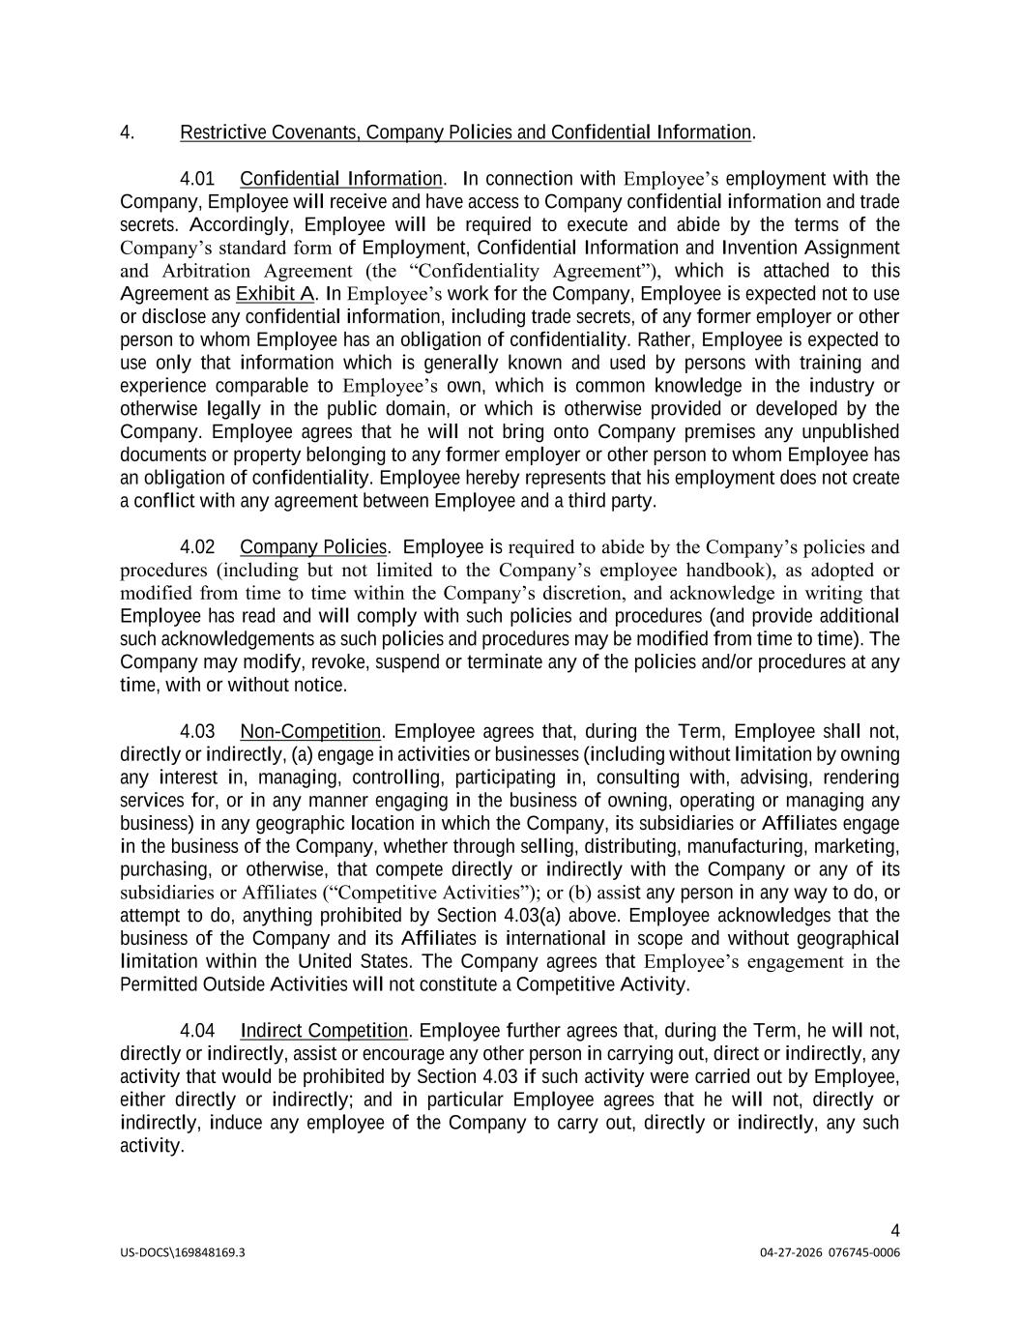
US-DOCS\169848169.3 04-27-2026 076745-0006 4 4. Restrictive Covenants, Company Policies and Confidential Information. 4.01 Confidential Information. In connection with Employee’s employment with the Company, Employee will receive and have access to Company confidential information and trade secrets. Accordingly, Employee will be required to execute and abide by the terms of the Company’s standard form of Employment, Confidential Information and Invention Assignment and Arbitration Agreement (the “Confidentiality Agreement”), which is attached to this Agreement as Exhibit A. In Employee’s work for the Company, Employee is expected not to use or disclose any confidential information, including trade secrets, of any former employer or other person to whom Employee has an obligation of confidentiality. Rather, Employee is expected to use only that information which is generally known and used by persons with training and experience comparable to Employee’s own, which is common knowledge in the industry or otherwise legally in the public domain, or which is otherwise provided or developed by the Company. Employee agrees that he will not bring onto Company premises any unpublished documents or property belonging to any former employer or other person to whom Employee has an obligation of confidentiality. Employee hereby represents that his employment does not create a conflict with any agreement between Employee and a third party. 4.02 Company Policies. Employee is required to abide by the Company’s policies and procedures (including but not limited to the Company’s employee handbook), as adopted or modified from time to time within the Company’s discretion, and acknowledge in writing that Employee has read and will comply with such policies and procedures (and provide additional such acknowledgements as such policies and procedures may be modified from time to time). The Company may modify, revoke, suspend or terminate any of the policies and/or procedures at any time, with or without notice. 4.03 Non-Competition. Employee agrees that, during the Term, Employee shall not, directly or indirectly, (a) engage in activities or businesses (including without limitation by owning any interest in, managing, controlling, participating in, consulting with, advising, rendering services for, or in any manner engaging in the business of owning, operating or managing any business) in any geographic location in which the Company, its subsidiaries or Affiliates engage in the business of the Company, whether through selling, distributing, manufacturing, marketing, purchasing, or otherwise, that compete directly or indirectly with the Company or any of its subsidiaries or Affiliates (“Competitive Activities”); or (b) assist any person in any way to do, or attempt to do, anything prohibited by Section 4.03(a) above. Employee acknowledges that the business of the Company and its Affiliates is international in scope and without geographical limitation within the United States. The Company agrees that Employee’s engagement in the Permitted Outside Activities will not constitute a Competitive Activity. 4.04 Indirect Competition. Employee further agrees that, during the Term, he will not, directly or indirectly, assist or encourage any other person in carrying out, direct or indirectly, any activity that would be prohibited by Section 4.03 if such activity were carried out by Employee, either directly or indirectly; and in particular Employee agrees that he will not, directly or indirectly, induce any employee of the Company to carry out, directly or indirectly, any such activity.

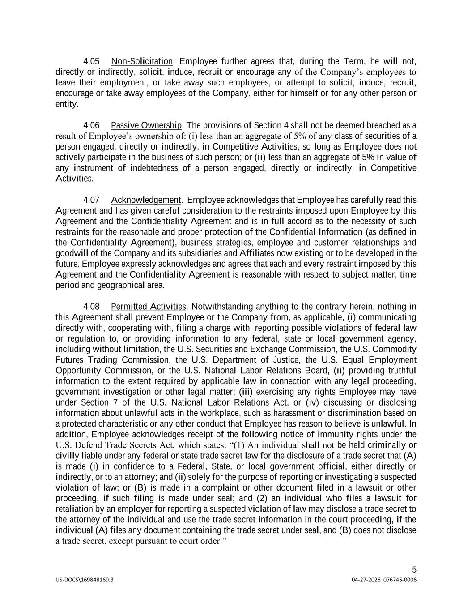
US-DOCS\169848169.3 04-27-2026 076745-0006 5 4.05 Non-Solicitation. Employee further agrees that, during the Term, he will not, directly or indirectly, solicit, induce, recruit or encourage any of the Company’s employees to leave their employment, or take away such employees, or attempt to solicit, induce, recruit, encourage or take away employees of the Company, either for himself or for any other person or entity. 4.06 Passive Ownership. The provisions of Section 4 shall not be deemed breached as a result of Employee’s ownership of: (i) less than an aggregate of 5% of any class of securities of a person engaged, directly or indirectly, in Competitive Activities, so long as Employee does not actively participate in the business of such person; or (ii) less than an aggregate of 5% in value of any instrument of indebtedness of a person engaged, directly or indirectly, in Competitive Activities. 4.07 Acknowledgement. Employee acknowledges that Employee has carefully read this Agreement and has given careful consideration to the restraints imposed upon Employee by this Agreement and the Confidentiality Agreement and is in full accord as to the necessity of such restraints for the reasonable and proper protection of the Confidential Information (as defined in the Confidentiality Agreement), business strategies, employee and customer relationships and goodwill of the Company and its subsidiaries and Affiliates now existing or to be developed in the future. Employee expressly acknowledges and agrees that each and every restraint imposed by this Agreement and the Confidentiality Agreement is reasonable with respect to subject matter, time period and geographical area. 4.08 Permitted Activities. Notwithstanding anything to the contrary herein, nothing in this Agreement shall prevent Employee or the Company from, as applicable, (i) communicating directly with, cooperating with, filing a charge with, reporting possible violations of federal law or regulation to, or providing information to any federal, state or local government agency, including without limitation, the U.S. Securities and Exchange Commission, the U.S. Commodity Futures Trading Commission, the U.S. Department of Justice, the U.S. Equal Employment Opportunity Commission, or the U.S. National Labor Relations Board, (ii) providing truthful information to the extent required by applicable law in connection with any legal proceeding, government investigation or other legal matter; (iii) exercising any rights Employee may have under Section 7 of the U.S. National Labor Relations Act, or (iv) discussing or disclosing information about unlawful acts in the workplace, such as harassment or discrimination based on a protected characteristic or any other conduct that Employee has reason to believe is unlawful. In addition, Employee acknowledges receipt of the following notice of immunity rights under the U.S. Defend Trade Secrets Act, which states: “(1) An individual shall not be held criminally or civilly liable under any federal or state trade secret law for the disclosure of a trade secret that (A) is made (i) in confidence to a Federal, State, or local government official, either directly or indirectly, or to an attorney; and (ii) solely for the purpose of reporting or investigating a suspected violation of law; or (B) is made in a complaint or other document filed in a lawsuit or other proceeding, if such filing is made under seal; and (2) an individual who files a lawsuit for retaliation by an employer for reporting a suspected violation of law may disclose a trade secret to the attorney of the individual and use the trade secret information in the court proceeding, if the individual (A) files any document containing the trade secret under seal, and (B) does not disclose a trade secret, except pursuant to court order.”

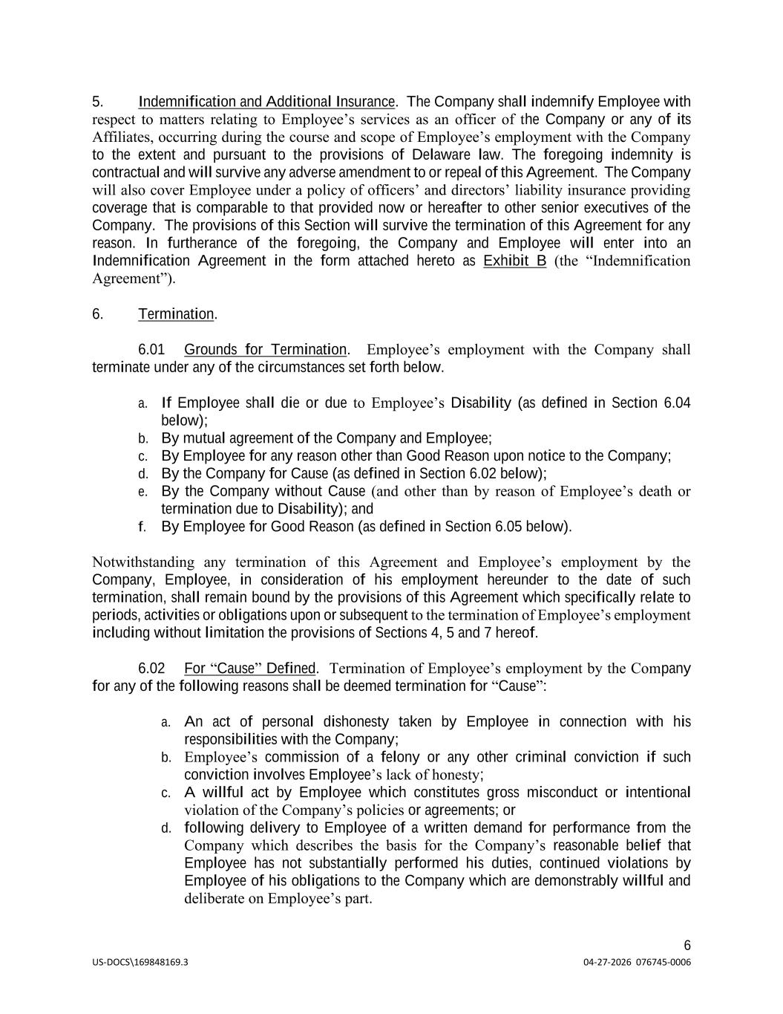
US-DOCS\169848169.3 04-27-2026 076745-0006 6 5. Indemnification and Additional Insurance. The Company shall indemnify Employee with respect to matters relating to Employee’s services as an officer of the Company or any of its Affiliates, occurring during the course and scope of Employee’s employment with the Company to the extent and pursuant to the provisions of Delaware law. The foregoing indemnity is contractual and will survive any adverse amendment to or repeal of this Agreement. The Company will also cover Employee under a policy of officers’ and directors’ liability insurance providing coverage that is comparable to that provided now or hereafter to other senior executives of the Company. The provisions of this Section will survive the termination of this Agreement for any reason. In furtherance of the foregoing, the Company and Employee will enter into an Indemnification Agreement in the form attached hereto as Exhibit B (the “Indemnification Agreement”). 6. Termination. 6.01 Grounds for Termination. Employee’s employment with the Company shall terminate under any of the circumstances set forth below. a. If Employee shall die or due to Employee’s Disability (as defined in Section 6.04 below); b. By mutual agreement of the Company and Employee; c. By Employee for any reason other than Good Reason upon notice to the Company; d. By the Company for Cause (as defined in Section 6.02 below); e. By the Company without Cause (and other than by reason of Employee’s death or termination due to Disability); and f. By Employee for Good Reason (as defined in Section 6.05 below). Notwithstanding any termination of this Agreement and Employee’s employment by the Company, Employee, in consideration of his employment hereunder to the date of such termination, shall remain bound by the provisions of this Agreement which specifically relate to periods, activities or obligations upon or subsequent to the termination of Employee’s employment including without limitation the provisions of Sections 4, 5 and 7 hereof. 6.02 For “Cause” Defined. Termination of Employee’s employment by the Company for any of the following reasons shall be deemed termination for “Cause”: a. An act of personal dishonesty taken by Employee in connection with his responsibilities with the Company; b. Employee’s commission of a felony or any other criminal conviction if such conviction involves Employee’s lack of honesty; c. A willful act by Employee which constitutes gross misconduct or intentional violation of the Company’s policies or agreements; or d. following delivery to Employee of a written demand for performance from the Company which describes the basis for the Company’s reasonable belief that Employee has not substantially performed his duties, continued violations by Employee of his obligations to the Company which are demonstrably willful and deliberate on Employee’s part.

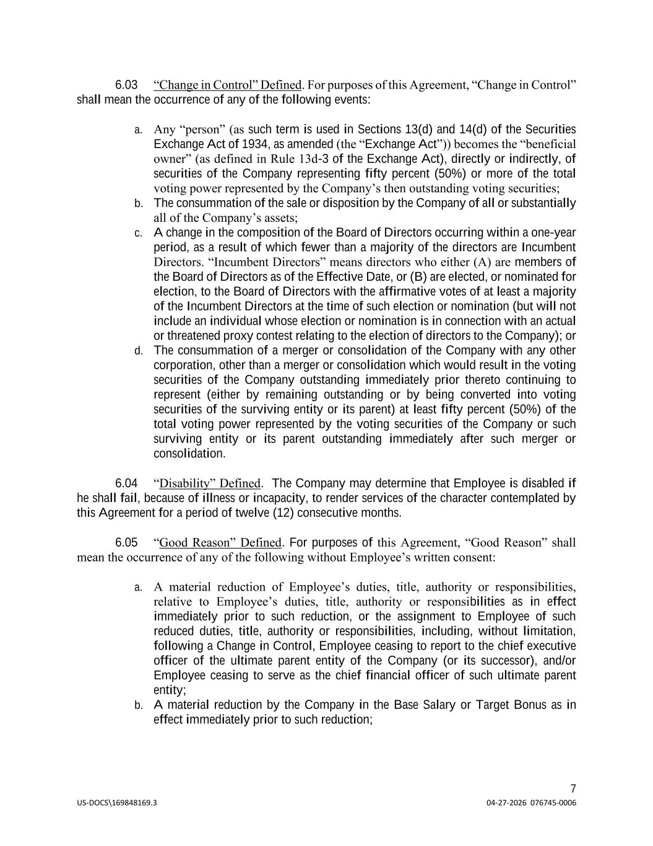
US-DOCS\169848169.3 04-27-2026 076745-0006 7 6.03 “Change in Control” Defined. For purposes of this Agreement, “Change in Control” shall mean the occurrence of any of the following events: a. Any “person” (as such term is used in Sections 13(d) and 14(d) of the Securities Exchange Act of 1934, as amended (the “Exchange Act”)) becomes the “beneficial owner” (as defined in Rule 13d-3 of the Exchange Act), directly or indirectly, of securities of the Company representing fifty percent (50%) or more of the total voting power represented by the Company’s then outstanding voting securities; b. The consummation of the sale or disposition by the Company of all or substantially all of the Company’s assets; c. A change in the composition of the Board of Directors occurring within a one-year period, as a result of which fewer than a majority of the directors are Incumbent Directors. “Incumbent Directors” means directors who either (A) are members of the Board of Directors as of the Effective Date, or (B) are elected, or nominated for election, to the Board of Directors with the affirmative votes of at least a majority of the Incumbent Directors at the time of such election or nomination (but will not include an individual whose election or nomination is in connection with an actual or threatened proxy contest relating to the election of directors to the Company); or d. The consummation of a merger or consolidation of the Company with any other corporation, other than a merger or consolidation which would result in the voting securities of the Company outstanding immediately prior thereto continuing to represent (either by remaining outstanding or by being converted into voting securities of the surviving entity or its parent) at least fifty percent (50%) of the total voting power represented by the voting securities of the Company or such surviving entity or its parent outstanding immediately after such merger or consolidation. 6.04 “Disability” Defined. The Company may determine that Employee is disabled if he shall fail, because of illness or incapacity, to render services of the character contemplated by this Agreement for a period of twelve (12) consecutive months. 6.05 “Good Reason” Defined. For purposes of this Agreement, “Good Reason” shall mean the occurrence of any of the following without Employee’s written consent: a. A material reduction of Employee’s duties, title, authority or responsibilities, relative to Employee’s duties, title, authority or responsibilities as in effect immediately prior to such reduction, or the assignment to Employee of such reduced duties, title, authority or responsibilities, including, without limitation, following a Change in Control, Employee ceasing to report to the chief executive officer of the ultimate parent entity of the Company (or its successor), and/or Employee ceasing to serve as the chief financial officer of such ultimate parent entity; b. A material reduction by the Company in the Base Salary or Target Bonus as in effect immediately prior to such reduction;

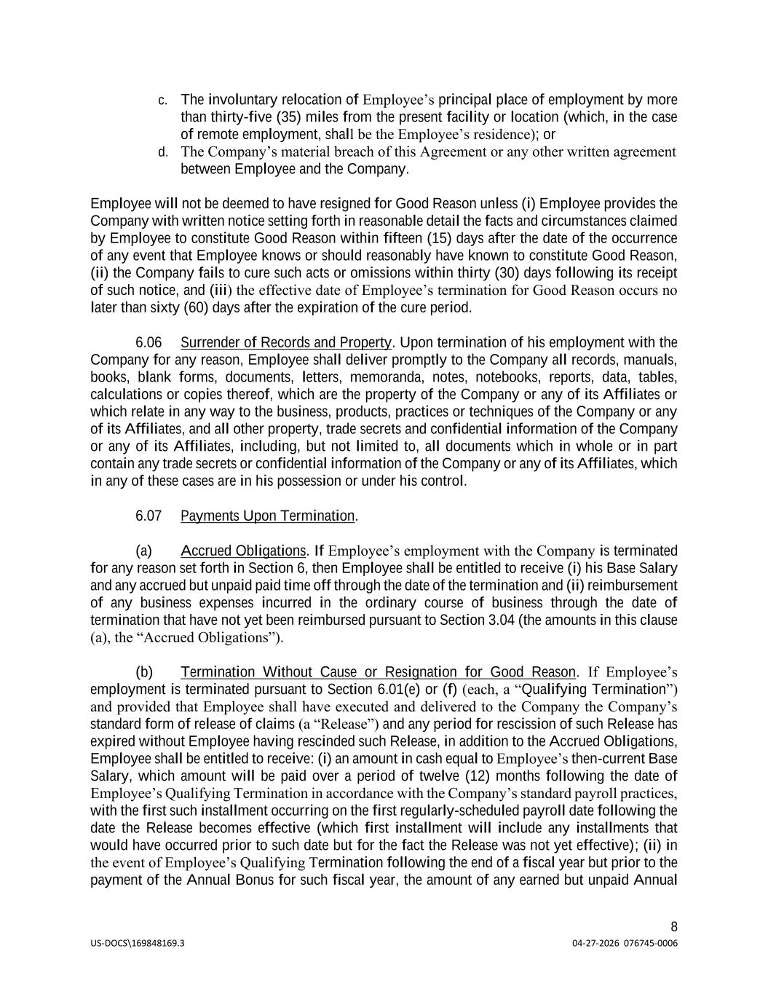
US-DOCS\169848169.3 04-27-2026 076745-0006 8 c. The involuntary relocation of Employee’s principal place of employment by more than thirty-five (35) miles from the present facility or location (which, in the case of remote employment, shall be the Employee’s residence); or d. The Company’s material breach of this Agreement or any other written agreement between Employee and the Company. Employee will not be deemed to have resigned for Good Reason unless (i) Employee provides the Company with written notice setting forth in reasonable detail the facts and circumstances claimed by Employee to constitute Good Reason within fifteen (15) days after the date of the occurrence of any event that Employee knows or should reasonably have known to constitute Good Reason, (ii) the Company fails to cure such acts or omissions within thirty (30) days following its receipt of such notice, and (iii) the effective date of Employee’s termination for Good Reason occurs no later than sixty (60) days after the expiration of the cure period. 6.06 Surrender of Records and Property. Upon termination of his employment with the Company for any reason, Employee shall deliver promptly to the Company all records, manuals, books, blank forms, documents, letters, memoranda, notes, notebooks, reports, data, tables, calculations or copies thereof, which are the property of the Company or any of its Affiliates or which relate in any way to the business, products, practices or techniques of the Company or any of its Affiliates, and all other property, trade secrets and confidential information of the Company or any of its Affiliates, including, but not limited to, all documents which in whole or in part contain any trade secrets or confidential information of the Company or any of its Affiliates, which in any of these cases are in his possession or under his control. 6.07 Payments Upon Termination. (a) Accrued Obligations. If Employee’s employment with the Company is terminated for any reason set forth in Section 6, then Employee shall be entitled to receive (i) his Base Salary and any accrued but unpaid paid time off through the date of the termination and (ii) reimbursement of any business expenses incurred in the ordinary course of business through the date of termination that have not yet been reimbursed pursuant to Section 3.04 (the amounts in this clause (a), the “Accrued Obligations”). (b) Termination Without Cause or Resignation for Good Reason. If Employee’s employment is terminated pursuant to Section 6.01(e) or (f) (each, a “Qualifying Termination”) and provided that Employee shall have executed and delivered to the Company the Company’s standard form of release of claims (a “Release”) and any period for rescission of such Release has expired without Employee having rescinded such Release, in addition to the Accrued Obligations, Employee shall be entitled to receive: (i) an amount in cash equal to Employee’s then-current Base Salary, which amount will be paid over a period of twelve (12) months following the date of Employee’s Qualifying Termination in accordance with the Company’s standard payroll practices, with the first such installment occurring on the first regularly-scheduled payroll date following the date the Release becomes effective (which first installment will include any installments that would have occurred prior to such date but for the fact the Release was not yet effective); (ii) in the event of Employee’s Qualifying Termination following the end of a fiscal year but prior to the payment of the Annual Bonus for such fiscal year, the amount of any earned but unpaid Annual

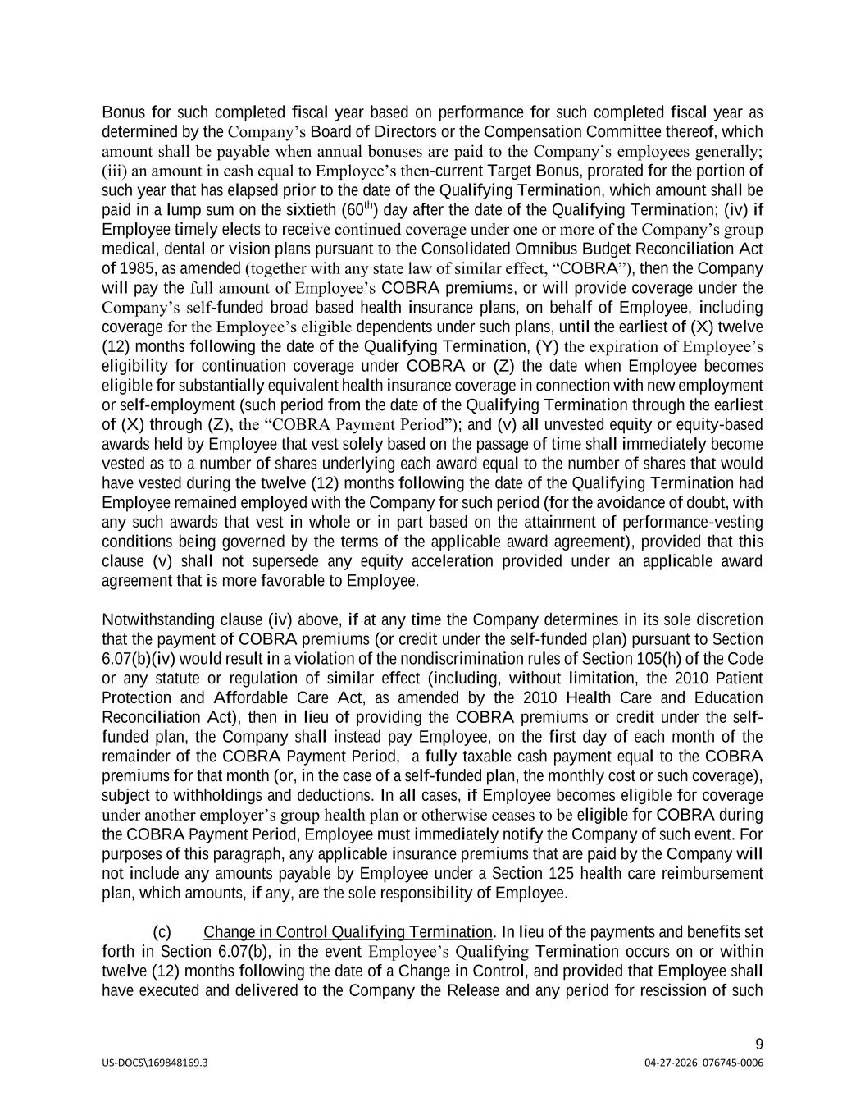
US-DOCS\169848169.3 04-27-2026 076745-0006 9 Bonus for such completed fiscal year based on performance for such completed fiscal year as determined by the Company’s Board of Directors or the Compensation Committee thereof, which amount shall be payable when annual bonuses are paid to the Company’s employees generally; (iii) an amount in cash equal to Employee’s then-current Target Bonus, prorated for the portion of such year that has elapsed prior to the date of the Qualifying Termination, which amount shall be paid in a lump sum on the sixtieth (60th) day after the date of the Qualifying Termination; (iv) if Employee timely elects to receive continued coverage under one or more of the Company’s group medical, dental or vision plans pursuant to the Consolidated Omnibus Budget Reconciliation Act of 1985, as amended (together with any state law of similar effect, “COBRA”), then the Company will pay the full amount of Employee’s COBRA premiums, or will provide coverage under the Company’s self-funded broad based health insurance plans, on behalf of Employee, including coverage for the Employee’s eligible dependents under such plans, until the earliest of (X) twelve (12) months following the date of the Qualifying Termination, (Y) the expiration of Employee’s eligibility for continuation coverage under COBRA or (Z) the date when Employee becomes eligible for substantially equivalent health insurance coverage in connection with new employment or self-employment (such period from the date of the Qualifying Termination through the earliest of (X) through (Z), the “COBRA Payment Period”); and (v) all unvested equity or equity-based awards held by Employee that vest solely based on the passage of time shall immediately become vested as to a number of shares underlying each award equal to the number of shares that would have vested during the twelve (12) months following the date of the Qualifying Termination had Employee remained employed with the Company for such period (for the avoidance of doubt, with any such awards that vest in whole or in part based on the attainment of performance-vesting conditions being governed by the terms of the applicable award agreement), provided that this clause (v) shall not supersede any equity acceleration provided under an applicable award agreement that is more favorable to Employee. Notwithstanding clause (iv) above, if at any time the Company determines in its sole discretion that the payment of COBRA premiums (or credit under the self-funded plan) pursuant to Section 6.07(b)(iv) would result in a violation of the nondiscrimination rules of Section 105(h) of the Code or any statute or regulation of similar effect (including, without limitation, the 2010 Patient Protection and Affordable Care Act, as amended by the 2010 Health Care and Education Reconciliation Act), then in lieu of providing the COBRA premiums or credit under the self- funded plan, the Company shall instead pay Employee, on the first day of each month of the remainder of the COBRA Payment Period, a fully taxable cash payment equal to the COBRA premiums for that month (or, in the case of a self-funded plan, the monthly cost or such coverage), subject to withholdings and deductions. In all cases, if Employee becomes eligible for coverage under another employer’s group health plan or otherwise ceases to be eligible for COBRA during the COBRA Payment Period, Employee must immediately notify the Company of such event. For purposes of this paragraph, any applicable insurance premiums that are paid by the Company will not include any amounts payable by Employee under a Section 125 health care reimbursement plan, which amounts, if any, are the sole responsibility of Employee. (c) Change in Control Qualifying Termination. In lieu of the payments and benefits set forth in Section 6.07(b), in the event Employee’s Qualifying Termination occurs on or within twelve (12) months following the date of a Change in Control, and provided that Employee shall have executed and delivered to the Company the Release and any period for rescission of such

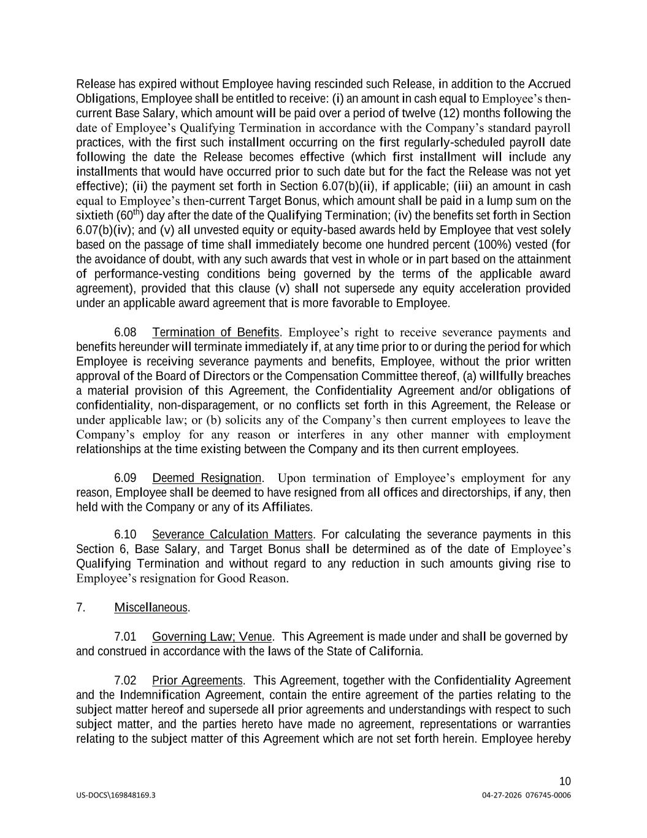
US-DOCS\169848169.3 04-27-2026 076745-0006 10 Release has expired without Employee having rescinded such Release, in addition to the Accrued Obligations, Employee shall be entitled to receive: (i) an amount in cash equal to Employee’s then- current Base Salary, which amount will be paid over a period of twelve (12) months following the date of Employee’s Qualifying Termination in accordance with the Company’s standard payroll practices, with the first such installment occurring on the first regularly-scheduled payroll date following the date the Release becomes effective (which first installment will include any installments that would have occurred prior to such date but for the fact the Release was not yet effective); (ii) the payment set forth in Section 6.07(b)(ii), if applicable; (iii) an amount in cash equal to Employee’s then-current Target Bonus, which amount shall be paid in a lump sum on the sixtieth (60th) day after the date of the Qualifying Termination; (iv) the benefits set forth in Section 6.07(b)(iv); and (v) all unvested equity or equity-based awards held by Employee that vest solely based on the passage of time shall immediately become one hundred percent (100%) vested (for the avoidance of doubt, with any such awards that vest in whole or in part based on the attainment of performance-vesting conditions being governed by the terms of the applicable award agreement), provided that this clause (v) shall not supersede any equity acceleration provided under an applicable award agreement that is more favorable to Employee. 6.08 Termination of Benefits. Employee’s right to receive severance payments and benefits hereunder will terminate immediately if, at any time prior to or during the period for which Employee is receiving severance payments and benefits, Employee, without the prior written approval of the Board of Directors or the Compensation Committee thereof, (a) willfully breaches a material provision of this Agreement, the Confidentiality Agreement and/or obligations of confidentiality, non-disparagement, or no conflicts set forth in this Agreement, the Release or under applicable law; or (b) solicits any of the Company’s then current employees to leave the Company’s employ for any reason or interferes in any other manner with employment relationships at the time existing between the Company and its then current employees. 6.09 Deemed Resignation. Upon termination of Employee’s employment for any reason, Employee shall be deemed to have resigned from all offices and directorships, if any, then held with the Company or any of its Affiliates. 6.10 Severance Calculation Matters. For calculating the severance payments in this Section 6, Base Salary, and Target Bonus shall be determined as of the date of Employee’s Qualifying Termination and without regard to any reduction in such amounts giving rise to Employee’s resignation for Good Reason. 7. Miscellaneous. 7.01 Governing Law; Venue. This Agreement is made under and shall be governed by and construed in accordance with the laws of the State of California. 7.02 Prior Agreements. This Agreement, together with the Confidentiality Agreement and the Indemnification Agreement, contain the entire agreement of the parties relating to the subject matter hereof and supersede all prior agreements and understandings with respect to such subject matter, and the parties hereto have made no agreement, representations or warranties relating to the subject matter of this Agreement which are not set forth herein. Employee hereby

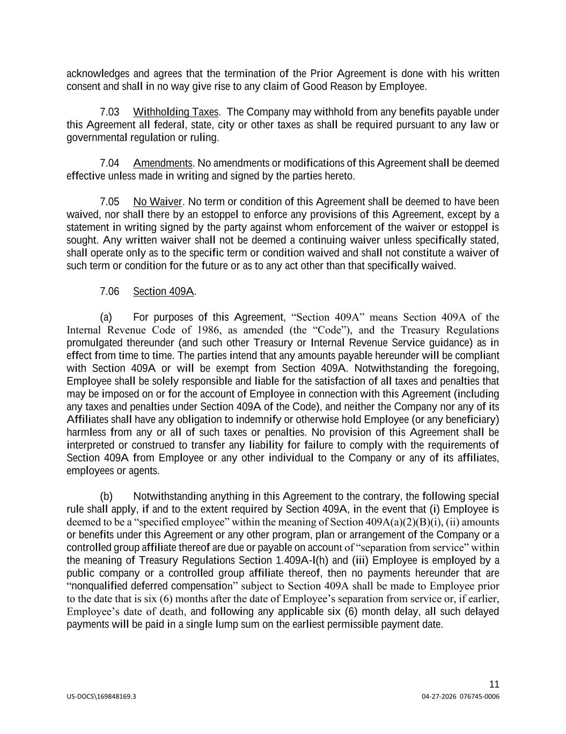
US-DOCS\169848169.3 04-27-2026 076745-0006 11 acknowledges and agrees that the termination of the Prior Agreement is done with his written consent and shall in no way give rise to any claim of Good Reason by Employee. 7.03 Withholding Taxes. The Company may withhold from any benefits payable under this Agreement all federal, state, city or other taxes as shall be required pursuant to any law or governmental regulation or ruling. 7.04 Amendments. No amendments or modifications of this Agreement shall be deemed effective unless made in writing and signed by the parties hereto. 7.05 No Waiver. No term or condition of this Agreement shall be deemed to have been waived, nor shall there by an estoppel to enforce any provisions of this Agreement, except by a statement in writing signed by the party against whom enforcement of the waiver or estoppel is sought. Any written waiver shall not be deemed a continuing waiver unless specifically stated, shall operate only as to the specific term or condition waived and shall not constitute a waiver of such term or condition for the future or as to any act other than that specifically waived. 7.06 Section 409A. (a) For purposes of this Agreement, “Section 409A” means Section 409A of the Internal Revenue Code of 1986, as amended (the “Code”), and the Treasury Regulations promulgated thereunder (and such other Treasury or Internal Revenue Service guidance) as in effect from time to time. The parties intend that any amounts payable hereunder will be compliant with Section 409A or will be exempt from Section 409A. Notwithstanding the foregoing, Employee shall be solely responsible and liable for the satisfaction of all taxes and penalties that may be imposed on or for the account of Employee in connection with this Agreement (including any taxes and penalties under Section 409A of the Code), and neither the Company nor any of its Affiliates shall have any obligation to indemnify or otherwise hold Employee (or any beneficiary) harmless from any or all of such taxes or penalties. No provision of this Agreement shall be interpreted or construed to transfer any liability for failure to comply with the requirements of Section 409A from Employee or any other individual to the Company or any of its affiliates, employees or agents. (b) Notwithstanding anything in this Agreement to the contrary, the following special rule shall apply, if and to the extent required by Section 409A, in the event that (i) Employee is deemed to be a “specified employee” within the meaning of Section 409A(a)(2)(B)(i), (ii) amounts or benefits under this Agreement or any other program, plan or arrangement of the Company or a controlled group affiliate thereof are due or payable on account of “separation from service” within the meaning of Treasury Regulations Section 1.409A-l(h) and (iii) Employee is employed by a public company or a controlled group affiliate thereof, then no payments hereunder that are “nonqualified deferred compensation” subject to Section 409A shall be made to Employee prior to the date that is six (6) months after the date of Employee’s separation from service or, if earlier, Employee’s date of death, and following any applicable six (6) month delay, all such delayed payments will be paid in a single lump sum on the earliest permissible payment date.

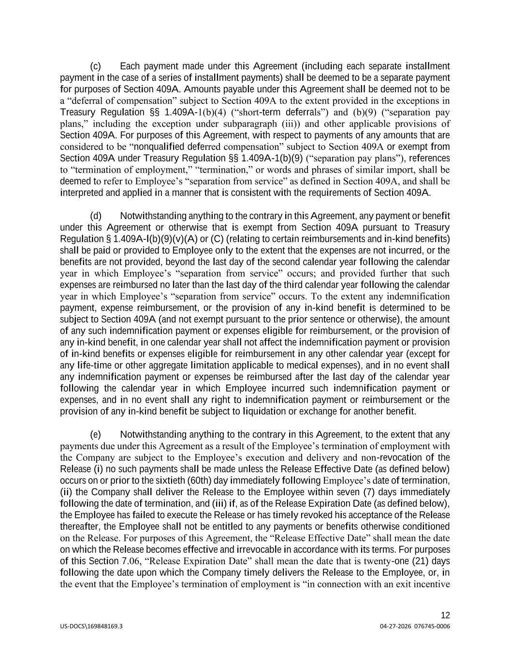
US-DOCS\169848169.3 04-27-2026 076745-0006 12 (c) Each payment made under this Agreement (including each separate installment payment in the case of a series of installment payments) shall be deemed to be a separate payment for purposes of Section 409A. Amounts payable under this Agreement shall be deemed not to be a “deferral of compensation” subject to Section 409A to the extent provided in the exceptions in Treasury Regulation §§ 1.409A-1(b)(4) (“short-term deferrals”) and (b)(9) (“separation pay plans,” including the exception under subparagraph (iii)) and other applicable provisions of Section 409A. For purposes of this Agreement, with respect to payments of any amounts that are considered to be “nonqualified deferred compensation” subject to Section 409A or exempt from Section 409A under Treasury Regulation §§ 1.409A-1(b)(9) (“separation pay plans”), references to “termination of employment,” “termination,” or words and phrases of similar import, shall be deemed to refer to Employee’s “separation from service” as defined in Section 409A, and shall be interpreted and applied in a manner that is consistent with the requirements of Section 409A. (d) Notwithstanding anything to the contrary in this Agreement, any payment or benefit under this Agreement or otherwise that is exempt from Section 409A pursuant to Treasury Regulation § 1.409A-l(b)(9)(v)(A) or (C) (relating to certain reimbursements and in-kind benefits) shall be paid or provided to Employee only to the extent that the expenses are not incurred, or the benefits are not provided, beyond the last day of the second calendar year following the calendar year in which Employee’s “separation from service” occurs; and provided further that such expenses are reimbursed no later than the last day of the third calendar year following the calendar year in which Employee’s “separation from service” occurs. To the extent any indemnification payment, expense reimbursement, or the provision of any in-kind benefit is determined to be subject to Section 409A (and not exempt pursuant to the prior sentence or otherwise), the amount of any such indemnification payment or expenses eligible for reimbursement, or the provision of any in-kind benefit, in one calendar year shall not affect the indemnification payment or provision of in-kind benefits or expenses eligible for reimbursement in any other calendar year (except for any life-time or other aggregate limitation applicable to medical expenses), and in no event shall any indemnification payment or expenses be reimbursed after the last day of the calendar year following the calendar year in which Employee incurred such indemnification payment or expenses, and in no event shall any right to indemnification payment or reimbursement or the provision of any in-kind benefit be subject to liquidation or exchange for another benefit. (e) Notwithstanding anything to the contrary in this Agreement, to the extent that any payments due under this Agreement as a result of the Employee’s termination of employment with the Company are subject to the Employee’s execution and delivery and non-revocation of the Release (i) no such payments shall be made unless the Release Effective Date (as defined below) occurs on or prior to the sixtieth (60th) day immediately following Employee’s date of termination, (ii) the Company shall deliver the Release to the Employee within seven (7) days immediately following the date of termination, and (iii) if, as of the Release Expiration Date (as defined below), the Employee has failed to execute the Release or has timely revoked his acceptance of the Release thereafter, the Employee shall not be entitled to any payments or benefits otherwise conditioned on the Release. For purposes of this Agreement, the “Release Effective Date” shall mean the date on which the Release becomes effective and irrevocable in accordance with its terms. For purposes of this Section 7.06, “Release Expiration Date” shall mean the date that is twenty-one (21) days following the date upon which the Company timely delivers the Release to the Employee, or, in the event that the Employee’s termination of employment is “in connection with an exit incentive

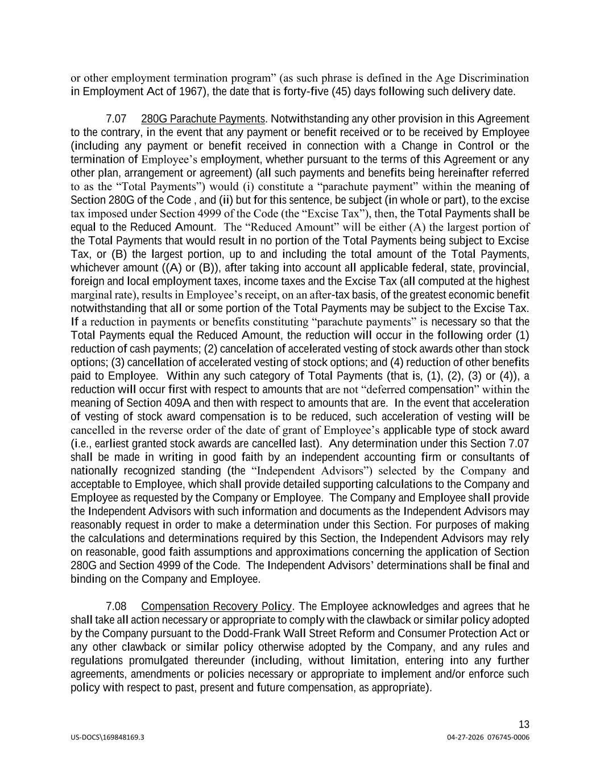
US-DOCS\169848169.3 04-27-2026 076745-0006 13 or other employment termination program” (as such phrase is defined in the Age Discrimination in Employment Act of 1967), the date that is forty-five (45) days following such delivery date. 7.07 280G Parachute Payments. Notwithstanding any other provision in this Agreement to the contrary, in the event that any payment or benefit received or to be received by Employee (including any payment or benefit received in connection with a Change in Control or the termination of Employee’s employment, whether pursuant to the terms of this Agreement or any other plan, arrangement or agreement) (all such payments and benefits being hereinafter referred to as the “Total Payments”) would (i) constitute a “parachute payment” within the meaning of Section 280G of the Code , and (ii) but for this sentence, be subject (in whole or part), to the excise tax imposed under Section 4999 of the Code (the “Excise Tax”), then, the Total Payments shall be equal to the Reduced Amount. The “Reduced Amount” will be either (A) the largest portion of the Total Payments that would result in no portion of the Total Payments being subject to Excise Tax, or (B) the largest portion, up to and including the total amount of the Total Payments, whichever amount ((A) or (B)), after taking into account all applicable federal, state, provincial, foreign and local employment taxes, income taxes and the Excise Tax (all computed at the highest marginal rate), results in Employee’s receipt, on an after-tax basis, of the greatest economic benefit notwithstanding that all or some portion of the Total Payments may be subject to the Excise Tax. If a reduction in payments or benefits constituting “parachute payments” is necessary so that the Total Payments equal the Reduced Amount, the reduction will occur in the following order (1) reduction of cash payments; (2) cancelation of accelerated vesting of stock awards other than stock options; (3) cancellation of accelerated vesting of stock options; and (4) reduction of other benefits paid to Employee. Within any such category of Total Payments (that is, (1), (2), (3) or (4)), a reduction will occur first with respect to amounts that are not “deferred compensation” within the meaning of Section 409A and then with respect to amounts that are. In the event that acceleration of vesting of stock award compensation is to be reduced, such acceleration of vesting will be cancelled in the reverse order of the date of grant of Employee’s applicable type of stock award (i.e., earliest granted stock awards are cancelled last). Any determination under this Section 7.07 shall be made in writing in good faith by an independent accounting firm or consultants of nationally recognized standing (the “Independent Advisors”) selected by the Company and acceptable to Employee, which shall provide detailed supporting calculations to the Company and Employee as requested by the Company or Employee. The Company and Employee shall provide the Independent Advisors with such information and documents as the Independent Advisors may reasonably request in order to make a determination under this Section. For purposes of making the calculations and determinations required by this Section, the Independent Advisors may rely on reasonable, good faith assumptions and approximations concerning the application of Section 280G and Section 4999 of the Code. The Independent Advisors’ determinations shall be final and binding on the Company and Employee. 7.08 Compensation Recovery Policy. The Employee acknowledges and agrees that he shall take all action necessary or appropriate to comply with the clawback or similar policy adopted by the Company pursuant to the Dodd-Frank Wall Street Reform and Consumer Protection Act or any other clawback or similar policy otherwise adopted by the Company, and any rules and regulations promulgated thereunder (including, without limitation, entering into any further agreements, amendments or policies necessary or appropriate to implement and/or enforce such policy with respect to past, present and future compensation, as appropriate).

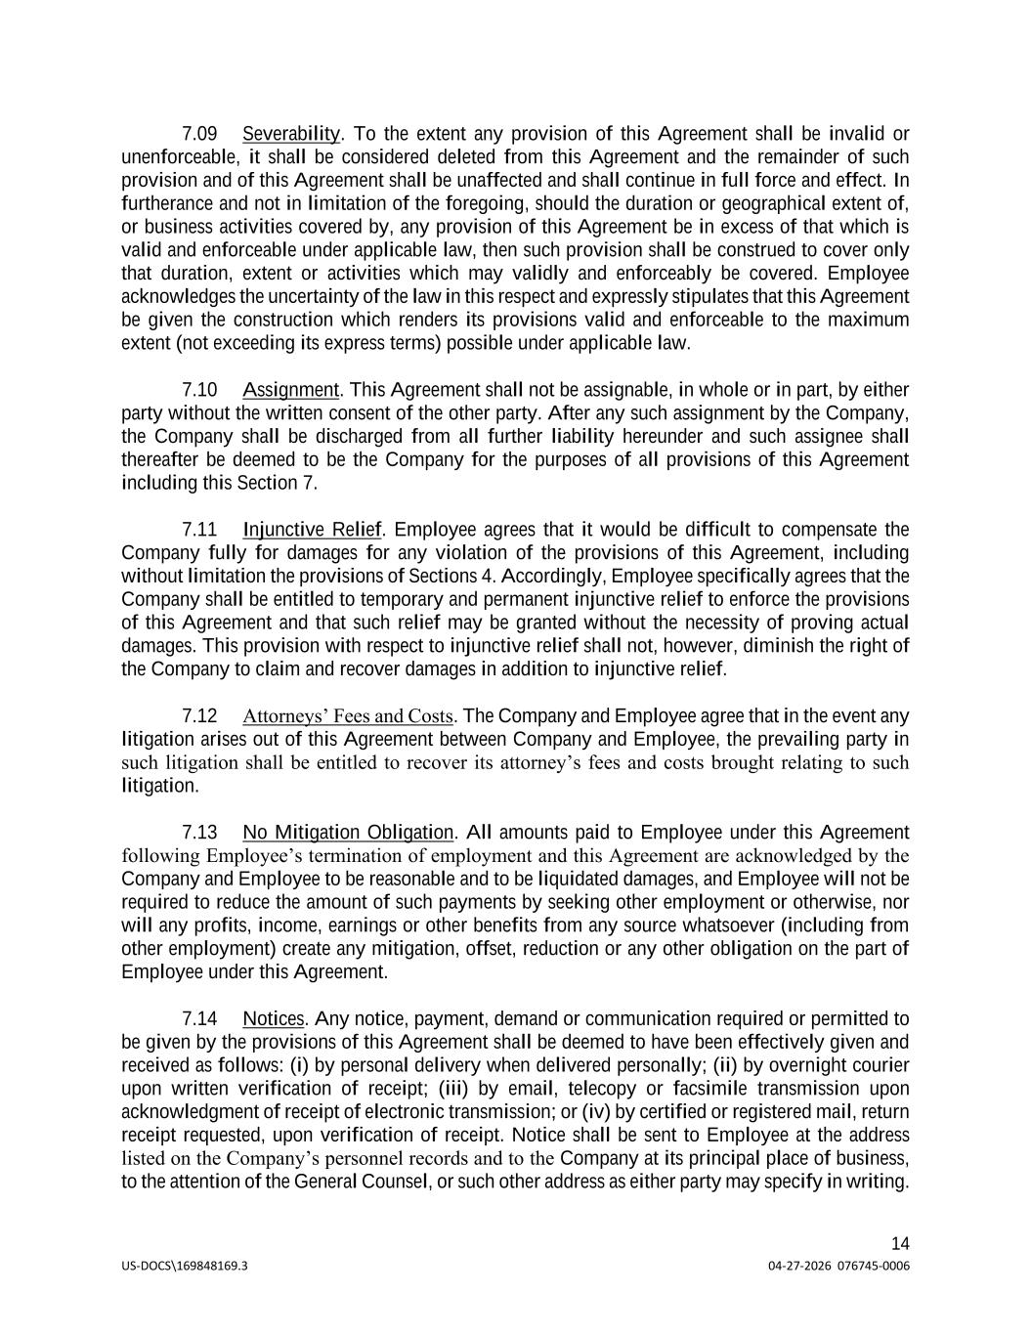
US-DOCS\169848169.3 04-27-2026 076745-0006 14 7.09 Severability. To the extent any provision of this Agreement shall be invalid or unenforceable, it shall be considered deleted from this Agreement and the remainder of such provision and of this Agreement shall be unaffected and shall continue in full force and effect. In furtherance and not in limitation of the foregoing, should the duration or geographical extent of, or business activities covered by, any provision of this Agreement be in excess of that which is valid and enforceable under applicable law, then such provision shall be construed to cover only that duration, extent or activities which may validly and enforceably be covered. Employee acknowledges the uncertainty of the law in this respect and expressly stipulates that this Agreement be given the construction which renders its provisions valid and enforceable to the maximum extent (not exceeding its express terms) possible under applicable law. 7.10 Assignment. This Agreement shall not be assignable, in whole or in part, by either party without the written consent of the other party. After any such assignment by the Company, the Company shall be discharged from all further liability hereunder and such assignee shall thereafter be deemed to be the Company for the purposes of all provisions of this Agreement including this Section 7. 7.11 Injunctive Relief. Employee agrees that it would be difficult to compensate the Company fully for damages for any violation of the provisions of this Agreement, including without limitation the provisions of Sections 4. Accordingly, Employee specifically agrees that the Company shall be entitled to temporary and permanent injunctive relief to enforce the provisions of this Agreement and that such relief may be granted without the necessity of proving actual damages. This provision with respect to injunctive relief shall not, however, diminish the right of the Company to claim and recover damages in addition to injunctive relief. 7.12 Attorneys’ Fees and Costs. The Company and Employee agree that in the event any litigation arises out of this Agreement between Company and Employee, the prevailing party in such litigation shall be entitled to recover its attorney’s fees and costs brought relating to such litigation. 7.13 No Mitigation Obligation. All amounts paid to Employee under this Agreement following Employee’s termination of employment and this Agreement are acknowledged by the Company and Employee to be reasonable and to be liquidated damages, and Employee will not be required to reduce the amount of such payments by seeking other employment or otherwise, nor will any profits, income, earnings or other benefits from any source whatsoever (including from other employment) create any mitigation, offset, reduction or any other obligation on the part of Employee under this Agreement. 7.14 Notices. Any notice, payment, demand or communication required or permitted to be given by the provisions of this Agreement shall be deemed to have been effectively given and received as follows: (i) by personal delivery when delivered personally; (ii) by overnight courier upon written verification of receipt; (iii) by email, telecopy or facsimile transmission upon acknowledgment of receipt of electronic transmission; or (iv) by certified or registered mail, return receipt requested, upon verification of receipt. Notice shall be sent to Employee at the address listed on the Company’s personnel records and to the Company at its principal place of business, to the attention of the General Counsel, or such other address as either party may specify in writing.

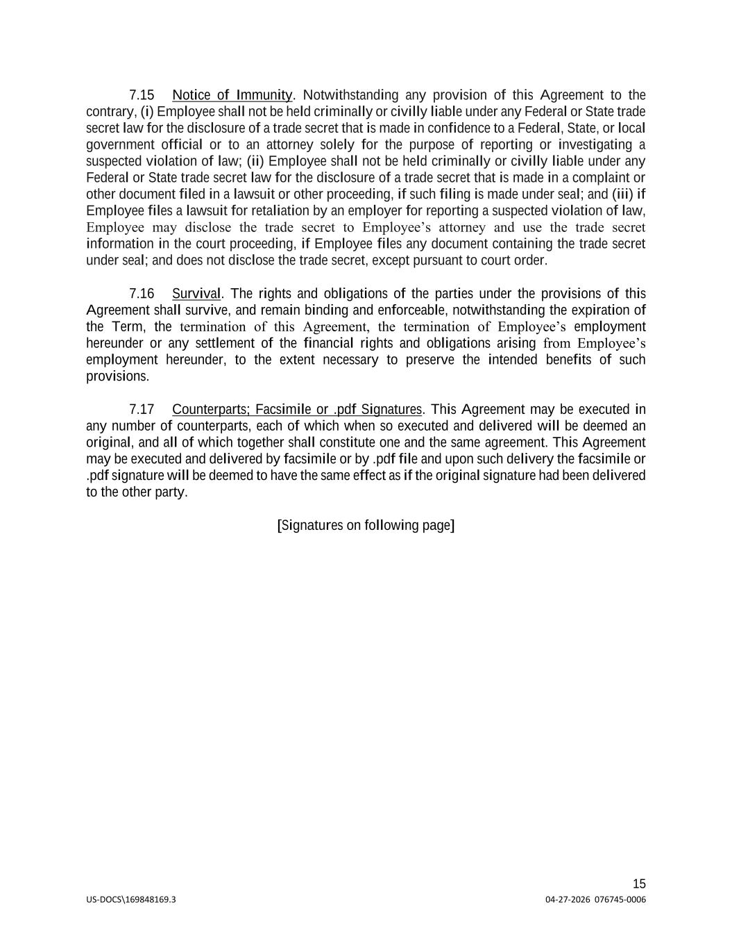
US-DOCS\169848169.3 04-27-2026 076745-0006 15 7.15 Notice of Immunity. Notwithstanding any provision of this Agreement to the contrary, (i) Employee shall not be held criminally or civilly liable under any Federal or State trade secret law for the disclosure of a trade secret that is made in confidence to a Federal, State, or local government official or to an attorney solely for the purpose of reporting or investigating a suspected violation of law; (ii) Employee shall not be held criminally or civilly liable under any Federal or State trade secret law for the disclosure of a trade secret that is made in a complaint or other document filed in a lawsuit or other proceeding, if such filing is made under seal; and (iii) if Employee files a lawsuit for retaliation by an employer for reporting a suspected violation of law, Employee may disclose the trade secret to Employee’s attorney and use the trade secret information in the court proceeding, if Employee files any document containing the trade secret under seal; and does not disclose the trade secret, except pursuant to court order. 7.16 Survival. The rights and obligations of the parties under the provisions of this Agreement shall survive, and remain binding and enforceable, notwithstanding the expiration of the Term, the termination of this Agreement, the termination of Employee’s employment hereunder or any settlement of the financial rights and obligations arising from Employee’s employment hereunder, to the extent necessary to preserve the intended benefits of such provisions. 7.17 Counterparts; Facsimile or .pdf Signatures. This Agreement may be executed in any number of counterparts, each of which when so executed and delivered will be deemed an original, and all of which together shall constitute one and the same agreement. This Agreement may be executed and delivered by facsimile or by .pdf file and upon such delivery the facsimile or .pdf signature will be deemed to have the same effect as if the original signature had been delivered to the other party. [Signatures on following page]

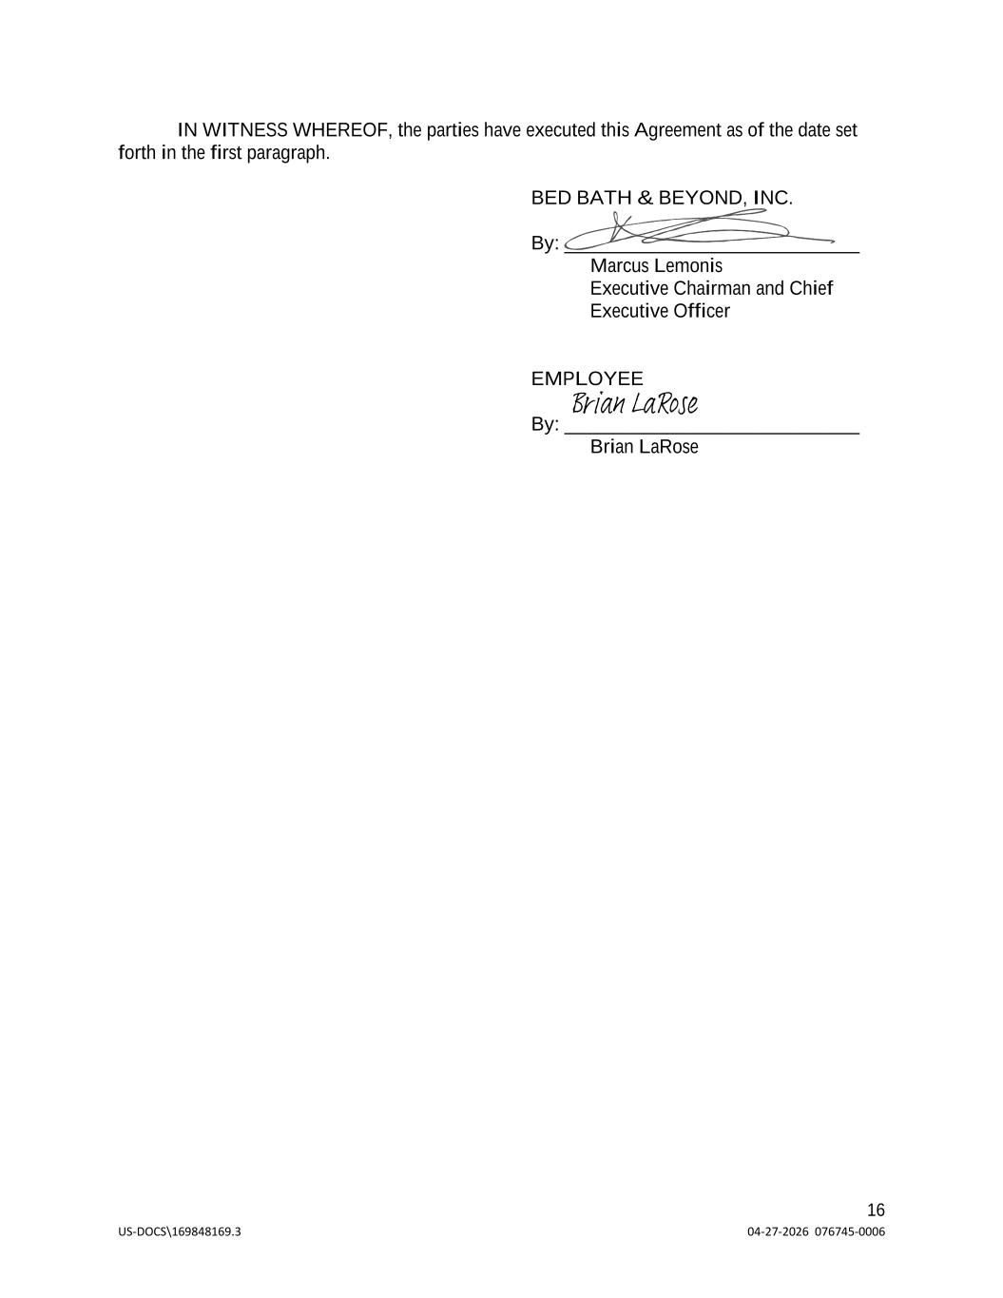
US-DOCS\169848169.3 04-27-2026 076745-0006 16 IN WITNESS WHEREOF, the parties have executed this Agreement as of the date set forth in the first paragraph. BED BATH & BEYOND, INC. By: ______________________________ Marcus Lemonis Executive Chairman and Chief Executive Officer EMPLOYEE By: ______________________________ Brian LaRose Brian LaRose


US-DOCS\169848169.3 04-27-2026 076745-0006 17 EXHIBIT A Confidentiality Agreement [Attached]


US-DOCS\169848169.3 04-27-2026 076745-0006 18 EXHIBIT B Indemnification Agreement [Attached]

EMPLOYMENT AGREEMENT
THIS EMPLOYMENT AGREEMENT (this “Agreement”) is entered into as of April 2, 2026 and effective as of April 2, 2026 (the “Effective Date”), by and between Lisa Foley (“Employee”) and Bed Bath & Beyond, Inc., a Delaware corporation (“Bed Bath & Beyond,” and, together with any of the Affiliates of Bed Bath & Beyond as may employ Employee from time to time, and any successor(s) thereto, the “Company”).
RECITALS
WHEREAS, commencing on the Effective Date, the Company desires to employ Employee as its Chief Operating Officer pursuant to the terms set forth in this Agreement, and Employee desires to be employed by Company pursuant to the terms and conditions of this Agreement.
NOW, THEREFORE, for good and valuable consideration, the receipt and sufficiency of which is hereby acknowledged, the parties agree as follows:
1. Employment. The Company agrees to employ Employee as the Company’s Chief Operating Officer on the terms and conditions set forth in this Agreement, and Employee agrees to accept such employment and agrees to perform the services and duties for the Company as herein provided for the period and upon the other terms and conditions set forth in this Agreement. Employee shall be subject to the direction of the Company’s President or, in the case of the President’s incapacity or unavailability, the Executive Chairman and Chief Executive Officer. Employee’s employment hereunder will commence on the Effective Date and continue until terminated pursuant to Section 6 below (the “Term”). Employee’s employment with the Company under this Agreement is on an at-will basis, meaning that either Employee or the Company may terminate the employment at any time for any reason or no reason. Notwithstanding the foregoing, Employee may be entitled to severance upon certain qualifying terminations of employment, as outlined in Section 6 below.
2. Position and Duties.
2.01 Title. During the Term, Employee agrees to serve as the Company’s Chief Operating Officer and undertake such additional duties as may be directed by the Company’s President, Executive Chairman and Chief Executive Officer or Board of Directors.
2.02 Duties: Location.
(a) During the Term of this Agreement, Employee agrees to serve the Company and Employee will faithfully and to the best of her ability discharge her duties and will devote substantially all of her business time and effort to the business and affairs of the Company, its direct and indirect subsidiaries and certain Affiliates (as defined below) of the Company. Employee shall not engage in other employment or become involved in other business ventures requiring Employee’s time, absent the prior written consent of the President, which consent may be withheld or denied in the sole discretion of the President. In addition, Employee understands that the Company’s Board of Directors may, from time to time, direct that Employee assist and provide services to one or more other entities directly or indirectly owned or controlled by, or under common ownership or control with, the Company (“Affiliates”). Employee will also be expected to adhere to the general employment policies and practices of the Company that may be in effect from time to time.
1

|US-DOCS\169935849.1|| | |
(b) Notwithstanding the foregoing, Employee shall be permitted to (i) manage her personal investments, and (ii) participate in, and be involved with, community, educational, charitable, professional, and religious organizations, and not-for-profit businesses that do not compete with the Company or any of its Affiliates (the “Permitted Outside Activities”).
(c) Employee shall perform Employee’s duties under this Agreement primarily from the Company’s offices in Nashville, Tennessee, subject to reasonable business travel to the Company’s offices and elsewhere as necessitated by Employee’s duties or as reasonably requested by the Company’s Board of Directors from time to time.
3. Compensation.
3.01 Base Salary. During the Term of this Agreement, the Company shall pay to Employee a base annual salary of Five Hundred Thousand and No/100 Dollars ($500,000), which shall be subject to annual review by the Company’s Board of Directors or the Compensation Committee thereof (“Base Salary”). Employee’s Base Salary shall be paid in accordance with the Company's normal payroll procedures and policies.
3.02 Annual Bonus. For each fiscal year during the Term, Employee shall have the opportunity to earn an annual bonus (“Annual Bonus”) based on performance against specified performance objectives to be established prior to or as soon as practicable following the commencement of each fiscal year by the Company’s Board of Directors or the Compensation Committee thereof. For each fiscal year during the Term, Employee’s target annual bonus for each fiscal year shall be 50% of her Base Salary (“Target Bonus”). Except as set forth in Section 6, Employee must be employed on the day that Annual Bonuses (if any) are paid in order to earn such Annual Bonus. For 2026, Employee’s Target Bonus and final Annual Bonus for all purposes under this Agreement will be calculated based on her base salary actually received during the year (for the avoidance of doubt, based on her base salary prior to the Effective Date paid by The Brand Home Collective, Inc. at the rate in effect for the portion of the year prior to the Effective Date, and based on the Base Salary for the portion of the year following the Effective Date).
3.03 Benefits. Employee may participate in all employee benefit plans or programs of the Company consistent with such plans and programs of the Company, provided that in no event shall Employee be eligible to participate in the Company’s Key Employee Severance Plan or any other severance plan or program of the Company, except as set forth in Section 6. The Company does not guarantee the adoption or continuance of any particular employee benefit plan or program during the term of this Agreement, and Employee’s participation in any such plan or program shall be subject to the provisions, rules and regulations applicable thereto.
3.04 Expenses; Contributions. Company agrees to reimburse all reasonable business expenses incurred by Employee consistent with the Company’s policies regarding reimbursement in the performance of Employee’s duties under this Agreement.
3.05 Vacation and Sick leave. Employee shall be entitled to paid time off to be used (without set limits) for purposes such as vacation, relaxation, personal or family needs. Absences shall be governed by Company leave policies (subject to the limits specified in those policies).
3.06 Sign-On Equity Award. As soon as reasonably practicable following the Effective Date, Employee shall be eligible to receive an equity award with a target value of
2

|US-DOCS\169935849.1|| | |
$1,500,000 that will vest over a period of four years (the “Sign-On Equity Award”). The Sign-On Equity Award will be granted as follows: (i) 70% of the Sign-On Equity Award will be granted in the form of time-based restricted stock units with a grant value of $1,050,000, vesting in four equal installments on each of the first, second, third, and fourth anniversaries of the Effective Date, and (ii) 30% of the Sign-On Equity Award will be granted in the form of performance-based restricted stock units with a target value of $450,000 (assuming “target” performance), vesting over four years from the Effective Date, with 25% of the award eligible to vest based on performance for each of 2026, 2027, 2028 and 2029 based on annual performance metrics to be established at the beginning of each year by the Board of Directors, in each case, subject to Employee’s continued service through the applicable vesting dates. For the avoidance of doubt, the annual performance metrics for 2026 shall be the same as those metrics established by the Board of Directors or the Compensation Committee for purposes of the performance-based restricted stock units granted to the Company’s other executive officers for such year. The Sign-On Equity Award will be granted pursuant to the 2005 Plan, or a successor equity plan, and the terms of an applicable award agreement.
3.07 Annual Awards. Employee may be eligible for additional refresh awards to be approved by the Company’s Board of Directors or the Compensation Committee thereof at their discretion based on Employee’s performance and Company performance in the future.
3.08 No Additional Compensation. As of the Effective Date, the compensation set forth in this Section 3 represents the sole compensation Employee is entitled to receive in exchange for serving as Chief Operating Officer of the Company, and, for the avoidance of doubt, Employee shall not be entitled to any additional compensation in respect of her role as an officer or director of any subsidiary or affiliate of the Company.
4. Restrictive Covenants, Company Policies and Confidential Information.
4.01 Confidential Information. In connection with Employee’s employment with the Company, Employee will receive and have access to Company confidential information and trade secrets. Accordingly, Employee will be required to execute and abide by the terms of the Company’s standard form of Employment, Confidential Information and Invention Assignment and Arbitration Agreement (the “Confidentiality Agreement”), which is attached to this Agreement as Exhibit A. In Employee’s work for the Company, Employee is expected not to use or disclose any confidential information, including trade secrets, of any former employer or other person to whom Employee has an obligation of confidentiality. Rather, Employee is expected to use only that information which is generally known and used by persons with training and experience comparable to Employee’s own, which is common knowledge in the industry or otherwise legally in the public domain, or which is otherwise provided or developed by the Company. Employee agrees that she will not bring onto Company premises any unpublished documents or property belonging to any former employer or other person to whom Employee has an obligation of confidentiality. Employee hereby represents that her employment does not create a conflict with any agreement between Employee and a third party.
4.02 Company Policies. Employee is required to abide by the Company’s policies and procedures (including but not limited to the Company’s employee handbook), as adopted or modified from time to time within the Company’s discretion, and acknowledge in writing that Employee has read and will comply with such policies and procedures (and provide additional
3

|US-DOCS\169935849.1|| | |
such acknowledgements as such policies and procedures may be modified from time to time). The Company may modify, revoke, suspend or terminate any of the policies and/or procedures at any time, with or without notice.
4.03 Non-Competition. Employee agrees that, during the Term and for a period of one year after the termination of Employee’s employment or service for any reason (the “Non-Compete Period”), Employee shall not, directly or indirectly, (a) engage in activities or businesses (including without limitation by owning any interest in, managing, controlling, participating in, consulting with, advising, rendering services for, or in any manner engaging in the business of owning, operating or managing any business) in any geographic location in which the Company, its subsidiaries or Affiliates engage in the business of the Company, whether through selling, distributing, manufacturing, marketing, purchasing, or otherwise, that compete directly or indirectly with the Company or any of its subsidiaries or Affiliates (“Competitive Activities”); or (b) assist any person in any way to do, or attempt to do, anything prohibited by Section 4.03(a) above. Employee acknowledges that the business of the Company and its Affiliates is international in scope and without geographical limitation within the United States. The Company agrees that Employee’s engagement in the Permitted Outside Activities will not constitute a Competitive Activity.
4.04 Indirect Competition. Employee further agrees that, during the Term and the Non-Compete Period, she will not, directly or indirectly, assist or encourage any other person in carrying out, direct or indirectly, any activity that would be prohibited by Section 4.03 if such activity were carried out by Employee, either directly or indirectly; and in particular Employee agrees that she will not, directly or indirectly, induce any employee of the Company to carry out, directly or indirectly, any such activity.
4.05 Non-Solicitation. Employee further agrees that, during the Term and the Non-Compete Period, she will not, directly or indirectly, solicit, induce, recruit or encourage any of the Company’s employees to leave their employment, or take away such employees, or attempt to solicit, induce, recruit, encourage or take away employees of the Company, either for herself or for any other person or entity.
4.06 Tolling of Period and Enforceability. The Non-Compete Period shall be tolled during (and shall be deemed automatically extended by) any period in which Employee is in violation of the provisions of this Section 4. If a final and non-appealable judicial determination is made that any of the provisions of this Section 4 constitutes an unreasonable or otherwise unenforceable restriction against Employee, the provisions of this Section 4 will not be rendered void but will be deemed to be modified to the minimum extent necessary to remain in force and effect for the longest period and largest geographic area that would not constitute such an unreasonable or unenforceable restriction. Moreover, and without limiting the generality of Section 4, notwithstanding the fact that any provision of this Section 4 is determined to not be enforceable through specific performance, the Company will nevertheless be entitled to recover monetary damages as a result of Employee’s breach of such provision.
4.07 Passive Ownership. The provisions of Section 4 shall not be deemed breached as a result of Employee’s ownership of: (i) less than an aggregate of 5% of any class of securities of a person engaged, directly or indirectly, in Competitive Activities, so long as Employee does not actively participate in the business of such person; or (ii) less than an aggregate of 5% in
4

|US-DOCS\169935849.1|| | |
value of any instrument of indebtedness of a person engaged, directly or indirectly, in Competitive Activities.
4.08 Acknowledgement. Employee acknowledges that Employee has carefully read this Agreement and has given careful consideration to the restraints imposed upon Employee by this Agreement and the Confidentiality Agreement and is in full accord as to the necessity of such restraints for the reasonable and proper protection of the Confidential Information (as defined in the Confidentiality Agreement), business strategies, employee and customer relationships and goodwill of the Company and its subsidiaries and Affiliates now existing or to be developed in the future. Employee expressly acknowledges and agrees that each and every restraint imposed by this Agreement and the Confidentiality Agreement is reasonable with respect to subject matter, time period and geographical area. Employee further acknowledges that although Employee’s compliance with the covenants contained in the Confidentiality Agreement and this Section 4 may prevent Employee from earning a livelihood in a business similar to the business of the Company, Employee’s experience and capabilities are such that Employee has other opportunities to earn a livelihood and adequate means of support for Employee and Employee’s dependents.
4.09 Permitted Activities. Notwithstanding anything to the contrary herein, nothing in this Agreement shall prevent Employee or the Company from, as applicable, (i) communicating directly with, cooperating with, filing a charge with, reporting possible violations of federal law or regulation to, or providing information to any federal, state or local government agency, including without limitation, the U.S. Securities and Exchange Commission, the U.S. Commodity Futures Trading Commission, the U.S. Department of Justice, the U.S. Equal Employment Opportunity Commission, or the U.S. National Labor Relations Board, (ii) providing truthful information to the extent required by applicable law in connection with any legal proceeding, government investigation or other legal matter; (iii) exercising any rights Employee may have under Section 7 of the U.S. National Labor Relations Act, or (iv) discussing or disclosing information about unlawful acts in the workplace, such as harassment or discrimination based on a protected characteristic or any other conduct that Employee has reason to believe is unlawful. In addition, Employee acknowledges receipt of the following notice of immunity rights under the U.S. Defend Trade Secrets Act, which states: “(1) An individual shall not be held criminally or civilly liable under any federal or state trade secret law for the disclosure of a trade secret that (A) is made (i) in confidence to a Federal, State, or local government official, either directly or indirectly, or to an attorney; and (ii) solely for the purpose of reporting or investigating a suspected violation of law; or (B) is made in a complaint or other document filed in a lawsuit or other proceeding, if such filing is made under seal; and (2) an individual who files a lawsuit for retaliation by an employer for reporting a suspected violation of law may disclose a trade secret to the attorney of the individual and use the trade secret information in the court proceeding, if the individual (A) files any document containing the trade secret under seal, and (B) does not disclose a trade secret, except pursuant to court order.”
5. Indemnification and Additional Insurance. The Company shall indemnify Employee with respect to matters relating to Employee’s services as an officer of the Company or any of its Affiliates, occurring during the course and scope of Employee’s employment with the Company to the extent and pursuant to the provisions of Delaware law. The foregoing indemnity is contractual and will survive any adverse amendment to or repeal of this Agreement. The
5

|US-DOCS\169935849.1|| | |
Company will also cover Employee under a policy of officers’ and directors’ liability insurance providing coverage that is comparable to that provided now or hereafter to other senior executives of the Company. The provisions of this Section will survive the termination of this Agreement for any reason. In furtherance of the foregoing, the Company and Employee will enter into an Indemnification Agreement in the form attached hereto as Exhibit B (the “Indemnification Agreement”).
6. Termination.
6.01 Grounds for Termination. Employee’s employment with the Company shall terminate under any of the circumstances set forth below.
a.If Employee shall die or due to Employee’s Disability (as defined in Section 6.04 below);
b.By mutual agreement of the Company and Employee;
c.By Employee for any reason other than Good Reason upon notice to the Company;
d.By the Company for Cause (as defined in Section 6.02 below);
e.By the Company without Cause (and other than by reason of Employee’s death or termination due to Disability); and
f.By Employee for Good Reason (as defined in Section 6.04 below).
Notwithstanding any termination of this Agreement and Employee’s employment by the Company, Employee, in consideration of her employment hereunder to the date of such termination, shall remain bound by the provisions of this Agreement which specifically relate to periods, activities or obligations upon or subsequent to the termination of Employee’s employment including without limitation the provisions of Sections 4, 5 and 7 hereof.
6.02 For “Cause” Defined. Termination of Employee’s employment by the Company for any of the following reasons shall be deemed termination for “Cause”:
a.An act of personal dishonesty taken by Employee in connection with her responsibilities with the Company;
b.Employee’s commission of a felony or any other criminal conviction if such conviction involves Employee’s lack of honesty;
c.A willful act by Employee which constitutes gross misconduct or intentional violation of the Company’s policies or agreements; or
d.Following delivery to Employee of a written demand for performance from the Company which describes the basis for the Company’s reasonable belief that Employee has not substantially performed her duties, continued violations by Employee of her obligations to the Company which are demonstrably willful and deliberate on Employee’s part.
6.03 “Change in Control” Defined. For purposes of this Agreement, “Change in Control” shall mean the occurrence of any of the following events:
a.Any “person” (as such term is used in Sections 13(d) and 14(d) of the Securities Exchange Act of 1934, as amended (the “Exchange Act”)) becomes the “beneficial owner” (as defined in Rule 13d-3 of the Exchange Act), directly or indirectly, of securities of the Company representing fifty percent (50%) or more
6

|US-DOCS\169935849.1|| | |
of the total voting power represented by the Company’s then outstanding voting securities;
b.The consummation of the sale or disposition by the Company of all or substantially all of the Company’s assets;
c.A change in the composition of the Board of Directors occurring within a one-year period, as a result of which fewer than a majority of the directors are Incumbent Directors. “Incumbent Directors” means directors who either (A) are members of the Board of Directors as of the Effective Date, or (B) are elected, or nominated for election, to the Board of Directors with the affirmative votes of at least a majority of the Incumbent Directors at the time of such election or nomination (but will not include an individual whose election or nomination is in connection with an actual or threatened proxy contest relating to the election of directors to the Company); or
d.The consummation of a merger or consolidation of the Company with any other corporation, other than a merger or consolidation which would result in the voting securities of the Company outstanding immediately prior thereto continuing to represent (either by remaining outstanding or by being converted into voting securities of the surviving entity or its parent) at least fifty percent (50%) of the total voting power represented by the voting securities of the Company or such surviving entity or its parent outstanding immediately after such merger or consolidation.
6.04 “Disability” Defined. The Company may determine that Employee is disabled if she shall fail, because of illness or incapacity, to render services of the character contemplated by this Agreement for a period of twelve (12) consecutive months.
6.05 “Good Reason” Defined. For purposes of this Agreement, “Good Reason” shall mean the occurrence of any of the following without Employee’s written consent:
a.A material reduction of Employee’s duties, authority or responsibilities, relative to Employee’s duties, authority or responsibilities as in effect immediately prior to such reduction, or the assignment to Employee of such reduced duties, authority or responsibilities, including, without limitation, following a Change in Control, Employee ceasing to report to the president or chief executive officer or the board of directors of the ultimate parent entity of the Company (or its successor), and/or Employee ceasing to serve as the chief operating officer (or a more senior position) of such ultimate parent entity; provided that, prior to a Change in Control, a change in title or reporting relationship alone shall not constitute Good Reason;
b.A material reduction by the Company in the Base Salary or Target Bonus as in effect immediately prior to such reduction; provided that if the salaries or target bonuses of substantially all of the Company’s senior executive officers are contemporaneously and proportionately reduced, a reduction in Employee’s Base Salary or Target Bonus will not constitute “Good Reason” hereunder;
c.The involuntary relocation of Employee’s principal place of employment by more than thirty-five (35) miles from the present facility or location; or
7

|US-DOCS\169935849.1|| | |
d.The Company’s material breach of this Agreement or any other written agreement between Employee and the Company.

Employee will not be deemed to have resigned for Good Reason unless (i) Employee provides the Company with written notice setting forth in reasonable detail the facts and circumstances claimed by Employee to constitute Good Reason within fifteen (15) days after the date of the occurrence of any event that Employee knows or should reasonably have known to constitute Good Reason, (ii) the Company fails to cure such acts or omissions within thirty (30) days following its receipt of such notice, and (iii) the effective date of Employee’s termination for Good Reason occurs no later than sixty (60) days after the expiration of the cure period.
6.06 Surrender of Records and Property. Upon termination of her employment with the Company for any reason, Employee shall deliver promptly to the Company all records, manuals, books, blank forms, documents, letters, memoranda, notes, notebooks, reports, data, tables, calculations or copies thereof, which are the property of the Company or any of its Affiliates or which relate in any way to the business, products, practices or techniques of the Company or any of its Affiliates, and all other property, trade secrets and confidential information of the Company or any of its Affiliates, including, but not limited to, all documents which in whole or in part contain any trade secrets or confidential information of the Company or any of its Affiliates, which in any of these cases are in her possession or under her control.
6.07 Payments Upon Termination.
(a)Accrued Obligations. If Employee’s employment with the Company is terminated for any reason set forth in Section 6, then Employee shall be entitled to receive (i) her Base Salary and any accrued but unpaid paid time off through the date of the termination and (ii) reimbursement of any business expenses incurred in the ordinary course of business through the date of termination that have not yet been reimbursed pursuant to Section 3.04 (the amounts in this clause (a), the “Accrued Obligations”).

(b)Termination Without Cause or Resignation for Good Reason. If Employee’s employment is terminated pursuant to Section 6.01(e) or (f) (each, a “Qualifying Termination”) and provided that Employee shall have executed and delivered to the Company the Company’s standard form of release of claims (a “Release”) and any period for rescission of such Release has expired without Employee having rescinded such Release, in addition to the Accrued Obligations, Employee shall be entitled to receive: (i) an amount in cash equal to Employee’s then-current Base Salary, which amount will be paid over a period of twelve (12) months following the date of Employee’s Qualifying Termination in accordance with the Company’s standard payroll practices, with the first such installment occurring on the first regularly-scheduled payroll date following the date the Release becomes effective (which first installment will include any installments that would have occurred prior to such date but for the fact the Release was not yet effective); (ii) in the event of Employee’s Qualifying Termination following the end of a fiscal year but prior to the payment of the Annual Bonus for such fiscal year, the amount of any earned but unpaid Annual Bonus for such completed fiscal year based on performance for such completed fiscal year as determined by the Company’s Board of Directors or the Compensation Committee thereof, which amount shall be payable when annual bonuses are paid to the Company’s employees generally; and (iii) if Employee timely elects to receive
8

|US-DOCS\169935849.1|| | |
continued coverage under one or more of the Company’s group medical, dental or vision plans pursuant to the Consolidated Omnibus Budget Reconciliation Act of 1985, as amended (together with any state law of similar effect, “COBRA”), then the Company will pay the full amount of Employee’s COBRA premiums, or will provide coverage under the Company’s self-funded broad based health insurance plans, on behalf of Employee, including coverage for the Employee’s eligible dependents under such plans, until the earliest of (X) twelve (12) months following the date of the Qualifying Termination, (Y) the expiration of Employee’s eligibility for continuation coverage under COBRA or (Z) the date when Employee becomes eligible for substantially equivalent health insurance coverage in connection with new employment or self-employment (such period from the date of the Qualifying Termination through the earliest of (X) through (Z), the “COBRA Payment Period”).

Notwithstanding clause (iv) above, if at any time the Company determines in its sole discretion that the payment of COBRA premiums (or credit under the self-funded plan) pursuant to Section 6.07(b)(iv) would result in a violation of the nondiscrimination rules of Section 105(h) of the Code or any statute or regulation of similar effect (including, without limitation, the 2010 Patient Protection and Affordable Care Act, as amended by the 2010 Health Care and Education Reconciliation Act), then in lieu of providing the COBRA premiums or credit under the self-funded plan, the Company shall instead pay Employee, on the first day of each month of the remainder of the COBRA Payment Period, a fully taxable cash payment equal to the COBRA premiums for that month (or, in the case of a self-funded plan, the monthly cost or such coverage), subject to withholdings and deductions. In all cases, if Employee becomes eligible for coverage under another employer’s group health plan or otherwise ceases to be eligible for COBRA during the COBRA Payment Period, Employee must immediately notify the Company of such event. For purposes of this paragraph, any applicable insurance premiums that are paid by the Company will not include any amounts payable by Employee under a Section 125 health care reimbursement plan, which amounts, if any, are the sole responsibility of Employee.

(c)Change in Control Qualifying Termination. In lieu of the payments and benefits set forth in Section 6.07(b), in the event Employee’s Qualifying Termination occurs on or within twelve (12) months following the date of a Change in Control, and provided that Employee shall have executed and delivered to the Company the Release and any period for rescission of such Release has expired without Employee having rescinded such Release, in addition to the Accrued Obligations, Employee shall be entitled to receive: (i) an amount in cash equal to Employee’s then-current Base Salary, which amount will be paid over a period of twelve (12) months following the date of Employee’s Qualifying Termination in accordance with the Company’s standard payroll practices, with the first such installment occurring on the first regularly-scheduled payroll date following the date the Release becomes effective (which first installment will include any installments that would have occurred prior to such date but for the fact the Release was not yet effective); (ii) the payment set forth in Section 6.07(b)(ii), if applicable; (iii) an amount in cash equal to Employee’s then-current Target Bonus, which amount shall be paid in a lump sum on the sixtieth (60th) day after the date of the Qualifying Termination; (iv) the benefits set forth in Section 6.07(b)(iv); and (v) all unvested equity or equity-based awards held by Employee that vest solely based on the passage of time shall immediately become one hundred percent (100%) vested (for the avoidance of doubt, with any such awards that vest in
9

|US-DOCS\169935849.1|| | |
whole or in part based on the attainment of performance-vesting conditions being governed by the terms of the applicable award agreement), provided that this clause (v) shall not supersede any equity acceleration provided under an applicable award agreement that is more favorable to Employee.

1.08Termination of Benefits. Employee’s right to receive severance payments and benefits hereunder will terminate immediately if, at any time prior to or during the period for which Employee is receiving severance payments and benefits, Employee, without the prior written approval of the Board of Directors or the Compensation Committee thereof, (a) willfully breaches a material provision of this Agreement, the Confidentiality Agreement and/or obligations of confidentiality, non-solicitation, non-disparagement, no conflicts or non-competition set forth in this Agreement, the Release or under applicable law; or (b) solicits any of the Company’s then current employees to leave the Company’s employ for any reason or interferes in any other manner with employment relationships at the time existing between the Company and its then current employees.

1.09Deemed Resignation. Upon termination of Employee’s employment for any reason, Employee shall be deemed to have resigned from all offices and directorships, if any, then held with the Company or any of its Affiliates.
1.10Severance Calculation Matters. For calculating the severance payments in this Section 6, Base Salary, and Target Bonus shall be determined as of the date of Employee’s Qualifying Termination and without regard to any reduction in such amounts giving rise to Employee’s resignation for Good Reason.

7. Miscellaneous.

7.01 Governing Law; Venue. This Agreement is made under and shall be governed by and construed in accordance with the laws of the State of Tennessee.

7.02 Prior Agreements. This Agreement, together with the Confidentiality Agreement and the Indemnification Agreement, contain the entire agreement of the parties relating to the subject matter hereof and supersede all prior agreements and understandings with respect to such subject matter, and the parties hereto have made no agreement, representations or warranties relating to the subject matter of this Agreement which are not set forth herein. Specifically, on the Effective Date, that certain Employment Agreement dated as of October 20, 2025, between Employee and The Brand House Collective, Inc. (the “Prior Agreement”) is hereby terminated and shall be of no further force or effect. Employee hereby acknowledges and agrees that the termination of the Prior Agreement is done with her written consent and shall in no way give rise to any claim of Good Reason by Employee.

7.03 Withholding Taxes. The Company may withhold from any benefits payable under this Agreement all federal, state, city or other taxes as shall be required pursuant to any law or governmental regulation or ruling.

10

|US-DOCS\169935849.1|| | |
7.04 Amendments. No amendments or modifications of this Agreement shall be deemed effective unless made in writing and signed by the parties hereto.
7.05 No Waiver. No term or condition of this Agreement shall be deemed to have been waived, nor shall there by an estoppel to enforce any provisions of this Agreement, except by a statement in writing signed by the party against whom enforcement of the waiver or estoppel is sought. Any written waiver shall not be deemed a continuing waiver unless specifically stated, shall operate only as to the specific term or condition waived and shall not constitute a waiver of such term or condition for the future or as to any act other than that specifically waived.
7.06 Section 409A.
(a) For purposes of this Agreement, “Section 409A” means Section 409A of the Internal Revenue Code of 1986, as amended (the “Code”), and the Treasury Regulations promulgated thereunder (and such other Treasury or Internal Revenue Service guidance) as in effect from time to time. The parties intend that any amounts payable hereunder will be compliant with Section 409A or will be exempt from Section 409A. Notwithstanding the foregoing, Employee shall be solely responsible and liable for the satisfaction of all taxes and penalties that may be imposed on or for the account of Employee in connection with this Agreement (including any taxes and penalties under Section 409A of the Code), and neither the Company nor any of its Affiliates shall have any obligation to indemnify or otherwise hold Employee (or any beneficiary) harmless from any or all of such taxes or penalties. No provision of this Agreement shall be interpreted or construed to transfer any liability for failure to comply with the requirements of Section 409A from Employee or any other individual to the Company or any of its affiliates, employees or agents.
(b) Notwithstanding anything in this Agreement to the contrary, the following special rule shall apply, if and to the extent required by Section 409A, in the event that (i) Employee is deemed to be a “specified employee” within the meaning of Section 409A(a)(2)(B)(i), (ii) amounts or benefits under this Agreement or any other program, plan or arrangement of the Company or a controlled group affiliate thereof are due or payable on account of “separation from service” within the meaning of Treasury Regulations Section 1.409A-l(h) and (iii) Employee is employed by a public company or a controlled group affiliate thereof, then no payments hereunder that are “nonqualified deferred compensation” subject to Section 409A shall be made to Employee prior to the date that is six (6) months after the date of Employee’s separation from service or, if earlier, Employee’s date of death, and following any applicable six (6) month delay, all such delayed payments will be paid in a single lump sum on the earliest permissible payment date.
(c) Each payment made under this Agreement (including each separate installment payment in the case of a series of installment payments) shall be deemed to be a separate payment for purposes of Section 409A. Amounts payable under this Agreement shall be deemed not to be a “deferral of compensation” subject to Section 409A to the extent provided in the exceptions in Treasury Regulation §§ 1.409A-1(b)(4) (“short-term deferrals”) and (b)(9) (“separation pay plans,” including the exception under subparagraph (iii)) and other applicable provisions of Section 409A. For purposes of this Agreement, with respect to payments of any amounts that are considered to be “nonqualified deferred compensation” subject to Section 409A or exempt from Section 409A under Treasury Regulation §§ 1.409A-1(b)(9) (“separation pay
11

|US-DOCS\169935849.1|| | |
plans”), references to “termination of employment,” “termination,” or words and phrases of similar import, shall be deemed to refer to Employee’s “separation from service” as defined in Section 409A, and shall be interpreted and applied in a manner that is consistent with the requirements of Section 409A.
(d) Notwithstanding anything to the contrary in this Agreement, any payment or benefit under this Agreement or otherwise that is exempt from Section 409A pursuant to Treasury Regulation § 1.409A-l(b)(9)(v)(A) or (C) (relating to certain reimbursements and in-kind benefits) shall be paid or provided to Employee only to the extent that the expenses are not incurred, or the benefits are not provided, beyond the last day of the second calendar year following the calendar year in which Employee’s “separation from service” occurs; and provided further that such expenses are reimbursed no later than the last day of the third calendar year following the calendar year in which Employee’s “separation from service” occurs. To the extent any indemnification payment, expense reimbursement, or the provision of any in-kind benefit is determined to be subject to Section 409A (and not exempt pursuant to the prior sentence or otherwise), the amount of any such indemnification payment or expenses eligible for reimbursement, or the provision of any in-kind benefit, in one calendar year shall not affect the indemnification payment or provision of in-kind benefits or expenses eligible for reimbursement in any other calendar year (except for any life-time or other aggregate limitation applicable to medical expenses), and in no event shall any indemnification payment or expenses be reimbursed after the last day of the calendar year following the calendar year in which Employee incurred such indemnification payment or expenses, and in no event shall any right to indemnification payment or reimbursement or the provision of any in-kind benefit be subject to liquidation or exchange for another benefit.
(e) Notwithstanding anything to the contrary in this Agreement, to the extent that any payments due under this Agreement as a result of the Employee’s termination of employment with the Company are subject to the Employee’s execution and delivery and non-revocation of the Release (i) no such payments shall be made unless the Release Effective Date (as defined below) occurs on or prior to the sixtieth (60th) day immediately following Employee’s date of termination, (ii) the Company shall deliver the Release to the Employee within seven (7) days immediately following the date of termination, and (iii) if, as of the Release Expiration Date (as defined below), the Employee has failed to execute the Release or has timely revoked her acceptance of the Release thereafter, the Employee shall not be entitled to any payments or benefits otherwise conditioned on the Release. For purposes of this Agreement, the “Release Effective Date” shall mean the date on which the Release becomes effective and irrevocable in accordance with its terms. For purposes of this Section 7.06, “Release Expiration Date” shall mean the date that is twenty-one (21) days following the date upon which the Company timely delivers the Release to the Employee, or, in the event that the Employee’s termination of employment is “in connection with an exit incentive or other employment termination program” (as such phrase is defined in the Age Discrimination in Employment Act of 1967), the date that is forty-five (45) days following such delivery date.
7.07 280G Parachute Payments. Notwithstanding any other provision in this Agreement to the contrary, in the event that any payment or benefit received or to be received by Employee (including any payment or benefit received in connection with a Change in Control or the termination of Employee’s employment, whether pursuant to the terms of this Agreement or
12

|US-DOCS\169935849.1|| | |
any other plan, arrangement or agreement) (all such payments and benefits being hereinafter referred to as the “Total Payments”) would (i) constitute a “parachute payment” within the meaning of Section 280G of the Code , and (ii) but for this sentence, be subject (in whole or part), to the excise tax imposed under Section 4999 of the Code (the “Excise Tax”), then, the Total Payments shall be equal to the Reduced Amount. The “Reduced Amount” will be either (A) the largest portion of the Total Payments that would result in no portion of the Total Payments being subject to Excise Tax, or (B) the largest portion, up to and including the total amount of the Total Payments, whichever amount ((A) or (B)), after taking into account all applicable federal, state, provincial, foreign and local employment taxes, income taxes and the Excise Tax (all computed at the highest marginal rate), results in Employee’s receipt, on an after-tax basis, of the greatest economic benefit notwithstanding that all or some portion of the Total Payments may be subject to the Excise Tax. If a reduction in payments or benefits constituting “parachute payments” is necessary so that the Total Payments equal the Reduced Amount, the reduction will occur in the following order (1) reduction of cash payments; (2) cancelation of accelerated vesting of stock awards other than stock options; (3) cancellation of accelerated vesting of stock options; and (4) reduction of other benefits paid to Employee. Within any such category of Total Payments (that is, (1), (2), (3) or (4)), a reduction will occur first with respect to amounts that are not “deferred compensation” within the meaning of Section 409A and then with respect to amounts that are. In the event that acceleration of vesting of stock award compensation is to be reduced, such acceleration of vesting will be cancelled in the reverse order of the date of grant of Employee’s applicable type of stock award (i.e., earliest granted stock awards are cancelled last). Any determination under this Section 7.07 shall be made in writing in good faith by an independent accounting firm or consultants of nationally recognized standing (the “Independent Advisors”) selected by the Company and acceptable to Employee, which shall provide detailed supporting calculations to the Company and Employee as requested by the Company or Employee. The Company and Employee shall provide the Independent Advisors with such information and documents as the Independent Advisors may reasonably request in order to make a determination under this Section. For purposes of making the calculations and determinations required by this Section, the Independent Advisors may rely on reasonable, good faith assumptions and approximations concerning the application of Section 280G and Section 4999 of the Code. The Independent Advisors’ determinations shall be final and binding on the Company and Employee.
7.08 Compensation Recovery Policy. The Employee acknowledges and agrees that she shall take all action necessary or appropriate to comply with the clawback or similar policy adopted by the Company pursuant to the Dodd-Frank Wall Street Reform and Consumer Protection Act or any other clawback or similar policy otherwise adopted by the Company, and any rules and regulations promulgated thereunder (including, without limitation, entering into any further agreements, amendments or policies necessary or appropriate to implement and/or enforce such policy with respect to past, present and future compensation, as appropriate).
7.09 Severability. To the extent any provision of this Agreement shall be invalid or unenforceable, it shall be considered deleted from this Agreement and the remainder of such provision and of this Agreement shall be unaffected and shall continue in full force and effect. In furtherance and not in limitation of the foregoing, should the duration or geographical extent of, or business activities covered by, any provision of this Agreement be in excess of that which is
13

|US-DOCS\169935849.1|| | |
valid and enforceable under applicable law, then such provision shall be construed to cover only that duration, extent or activities which may validly and enforceably be covered. Employee acknowledges the uncertainty of the law in this respect and expressly stipulates that this Agreement be given the construction which renders its provisions valid and enforceable to the maximum extent (not exceeding its express terms) possible under applicable law.
7.10 Assignment. This Agreement shall not be assignable, in whole or in part, by either party without the written consent of the other party. After any such assignment by the Company, the Company shall be discharged from all further liability hereunder and such assignee shall thereafter be deemed to be the Company for the purposes of all provisions of this Agreement including this Section 7.
7.11 Injunctive Relief. Employee agrees that it would be difficult to compensate the Company fully for damages for any violation of the provisions of this Agreement, including without limitation the provisions of Sections 4. Accordingly, Employee specifically agrees that the Company shall be entitled to temporary and permanent injunctive relief to enforce the provisions of this Agreement and that such relief may be granted without the necessity of proving actual damages. This provision with respect to injunctive relief shall not, however, diminish the right of the Company to claim and recover damages in addition to injunctive relief.
7.12 Attorneys’ Fees and Costs. The Company and Employee agree that in the event any litigation arises out of this Agreement between Company and Employee, the prevailing party in such litigation shall be entitled to recover its attorney’s fees and costs brought relating to such litigation.
7.13 No Mitigation Obligation. All amounts paid to Employee under this Agreement following Employee’s termination of employment and this Agreement are acknowledged by the Company and Employee to be reasonable and to be liquidated damages, and Employee will not be required to reduce the amount of such payments by seeking other employment or otherwise, nor will any profits, income, earnings or other benefits from any source whatsoever (including from other employment) create any mitigation, offset, reduction or any other obligation on the part of Employee under this Agreement.
7.14 Notices. Any notice, payment, demand or communication required or permitted to be given by the provisions of this Agreement shall be deemed to have been effectively given and received as follows: (i) by personal delivery when delivered personally; (ii) by overnight courier upon written verification of receipt; (iii) by email, telecopy or facsimile transmission upon acknowledgment of receipt of electronic transmission; or (iv) by certified or registered mail, return receipt requested, upon verification of receipt. Notice shall be sent to Employee at the address listed on the Company’s personnel records and to the Company at its principal place of business, to the attention of the General Counsel, or such other address as either party may specify in writing.
7.15 Notice of Immunity. Notwithstanding any provision of this Agreement to the contrary, (i) Employee shall not be held criminally or civilly liable under any Federal or State trade secret law for the disclosure of a trade secret that is made in confidence to a Federal, State, or local government official or to an attorney solely for the purpose of reporting or investigating a suspected violation of law; (ii) Employee shall not be held criminally or civilly liable under any Federal or State trade secret law for the disclosure of a trade secret that is made in a complaint or
14

|US-DOCS\169935849.1|| | |
other document filed in a lawsuit or other proceeding, if such filing is made under seal; and (iii) if Employee files a lawsuit for retaliation by an employer for reporting a suspected violation of law, Employee may disclose the trade secret to Employee’s attorney and use the trade secret information in the court proceeding, if Employee files any document containing the trade secret under seal; and does not disclose the trade secret, except pursuant to court order.
7.16 Survival. The rights and obligations of the parties under the provisions of this Agreement shall survive, and remain binding and enforceable, notwithstanding the expiration of the Term, the termination of this Agreement, the termination of Employee’s employment hereunder or any settlement of the financial rights and obligations arising from Employee’s employment hereunder, to the extent necessary to preserve the intended benefits of such provisions.
7.17 Counterparts; Facsimile or .pdf Signatures. This Agreement may be executed in any number of counterparts, each of which when so executed and delivered will be deemed an original, and all of which together shall constitute one and the same agreement. This Agreement may be executed and delivered by facsimile or by .pdf file and upon such delivery the facsimile or .pdf signature will be deemed to have the same effect as if the original signature had been delivered to the other party.
[Signatures on following page]
15

|US-DOCS\169935849.1|| | |
IN WITNESS WHEREOF, the parties have executed this Agreement as of the date set forth in the first paragraph.

BED BATH & BEYOND, INC.

By: /s/ Marcus Lemonis
Marcus Lemonis
Executive Chairman and Chief Executive Officer

EMPLOYEE

By: /s/ Lisa Foley
Lisa Foley

16

|US-DOCS\169935849.1|| | |
EXHIBIT A

Confidentiality Agreement

[Attached]

17

|US-DOCS\169935849.1|| | |
EXHIBIT B

Indemnification Agreement

[Attached]

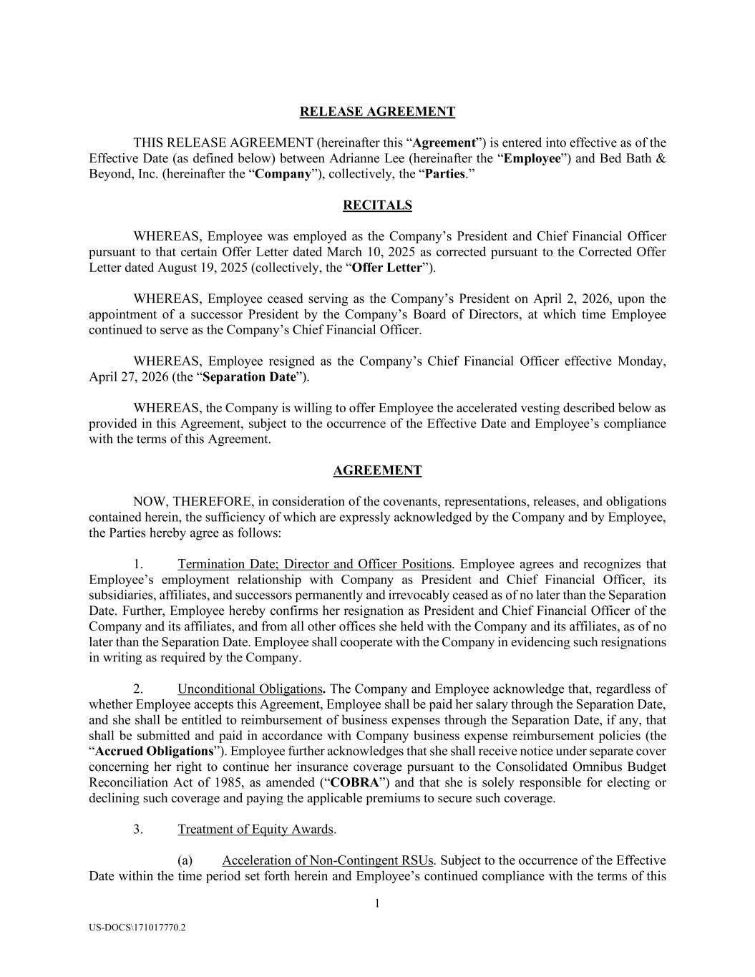
18

|US-DOCS\169935849.1|| | |
1 US-DOCS\171017770.2 RELEASE AGREEMENT THIS RELEASE AGREEMENT (hereinafter this “Agreement”) is entered into effective as of the Effective Date (as defined below) between Adrianne Lee (hereinafter the “Employee”) and Bed Bath & Beyond, Inc. (hereinafter the “Company”), collectively, the “Parties.” RECITALS WHEREAS, Employee was employed as the Company’s President and Chief Financial Officer pursuant to that certain Offer Letter dated March 10, 2025 as corrected pursuant to the Corrected Offer Letter dated August 19, 2025 (collectively, the “Offer Letter”). WHEREAS, Employee ceased serving as the Company’s President on April 2, 2026, upon the appointment of a successor President by the Company’s Board of Directors, at which time Employee continued to serve as the Company’s Chief Financial Officer. WHEREAS, Employee resigned as the Company’s Chief Financial Officer effective Monday, April 27, 2026 (the “Separation Date”). WHEREAS, the Company is willing to offer Employee the accelerated vesting described below as provided in this Agreement, subject to the occurrence of the Effective Date and Employee’s compliance with the terms of this Agreement. AGREEMENT NOW, THEREFORE, in consideration of the covenants, representations, releases, and obligations contained herein, the sufficiency of which are expressly acknowledged by the Company and by Employee, the Parties hereby agree as follows: 1. Termination Date; Director and Officer Positions. Employee agrees and recognizes that Employee’s employment relationship with Company as President and Chief Financial Officer, its subsidiaries, affiliates, and successors permanently and irrevocably ceased as of no later than the Separation Date. Further, Employee hereby confirms her resignation as President and Chief Financial Officer of the Company and its affiliates, and from all other offices she held with the Company and its affiliates, as of no later than the Separation Date. Employee shall cooperate with the Company in evidencing such resignations in writing as required by the Company. 2. Unconditional Obligations. The Company and Employee acknowledge that, regardless of whether Employee accepts this Agreement, Employee shall be paid her salary through the Separation Date, and she shall be entitled to reimbursement of business expenses through the Separation Date, if any, that shall be submitted and paid in accordance with Company business expense reimbursement policies (the “Accrued Obligations”). Employee further acknowledges that she shall receive notice under separate cover concerning her right to continue her insurance coverage pursuant to the Consolidated Omnibus Budget Reconciliation Act of 1985, as amended (“COBRA”) and that she is solely responsible for electing or declining such coverage and paying the applicable premiums to secure such coverage. 3. Treatment of Equity Awards. (a) Acceleration of Non-Contingent RSUs. Subject to the occurrence of the Effective Date within the time period set forth herein and Employee’s continued compliance with the terms of this

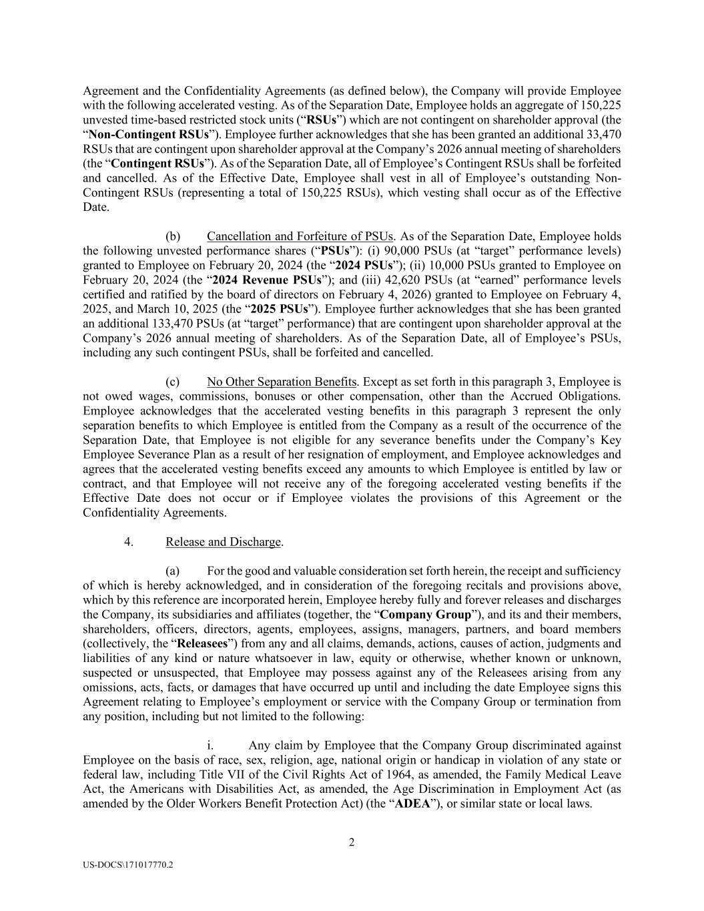
2 US-DOCS\171017770.2 Agreement and the Confidentiality Agreements (as defined below), the Company will provide Employee with the following accelerated vesting. As of the Separation Date, Employee holds an aggregate of 150,225 unvested time-based restricted stock units (“RSUs”) which are not contingent on shareholder approval (the “Non-Contingent RSUs”). Employee further acknowledges that she has been granted an additional 33,470 RSUs that are contingent upon shareholder approval at the Company’s 2026 annual meeting of shareholders (the “Contingent RSUs”). As of the Separation Date, all of Employee’s Contingent RSUs shall be forfeited and cancelled. As of the Effective Date, Employee shall vest in all of Employee’s outstanding Non- Contingent RSUs (representing a total of 150,225 RSUs), which vesting shall occur as of the Effective Date. (b) Cancellation and Forfeiture of PSUs. As of the Separation Date, Employee holds the following unvested performance shares (“PSUs”): (i) 90,000 PSUs (at “target” performance levels) granted to Employee on February 20, 2024 (the “2024 PSUs”); (ii) 10,000 PSUs granted to Employee on February 20, 2024 (the “2024 Revenue PSUs”); and (iii) 42,620 PSUs (at “earned” performance levels certified and ratified by the board of directors on February 4, 2026) granted to Employee on February 4, 2025, and March 10, 2025 (the “2025 PSUs”). Employee further acknowledges that she has been granted an additional 133,470 PSUs (at “target” performance) that are contingent upon shareholder approval at the Company’s 2026 annual meeting of shareholders. As of the Separation Date, all of Employee’s PSUs, including any such contingent PSUs, shall be forfeited and cancelled. (c) No Other Separation Benefits. Except as set forth in this paragraph 3, Employee is not owed wages, commissions, bonuses or other compensation, other than the Accrued Obligations. Employee acknowledges that the accelerated vesting benefits in this paragraph 3 represent the only separation benefits to which Employee is entitled from the Company as a result of the occurrence of the Separation Date, that Employee is not eligible for any severance benefits under the Company’s Key Employee Severance Plan as a result of her resignation of employment, and Employee acknowledges and agrees that the accelerated vesting benefits exceed any amounts to which Employee is entitled by law or contract, and that Employee will not receive any of the foregoing accelerated vesting benefits if the Effective Date does not occur or if Employee violates the provisions of this Agreement or the Confidentiality Agreements. 4. Release and Discharge. (a) For the good and valuable consideration set forth herein, the receipt and sufficiency of which is hereby acknowledged, and in consideration of the foregoing recitals and provisions above, which by this reference are incorporated herein, Employee hereby fully and forever releases and discharges the Company, its subsidiaries and affiliates (together, the “Company Group”), and its and their members, shareholders, officers, directors, agents, employees, assigns, managers, partners, and board members (collectively, the “Releasees”) from any and all claims, demands, actions, causes of action, judgments and liabilities of any kind or nature whatsoever in law, equity or otherwise, whether known or unknown, suspected or unsuspected, that Employee may possess against any of the Releasees arising from any omissions, acts, facts, or damages that have occurred up until and including the date Employee signs this Agreement relating to Employee’s employment or service with the Company Group or termination from any position, including but not limited to the following: i. Any claim by Employee that the Company Group discriminated against Employee on the basis of race, sex, religion, age, national origin or handicap in violation of any state or federal law, including Title VII of the Civil Rights Act of 1964, as amended, the Family Medical Leave Act, the Americans with Disabilities Act, as amended, the Age Discrimination in Employment Act (as amended by the Older Workers Benefit Protection Act) (the “ADEA”), or similar state or local laws.

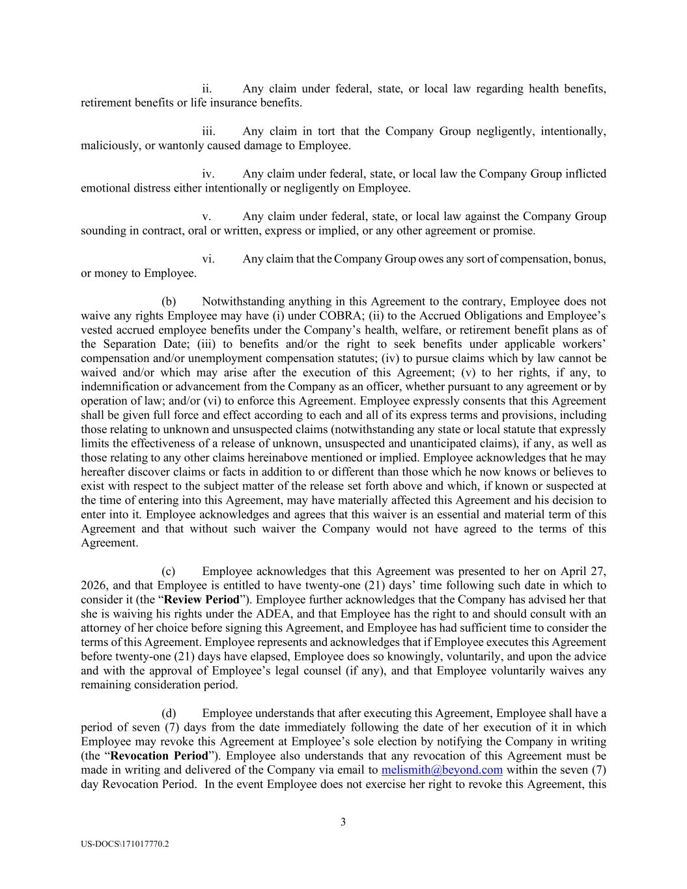
3 US-DOCS\171017770.2 ii. Any claim under federal, state, or local law regarding health benefits, retirement benefits or life insurance benefits. iii. Any claim in tort that the Company Group negligently, intentionally, maliciously, or wantonly caused damage to Employee. iv. Any claim under federal, state, or local law the Company Group inflicted emotional distress either intentionally or negligently on Employee. v. Any claim under federal, state, or local law against the Company Group sounding in contract, oral or written, express or implied, or any other agreement or promise. vi. Any claim that the Company Group owes any sort of compensation, bonus, or money to Employee. (b) Notwithstanding anything in this Agreement to the contrary, Employee does not waive any rights Employee may have (i) under COBRA; (ii) to the Accrued Obligations and Employee’s vested accrued employee benefits under the Company’s health, welfare, or retirement benefit plans as of the Separation Date; (iii) to benefits and/or the right to seek benefits under applicable workers’ compensation and/or unemployment compensation statutes; (iv) to pursue claims which by law cannot be waived and/or which may arise after the execution of this Agreement; (v) to her rights, if any, to indemnification or advancement from the Company as an officer, whether pursuant to any agreement or by operation of law; and/or (vi) to enforce this Agreement. Employee expressly consents that this Agreement shall be given full force and effect according to each and all of its express terms and provisions, including those relating to unknown and unsuspected claims (notwithstanding any state or local statute that expressly limits the effectiveness of a release of unknown, unsuspected and unanticipated claims), if any, as well as those relating to any other claims hereinabove mentioned or implied. Employee acknowledges that he may hereafter discover claims or facts in addition to or different than those which he now knows or believes to exist with respect to the subject matter of the release set forth above and which, if known or suspected at the time of entering into this Agreement, may have materially affected this Agreement and his decision to enter into it. Employee acknowledges and agrees that this waiver is an essential and material term of this Agreement and that without such waiver the Company would not have agreed to the terms of this Agreement. (c) Employee acknowledges that this Agreement was presented to her on April 27, 2026, and that Employee is entitled to have twenty-one (21) days’ time following such date in which to consider it (the “Review Period”). Employee further acknowledges that the Company has advised her that she is waiving his rights under the ADEA, and that Employee has the right to and should consult with an attorney of her choice before signing this Agreement, and Employee has had sufficient time to consider the terms of this Agreement. Employee represents and acknowledges that if Employee executes this Agreement before twenty-one (21) days have elapsed, Employee does so knowingly, voluntarily, and upon the advice and with the approval of Employee’s legal counsel (if any), and that Employee voluntarily waives any remaining consideration period. (d) Employee understands that after executing this Agreement, Employee shall have a period of seven (7) days from the date immediately following the date of her execution of it in which Employee may revoke this Agreement at Employee’s sole election by notifying the Company in writing (the “Revocation Period”). Employee also understands that any revocation of this Agreement must be made in writing and delivered of the Company via email to melismith@beyond.com within the seven (7) day Revocation Period. In the event Employee does not exercise her right to revoke this Agreement, this

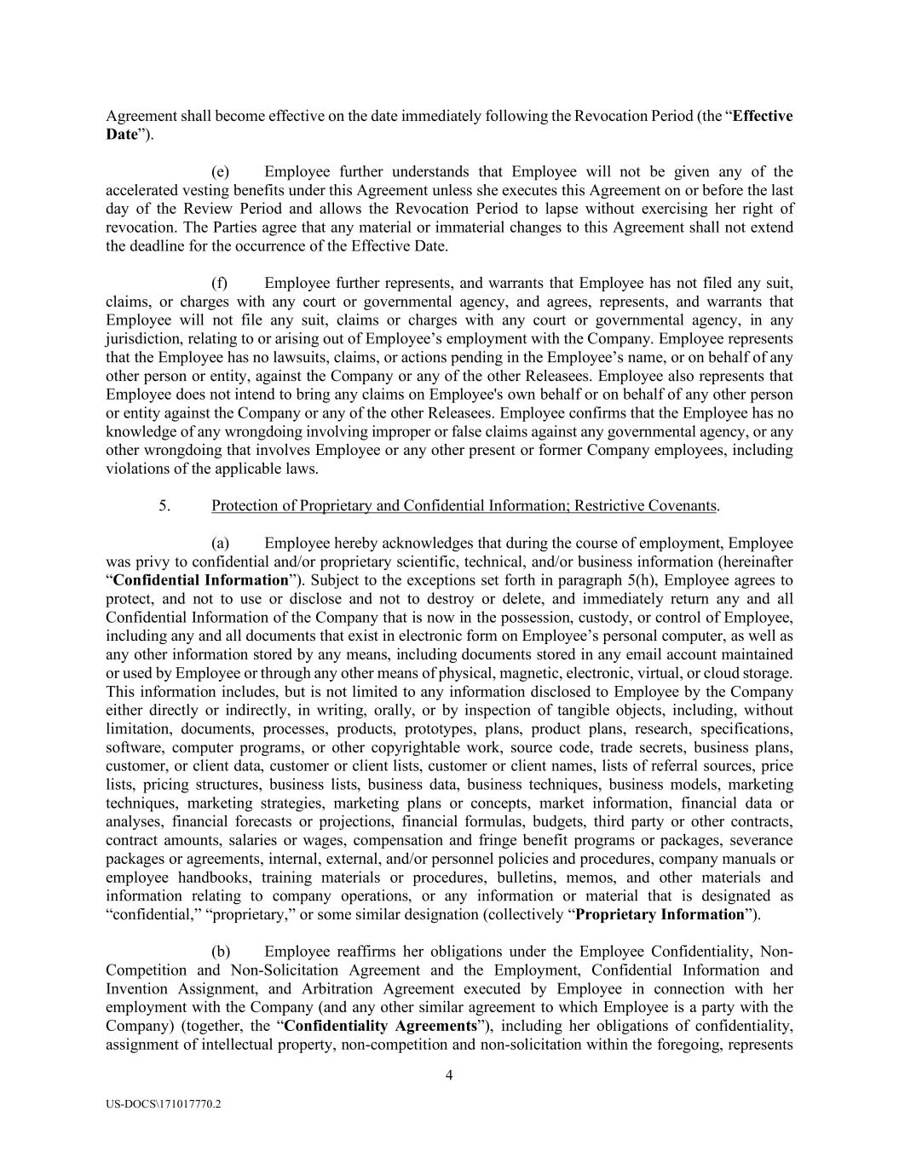
4 US-DOCS\171017770.2 Agreement shall become effective on the date immediately following the Revocation Period (the “Effective Date”). (e) Employee further understands that Employee will not be given any of the accelerated vesting benefits under this Agreement unless she executes this Agreement on or before the last day of the Review Period and allows the Revocation Period to lapse without exercising her right of revocation. The Parties agree that any material or immaterial changes to this Agreement shall not extend the deadline for the occurrence of the Effective Date. (f) Employee further represents, and warrants that Employee has not filed any suit, claims, or charges with any court or governmental agency, and agrees, represents, and warrants that Employee will not file any suit, claims or charges with any court or governmental agency, in any jurisdiction, relating to or arising out of Employee’s employment with the Company. Employee represents that the Employee has no lawsuits, claims, or actions pending in the Employee’s name, or on behalf of any other person or entity, against the Company or any of the other Releasees. Employee also represents that Employee does not intend to bring any claims on Employee's own behalf or on behalf of any other person or entity against the Company or any of the other Releasees. Employee confirms that the Employee has no knowledge of any wrongdoing involving improper or false claims against any governmental agency, or any other wrongdoing that involves Employee or any other present or former Company employees, including violations of the applicable laws. 5. Protection of Proprietary and Confidential Information; Restrictive Covenants. (a) Employee hereby acknowledges that during the course of employment, Employee was privy to confidential and/or proprietary scientific, technical, and/or business information (hereinafter “Confidential Information”). Subject to the exceptions set forth in paragraph 5(h), Employee agrees to protect, and not to use or disclose and not to destroy or delete, and immediately return any and all Confidential Information of the Company that is now in the possession, custody, or control of Employee, including any and all documents that exist in electronic form on Employee’s personal computer, as well as any other information stored by any means, including documents stored in any email account maintained or used by Employee or through any other means of physical, magnetic, electronic, virtual, or cloud storage. This information includes, but is not limited to any information disclosed to Employee by the Company either directly or indirectly, in writing, orally, or by inspection of tangible objects, including, without limitation, documents, processes, products, prototypes, plans, product plans, research, specifications, software, computer programs, or other copyrightable work, source code, trade secrets, business plans, customer, or client data, customer or client lists, customer or client names, lists of referral sources, price lists, pricing structures, business lists, business data, business techniques, business models, marketing techniques, marketing strategies, marketing plans or concepts, market information, financial data or analyses, financial forecasts or projections, financial formulas, budgets, third party or other contracts, contract amounts, salaries or wages, compensation and fringe benefit programs or packages, severance packages or agreements, internal, external, and/or personnel policies and procedures, company manuals or employee handbooks, training materials or procedures, bulletins, memos, and other materials and information relating to company operations, or any information or material that is designated as “confidential,” “proprietary,” or some similar designation (collectively “Proprietary Information”). (b) Employee reaffirms her obligations under the Employee Confidentiality, Non- Competition and Non-Solicitation Agreement and the Employment, Confidential Information and Invention Assignment, and Arbitration Agreement executed by Employee in connection with her employment with the Company (and any other similar agreement to which Employee is a party with the Company) (together, the “Confidentiality Agreements”), including her obligations of confidentiality, assignment of intellectual property, non-competition and non-solicitation within the foregoing, represents

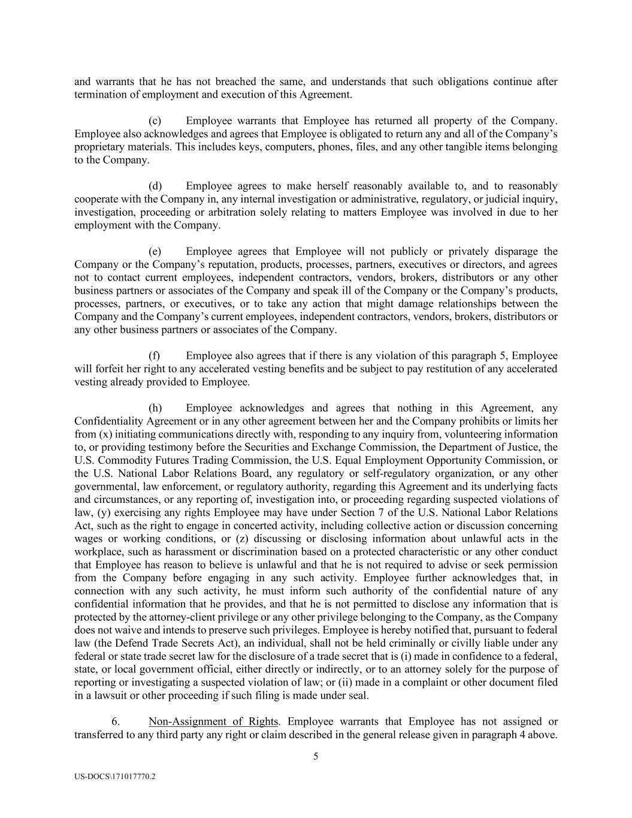
5 US-DOCS\171017770.2 and warrants that he has not breached the same, and understands that such obligations continue after termination of employment and execution of this Agreement. (c) Employee warrants that Employee has returned all property of the Company. Employee also acknowledges and agrees that Employee is obligated to return any and all of the Company’s proprietary materials. This includes keys, computers, phones, files, and any other tangible items belonging to the Company. (d) Employee agrees to make herself reasonably available to, and to reasonably cooperate with the Company in, any internal investigation or administrative, regulatory, or judicial inquiry, investigation, proceeding or arbitration solely relating to matters Employee was involved in due to her employment with the Company. (e) Employee agrees that Employee will not publicly or privately disparage the Company or the Company’s reputation, products, processes, partners, executives or directors, and agrees not to contact current employees, independent contractors, vendors, brokers, distributors or any other business partners or associates of the Company and speak ill of the Company or the Company’s products, processes, partners, or executives, or to take any action that might damage relationships between the Company and the Company’s current employees, independent contractors, vendors, brokers, distributors or any other business partners or associates of the Company. (f) Employee also agrees that if there is any violation of this paragraph 5, Employee will forfeit her right to any accelerated vesting benefits and be subject to pay restitution of any accelerated vesting already provided to Employee. (h) Employee acknowledges and agrees that nothing in this Agreement, any Confidentiality Agreement or in any other agreement between her and the Company prohibits or limits her from (x) initiating communications directly with, responding to any inquiry from, volunteering information to, or providing testimony before the Securities and Exchange Commission, the Department of Justice, the U.S. Commodity Futures Trading Commission, the U.S. Equal Employment Opportunity Commission, or the U.S. National Labor Relations Board, any regulatory or self-regulatory organization, or any other governmental, law enforcement, or regulatory authority, regarding this Agreement and its underlying facts and circumstances, or any reporting of, investigation into, or proceeding regarding suspected violations of law, (y) exercising any rights Employee may have under Section 7 of the U.S. National Labor Relations Act, such as the right to engage in concerted activity, including collective action or discussion concerning wages or working conditions, or (z) discussing or disclosing information about unlawful acts in the workplace, such as harassment or discrimination based on a protected characteristic or any other conduct that Employee has reason to believe is unlawful and that he is not required to advise or seek permission from the Company before engaging in any such activity. Employee further acknowledges that, in connection with any such activity, he must inform such authority of the confidential nature of any confidential information that he provides, and that he is not permitted to disclose any information that is protected by the attorney-client privilege or any other privilege belonging to the Company, as the Company does not waive and intends to preserve such privileges. Employee is hereby notified that, pursuant to federal law (the Defend Trade Secrets Act), an individual, shall not be held criminally or civilly liable under any federal or state trade secret law for the disclosure of a trade secret that is (i) made in confidence to a federal, state, or local government official, either directly or indirectly, or to an attorney solely for the purpose of reporting or investigating a suspected violation of law; or (ii) made in a complaint or other document filed in a lawsuit or other proceeding if such filing is made under seal. 6. Non-Assignment of Rights. Employee warrants that Employee has not assigned or transferred to any third party any right or claim described in the general release given in paragraph 4 above.

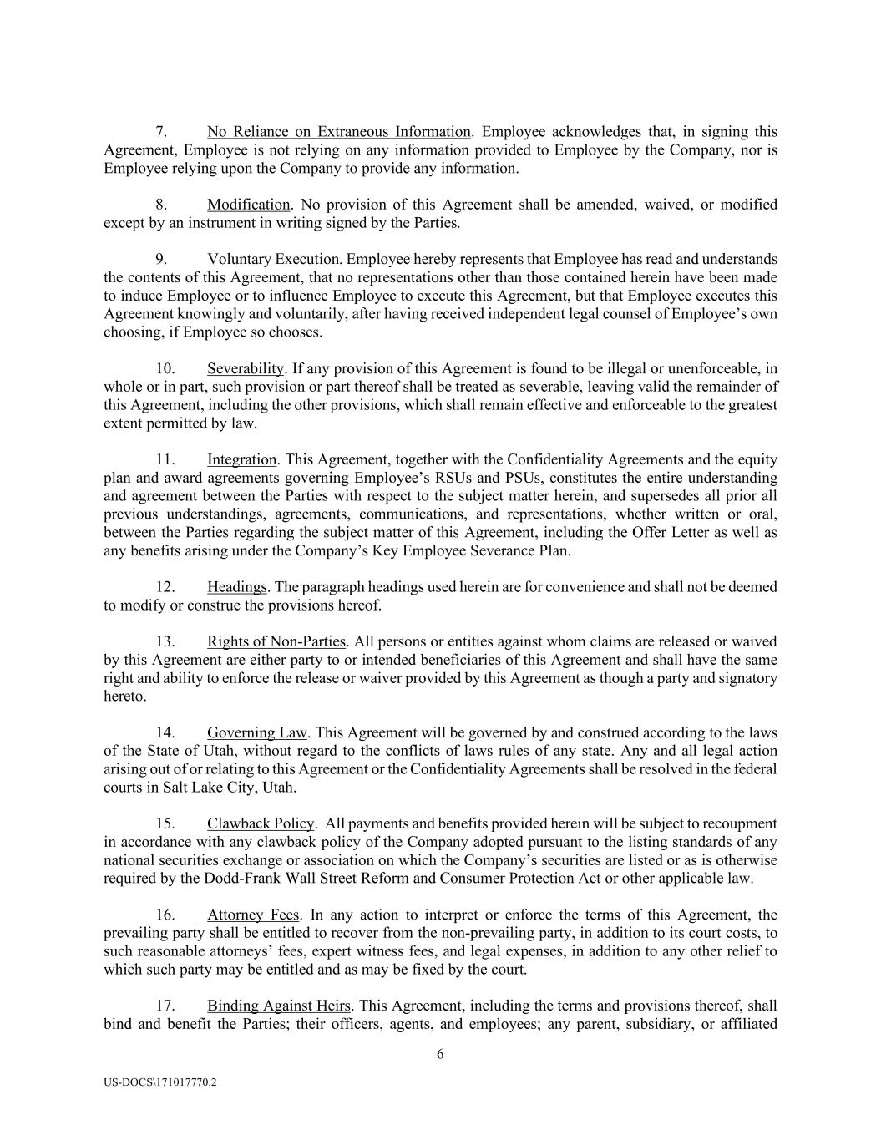
6 US-DOCS\171017770.2 7. No Reliance on Extraneous Information. Employee acknowledges that, in signing this Agreement, Employee is not relying on any information provided to Employee by the Company, nor is Employee relying upon the Company to provide any information. 8. Modification. No provision of this Agreement shall be amended, waived, or modified except by an instrument in writing signed by the Parties. 9. Voluntary Execution. Employee hereby represents that Employee has read and understands the contents of this Agreement, that no representations other than those contained herein have been made to induce Employee or to influence Employee to execute this Agreement, but that Employee executes this Agreement knowingly and voluntarily, after having received independent legal counsel of Employee’s own choosing, if Employee so chooses. 10. Severability. If any provision of this Agreement is found to be illegal or unenforceable, in whole or in part, such provision or part thereof shall be treated as severable, leaving valid the remainder of this Agreement, including the other provisions, which shall remain effective and enforceable to the greatest extent permitted by law. 11. Integration. This Agreement, together with the Confidentiality Agreements and the equity plan and award agreements governing Employee’s RSUs and PSUs, constitutes the entire understanding and agreement between the Parties with respect to the subject matter herein, and supersedes all prior all previous understandings, agreements, communications, and representations, whether written or oral, between the Parties regarding the subject matter of this Agreement, including the Offer Letter as well as any benefits arising under the Company’s Key Employee Severance Plan. 12. Headings. The paragraph headings used herein are for convenience and shall not be deemed to modify or construe the provisions hereof. 13. Rights of Non-Parties. All persons or entities against whom claims are released or waived by this Agreement are either party to or intended beneficiaries of this Agreement and shall have the same right and ability to enforce the release or waiver provided by this Agreement as though a party and signatory hereto. 14. Governing Law. This Agreement will be governed by and construed according to the laws of the State of Utah, without regard to the conflicts of laws rules of any state. Any and all legal action arising out of or relating to this Agreement or the Confidentiality Agreements shall be resolved in the federal courts in Salt Lake City, Utah. 15. Clawback Policy. All payments and benefits provided herein will be subject to recoupment in accordance with any clawback policy of the Company adopted pursuant to the listing standards of any national securities exchange or association on which the Company’s securities are listed or as is otherwise required by the Dodd-Frank Wall Street Reform and Consumer Protection Act or other applicable law. 16. Attorney Fees. In any action to interpret or enforce the terms of this Agreement, the prevailing party shall be entitled to recover from the non-prevailing party, in addition to its court costs, to such reasonable attorneys’ fees, expert witness fees, and legal expenses, in addition to any other relief to which such party may be entitled and as may be fixed by the court. 17. Binding Against Heirs. This Agreement, including the terms and provisions thereof, shall bind and benefit the Parties; their officers, agents, and employees; any parent, subsidiary, or affiliated

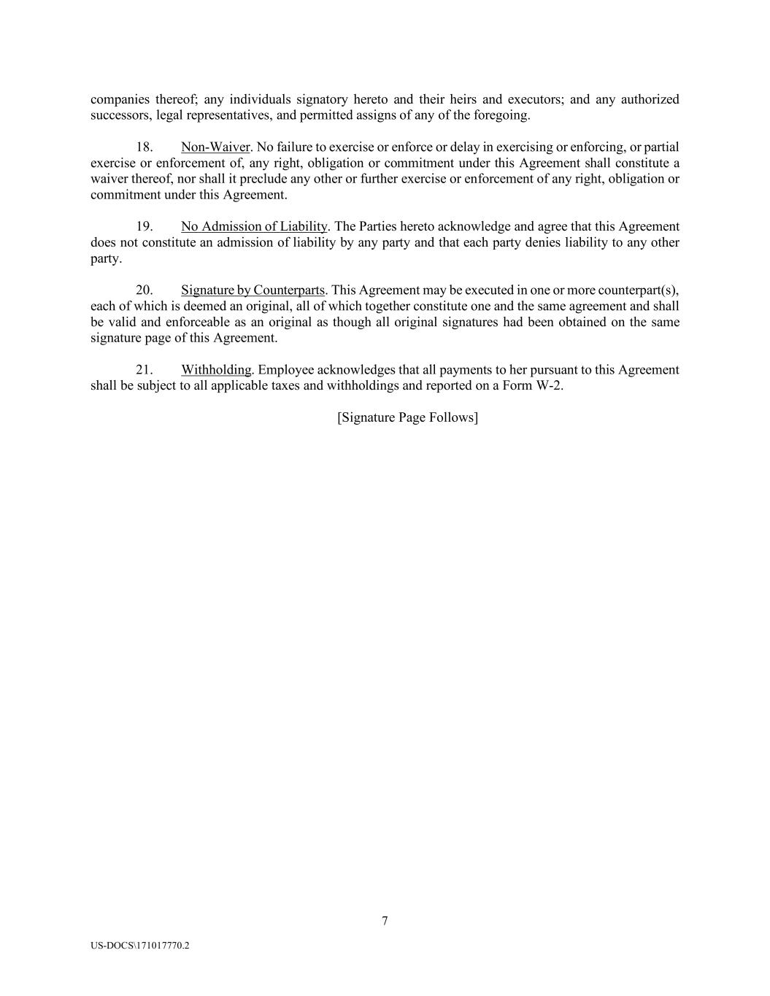
7 US-DOCS\171017770.2 companies thereof; any individuals signatory hereto and their heirs and executors; and any authorized successors, legal representatives, and permitted assigns of any of the foregoing. 18. Non-Waiver. No failure to exercise or enforce or delay in exercising or enforcing, or partial exercise or enforcement of, any right, obligation or commitment under this Agreement shall constitute a waiver thereof, nor shall it preclude any other or further exercise or enforcement of any right, obligation or commitment under this Agreement. 19. No Admission of Liability. The Parties hereto acknowledge and agree that this Agreement does not constitute an admission of liability by any party and that each party denies liability to any other party. 20. Signature by Counterparts. This Agreement may be executed in one or more counterpart(s), each of which is deemed an original, all of which together constitute one and the same agreement and shall be valid and enforceable as an original as though all original signatures had been obtained on the same signature page of this Agreement. 21. Withholding. Employee acknowledges that all payments to her pursuant to this Agreement shall be subject to all applicable taxes and withholdings and reported on a Form W-2. [Signature Page Follows]

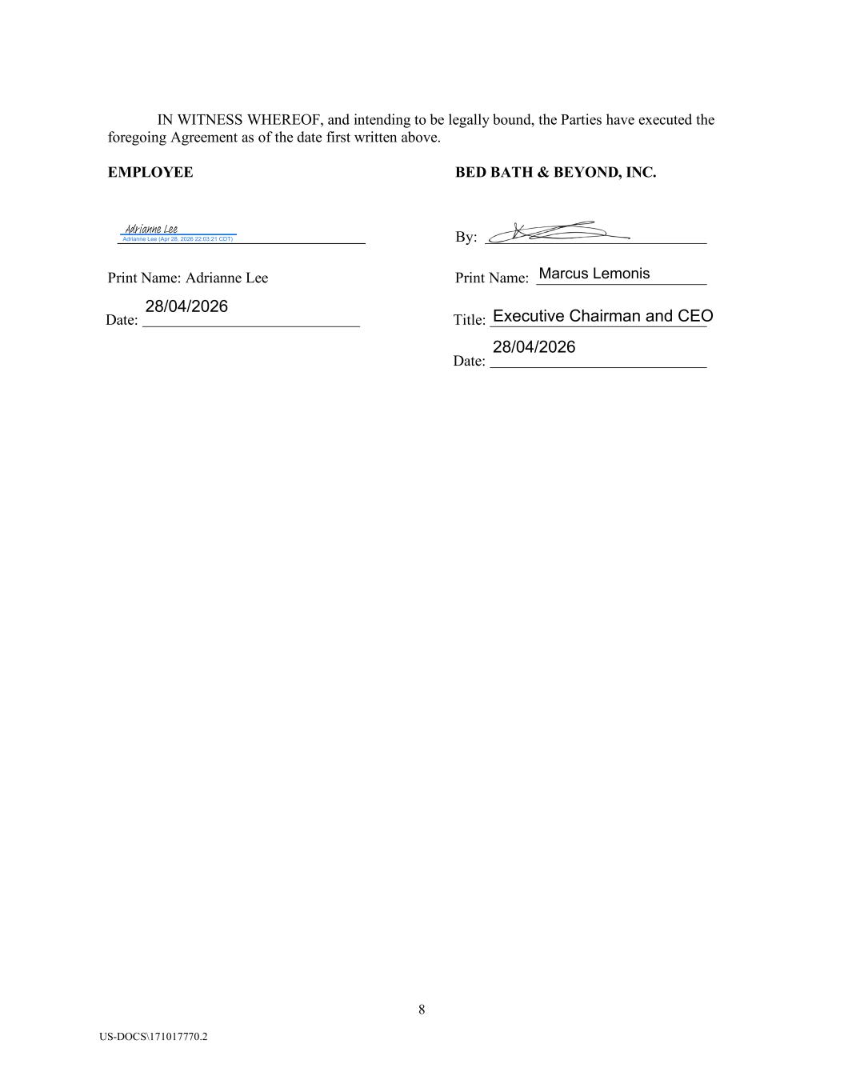
8 US-DOCS\171017770.2 IN WITNESS WHEREOF, and intending to be legally bound, the Parties have executed the foregoing Agreement as of the date first written above. EMPLOYEE BED BATH & BEYOND, INC. By: Print Name: Adrianne Lee Print Name: Date: Title: Date: Marcus Lemonis Executive Chairman and CEO 28/04/2026 Adrianne Lee (Apr 28, 2026 22:03:21 CDT) Adrianne Lee 28/04/2026

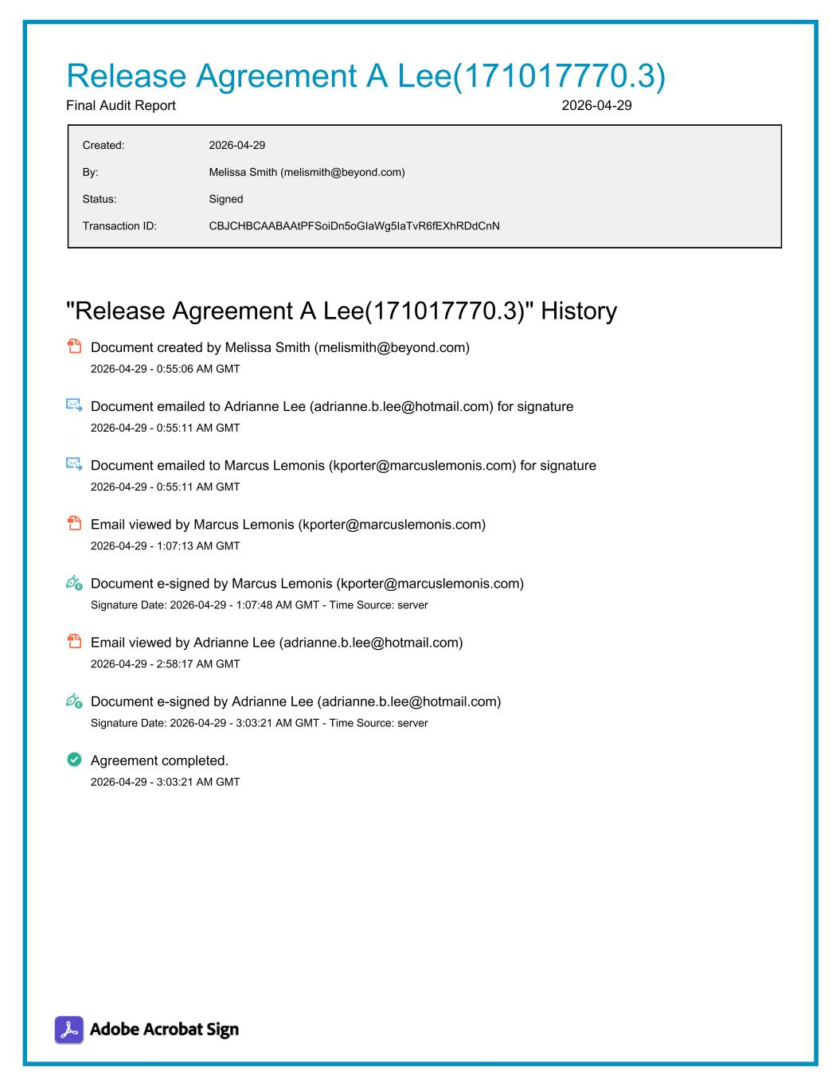
Release Agreement A Lee(171017770.3) Final Audit Report 2026-04-29 Created: 2026-04-29 By: Melissa Smith (melismith@beyond.com) Status: Signed Transaction ID: CBJCHBCAABAAtPFSoiDn5oGIaWg5IaTvR6fEXhRDdCnN "Release Agreement A Lee(171017770.3)" History Document created by Melissa Smith (melismith@beyond.com) 2026-04-29 - 0:55:06 AM GMT Document emailed to Adrianne Lee (adrianne.b.lee@hotmail.com) for signature 2026-04-29 - 0:55:11 AM GMT Document emailed to Marcus Lemonis (kporter@marcuslemonis.com) for signature 2026-04-29 - 0:55:11 AM GMT Email viewed by Marcus Lemonis (kporter@marcuslemonis.com) 2026-04-29 - 1:07:13 AM GMT Document e-signed by Marcus Lemonis (kporter@marcuslemonis.com) Signature Date: 2026-04-29 - 1:07:48 AM GMT - Time Source: server Email viewed by Adrianne Lee (adrianne.b.lee@hotmail.com) 2026-04-29 - 2:58:17 AM GMT Document e-signed by Adrianne Lee (adrianne.b.lee@hotmail.com) Signature Date: 2026-04-29 - 3:03:21 AM GMT - Time Source: server Agreement completed. 2026-04-29 - 3:03:21 AM GMT

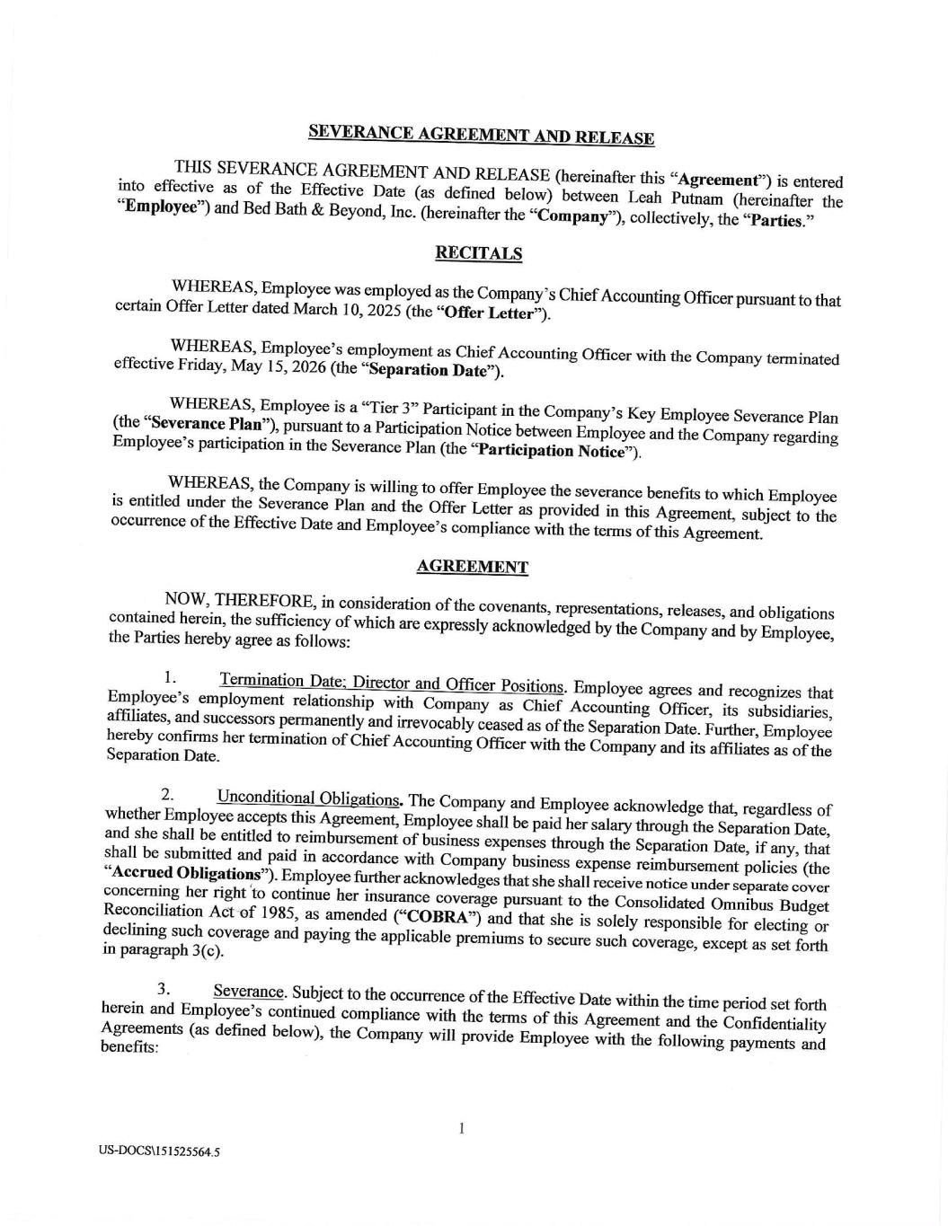

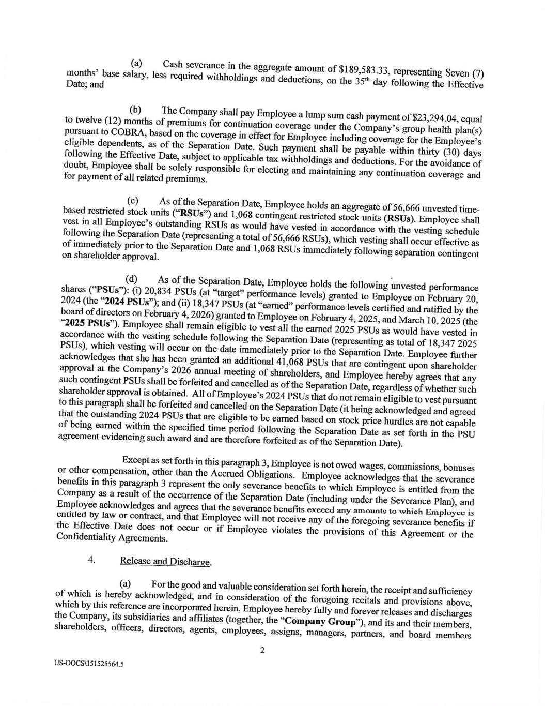

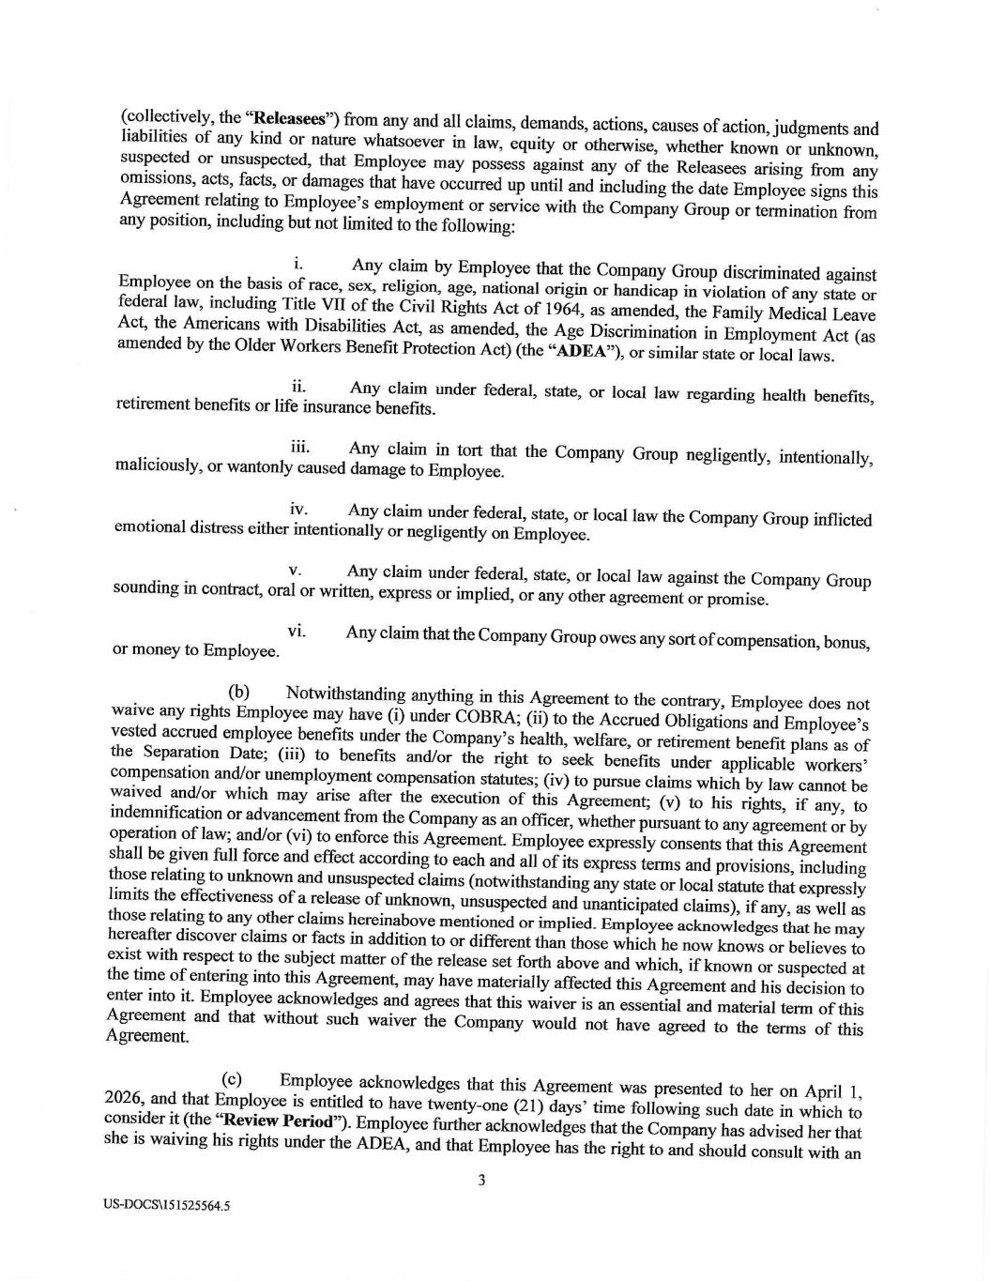

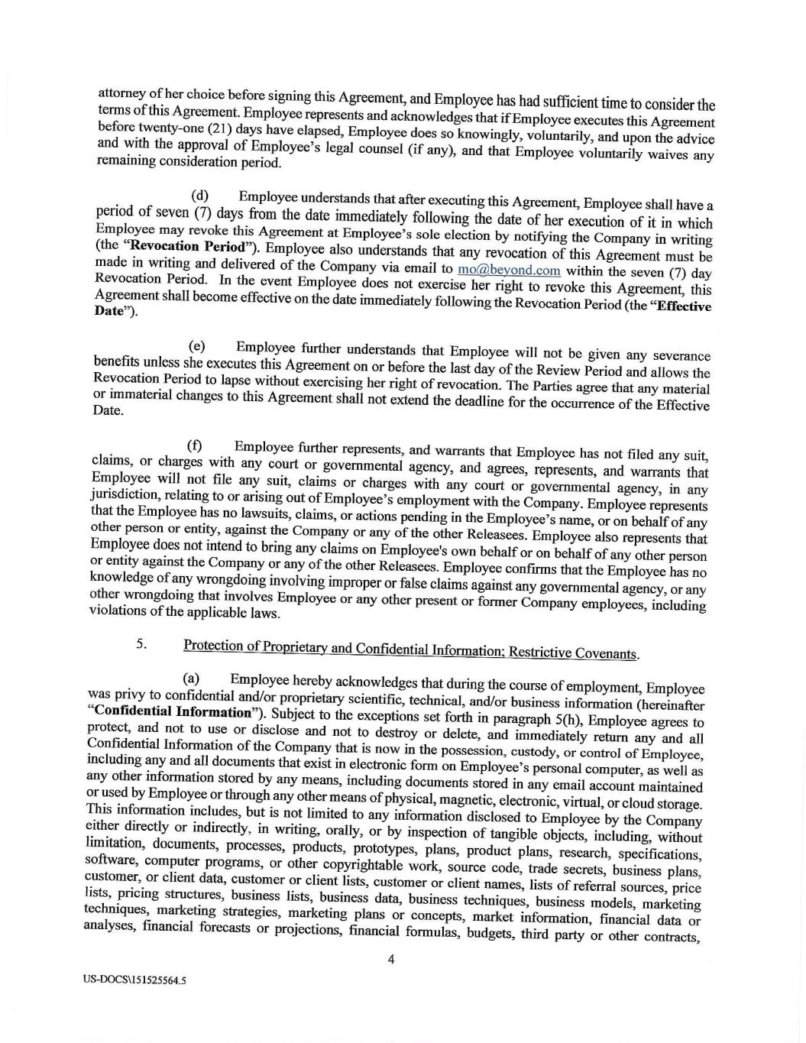

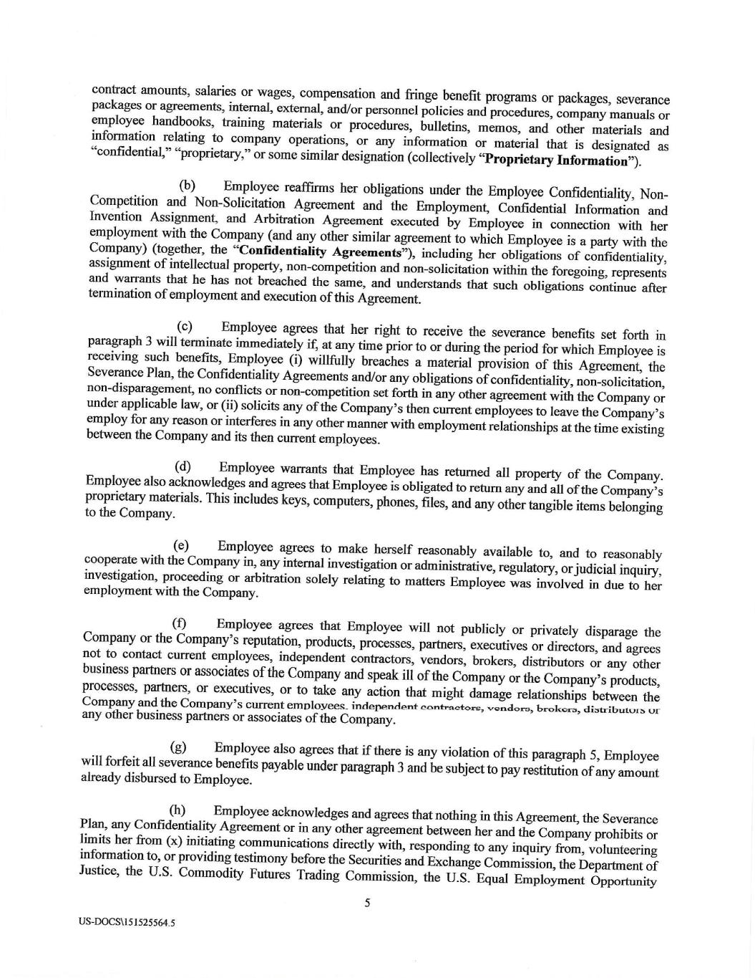

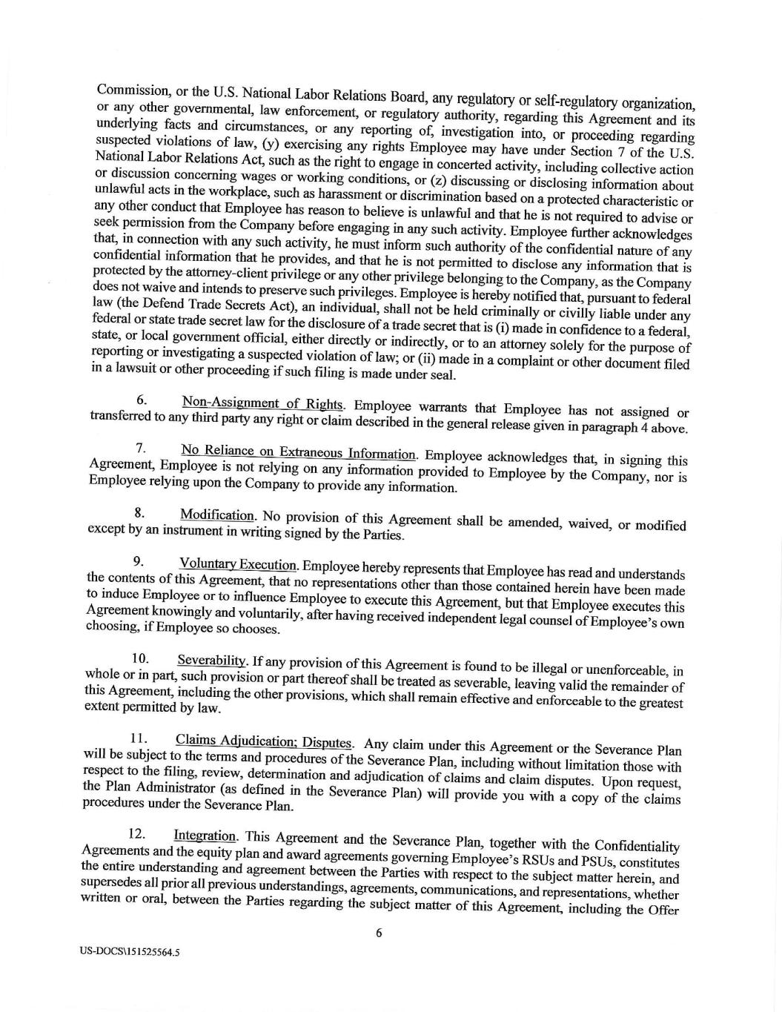

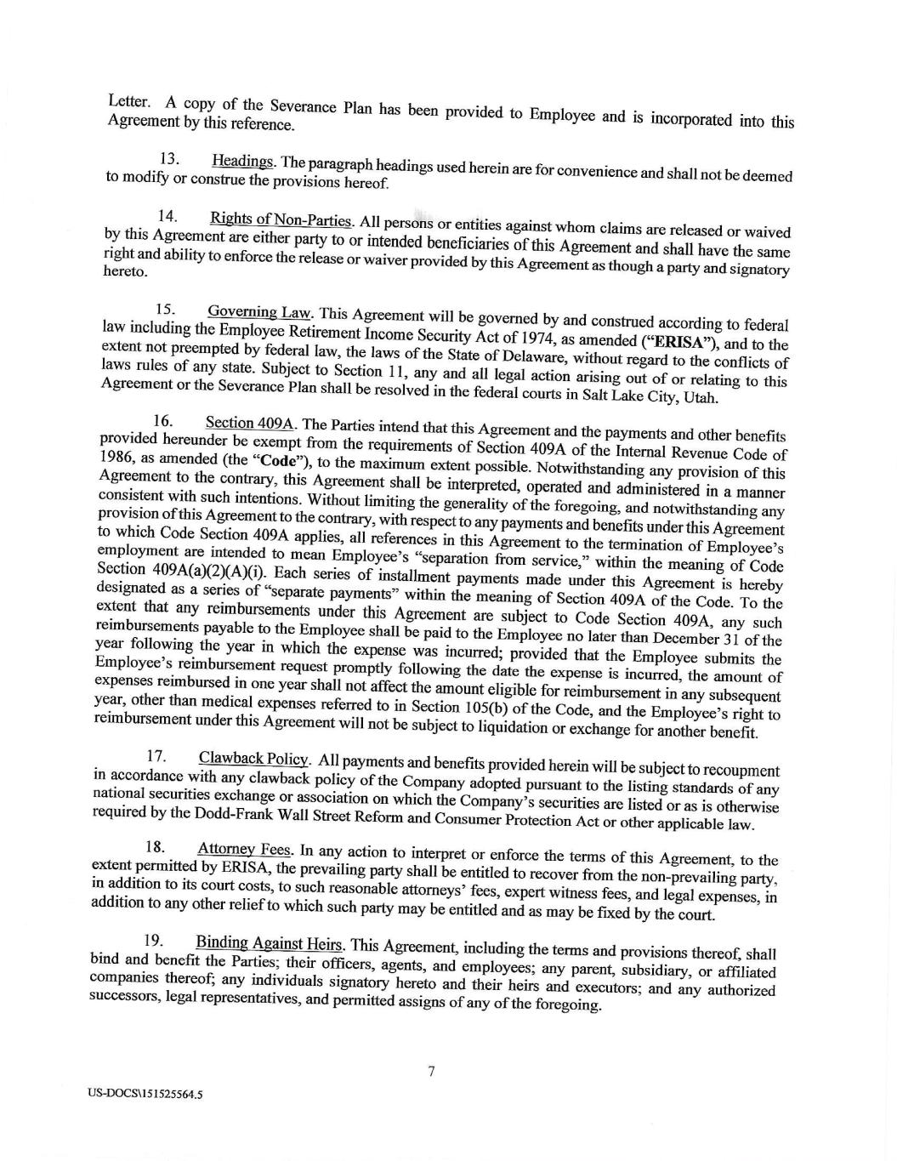

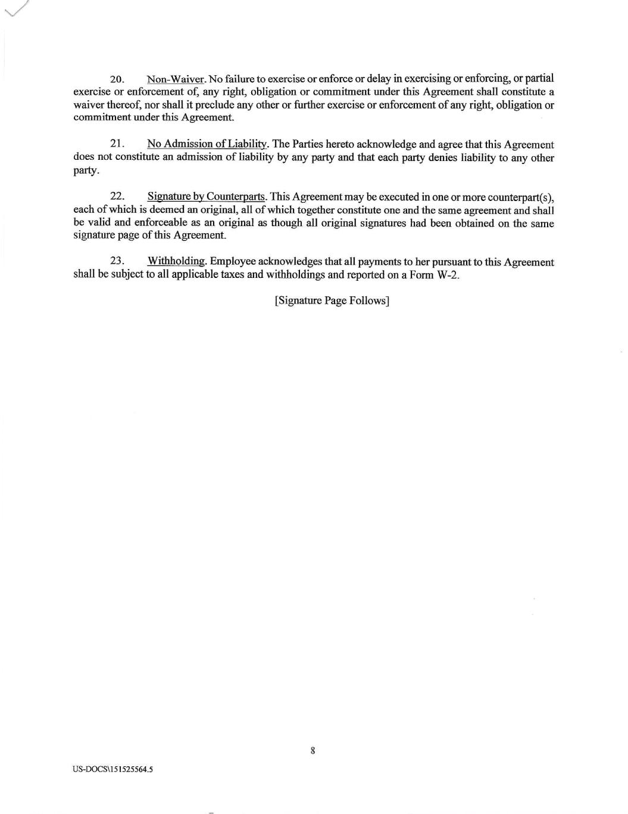

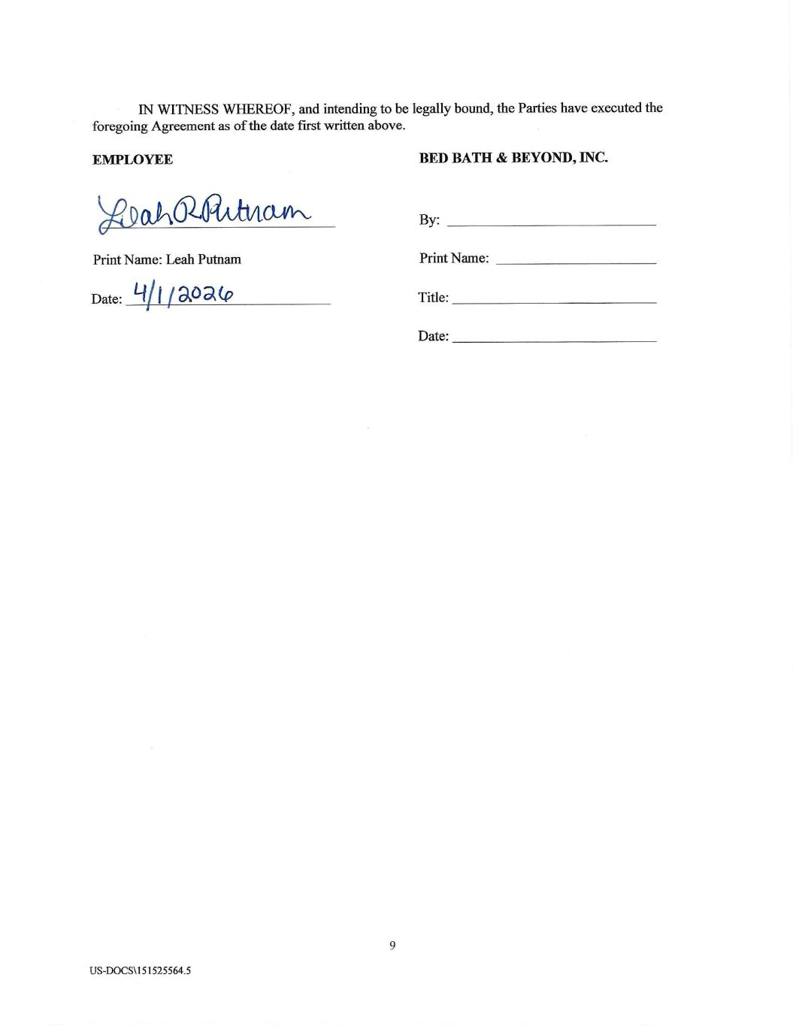

Exhibit 31.1

CERTIFICATION

I, Marcus A. Lemonis, certify that:

1. I have reviewed this Quarterly Report on Form 10-Q of Bed Bath & Beyond, Inc.;

2. Based on my knowledge, this report does not contain any untrue statement of a material fact or omit to state a material fact necessary to make the statements made, in light of the circumstances under which such statements were made, not misleading with respect to the period covered by this report;

3. Based on my knowledge, the financial statements, and other financial information included in this report, fairly present in all material respects the financial condition, results of operations and cash flows of the registrant as of, and for, the periods presented in this report;

4. The registrant’s other certifying officer(s) and I are responsible for establishing and maintaining disclosure controls and procedures (as defined in Exchange Act Rules 13a-15(e) and 15d-15(e)) and internal control over financial reporting (as defined in Exchange Act Rules 13a-15(f) and 15d-15(f)) for the registrant and have:

a. designed such disclosure controls and procedures, or caused such disclosure controls and procedures to be designed under our supervision, to ensure that material information relating to the registrant, including its consolidated subsidiaries, is made known to us by others within those entities, particularly during the period in which this report is being prepared;

b. designed such internal control over financial reporting, or caused such internal control over financial reporting to be designed under our supervision, to provide reasonable assurance regarding the reliability of financial reporting and the preparation of financial statements for external purposes in accordance with generally accepted accounting principles;

c. evaluated the effectiveness of the registrant’s disclosure controls and procedures and presented in this report our conclusions about the effectiveness of the disclosure controls and procedures, as of the end of the period covered by this report based on such evaluation; and

d. disclosed in this report any change in the registrant’s internal control over financial reporting that occurred during the registrant’s most recent fiscal quarter (the registrant’s fourth fiscal quarter in the case of an annual report) that has materially affected, or is reasonably likely to materially affect, the registrant’s internal control over financial reporting; and

5. The registrant’s other certifying officer(s) and I have disclosed, based on our most recent evaluation of internal control over financial reporting, to the registrant’s auditors and the audit committee of the registrant’s board of directors (or persons performing the equivalent functions):

a. all significant deficiencies and material weaknesses in the design or operation of internal control over financial reporting which are reasonably likely to adversely affect the registrant’s ability to record, process, summarize and report financial information; and

b. any fraud, whether or not material, that involves management or other employees who have a significant role in the registrant’s internal control over financial reporting.

Date: |  |  | August 4, 2026 |  |  | /s/ MARCUS A. LEMONIS
 |  |  |  |  |  | Marcus A. Lemonis
 |  |  |  |  |  | Executive Chairman and Chief Executive Officer
 |  |  |  |  |  | (Principal Executive Officer)

Exhibit 31.2

CERTIFICATION

I, Brian LaRose, certify that:

1. I have reviewed this Quarterly Report on Form 10-Q of Bed Bath & Beyond, Inc.;

2. Based on my knowledge, this report does not contain any untrue statement of a material fact or omit to state a material fact necessary to make the statements made, in light of the circumstances under which such statements were made, not misleading with respect to the period covered by this report;

3. Based on my knowledge, the financial statements, and other financial information included in this report, fairly present in all material respects the financial condition, results of operations and cash flows of the registrant as of, and for, the periods presented in this report;

4. The registrant’s other certifying officer(s) and I are responsible for establishing and maintaining disclosure controls and procedures (as defined in Exchange Act Rules 13a-15(e) and 15d-15(e)) and internal control over financial reporting (as defined in Exchange Act Rules 13a-15(f) and 15d-15(f)) for the registrant and have:

a. designed such disclosure controls and procedures, or caused such disclosure controls and procedures to be designed under our supervision, to ensure that material information relating to the registrant, including its consolidated subsidiaries, is made known to us by others within those entities, particularly during the period in which this report is being prepared;

b. designed such internal control over financial reporting, or caused such internal control over financial reporting to be designed under our supervision, to provide reasonable assurance regarding the reliability of financial reporting and the preparation of financial statements for external purposes in accordance with generally accepted accounting principles;

c. evaluated the effectiveness of the registrant’s disclosure controls and procedures and presented in this report our conclusions about the effectiveness of the disclosure controls and procedures, as of the end of the period covered by this report based on such evaluation; and

d. disclosed in this report any change in the registrant’s internal control over financial reporting that occurred during the registrant’s most recent fiscal quarter (the registrant’s fourth fiscal quarter in the case of an annual report) that has materially affected, or is reasonably likely to materially affect, the registrant’s internal control over financial reporting; and

5. The registrant’s other certifying officer(s) and I have disclosed, based on our most recent evaluation of internal control over financial reporting, to the registrant’s auditors and the audit committee of the registrant’s board of directors (or persons performing the equivalent functions):

a. all significant deficiencies and material weaknesses in the design or operation of internal control over financial reporting which are reasonably likely to adversely affect the registrant’s ability to record, process, summarize and report financial information; and

b. any fraud, whether or not material, that involves management or other employees who have a significant role in the registrant’s internal control over financial reporting.

Date: |  |  | August 4, 2026 |  |  | /s/ BRIAN LAROSE
 |  |  |  |  |  | Brian LaRose
 |  |  |  |  |  | Chief Financial Officer
 |  |  |  |  |  | (Principal Financial Officer)

Exhibit 32.1

CERTIFICATION OF PRINCIPAL EXECUTIVE OFFICER

PURSUANT TO

18 U.S.C. SECTION 1350,

AS ADOPTED PURSUANT TO

SECTION 906 OF THE SARBANES-OXLEY ACT OF 2002

I, Marcus A. Lemonis, certify, pursuant to 18 U.S.C. Section 1350, as adopted pursuant to Section 906 of the Sarbanes-Oxley Act of 2002, as amended, that the Quarterly Report on Form 10-Q of Bed Bath & Beyond, Inc. for the quarter ended June 30, 2026 (the "Report") fully complies with the requirements of Section 13(a) or 15(d) of the Securities Exchange Act of 1934, as amended, and that information contained in such Report fairly presents in all material respects the financial condition and results of operations of Bed Bath & Beyond, Inc.

Date: |  |  | August 4, 2026 |  |  | /s/ MARCUS A. LEMONIS
 |  |  |  |  |  | Marcus A. Lemonis
 |  |  |  |  |  | Executive Chairman and Chief Executive Officer
 |  |  |  |  |  | (Principal Executive Officer)

Exhibit 32.2

CERTIFICATION OF PRINCIPAL FINANCIAL OFFICER

PURSUANT TO

18 U.S.C. SECTION 1350,

AS ADOPTED PURSUANT TO

SECTION 906 OF THE SARBANES-OXLEY ACT OF 2002

I, Brian LaRose, certify, pursuant to 18 U.S.C. Section 1350, as adopted pursuant to Section 906 of the Sarbanes-Oxley Act of 2002, as amended, that the Quarterly Report on Form 10-Q of Bed Bath & Beyond, Inc. for the quarter ended June 30, 2026 (the "Report") fully complies with the requirements of Section 13(a) or 15(d) of the Securities Exchange Act of 1934, as amended, and that information contained in such Report fairly presents in all material respects the financial condition and results of operations of Bed Bath & Beyond, Inc.

Date: |  |  | August 4, 2026 |  |  | /s/ BRIAN LAROSE
 |  |  |  |  |  | Brian LaRose
 |  |  |  |  |  | Chief Financial Officer
 |  |  |  |  |  | (Principal Financial Officer)

